Όνομα
Το Πρόσωπο- The Face

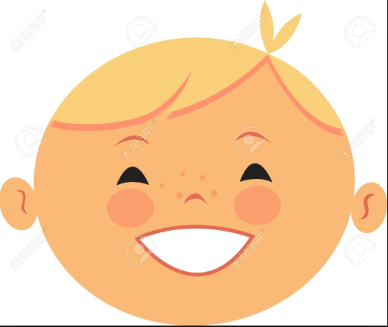
8
7
5
6
4
3
2
1
Write the correct facial part to the corresponding number in the space provided.
Word bank:
Μάτια, Μαλλιά, Αυτιά, Στόμα, Δόντια, Φρύδια, Βλέφαρες, Μύτη

- _____________________

- _____________________

- _____________________

- _____________________

- _____________________

- _____________________

- _____________________

- _____________________

