Stage 3 -Term 3: Θέμα -Topic: Olympic Games
Assessment Task: Εργασία – Project
Βαθμός: 10 -Marks: 10
Ημερομηνία Παράδοσης- Date Due: ____________
Όνομα/Name:
Τάξη/Year :
Χώρα/Country:

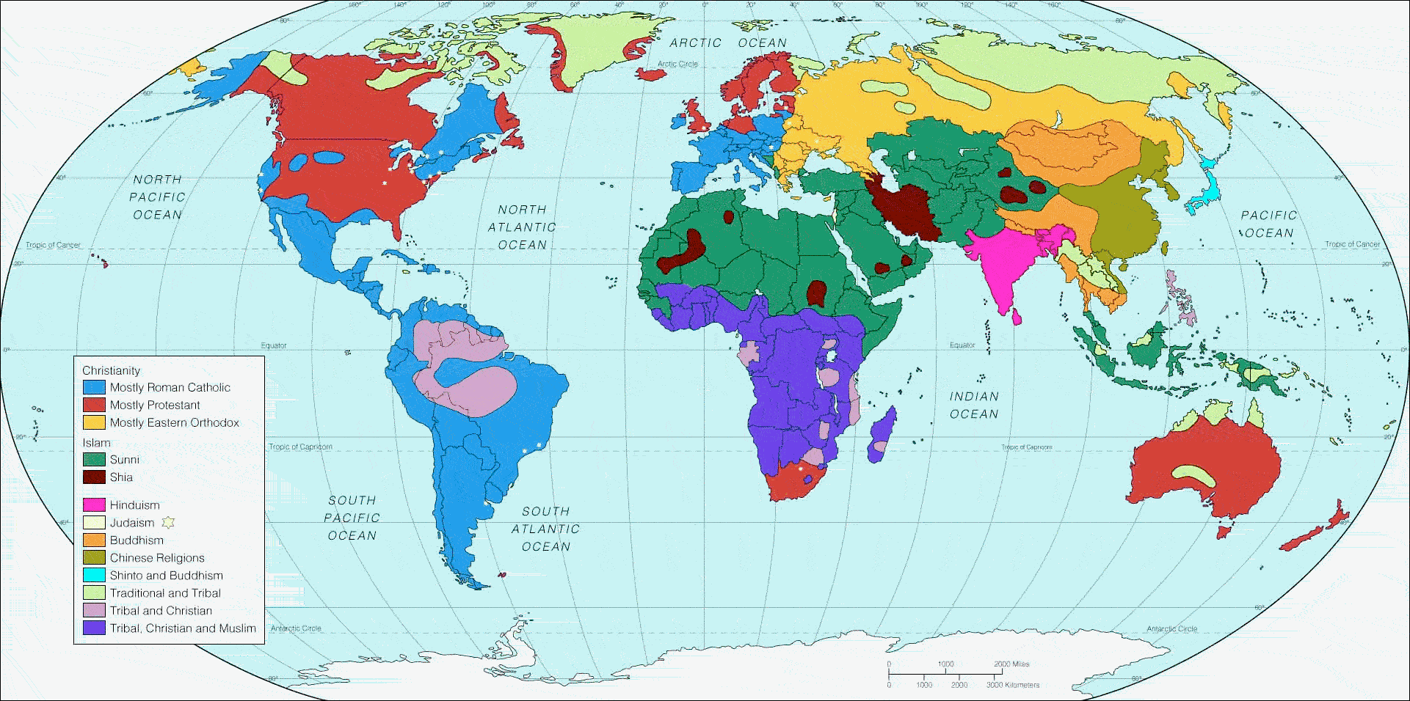

Task - Μέρη της εργασίας – Parts of the project
You must research the information below on a Country participating in the …………………….. Olympic Games. You must be prepared to present your information in Power Point/ film/poster form to the class. You will have approximately 3 weeks in total to design your presentation.
You should try and include the following information:
- Name of the country, its location, geography and flag
- Official languages of the country and its currency
- History of the country and landmarks
- The school system of that country (times, routines, etc)
- Food and drink from your chosen country
- Famous people from your chosen country and or famous athletes
- The country’s participation in the Olympic Games (when)
- Any other information you think is relevant
- References
Self-assessment sheet
Make comments under the following headings regarding your presentation
Researching the topic
What went well?
_________________________________________________________________________________________________________________________________________________________________________________________________________________________________
What could I do to improve next time?
_________________________________________________________________________________________________________________________________________________________________________________________________________________________________

Preparing the presentation
What went well?
_________________________________________________________________________________________________________________________________________________________________________________________________________________________________
What could I do to improve next time?
_________________________________________________________________________________________________________________________________________________________________________________________________________________________________
Presenting your research
What went well?
_________________________________________________________________________________________________________________________________________________________________________________________________________________________________
What could I do to improve next time?
_________________________________________________________________________________________________________________________________________________________________________________________________________________________________
« Citius, Altious, Fortious” - «Πιο γρήγορα, Πιο ψηλά, Πιο δυνατά»

You will be marked on:
Content
Creativity
Language skills
General appearance of your produced work.

Note: You should bring your work to school so that you may be given time during your Greek lesson to work on parts of your project.

Peer Assessment Sheet
Student’s Name | Opinion of Presentation  (eye contact, delivery, language (accuracy/pronunciation, speed etc) | Overall comments
Peer Assessment Sheet
Student’s Name | Opinion of Presentation  (eye contact, delivery, language (accuracy/pronunciation, speed etc) | Overall comments

