Unit of Work
Language: Turkish Years: 3 and 4 | Duration: 9 weeks (2hrs per week)
Unit description  Turkish Folktales  Students will explore different types of Turkish folktales and look carefully at each of the morals.  The tradition of folklore—folktales, jokes, legends, and the like—in the Turkish language is very rich, and is incorporated into everyday life and events.  Folktales were often employed to share a common history, to reinforce cultural values or highlight important traditions.  Folklore is all about human sufferings and pains which are transmitted in the forms of folk narrative, material culture, social folk customs and performing folk arts that has been passed down from generations. | Key concept  An aspect of folklore studies is that it helps us to understand the rich folklore and mystic tradition of our ancestors.
Learning intentions  We are learning the different types of Turkish folktales.  We are looking at the morals of the folktales.  We are learning to identify who, what, when, where and how and creating mind maps of the folktales.  We are learning to read a script of Hacıvat and Karagöz and performing it to the class.  We are learning a traditional Turkish dance based on a Turkish folktale.  We are creating artworks based on Turkish folklores and Turkish folktales. | Success criteria (goals):  I can identify different types of Turkish Folktales ie, heroic, funny, sad, love etc.  I can verbally tell the moral of the folktale.  I can breakdown the folktale into the following categories, who, what, when, where, and how.  I am participating in a traditional Turkish dance.  I have created different artworks based on folklore and folktales.  I can read the script of Hacıvat and Karagöz and role play it in front of the class.
Stage 2 outcome  A student:  LTU2-1C interacts with others to share information and participate in classroom activities in Turkish  LTU2-2C locates and classifies information in texts  LTU2-3C responds to texts in a variety of ways  LTU2-4C composes texts in Turkish using modelled language  LTU2-5U recognises pronunciation and intonation patterns of Turkish  LTU2-8U recognises how terms and expressions reflect aspects of culture | Sentence Structures  Simple structure of who, what, when, where, and how will be reviewed with each folktale  Simple sentence structure in Turkish will be used to answer short answer questions.  Suggested vocabulary  Kim, ne, zaman, nerde, nasıl, manevi, halk, hikaye
Resources  Blackline masters, tissues, scissors, glue, paper, drawing paper. | YouTube clips related to the concept  Websites  Online vocabulary quizzes  Worksheets and exercises  Flashcards, pictures and posters  Interactive whiteboard (IWB) activities  Templates for graphic organisers, e.g. Think/Pair/Share, Venn diagram

Suggested sequence of teaching learning and assessment activities
Week 1  What I know, What I want to know, What I learnt template to be discussed and filled in  What are folktales, discuss and brainstorm on board.  https://www.youtube.com/watch?v=QVYWqu_wIrc  http://halk-hikayesi.nedir.org/  Have the students look at the slideshow about Dede Korkut.  https://www.slideshare.net/aylasavasci/turkish-folk-tales  Have students read a Dede Korkut Folktale  https://www.turkedebiyati.org/dede_korkut_hikayeleri_ozeti.html  Break the folktale down in these categories  Who, What, When, Where, How?  What was the moral of this folktale?  Do a study on Dede Korkut.  https://www.turkedebiyati.org/dede-korkut-kimdir/  Who was he?  When did he live?  What kind of folktales did he tell?  Assessment: Have students retell a Dede Korkut folktale to one another. | Resources
Week 2  Have the students look at the slideshow about Mevlana (Rumi).  https://www.slideshare.net/aylasavasci/turkish-folk-tales  Have students read a Mevlana Folktale  http://hepsi10numara.com/mevlanadan-en-guze-10-hikaye/  https://studylib.net/doc/9243298/turkish-folk-tales  https://dusunmekvepaylasmak.blogspot.com/2013/01/mevlana-kimdir-mehmet-celaleddin-rumi.html  Break the folktale down in these categories  Who, What, When, Where, How?  What was the moral of this folktale?  Do a study on Mevlana.  http://www.erimsever.com/HzMevlana_Film.htm#Belgesel  Who was he?  When did he live?  What kind of folktales did he tell?  Assessment: Students to make an artwork of the whirling Dervishes. Using tissue paper they make the skirt and colour in the rest of the dervish and display around the room with quotes from Mevlana. | 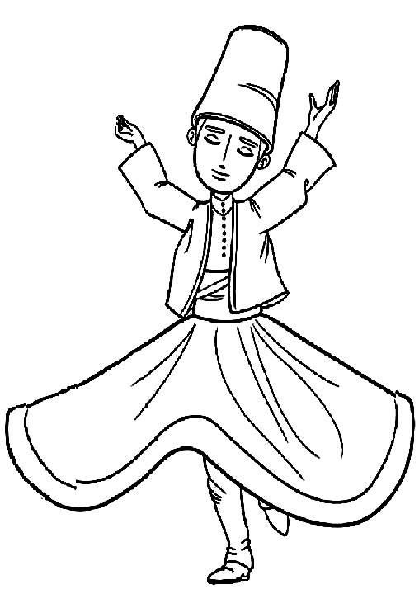
Week 3  Have the students look at the slideshow about Nasreddin Hoca.  https://www.slideshare.net/aylasavasci/turkish-folk-tales  Have students read a Nasreddin Hoca Folktale  https://masaloku.com.tr/nasrettin-hoca-fikralari  https://www.youtube.com/watch?v=f8WYlPTmtrQ  Break the folktale down in these categories  Who, What, When, Where, How?  What was the moral of this folktale?  Do a study on Nasreddin Hoca.  https://www.turkedebiyati.org/nasrettin_hoca.html  Who was he?  When did he live?  What kind of folktales did he tell?  Assessment: Students to draw Nasreddin Hoca and his famous donkey and give a description on his appearance. | 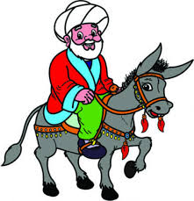
Week 4
Have the students look at the slideshow about Hacıvat and Karagöz.
https://www.slideshare.net/aylasavasci/turkish-folk-tales

Have students watch a Hacıvat and Karagöz Folktale
https://www.youtube.com/watch?v=8DbB81qguGc
Break the folktale down in these categories
Who, What, When, Where, How?
What was the moral of this folktale?
Do a study on Hacıvat and Karagöz.
https://www.youtube.com/watch?v=Wb-SeogSo3E
Who were they?
When did they live?
What kind of folktales did they tell?

Assessment: Have students role play a script of Hacivat and Karagoz and perform it to the class
https://www.egitimsistem.com/cok-komik-hacivat-ve-karagoz-diyaloglari-62831h.htm

Week 5
Have the students look at the slideshow about Keloğlan.
https://www.slideshare.net/aylasavasci/turkish-folk-tales

Have students watch a Folktale on Keloğlan
https://www.dailymotion.com/video/xxzx96
Break the folktale down in these categories
Who, What, When, Where, How?
What was the moral of this folktale?
Do a study on Keloğlan.
https://www.bilgiustam.com/keloglan-kimdir/
Who was he?
When did he live?
What kind of folktales did he tell?

Assessment: Have students research and write out another folktale about Keloğlan and comprise it into a book

Weeks 6 and 7
Çayda Çıra Folktale
Have student research the following information
Where has this folktale originated from?
What is the folktale?
Are their different versions of this folktale?
What are they?
Which part of Turkey is this story from?
Draw a picture relating to this folktale
Discuss and share information students have found.
Teacher to show the documentary on Çayda Çıra and introduce the dance for it
https://www.trtarsiv.com/ozel-video/en-yeniler/cayda-cira-hikayesi-117783
https://www.youtube.com/watch?v=nOOvbR2QU0g

Weeks 8 and 9
Assessment: Students learn and perform the folkdance to Çayda Çıra wearing the traditional clothing for that region.
https://www.youtube.com/watch?v=nOOvbR2QU0g
Evaluation
This could include:
- Teacher reflection on Unit
- Was there sufficient time for all activities/learning intentions?
- Were students able to demonstrate achievement of the outcomes?
- Were the activities/tasks engaging and effective?
- Were the resources relevant and stimulating?
- Were students interested in the learning?
- What worked well? What didn’t work well?
- What would I change for next time?
- Student self-assessment (Use success criteria as a check list)

