Using nursery rhymes as teaching material for Chinese teaching and learning. I have been using nursery rhymes for my teaching to primary school students.

Learning can be enhanced by singing songs children love.

Video of the songs are available on the Internet.

https://www.youtube.com/watch?v=rshE1d2RrPg

Teaching purpose:

《两只老虎》focused learning area : body parts；action word “run”

Grade:

Suitable for children of primary school age, stage 1-3 students, both from Chinese and non-Chinese background.

# 两只老虎 Two Tigers

**两只老虎**

**两只老虎，两只老虎**

**跑得快，跑得快**

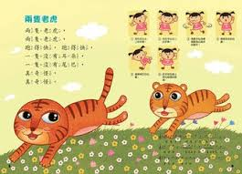

**一只没有耳朵**

**一只没有尾巴**

**真奇怪，真奇怪**

## 生词 New Words

|  |  |  |  |
| --- | --- | --- | --- |
| 两 | Two | 只 | Measure word |
| 老虎 | Tiger | 得 | Auxiliary word |
| 快 | Fast | 没有 | Not to have |
| 耳朵 | Ear | 尾巴 | Tail |
| 真 | Really | 奇怪 | Strange |

## 读一读 Reading Practice

## 1）

|  |  |  |
| --- | --- | --- |
| **两只老虎** | **两条鱼** | **一条狗** |
| **三只小猪** | **三只羊** | **两只猫** |
| **跑得快** | **飞得高** | **游得快** |
| **没有尾巴** | **没有眼睛** | **没有人** |
| **没有哥哥** | **真奇怪** | **真好玩** |
| **对不起** | **没关系** | **没太阳** |



## 2）

**小鸡、小鸭和青蛙**

**小鸡、小鸭和青蛙是朋友。小鸭请小鸡去游泳。**

**小鸡说：“叽叽叽，对不起，我不会。”**

**小鸭说：“嘎嘎嘎，没关系。”**

**青蛙说：“呱呱呱，我来了！我去！”**

请：invite 游泳：swim

对不起：I am sorry.

不会：cannot

没关系：That’s OK

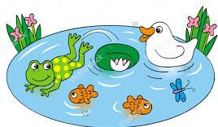

## 3）

|  |  |
| --- | --- |
| **小鸟会飞** | **小兔会跳**  小宝宝：baby |
| **小狗会叫** | **小宝宝会笑** |

