Counting the stars at night
Yun Dong-Ju
translation by Alex Rose

In the sky where seasons pass
Autumn fills the air.
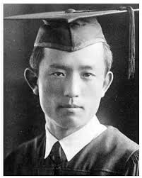
And ready I wait without worry
to count all the stars she bears

Now the reason I cannot tally
all the stars impressed on my heart, is
‘cause the morning soon comes,
my youth’s not quite done, and
another night still lays in store

One star for memories, and
One star for loving
One star for melancholy, and
Another for longing
One star for poetry, and
Another for ma, mother,
Mother, I will try to name all the stars after beautiful words: The names of school friends I sat with, foreign girls like Pae, Kyeong and Oak; girls who have now become mothers and other poor neighboring folk; the pigeons, the puppies, the hares, mules and deer, the names of such poets as Jammes and Rilke.

Yet all of these people so far away now.
And mother, the star,
is in Northern Jiandao

Pining for something
I scribble my name
into a star spattered hill.
Then bury it (again.)

As for the insect who wails through the night
on account of the pain of its name full of shame

But winter will pass bringing spring to my star.
As the tuft grows round gravestones
the grass will abound
where my name has been buried in that star spattered mound.

