Unit of Work
Language: Hindi Stage/Year: 3 | Duration: 10 weeks
Girra Catwalk 2020 (Fashion show)  Unit description  Students work in groups to research the traditional attire and fashion of a specific culture in India.  End task  Students are to create a poster of their findings and present it to the class. This will be followed by ‘Fashion show’ showcased at the end of the year. | Key concept(s):  In this program, the students will engage in a variety of activities to develop an understanding of cross-cultural significance through Indian textile industry.
Learning intentions:  We are learning to:  - Write a description  - Write sentences using adjectives  - Use present tense in Hindi  • The student will understand that there are different cultural standards and trends.  • The student will know that there are different cultural expectations.  • The student will be able to explain one cultureʼs clothing history. | Success criteria (goals):  I can:  - interact with others in Hindi  - write description of clothing in Hindi  - verbalise and write a description of a chosen clothing  - pronounce Hindi words accurately  - application of language structures and vocabulary relevant to the concept  - use of culturally appropriate language, gestures and behaviour
Syllabus outcomes
LHI2-1C: interacts with others to share information and participate in classroom activities in Hindi.
LHI2-2C: locates and classifies information in texts.
LHI2-4C: composes texts in Hindi using modelled language.
LHI2-5U: recognises pronunciation and intonation patterns of Hindi.
LHI2-6U: demonstrates understanding of basic Hindi writing conventions.
LHI2-7U: demonstrates understanding of elements of Hindi grammar in familiar language patterns.
LHI2-8U: demonstrates an awareness of how familiar texts are structured.
LHI2-9U: recognises how terms and expressions reflect aspects of culture.
Suggested vocabulary:
See the program for more vocabulary words.
Resources
YouTube clips related to the concept of food
Websites for researching food in different parts of India
Online vocabulary quizzes
Worksheets and exercises
Flashcards, pictures and posters
Interactive whiteboard (IWB) activities
Sequence of language teaching / learning activities, games, etc differentiation and preparation for task | Resources
Learning Intention:  I am learning to: identify different fabrics found around India.  Lesson 1: Building the field  This activity is designed to revisit different types of fabric found around India.  Show the following to the students:  Fabric in India: The following links shows different types of fabrics used in India in the textile industry.  http://www.vam.ac.uk/content/exhibitions/the-fabric-of-india/nature-and-making/  Brainstorm what they already know about fabric, what they want to know and at the end of the unit revise what they have learnt using sticky notes on KWL chart.  Explain to the students that they will be learning about different types of fabric across India and unique techniques of dyeing and printmaking.  Write clothes in Hindi on the board. Brainstorm different clothes in Hindi. Discuss traditional Indian clothes. Hand out vocabulary words to the students.  Choose a volunteer to come to the front of the class. Draw a pair of trousers on their back using your finger. The student draws the picture of clothing that he/she thinks on the board. Student says the word in Hindi. Assist the student to write/verbalise. Repeat with couple of more items of clothing. Using vocabulary words and flash cards, students repeat the activity in pairs. They can use mini whiteboards to draw. Students may score themselves to make it interesting. | Resources/Vocab words
 | KWL chart on butchers paper
Lesson 2: Designer page  Learning Intention:  We are learning to write a sentence using present tense in Hindi.  Success Criteria:  I can:  • present tense  • adjectives in Hindi to describe the outfit  • Hindi  Handout body outlines sheet to the students. Describe what the first body is wearing, for example, शनाया ने नीला घाघरा और पीली चोली पहनी हुई है। Students draw and colour the clothes according to what they hear. Brainstorm some ideas to describe a certain outfit. Differentiate the description to suit the needs of the students.  राधा ने गुलाबी रंग की धारियों वाली क़मीज़ पहनी है। उसने काली सलवार और रंग बिरंगा दुपट्टा लिया हुआ है। राधा ने सफ़ेद चप्पल पहनी है।  मोहित ने सफ़ेद कुर्ता पहना है। Easy  मोहित ने सफ़ेद फूलों वाला नीला कुर्ता पहना है।  Differentiation: background speakers: write the description in their books. | Handout with outline of the body  Colours
Lesson 3
Refer back to the lesson 1. Tell the students that they will be learning about different types of fabrics manufactured by the textile industry of India in the coming lessons. They will also learn unique techniques of colouring and printmaking. Since

Background knowledge for teacher about cotton
Cotton is the most important of all natural fibres, accounting for almost half of all textiles in the world. It is an excellent clothing material with a huge variety of uses. Because it is so strong it can be made into fine, thin textiles, as well as hard-wearing fabrics like denim.
Over the years the production of cloth and garments came to be linked with India's struggle for independence. Mahatma Gandhi used the domestic weaving industry as a way of alerting people to the reality of commercial domination by foreign rulers. 'Khadi' (cloth hand-woven from locally grown hand-spun cotton) became a symbol of independence and reinvigorated the hand-loom industry of India. India is the world’s second largest producer of cotton. (Source: Oxfam.org.uk)

Start by asking the students “What is cotton? – what do you know about cotton?”
Discuss: “Who is wearing cotton?” Discuss how many students are wearing cotton and the variety of items there are.
Cotton Story: Refer to prezi by cotton Australia https://prezi.com/tzrjuk06rqih/visual-story-of-cotton/
Watch the following clips regarding cotton production in Hindi.
https://www.youtube.com/watch?v=qF72JB5tmKA
https://www.youtube.com/watch?v=AIInvCKNRSw
Have a look at the map of India and discuss Top 10 cotton producing states in India. https://www.mapsofindia.com/top-ten/india-crops/cotton.html
Hand out Map of India and Australia and colour in the regions where cotton is produced.
Students construct flow charts in Hindi to show how cotton is processed. Brainstorm different clothes that can be made using cotton. Write sentences in Hindi. Use adjectives to describe your clothes.
Lesson 4 and 5: Weaving  Teacher background  Weaving is a textile craft in which two distinct sets of yarns or threads are interlaced to form a fabric or cloth. The threads which run lengthways are called the warp and the threads which run across from side to side are the weft or filling. Each part of India has its own weaving tradition, but Gujarat was the main centre of innovation for more than 500 years. As Gujarati weavers migrated, weaving techniques and technologies spread all over India. Source: Cotton Australia and Victoria and Albert museum (UK)  Tell students they are going to practice making fabric by weaving paper. Encourage students to look closely at their cotton clothing or samples. What do they notice? Elicit that there are threads which run horizontally (weft) and vertically (warp).  As a class, look at the video which shows how cotton is spun into plain woven cloth by Rajasthan Khadi Sang, a weaving cooperative in Rajasthan. https://vimeo.com/140773963.  Show students an example of weaving and of the paper weaving they will do. Follow the instructions from the link for detailed explanation of the procedure. | https://cottonaustralia.com.au  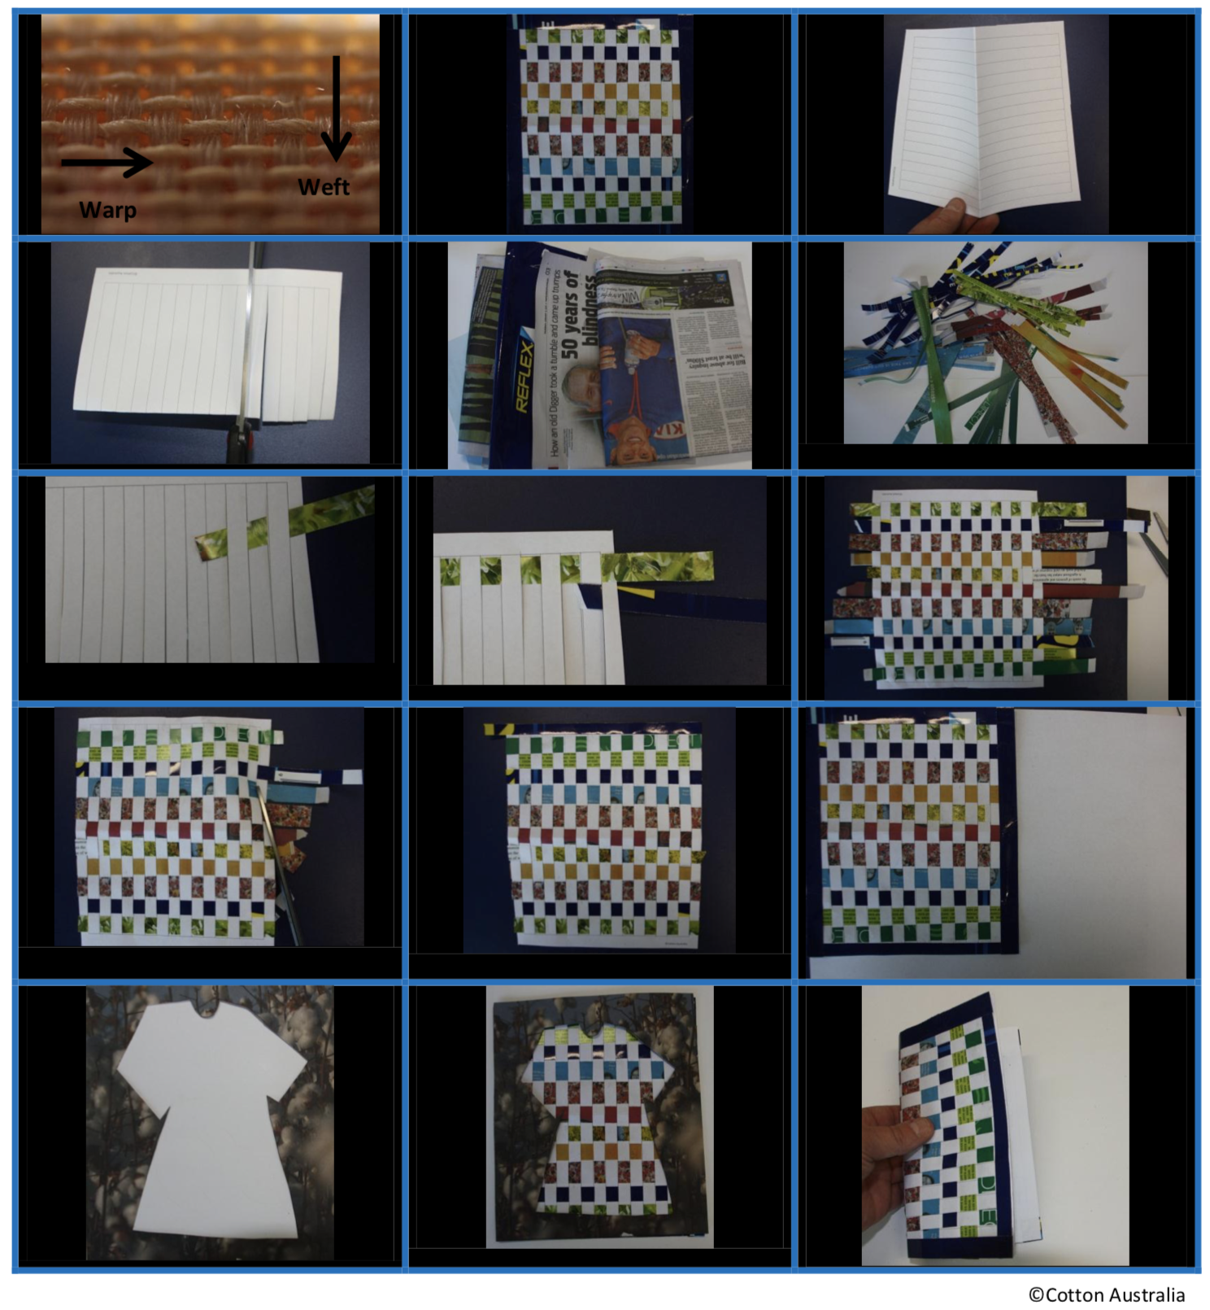
Lesson 6 and 7: Printmaking and dyeing  In India, printing patterns with wooden blocks is mainly associated with the north and west. Dress fabrics used small repeating floral patterns in several colours, requiring multiple blocks. Larger-scale motifs were printed for furnishings and tents. From the 14th century, if not earlier, western India used large blocks to produce huge wall hangings, which were exported to South East Asia. Artists from Gujarat tend to use floral motifs influenced by Persian art as a basis for their designs.  As a class, watch the video which shows step by step process of turning a plank of wood into an intricately carved printing block at Yaseen Wooden Block Makers in Jaipur, Rajasthan. https://vimeo.com/140778074  Look at different types of patterns on the printing block. Appreciate the designs on the blocks and discuss traditional patterns such as bagh print, ajrakh, paisley prints etc.  The students now apply the technique of printing on their t-Shirt/ cotton bags  Objective Students will be able to apply the technique of printing by creating a printed piece of art work.  Printing block  Students design their own fabric using printing blocks. Purchased from : https://gilbertstree.com/about/wood-block-printing/ | https://www.craftsvilla.com/blog/indian-prints-fabrics-bandhani-ikat-batik/  https://www.youtube.com/watch?v=TstBPOvYSTI
Lesson 8-10:  Learning Intention: We are learning  • The student will understand that there are different cultural standards and trends.  • The student will know that there are different cultural expectations.  • The student will be able to explain one cultureʼs clothing history.  Lead a class discussion on the following topics:  • How are trends and styles specific to culture?  • What are some Australian and Indian trends or styles that are truly unique?  Students are now to apply the skills and knowledge learnt in the previous lessons on the project.  Project  Summary: Students work in groups to research the traditional attire and fashion of a specific culture in India. Students are to create a poster of their findings and present it to the class. This will be followed by ‘Fashion show’ showcased at the end of the year.  Part A  1. Separate students into pairs or small groups.  2. Assign each group a specific culture to research. Students can pick a state or a particular region.  3. Students gather information on the history of the cultureʼs traditional dress and clothing trends and styles. Their research should include significance and history of these traditional attire.  4. Each group will create a poster with information to share with the class. The poster should include at least 3  image examples of clothing styles.  Part B  Invite groups to take turns presenting their research findings and posters. Each member must participate in the  presentation.  Part C: Catwalk  - You must wear an outfit of the traditional attire that matches your poster, if possible. If not, then they can wear whatever traditional clothing is available with them.  - You must write a description of your outfit on a flashcard for other people in your group to read while you walk the “runway” that includes the following things in Hindi:  - An introductory sentence. “(Your name) …. तनिश ने शेरवानी पहनी हुई है। [Your name is wearing)  - Which “designer” made the clothes (You can make up your own fashion name, or use the actual designer)  - Ex.: यह शेरवानी Tandon&Co ने design की है। (name of designer)  - A description of each visible item that includes:  - A description of each item (eg सलवार क़मीज़, धोती कुर्ता, साड़ी और ब्लाउस, etc.)  - What fabric or material is the outfit made from?  - The color or pattern of each item (Is the colour combination and design peculiar of any particular region? What is the significance?)  - Make sure that your adjectives match the gender and number of what you are describing  - A description of the outfit (Ex.: It’s fashionable/beautiful/ugly/old, etc…)  - YOU MUST USE COMPLETE SENTENCES IN HINDI! | - online access  - Cardboard  - coloured markers  - copies of grading rubric
Presentation, performance of goal task: Due at the end of the term
Evaluation:
How did the unit rate in these areas?
- Time allocated on topic

- Student understanding of content

- Opportunities for student reflection on learning
- Suitability of resources

- Variety of teaching strategies

- Integration of Quality Teaching strategies

- Integration of information and communication technology (ICT)

- Literacy and numeracy strategies used

- Learning across the curriculum content incorporated

Girra Catwalk 2020
Checklist/Marking criteria
Part A and B: Poster and presentation
I can: | Comments
- describe a costume design in writing in Hindi
- orally describe a costume design in Hindi (fluency)
- The poster contains images that are relevant to the region/culture
- Use correct sentence structure (Subject-Object-verb) in written and spoken Hindi
- speak fluently and nearly accurate language
- Respond orally to simple questions in relation to the costumes in Hindi
Part C: Catwalk and Flashcards:
Flashcards must include: | Comments
- Interesting introduction that captures audience attention well.
- Substantial amount of general information about type of clothing.
- Description of each visible item in the attire.
- Significance of any patters/colour combination on the outfit
- adjectives in the sentences and follow the correct sentence structure

