Fruits and Vegetables - Activities set 3
- Activity 1
Purpose:
- To read vocabulary related to fruits and vegetables
- To identify the numbers

Instructions
1-Students need to identify the name of the fruit
2-Put the number of the name under the fruit picture.

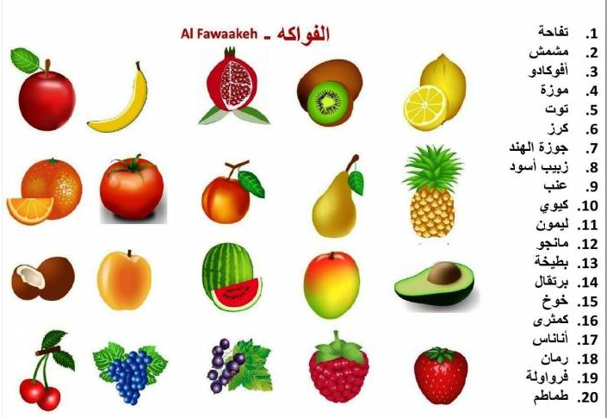

- Activity 2
Purpose:
1- To recognise letter sound relationship
2-To identify the long vowels
3- To recognise the vocabulary related to fruit and vegetables

Instructions:
1-Students will cut the pictures and glue them to make 2 dices.
2-Then they will play in groups of two, where the first student roll the Fruit dice, and the 2nd
3-student has to look for the name and show/write it on a side paper provided to the class.
4-They can switch the roles, the first student will get the names dice and the 2nd student will get the pictures dice and they play again.
- We have to concentrate on long/short vowels in while doing the activity i.e.:

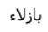 |  | 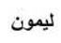
Long vowel | Long vowel | Long vowel | Short vowel
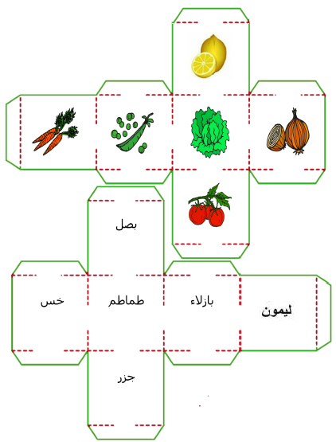

- Activity 3
Purpose:
1- To recognise letter sound relationship
2-To identify the long vowels
3- To recognise the vocabulary related to fruit and vegetables

Instructions:
- The students will have to cut out the dice, glue it and make a proper dice made out of cardboard provided in class
- Then they have to cut the names of the fruits/veggies.
- They can play either per 2 groups or 2 students.
  - The 1st groups/student roll the dice. Whenever it will land on the fruit picture
  - The 2nd group/student have to pick the correct name of the fruit and place it in the table below
  - They have to place the name according to the long/short vowel circled in the name.
  - They have to specify the letter in the column next to the name by writing the name if possible (or by gluing the name cut out) and the letter.
  - Example provided.
- They can switch dice between the groups/students each time they roll the dice
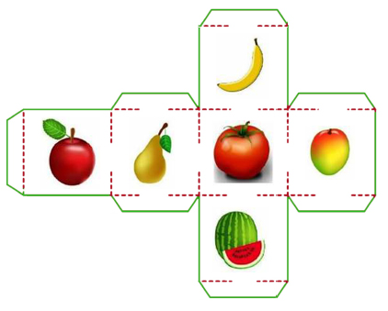

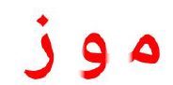
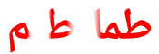

Long Vowels | Letter | Short Vowels | Letter

