Amistad Latina Spanish School Inc.
Unit: Where I come from? Teacher: Vanesa Mezones
LANGUAGE: Spanish STAGE 3 /YEAR 3 |  | DURATION: 10 weeks (2 hours p/w)
Unit description, goal task: Where I come from – Spanish Culture Expo  Students organise and present an information stall at the Spanish culture expo in the community school for other classroom groups and parents.  Each group displays and explains aspects of Spanish culture special to their country of origin (Spain or Hispanic America). |  | Key concept(s):  Understanding Cultural connections through and expo:  1.-The country in the world map, states, dialects, population, religion  2.-Traditions culture  3.-Heritage  4.-Gastronomy  5.-Dances  6.-Tourist places
Learning intentions:  - Identify the cultural / heritage aspects of the country of origin of the students (or their parents).  - Identify the different countries where Spanish is spoken as an official language, their cultural characteristics, and their location on the map.  - Understand the emotional connections that are transmitted through gastronomy, traditions, and music. |  | Success criteria. Students will be successful if they can:  - collaboratively design and produce a presentation highlighting the cultural/ heritage aspects of the country of origin  - organise information with pictures and names on a cardboard  - explain the ingredients and tastes of the typical food or if it’s possible to bring some food sample (with the help of parents)  - design and present a cultural expo stall
Objectives and outcomes (SYLLABUS)
A student:
Interacting – exchanging information, ideas and opinions, and socialising, planning, and negotiating.
- uses Spanish to interact with others to exchange information and opinions, and to participate in classroom activities (LSP3-1C)
Accessing and responding – obtaining, processing, and responding to information through a range of spoken, written, digital and/or multimodal texts
- obtains and processes information in text, using contextual and other cues (LSP3-2C)
Composing – creating spoken, written, bilingual, digital and/or multimodal texts
- composes texts in Spanish using series of sentences (LSP3-4C)

Systems of language- understanding the language system including sound, writing, grammar, and text structure; and how language changes over time and place
- applies key features of Spanish pronunciation and intonation (LAS3-5U)
- applies basic Spanish writing conventions (LSP3-6U)
- demonstrates understanding of Spanish grammatical structures (LSP3-7U)
The role of language and culture – understanding and reflecting on the role of language and culture in the exchange of meaning, and considering how interaction shapes communication and identity.
- Makes connections between cultural practices and language use (LSP3-8U)

Suggested vocabulary:  - Name of country/ countries, states, religion  - Capital, north, south  - city/cities, languages, population  - cultural food, likes and dislikes  - Birthdays, parties, dances  - Delicious, healthy, popular  - Different music styles |  | Sentence structures:  - This is (country) and I (or my parents) come from the (region) of (country)  - I’m + nationality  - This country is in (location) …….. and its capital is …………  - The population of the (country) is …………  - The languages spoken in (country) is ……...  - The religion is ……………….  - (my country) are known for their special delicious food such as ……………  - On (special occasion or party) we used to listen to ……  - This is (city) and it is in (location) …………… of (country)  - My country has beautiful places to visit and enjoy like: ……………
Resources:  - Lessons displayed on powerpoint presentation  - World map  - Country map – country map outline  - Latinoamerica travel brochures  - Information books or texts  - Cardboards to display their work |  | - Flashcards with expression about like and dislikes  - Speaker and internet (YouTube and Netflix)  - Worksheets to complete  - Colours, markers, and pencils  - Tables to the expo  - Blue tack
Organisation of the unit:
The task is to create a Spanish expo stall and present it to the other classroom groups and parents in the community language. The expo is about the countries where Spanish is the official language, their main cultural aspects and location in the map. The purpose is encouraging identity with the heritage of the family, learn about different cultural aspects of Spanish-speaking countries and create a community united by the same language.

What will we need to get there? we will learn the language we to do the task, then we form teams, and each team will work on their task performance/product, to perform in week 8 | What we already know (Building the field): a brief history about where Spanish people come from. How the geographical region shapes our cultural, traditional lifestyle.

Sequence of language teaching / learning activities. Differentiation and preparation for task | Resources
Week 1 and 2 (4 hours)  Unit introduction and final task discussion  - Introduce the unit of work and the goal task  - Brainstorm what an expo is  - Survey students on where they come from, write the number on the board  - Review previous knowledge about Spanish speaking countries and with a song  - Set up groups (between 2 or 3 students) and allocate roles within each group  - Students choose a country for their expo based on where they come from or a country they are interested in.  - Display the world map on the smart board and brainstorm where we come from, and locate the countries on the world map  - Brainstorm and discuss the different parts of the country (north or south) and its capital  - Introduce the sentence structure:  - This is (country) I (or my parents) come from the (region) of (country)  - I’m + (nationality)  - Students take turns to introduce themselves and where they (or their parents) come from.  Individual task: Students highlight their country on the worksheet given, the state the country they (or theirs parents) come from and the capital in Spanish.  Group work: Students will form groups and negotiate roles (gastronomy, music, and tourist places) and start planning general info about the country like location in the map, capital, population, religion, languages, etc in a cardboard. | - Pictures related to expos  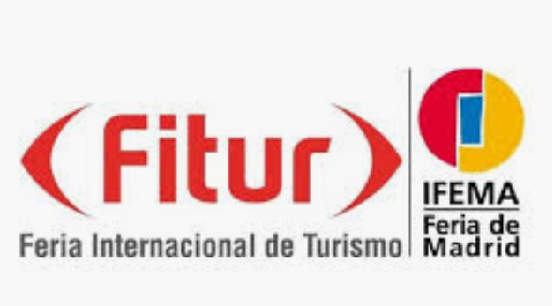  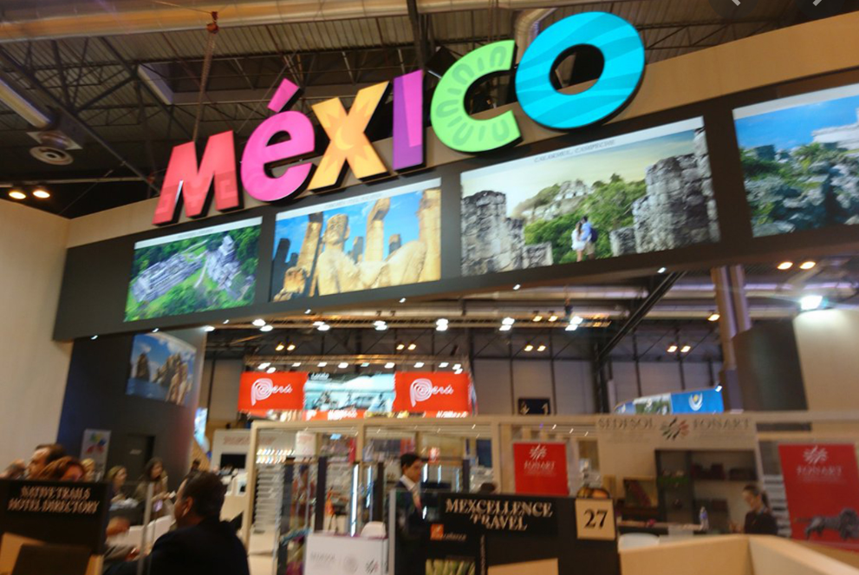  - Song about Spanish speaking countries  https://youtu.be/zxkQm1px3GE
Week 3 and 4 (4 hours)  General information of the chosen country  - Revisit the country map and locate the main cities  - Review numbers in big amounts to talk about population  - Identify the population and the languages spoken in the country  - Brainstorming about languages spoken in a country  - Brainstorming about religions in general  - Introduce the sentences structures:  - This country is in (location) …………… and its capital is …………  - The population of the (country) is ……………  - The languages spoken in the (country) are ……………  - The religion is ……………….  - Students pair up to conduct a dialogue / conversation telling each other about the city they are from and the language they spoke.  Individual work: Students highlight their country, capital and other general information on the worksheet given and complete the sentences.  Group work: students will start researching and collecting information / data from a book or text about their country of origin and working on their presentations. | - Maps with Spanish speaking countries, its capitals and population.  - Worksheets to complete the sentences  - Flashcard with number and guide to learn the amounts  - Books or text with the information about the countries chosen
Week 5 and 6 (4 hours)  Cultural food  - Brainstorm different types of cultural food and list them on the board in Spanish  - Students take turns to tell what they like/ dislike to eat and give reasons.  - Discuss the importance of food in special event like birthdays  On Birthdays I eat………… with my family.  - Revise adjectives relating to food: delicious, popular, typical.  - Introduce the sentence structure:  - (my country)…………… is known for their special delicious food such as……………  Individual work: student copy the modelled sentences in worksheets. Students can add pictures of different food and add a caption in English and Spanish.  Group work: students will start researching and collecting information/ data about the cultural food of their country of origin and working on their presentations. | - Videos about typical food in countries chosen (at this moment Netflix have a good one “Street food Latinoamerica”  - Flashcard with vocabulary about common ingredients and different tastes (sweet, sour, salty, bitter, spicy…) and food texture (smooth, crispy, crumbly, hard, fibrous and chewy).
Week 7 (2 hours)  Traditional dances and music  - Brainstorm different types of traditional dances that people dance in different countries and list them on the board in Spanish.  - Introduce the sentence structure:  - On (special occasion or party) we used to listen to ……  - Express likes and dislikes related to music tastes from the country chosen.  - Students prepare a sentence based on the modelled one and share with the class.  - Watch a video related to the latin music and Why not try dancing imitating the teacher?  - Listen to a song and filling the gap of some words and identify the style  Individual work: students Listen to a song and filling the gap of some words and identify the style.  Group work: students will start researching and collecting information/ data about the music of their country of origin and working on their presentations. | - Internet and speaker  - Worksheets to complete  - Song “Color esperanza” https://youtu.be/GqOvxbFLwjY
Week 8 and 9 (4 hours)  Tourist places  - Brainstorming about what they think is a tourist place, which tourist places they know in the Spanish speaking country.  - Show the tourist brochure and ask the students find information about the country chosen  - Introduce the sentence structure:  - This is (city) and it is in (location) …………… of (country)  - My country has beautiful places to visit and enjoy like……..  - Revise adjectives relating to a place: old, beautiful, new, big, small, etc.  - Make a list of the places that the students would like to visit in the future and try to locate them on the map of the chosen country.  Individual work: Students complete the sentence based on what they researched.  Group work: students will start researching and collecting information/ data about the main tourist landmark of their country of origin and working on their presentations with pictures from the tourist brochure and its names. | - Tourist brochure (spare ones from a travel agency)  - Pictures of the countries chosen with the main tourist landmark  - Worksheet to complete
Week 10 (2 hours)
Presentation, performance of goal task
- The students will organise their stalls in the school hall.
- The students will invite students from other language groups to attend the Spanish Culture Expo.
- The students are going to explain the chosen country, its general information on the cardboard, the typical food, and tourist places.
- At the end, all the students are going to sing a song with different styles of latin music.
- The school Principal and other teachers will be invited for the final rich task.

Evaluation.
- Principals, teachers, parents, and others classroom groups are going to vote for their favourite country.
- The team winner will have a special surprise prize

