LANGUAGE :Arabic Language  Stage 3/Year 6  Level: Intermediate level  Unit’s topic : Arabic traditional festivals (Al Eid) | DURATION : 9 Weeks / 2 hours per week
Unit description : This unit provides opportunities for students to search and learn about Arabic traditional festivals (like Eid) , traditional customs , decorations, greeting expressions and family values. also understanding the differentiations between Arabs traditional festivals and Australian festivals .  Goal task : Designing and presenting a power point presentation about Arabic traditional festival like (Eid).  As for a goal task, students in groups of 4-5 students will design a power point presentation about Arabic traditional festival Al Eid .Through different activities in this unit, the students will be familier with the new vocabularies , learn new information, research ,write short sentences ,improve their conversation skills , understanding culture diversity, research and analyse skills of information from many resources, able to design a power point presentation about Eid festival , | Key concept(s):  Arabic culture greeting expressions, family values ,belongings, festival, celebration .decorations , customs.  Key processes :  participating , researching , describing , giving opinions, writing, summarizes , presenting.
Learning intentions  - Write a description of events .  - Learning of Arabic traditional habits , costumes and food in their festivals .  - Learn and use Arab common greeting sentences and expressions.  - Read a story , retelling story .  - Understanding culture differentiations.  - Learning the importance of celebrating Al Eid for Arabs community | Success criteria  Students will be able to:  - Describe an Arabic traditional festival like (Eid).  - Use Arabic greeting expressions .  - Compare between Arabic and Australian traditional festivals ,costumes ,food and families participations .  - Plan an Eid party.  - Write sentences to describe Al Eid.  - Implement and Present slides to describe Al Eid
Objectives and outcomes (SYLLABUS)  Strand :Communicating  Objective: Interaction-exchange information, idea and opinions and socialising, planning and negotiating  Outcome:  Uses Arabic to interact with others to exchange information and opinions, and to participate in classroom activities LAR3-1C | Content  Students:  - initiate interactions and exchange information with teacher and peers, (ACLARC033)  - participate in a group activity or shared event, (ACLARC033, ACLARC034)  Students with prior learning and/or experience will:  - initiate interactions with adults and peers to exchange information, ideas and opinions, (ACLARC145)  - collaborate with peers in group activities and shared experiences to make choices and arrangements, organise events and complete transactions, (ACLARC146)  - recounting an experience with their own family and friends (ACLARC137)
Objective: Accessing and Responding-obtaining processing and responding to information through a range of spoken, written, digital and/or multimodal texts  Outcomes:  obtains and processes information in texts, using contextual and other clues LAR3-2C:responds to texts using different formatsLAR3-3C | Students:  - obtain and organise information from a range of spoken, written and digital texts, (ACLARC035, ACLARC036)  - respond in English or target language to texts, using a range of formats, (ACLARC037)  Students with prior learning and/or experience will:  - locate and classify information from a range of spoken, written, digital and visual texts, (ACLARC147)  - respond in English or target language to ideas and information, using a range of formats for different audiences, (ACLARC142)
Objective: Composing- creating spoken, written, bilingual, digital and/or multimodal texts  Outcome  - composes texts Arabic using a series of sentences LAR3-4C | Students:  - compose informative and imaginative texts, using scaffolded models, for different purposes and audiences, (ACLARC038)  - create bilingual texts, such as signs, notices, games, displays, websites or word banks, for the school community, (ACLARC040)  - composing an original story using images, key sentences, and word bank as source material or creating an al to a well-known story  Students with prior learning and/or experience will:  - compose informative and imaginative texts for a variety of purposes and audiences, (ACLARC141, ACARC143)  - create bilingual texts and resources for their own language learning and the school community, (ACLARC145)
Strand :Understanding  Objective: The Role of Language and Culture- understanding and reflecting on the role of language and culture in the exchange of meaning, and considering how interaction shapes communication and identity  Outcome:  - makes connections between cultural practices and language use LAR3-9U | Students:  - understand that Arabic changes according to the context of use and reflects different relationships, (ACLARU151)  - understand that language use is shaped by the values and beliefs of a community, for example: (ACLARU153)  - describe aspects of own identity and reflect on differences between Target country and own language and culture, considering how this affects intercultural communication  Students with prior learning and/or experience will:  - reflect on their experiences in Arabic and English-speaking contexts, discussing adjustments made when moving from English to Arabic and vice versa, (ACLARC146)
Suggested vocabulary:  Celebration احتفال  Traditional تقليدي.  Festival مهرجان.  Holiday إجازة.  Feast  Presents هدايا.  Costume زي تقليدي.  Culture ثقافة.  Family members افراد العائلة.  Sweet حلوى.  Happy Eid عيد سعيد.  Eid AL Feter عيد الفطر.  Eid AL Adha عيد الأضحى.  Greeting sentences:… عبارات الترحيب  Happy Eid عيد سعد.  Decorations الزينة. | Sentence structures  Using adjectives  Describe objects  Greeting expressions:  -Blessed Eid to you and your family (. )  -May you celebrate this every year (. )  -Happy Eid AL feter (. )  -May all your good deeds be accepted by God (. )
Resources
YouTube , story book, Flash Cards, Bingo game
,Families’ photos, websites, Power Point
Games( Eid Al Abha search puzzles, Guess What,Role play )
Worksheets

Suggested sequence of teaching learning and assessment activities – BACKWARDS MAPPING FROM THE TASK
Introduce motivating goal task (purpose, audience, types, variety -> your choices)
Visual media examples of task in real world? What are its key features?
What will we need to get there?
Organisation of unit: we will learn the language you will need to do the task, then we form teams, and each team will work on their task performance/product, to perform in week x
What we already know: Building the field
Revision of some useful building-block language elements already mastered
Cultural background to concept?

Sequence of language teaching / learning activities, games, etc differentiation and preparation for task | Resources
Week 1/Lesson 1  Brainstorm ;  Questions about Arab festival Eid AL Fater and Eid Al Adha  Introduce the Unit topic  Watching a YouTube clip about Al EID  Think- pair- share: discuss the clip and share their experience.  Talk about the importance of Al Eid festival for Arabs community.  Set up groups and allocate rules with explaining the goal task presentations and requirements.  Learn the main vocabularies in this unit  Explain the meaning with examples  Write headings and vocabularies about the event of Al Eid .  Sharing opinions and experiences.  Lesson 2  Search about Al Eid , the traditional costume ,special food and sweet , families participate ..  Write the main ideas  Learning the list of vocabularies with explanation and examples.  Giving their opinion about AlEid festival events  Share with the group members  Allocate group members role  Design a timetable for the goal task | YouTube clip  https://www.youtube.com/watch?v=UiQYFz63C4U&feature=youtu.be  List of vocabularies  Whiteboards  Textures  Websites  Worksheets (timetable for the Goal Task )
Week 2 /Lesson 1  Reading a story about Al Eid  Discussion about the special food and sweet in Al Eid  Using Flash Cards about AlEid’s sweet and food  Retelling the story  Summaries the main ideas  Gamification (Guess what ) describe one of the traditional food or sweet and other students have to guess.  Search about Arabs traditional food and sweet  Write list of special traditional food and sweet  Share it with the group members  Lesson 2  Presenting Arabs traditional costumes  Watching Youtube clip about Arabs traditional costumes  Searching about special costumes for men and women  Giving opinions  Sharing ideas with other students  Individual task : write sentences to describe one of Arabs traditional costume  Group work : make a list of Arab traditional costumes | Storybook about AlEid  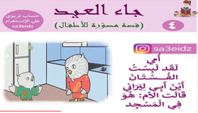  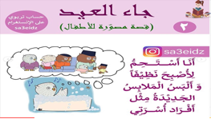  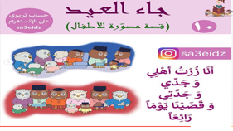  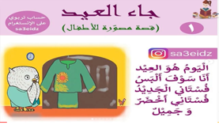  https://youtu.be/S8JEZpIwnSQ  Flash Cards  Websites  Presenting traditional costumes  Worksheet (list of Arab traditional costumes)
Week 3 /Lesson 1  Asking the students about their experience in AlEid with the family  Describe what usually happen in Eid day  Giving opinion  Share the ideas with other students  AL Eid’s songs  Lesson 2  Collect family’s photos in Al Eid ,  Sharing with other students  Present different decorations and preparations for Al Eid  Draw a picture showing a decorations , lights and preparations..  Group Task : acting how they celebrate Al Eid | Eid’s songs  https://www.youtube.com/watch?v=Bt-4VSmKLBU  Family’s photos in AlEid day  Decorations photos  Drawing sheet
Week 4 /Lesson 1  Listen to the story about Al Eid  Read the written story  Discussion about the ideas  Retelling the story  Quiz :complete the worksheet , sequence the events in the story .  Lesson 2  Eid Al Abha search puzzles game  This game is designed related to the main events , food, sweet, costumes .. related to Al Eid  Group Task : research about AlEid day routine ,  Write a sequence what happen from morning to night , celebrating .. | Digital story  https://www.youtube.com/watch?v=S8JEZpIwnSQ&feature=youtu.be  Worksheet (complete sequence of events )  Eid Al Abha search puzzles game  Research (websites)
Week 5 /Lesson 1  Watching a Youtube clip , focusing on the common greeting sentences in Al Eid  Discussion with students , explain the meanings  Summarise the common greetings sentences in AlEid  Share student’s experiences  Group Task : Write some of the common greeting sentences  Lesson 2  Group Task :research and collect pictures to use them in the goal task presentation  Write the main headings and ideas for the slides  Support the students with resources like websites ,books . | Research (websites)  YouTube  Eid Al-Adha | How to Offer Eid Greetings in Arabic  Eid Al-Adha | How to Offer Eid Greetings in Arabic  Pictures  Power point  websites
Week 6 /Lesson 1  Watching a youtube clip about Australian celebrations  Discuss about the differentiation between Arabs festivals (Al Eid ) and Australian festivals  Giving student’s opinion  Share ideas  Group task : complete the worksheet , fill the table of differentiations related to kinds of food ,sweets ,costumes, decorations , families participating ..  Assessing the work  Lesson 2  Group work : Interactive games such as memory games, matching games (Eid’s list of vocabularies)  prepare for the Goal Task  Complete the lists of food ,decorations , costumes ,sequence of events ..  Checking the work  Support students with other resources  Discussing about designing the presentation | YouTube  Worksheet(differentiations )  Pencils  Whiteboards  Interactive games such as memory games, matching games,  Power point
Week 7/Lesson 1  Activity ( Planing an Eid party)  Individual task : write a plan of Al Eid day  Share it with other students  Assessing students works  Lesson 2  Imagine and write a short story  Use the student’s plan of AL Eid to write a short story ,using greeting expressions ,the new vocabularies they have learnt and adjectives.  Retell the story in front of the students  Giving opinion | Plan an Eid party  Students’ plan of Al Eid day
Week 8/Lesson 1  Group work :  Prepare the power point slides  Complete the checklist of the goal task  Complete the draft of the presentation  Support students  Lesson 2  Revision of the main ideas and concepts of the unit topic  Asking and answering questions, Check the groups’ works  Group work :  Editing the slides  Finalize the works  Prepare the students for the presentation | Power point  Checklist  Whiteboards  Pencils  Power point
Week9 /Lesson 1  Practice as groups for presentation  Check the student’s works  Support the students  Lesson 2  Presentation day  Invite other students and teachers to the presentation  Present the Power Point group presentation  Support and praise the students  Assist and evaluate the works | Goal Task  Presentation day  Assessment
Presentation, performance of goal task

Evaluation and assessment:
Individual assessment for : worksheets of creating Eid day plan .
Writing list of greeting expressions.
Worksheet of ordering sequence story’s events.
Writing sentences using key words ,adjectives/ structure.
Ability of storytelling .
Group assessment. : participating as a group , creating and oral presentation .
Sharing ideas ,gamification.
Self assessment: Student evaluation form for presentation.

Marking Criteria
 | Outstanding | High | Sound | Basic | Limited
-Organisation and responses are organised and clearly.  -Exceeds the goal task requirements.  -Evidence of extensive research. | Completely clear , organised and orderly presentation.  -Exceeds the goal task requirements.  -Evidence of extensive research | -Most clear and orderly presentation in all parts  -Meets the  goal  task  requirements.  -Evidence of wide research | -Clear presentation in some parts but not all.  -Meets most of the goal task  requirements.  -Evidence of some research | -Clear presentation in few parts.  - Meets few of goal task.  -Evidence of little research | -Unclear in most parts of the presentation  -Meets very few of goal task requirements  -Evidence of very little research
Structure  Introduction  Body  Comparison  conclusion | -The introduction ,explanation ,conclusion and the presentation were exceptionally ,very well organised and very easy to understand | -The presentation gave a clear introduction of the unit topic.well organised presentation | -Clear introduction ,examples and conclusion ,but some parts not clear or not in the correct order to follow. | -Clear introduction of the unit topic , but most of parts not clear presentation. | -Not clear introduction , few examples, the follow of the presentation not clear
Using of arguments  Using facts and examples  Giving reasons for supporting viewpoint | -Puts highly informative presentation  -Many relevant supporting facts and examples | -Many examples and facts are most relevant  -Many of effective arguments presented | -Some of relative example are given  -Some of effective arguments presented | -Few supporting  Relevant  and examples  -Few of effective arguments made | Few or NO supporting examples  -No effective arguments given
Languag usage ,grammar and syntax | - The presenter used the best correct sentence structure ,syntax and  grammars.  -Never used the slang word in the presentation. | - The presenter used correct sentence structure ,syntax and  grammars.  - No slang word used | - The presenter mostly used correct sentence structure ,syntax and  grammars.  -Very few slang word used | -The presenter used correct sentence structure ,syntax and  grammars.  -Few slang word used | - The presenter used a few correct sentence structure ,syntax and grammars.  -Very often using the slang word .
Presentation style  The tone of voice  Eye contact  Speak clearly and directly  Level of enthusiasm are convincing to the audiences | -All presentation style features were used effectively | - Most of presentation style feature were presented and used | - Some feature were presented and used | - few feature were presented and used | -Very few feature were presented and used

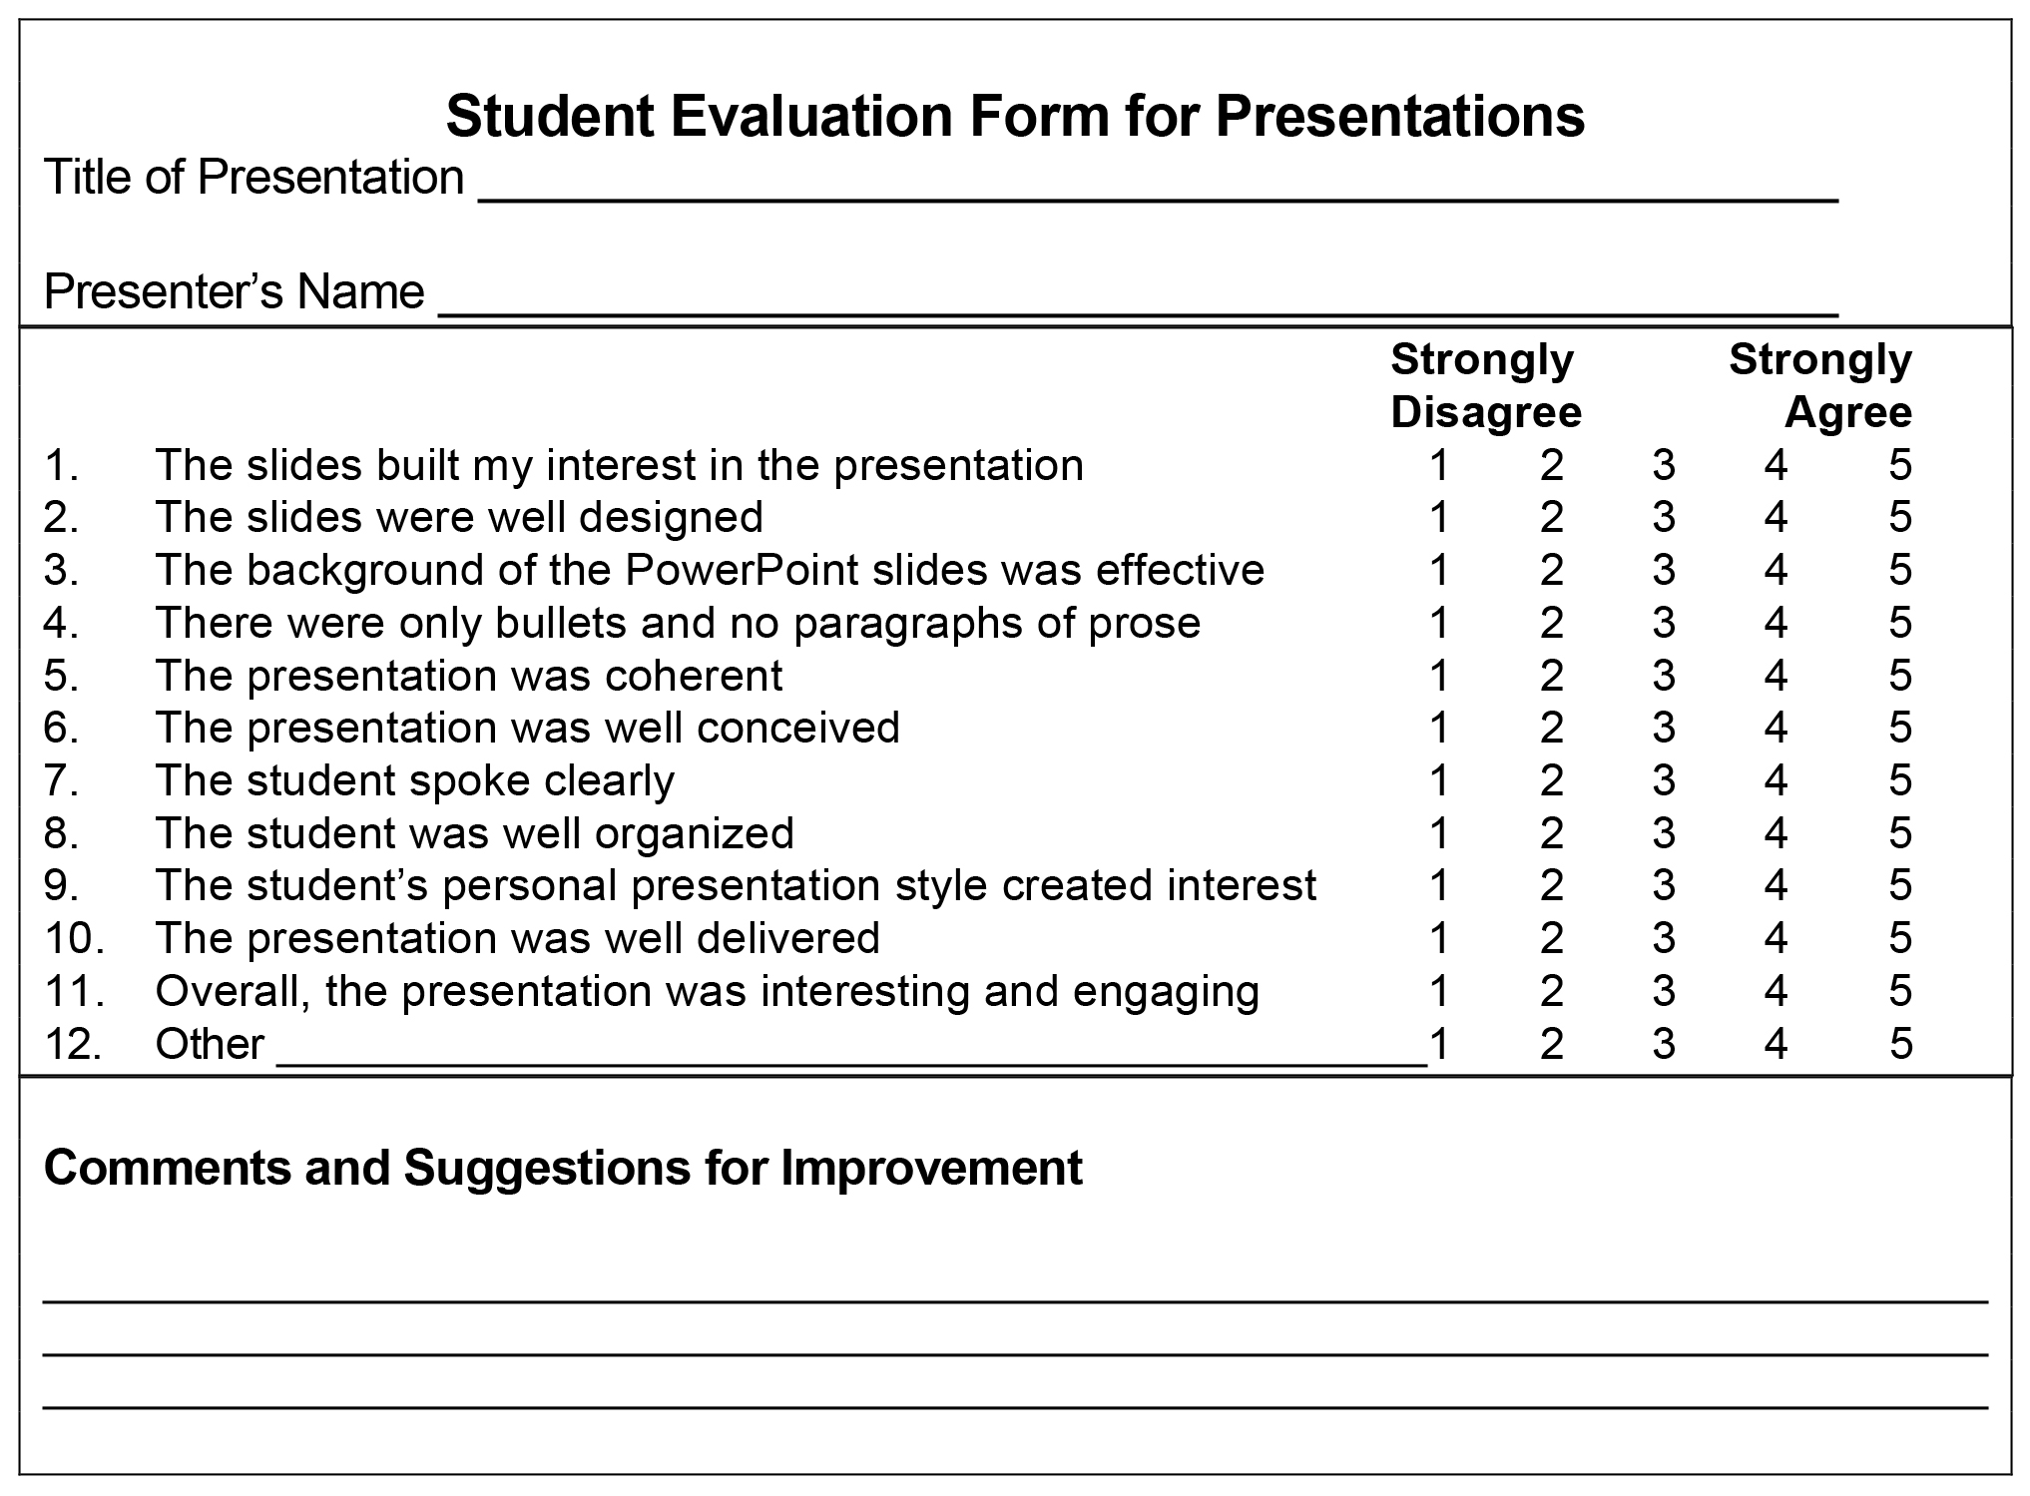

Reflection

Reflection is one of the foremost imperative parts of any style of learning, and could be an incredible tool to be utilised to
permit for more noteworthy learning.
As for the students are those who use Arabic as their second language, their proficiency level ought to be clearly identified because all of the lesson’s
exercises and tasks depend on the language level of the students.

The unit topic targeted on stage three students, most of the students are in intermediate level. The unit is about Arabic traditional festivals (AL Eid ) , focused on reading and writing skills, researching using websites and different resources to achieve the Goal task which is design and present a power point presentation about the most common Arabs festival Al Eid, learning new vocabularies , learning and using many of greeting expressions specially
in events like Al Eid , understanding cultures diversity and consolidated the utilise of data and communication technologies and had a setting of exceptionally differing learners within the classroom.
In the unit plan, I have recorded a list of new vocabularies related to the topic to be utilised within the lessons, so the students feel secure in learning, and to avoid them feel confused with many of unfamiliar vocabularies. In a viewpoint of teaching help, for the topic of AL Eid and to improve students knowledge and skills to achieve the goal task , we implement a sequence of activities and expertises like : presenting real Arabic traditional costumes within the learning process, and I observed that displaying of these costumes makes a difference to create the lesson more notable, significant, lively and interesting since students were interacting with genuine objects.
Another activity in my lessons were the games at the starting of the lesson, utilised as inspiration and engagement, for example BINGO
game which I created with words related to the unit topic from our list of new vocabularies , another game was Eid Al Abha search puzzles ,another example it was( Guess What game) one student provide a description of a specific traditional food , sweet ,costume ,family member ,decoration ,greeting expression... and the students have to guess the correct answer then write it on the board. All my teaching peers commonly concurred that this can be a fun and engaging begins to the lesson. It makes intrigued inside the students who advances interest for the rest of the lesson.
Another strength that was the utilising of ICT. This was the learning approach utilised for this lesson and was utilised to search and create understanding of the Arabic traditional events, culture diversity specially in traditional festivals ,improve students’ reading and writing
skills ,also data analyse , which leads to complete the power point presentation effectively .
Questions and answers activity may be an extraordinary way for students to brainstorm their thoughts in connection to the Arabic traditional festival, or replying a question. This also contributed to the formative evaluation amid the lesson which was a positive way to informally observe and assess my students. Another activities are writing a plan for Eid day ,to improve students writing skills , planing , sequencing the events , student’s time management.

One of the weaknesses that stood out within some lessons of the unit was time management and the number of activities and tasks completed during the lesson .It was apparent as I was displaying the lesson that there were a lot of exercises and perspectives to the lesson. Also, we spent long time on reading from the textbook, writing the new vocabularies on the board.
I started to think that there was not sufficient time for all of these learning experiences to happen within the designated time of one hour . I will consider time management, amount of works and activities. I will spend less time on starters and permitting the students more time to complete the main tasks.

Student’s Worksheet

Week:
Student name:………………………………………….. اسم الطالب:
Activity : Plan an Eid day celebration
تخطيط لاحتفال يوم العيد
Time  الوقت |  |  |  |  | Activities  الانشطة |  |  |  |  |  |  |  | Pictures/ Drawing  الصور/الرسم.
At 6:00 am  ٦:٠٠ صباحاً |  |  |  |  | أذهب الى صلاة العيد في ............................................ |  |  |  |  |  |  |  | 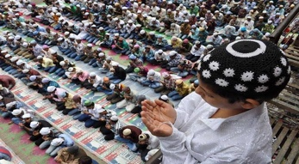
At 8:00 am  ٨:٠٠ صباحاً |  |  |  |  | أرتدي................. ......................  .......................................... |  |  |  |  |  |  |  | 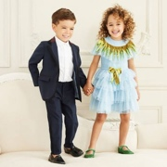
................... |  |  |  |  | أقبل ......................و....................  وأقول لهم .....................................  ...................................... |  |  |  |  |  |  |  | 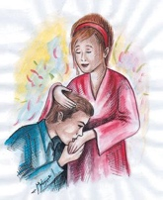
...................... |  |  |  |  | هدايا ............................................ |  |  |  |  |  |  |  | 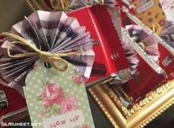
..................... |  |  |  |  | .................................................  .................................................
...................... |  |  |  |  | ...............................................  ...................................................
...................... |  |  |  |  | ..................................................  ...................................................
........................ |  |  |  |  | .................................................  ..................................................
........................ |  |  |  |  | ...............................................  .................................................
ع | ا | ث | ص | ح |  | ا | ن | ر | و | ر | س
ي | ل | ي | ل | ل |  | ل | م | ك | ر | ا | ب
د | ا | ا | ا | و |  | ا | ي | ن | ا | غ | ا
م | ق | ب | ة | ى |  | ض | غ | س | ك | ع | ك
ب | ا | ا | ا | ت |  | ح | ن | ف | و | ر | خ
ا | ر | ي | ل | س |  | ى | ى | د | ي | ا | ع
ر | ب | ا | ع | و |  | ر | ط | ف | د | ي | ع
ك | ن | د | ي | ق |  | د | ج | س | م | ل | ا
م | ا | ه | د | د |  | ي | ع | س | د | ي | ع
ا | ح | ت | ف | ا |  | ل | ا | ل | ع | ي | د
ل | ر | ة | د | ي |  | د | ج | ب | ا | ي | ث
س | ف | د | ي | ع |  | ل | ا | ة | ن | ي | ز
د | ي | ع | ل | ا |  | ت | ا | ي | و | ل | ح
Eid Al Adha Search Puzzles

عيد سعيد
حلويات العيد
عيد مبارك
صلاة العيد
احتفال العيد
ثياب جديدة
هدايا
الأقارب
زينة العيد
كعك
أغاني
حلوى
تسوق
المسجد
فرحان
سلام
عيد فطر
ثياب
عايد
غنى
خروف
كنس
بارك

