Activities
ما إسمك؟
مـا إسـمـكَ؟ مـا إسـمـكِ؟
What is your name? (Ask 4 friends)
أنا إسمي

---------------------------------

أنا إسمي

---------------------------------

أنا إسمي

---------------------------------

أنا إسمي

---------------------------------

My name is …
أنـا إسـمـي أنـا إسـمـي
________________________________________________________________________________
________________________________________________________________________________
________________________________________________________________________________
كـم عـمـرك؟
كـم عـمـركَ؟ كـم عـمـركِ؟
How old are you? (Ask 4 friends)
أنا عمري

سنوات -------------------

أنا عمري

سنوات -------------------

أنا عمري

سنوات -------------------

أنا عمري

سنوات -------------------

أَنـا عُـمْـري ....... سَـنَـوَات
أنـا عـمـري ....... سـنـوات
أنـا عـمـري ....... سـنـوات
أنـا عـمـري ....... سـنـوات

……………………………….................................
……………………………….................................
……………………………….................................
……………………………….................................

Which country are you from?
من أيـنَ أَنْتَ؟
من أيـنَ أَنْتِ؟
Sit in a circle and ask your classmates where they come from. Mark a tally for each student then create a column graph below=
لـبـنـان  Lebanon | الـعـراق  Iraq | مـصـر  Egypt | سوريا  Syria | …………..  …………. | …………..  ………….
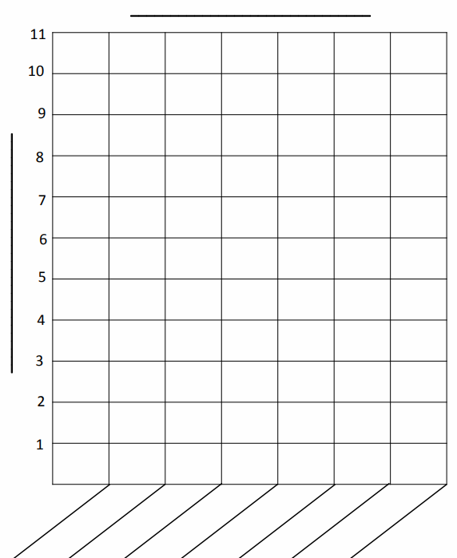

Which country were most students from? ……………………….
Which country had the least number of students? ……………………….

من أَي بَلد والِدَيْك؟
من أَي بَلد والِدَيْك؟
Where do you parents come from? (Ask 4 friends)
أبـي مـن ......................

أمـي مـن ......................

أبـي مـن ......................

أمـي مـن ......................

أبـي مـن ......................

أمـي مـن ......................

أبـي مـن ......................

أمـي مـن ......................

Your answer :
أَبـي مِـن ............
أَبـي مِـن ............
................................................................................................................................................................................................................
أُمـي مِـن ............
أُمـي مِـن ............
................................................................................................................................................................................................................
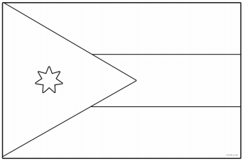
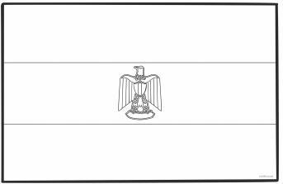
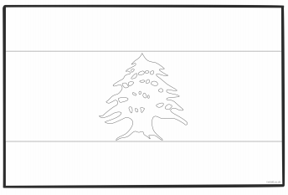
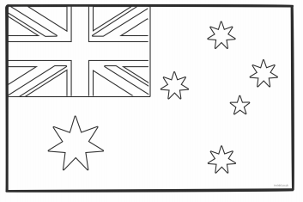
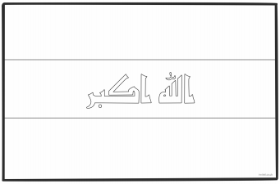
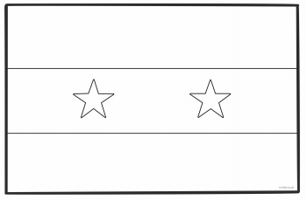
Write the name of each country under each flag and colour the flags in the correct colours.

