Term 1 Summative Assessment
Total Marks (30) Level: Beginners

- Apna naam Hindi mein likho. (2)

_________________________________________

- Sabhi swar likho. (5)

_______________________________________________________________________

_______________________________________________________________________

- Vyanjan pehchano: (5)

क, म, ब, ल, स, र, न, प, ग, ह

- Ye kaun se rang hain? (3)

___________ ___________ __________ ____________ __________

__________ ___________

- Ye kaun se ang hain? (6)
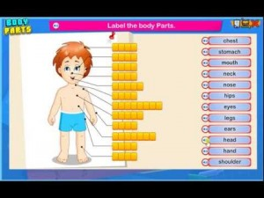
This Photo by Unknown Author is licensed under CC BY-NC

- Saptah ke dino ke naam batao. (3)

- Bharat ka jhanda banao aur rang bharkar unke naam likho. (6)

