History – My Family

Stage: Kindergarten | Unit Duration: 7 lessons | Weeks: 1 2 3 4 5 6 7 8 | Terms: 1 2 3 4
Unit Description and Overview | All students will develop the knowledge about their families (family structure, family titles, mother’s family, father’s family, grandparents, family physical description and their ages).  Students will also explore the importance of the immediate and extended family and different relationships among all family members.  Students will also learn and use vocabulary from the Assyrian and Chaldean Language throughout the unit, which they can use in other lessons.  Teaching and learning activities are designed to help students construct understanding for deeper learning. A variety of tasks will be included, both in theory and practice to ensure students get a mix of activities that cater to their needs.
Lesson Overview | 1. What is a family? (Who is in my family)  2. What does your family look like? How many brothers and sisters do you have?  3. Who are grandparents? How do you address them?  4. Father’s family.  5. Mother’s family.  6. In-laws family.  7. News (talk about your family)  8. Assessments
Organisation | All lessons are designed to ensure teachers lead learning and content and students have opportunities to listen and respond. This will ensure all students are active participants of their learning.  All lessons will include:  - Learning Intentions, Success Criteria, Vocabulary and Language, Warm Up and Wrap Up Activities.  - Modelled Teaching, Independent tasks, group tasks, partner tasks, Think/Pair/Share, technology use and reflection etc.
Essential Questions | - What is a family?  - Who lives in my family?  - What do my family member look like?  - How old are my family members?  - Who is in my father’s family?  - Who is in my mother’s family?
Assessment | Teachers have assessment opportunities before and after the unit to track progress. Students can verbally identify some farm animals to show their understanding before the unit commences and after. The assessment for learning is ongoing.
Technology and Useful Websites | Teachers may use resources such as iPads and laptops to support students with their learning. Students should be exposed to a variety of songs, rhymes, books etc. to support their learning.  Some websites that may be helpful for teachers to visit before and during the unit for support include:  https://www.youtube.com/watch?v=FHaObkHEkHQ (titles of family member in English)  https://www.youtube.com/watch?v=oJHar7NKdlg (Assyrian song on family)  https://www.youtube.com/watch?v=VvrG4JguNQk (family tree in English)
History – My Family

Year: Kindergarten Lesson Sequence: 1 of 7

Subject: My Family Topic: My Family and family members

Learning Intention: We are learning about a family and family members in Chaldean/Assyrian Language.

Success Criteria: I will be successful if I can identify family members in Chaldean/Assyrian language.

Key words: father, mother, brother, sister, baby brother/sister.

Resources: Finger Family Song, Family flash cards / poster in Chaldean/Assyrian (Resource A), My Family worksheet (Resource B), pencils, glue sticks and scissors

Starter:
- Class discussion:
- Brainstorm what a family is in English.
- Introduce the word ‘family’ in Chaldean/Assyrian.
- Brainstorm what who lives in a family in English.
- Introduce the family members’ words in Chaldean/Assyrian.
- Consolidate farm animal’s vocabulary using flashcards.
- Students take turns to tell the class about their families.
- Brainstorm what do you do with your family in English.

- Song: Finger Family song in Assyrian version https://www.facebook.com/BETKANU/videos/2487867927899540
- Display a family poster on the board and ask students to identify or repeat the names of the family members in Chaldean/Assyrian

- Game: Match pictures of family members.
- Teacher calls out a family member they learnt in Chaldean/Assyrian and one student at a time matches it to a picture.
Activity:
- Student will draw/colour in the family worksheet independently, with a partner or in a group.
Wrap-up:
- Teacher reads ‘My Family, Your Family’ in Chaldean/Assyrian
- Students retell and review the story

History – My Family

Year: Kindergarten Lesson Sequence: 2 of 7

Subject: My Family Topic: Describing My Family

Learning Intention: We are learning about describing family members in Chaldean/Assyrian Language.

Success Criteria: I will be successful if I can describe family members in Chaldean/Assyrian language.

Key words: father, mother, brother, sister, baby brother/sister, height, eye colour, hair colour.

Resources: Finger Family Song, family flash cards / poster in Chaldean/Assyrian (Resource A), Family Members worksheet (Resource C), pencils, glue sticks and scissors

Starter:
- Class discussion:
- Revise what a family is in Chaldean/Assyrian.
- Revise family members in Chaldean/Assyrian.
- Introduce the question: how many brothers /sisters do you have?
- Introduce the answer structure: I have 2 brothers/sisters.
- Brainstorm what does your brother/sister look like.
- Introduce the answer structure: my brother/sister has ……hair and…. eyes.

- Song: Finger Family song in Assyrian version https://www.facebook.com/BETKANU/videos/2487867927899540
- Display a family poster on the board and ask students to identify or repeat the names of the family members in Chaldean/Assyrian
- Using the same poster/ flash cards on the board, students start describing their family members and telling their age.
Activity:
- Using A4 sheet students draw and colour in their family members.

Wrap-up:
- Students sit in a circle and share their drawing with their class, talking about their family members.

History – My Family
Year: Kindergarten Lesson Sequence: 3 of 7

Subject: My Family Topic: My Grandparents

Learning Intention: We are learning about our grandparent in Chaldean/Assyrian Language.

Success Criteria: I will be successful if I can identify my grandparents in Chaldean/Assyrian language.

Key words: grandfather, grandmother, mother’s side and father’s side.

Resources: Finger Family Song, family flash cards / poster in Chaldean/Assyrian (Resource A), My Grandparents worksheet (Resource D), pencils, glue sticks and scissors

Starter:
- Class discussion:
- Revise the vocabulary from the previous lesson
- Brainstorm what is a grandparent.
- Introduce the word ‘grandparents’ in Chaldean/Assyrian
- Brainstorm the different ways of addressing your grandparents.
- Discuss the relationship you have with your grandparents.
- Students tell the class if they have grandparents and how many?

- Song: Song: Finger Family song in Assyrian version https://www.facebook.com/BETKANU/videos/2487867927899540
- Display a family poster on the board and ask students to identify or repeat the names of the family members in Chaldean/Assyrian
- Using the same poster/ flash cards on the board, students start describing their grandparents and their position in the family.
Activity:
- Using A4 sheets/ mini whiteboards, students will independently draw their family members and talk about how many people are there.

Wrap-up:
- Students draw a family tree on their boards and answer the questions about the family members
- Students sit in a circle and share their drawing with the class and talk about it.

History – My Family
Year: Kindergarten Lesson Sequence: 4 of 7

Subject: My Family Topic: My Father’s Family

Learning Intention: We are learning about father’s family in Chaldean/Assyrian Language.

Success Criteria: I will be successful if I can identify my father’s family in Chaldean/Assyrian language.

Key words: uncles, aunties and cousins.

Resources: Finger Family Song, family flash cards / poster in Chaldean/Assyrian (Resource A), My Relatives worksheet (Resource E), pencils, glue sticks and scissors

Starter:
- Class discussion:
- Revise the vocabulary from the previous lesson
- Brainstorm what do they about their uncles, aunties and cousins.
- Introduce the word ‘uncles, unties and cousins’ in Chaldean/Assyrian
- Explain to your students that in Assyrian each side has different name.
- Brainstorm the different ways of addressing your uncles, aunties and cousins.
- Discuss the relationship you have with your uncles, unties and cousins.
- Students tell the class if they have uncles, aunties and cousins and how many?

- Song: Song: Finger Family song in Assyrian version https://www.facebook.com/BETKANU/videos/2487867927899540
- Display an extended family poster on the board and ask students to identify or repeat the names of the family members in Chaldean/Assyrian
- Using the same poster/ flash cards on the board, students start describing their uncles, aunties and cousins and their position in the family.
Activity:
- Using A4 sheets, students will independently draw their uncles, aunties and cousins and label them.

Wrap-up:
- Game- students choose their partners. Student A says he or she has 2 uncles, 1 aunt and 3 cousins. Student A then will ask student B how many uncles, aunties, and cousins he/she has. Student B will answer the question.

History – My Family

Year: Kindergarten Lesson Sequence: 5 of 7

Subject: My Family Topic: My Mother’s Family

Learning Intention: We are learning about mother’s family in Chaldean/Assyrian Language.

Success Criteria: I will be successful if I can identify my mother’s family in Chaldean/Assyrian language.

Key words: uncles, aunties and cousins.

Resources: Finger Family Song, family flash cards / poster in Chaldean/Assyrian (Resource A), My Relatives Extended worksheet (Resource F), pencils, glue sticks and scissors

Starter:
- Class discussion:
- Revise the vocabulary from the previous lesson
- Brainstorm what do they about their uncles, aunties and cousins.
- Introduce the word ‘uncles, unties and cousins’ in Chaldean/Assyrian
- Explain to your students that in Assyrian each side has different name.
- Brainstorm the different ways of addressing your uncles, aunties and cousins.
- Discuss the relationship you have with your uncles, unties and cousins.
- Students tell the class if they have uncles, aunties and cousins and how many?

- Song: Song: Finger Family song in Assyrian version https://www.facebook.com/BETKANU/videos/2487867927899540
- Display an extended family poster on the board and ask students to identify or repeat the names of the family members in Chaldean/Assyrian
- Using the same poster/ flash cards on the board, students start describing their uncles, aunties and cousins and their position in the family.
Activity:
- Using A4 sheets, students will independently draw their uncles, aunties and cousins and label them.

Wrap-up:
- Game- students choose their partners. Student A says he or she has 2 uncles, 1 aunt and 3 cousins. Student A then will ask student B how many uncles, aunties, and cousins he/she has. Student B will answer the question.

History – My Family
Year: Kindergarten Lesson Sequence: 6 of 7

Subject: My Family Topic: In Laws

Learning Intention: We are learning about brother and sister-in-law in both sides in Chaldean/Assyrian Language.

Success Criteria: I will be successful if I can identify mothers’ side and fathers’ side (brother, sister-in-law).

Key words: uncles, aunties and cousins.

Resources: Finger Family Song, family flash cards / poster in Chaldean/Assyrian (Resource A), A4 Paper, pencils, glue sticks and scissors

Starter:
- Class discussion:
- Revise the vocabulary from the previous lesson
- Discuss the extended family and give examples from both mother’s and father ‘s side.
- Introduce the word ‘brother/ sister-in-law’ in Chaldean/Assyrian
- Explain to your students that in Assyrian each side has different name.
- Brainstorm the different ways of addressing your brother/sister-in-law.
- Discuss the relationship you have with your brother/ sister-in-law.
- Students tell the class if they have uncles, aunties and cousins and how many?

- Song: Song: Finger Family song in Assyrian version https://www.facebook.com/BETKANU/videos/2487867927899540
- Display an extended family poster on the board and ask students to identify or repeat the names of the family members in Chaldean/Assyrian
- Using the same poster/ flash cards on the board, students start describing their brother/sister-in-law and their position in the family.
Activity:
- Using A4 paper, students will independently draw their brother/sister-in-law and label them.

Wrap-up:
- Group activity- students form groups and talk about their families, describing them, telling their ages, their titles, and their positions in the family.

History – My Family
Year: Kindergarten Lesson Sequence: 7of 7

Subject: My Family Topic: My Family

Learning Intention: We are learning about our families in Chaldean/Assyrian Language.

Success Criteria: I will be successful if I can identify my immediate and extended family members,

Key words: mum, dad, brother, sister, grandparent, uncles, aunties and cousins.

Resources: Finger Family Song, family flash cards / poster in Chaldean/Assyrian (Resource A), A4 Paper, pencils, glue sticks and scissors

Starter:
- Class discussion:
- Revise the vocabulary from the previous lesson
- Discuss the extended family and give examples from both mother’s and father ‘s side.
- Introduce the structure of ‘news’
- ‘I have a big family. There are ……people in my family, mum, dad, brother, sister, myself, grandmother, grandfather, uncles, aunties, and cousins’.

- Song: Song: Finger Family song in Assyrian version https://www.facebook.com/BETKANU/videos/2487867927899540
- Display an extended family poster on the board and ask students to identify or repeat the names of the family members in Chaldean/Assyrian
- Using the same poster/ flash cards on the board, students start describing their family members and their position in the family.

Activity:
- Using A4 paper, students will independently draw their whole family and label them.

Wrap-up:
- Group activity- students form groups and talk about their families, describing them, telling their ages, their titles, and their positions in the family.

Resource A- Family Flash Cards
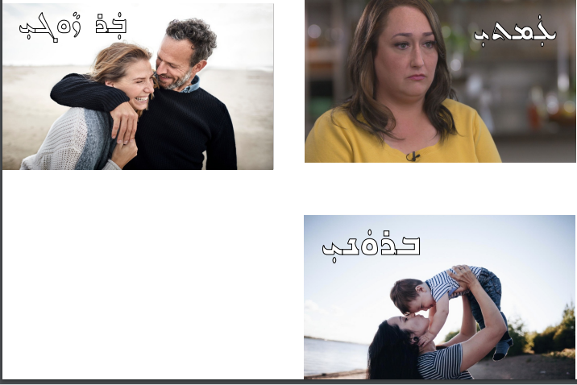
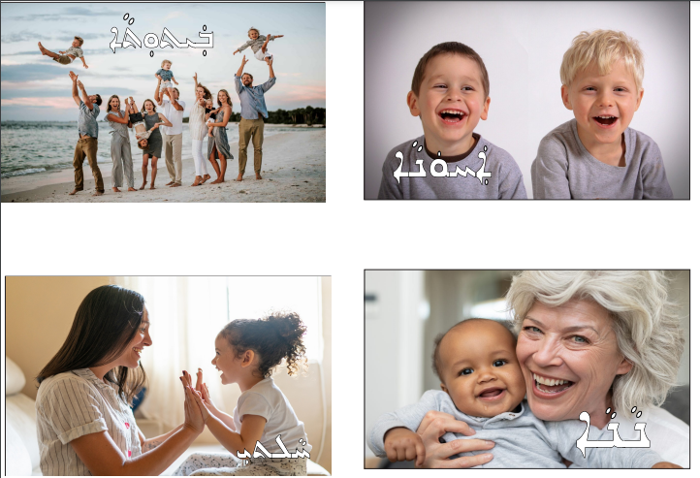
Resource A- Family Flash Cards
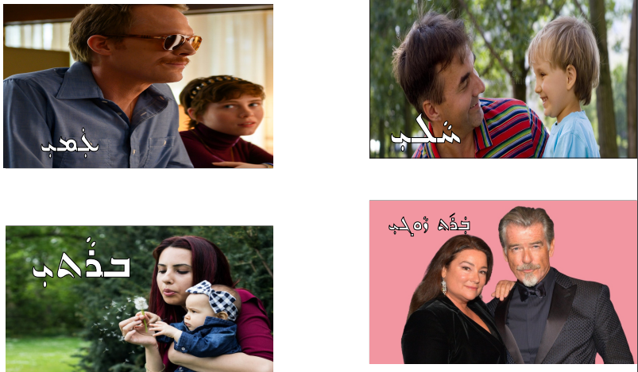
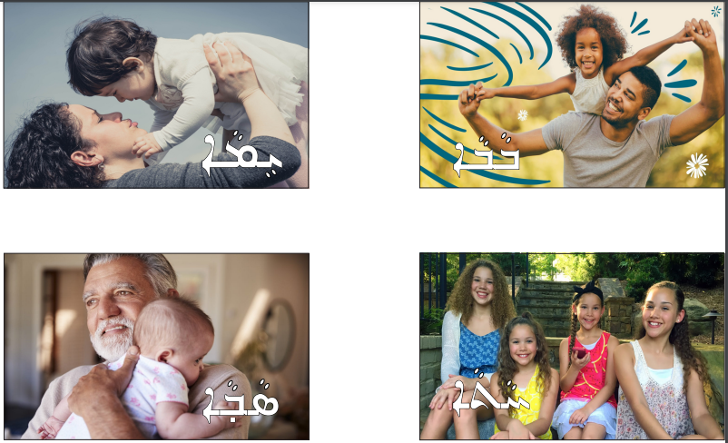

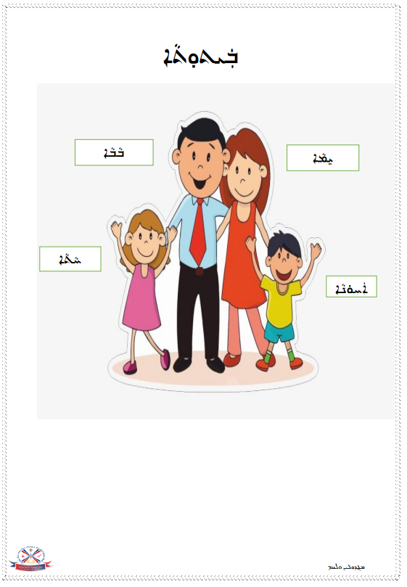
Resource B- My Family Worksheet
Resource B- My Family Worksheet

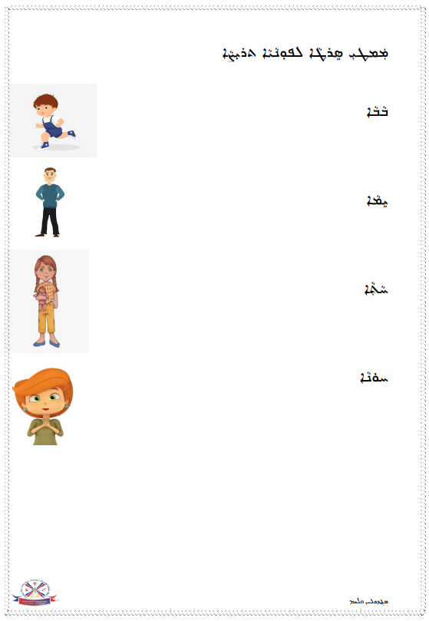
Resource B- My Family Worksheet
Resource B- My Family Worksheet
Resource C- Family Members Worksheet
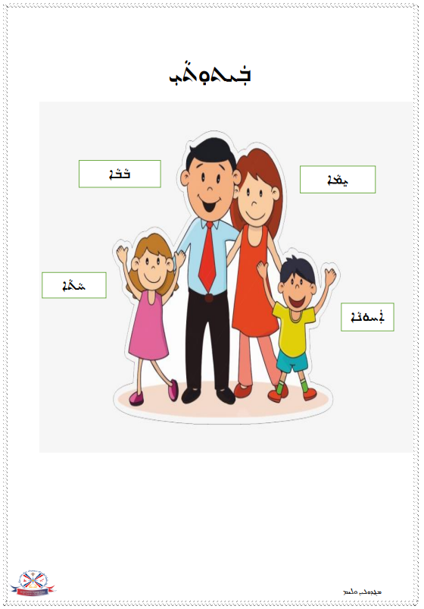
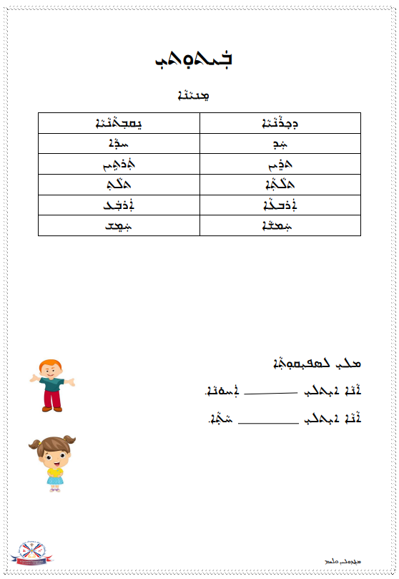
Resource C- Family Members Worksheet
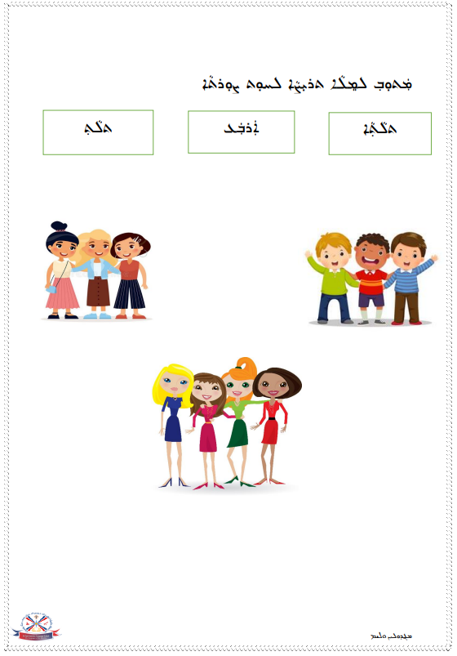
Resource C- Family Members Worksheet
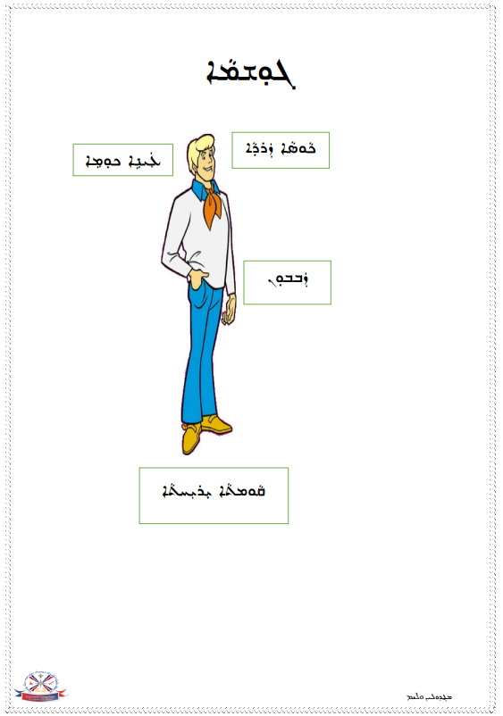
Resource C- Family Members Worksheet
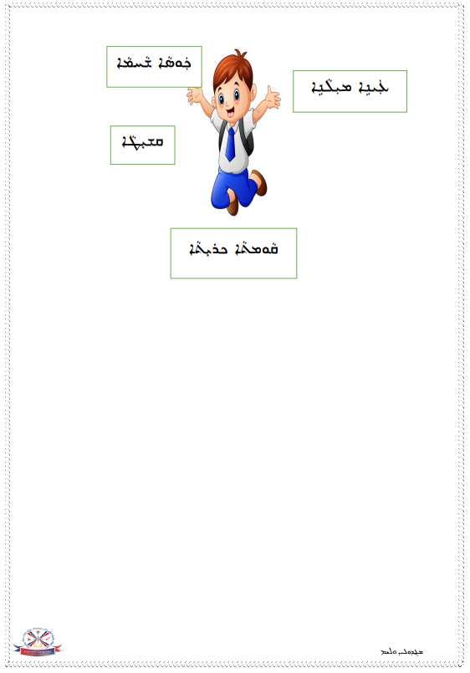
Resource C- Family Members Worksheet
Resource C- Family Members Worksheet
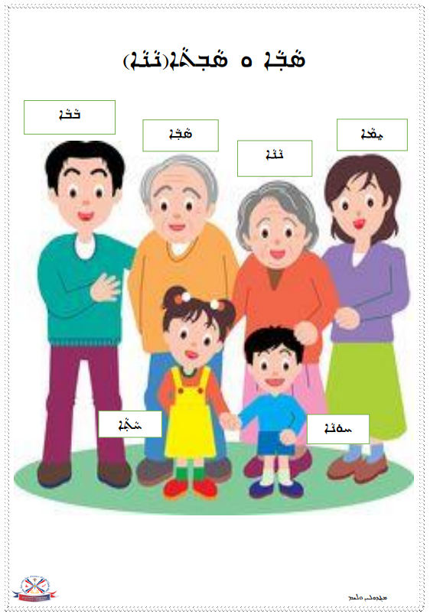
Resource D- My Grandparents Worksheet
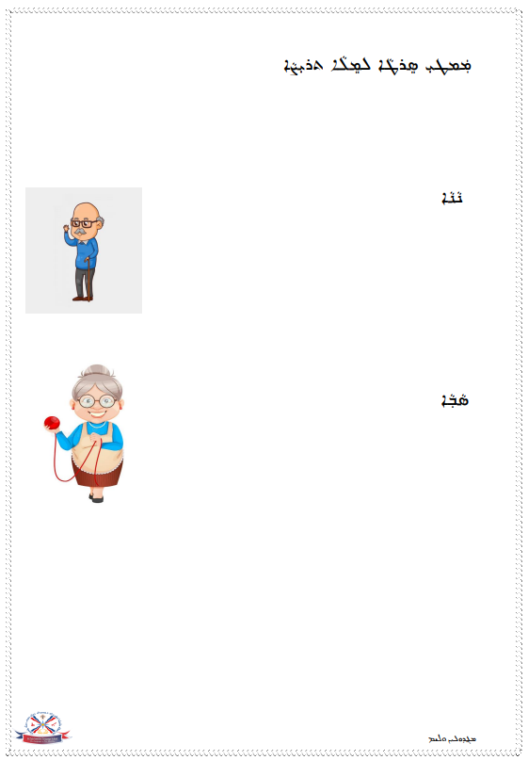
Resource D- My Grandparents Worksheet
Resource D- My Grandparents Worksheet
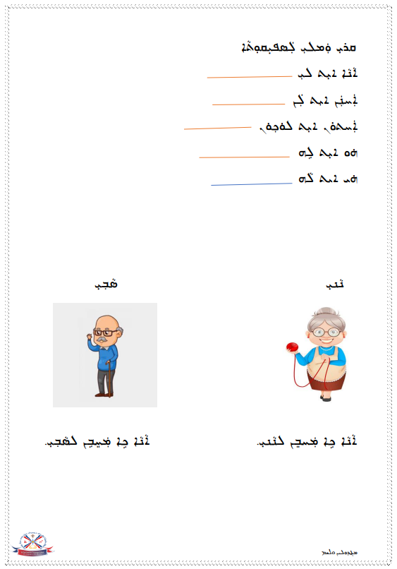
Resource D- My Grandparents Worksheet
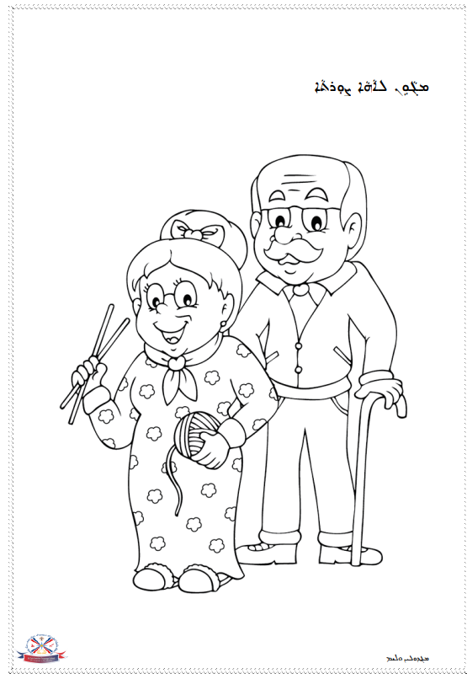
Resource D- My Grandparents Worksheet
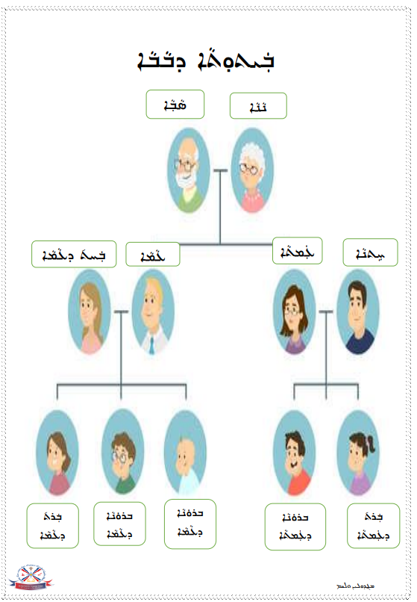
Resource E- My Relatives Worksheet
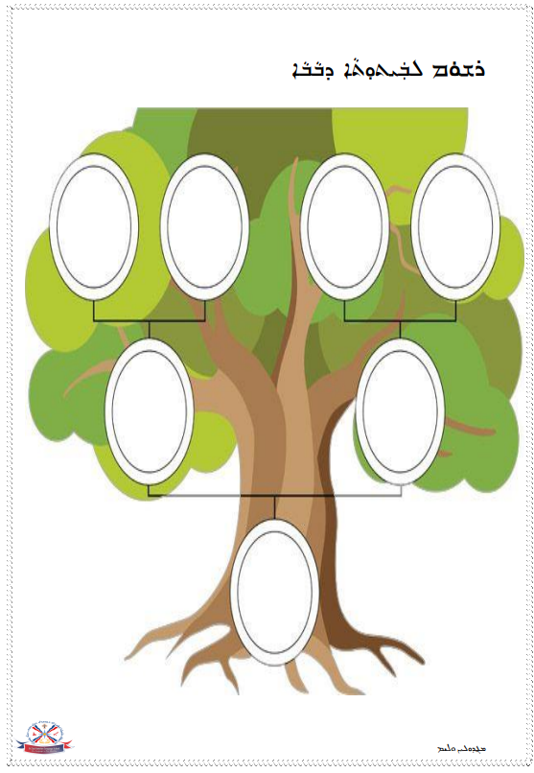
Resource E- My Relatives Worksheet
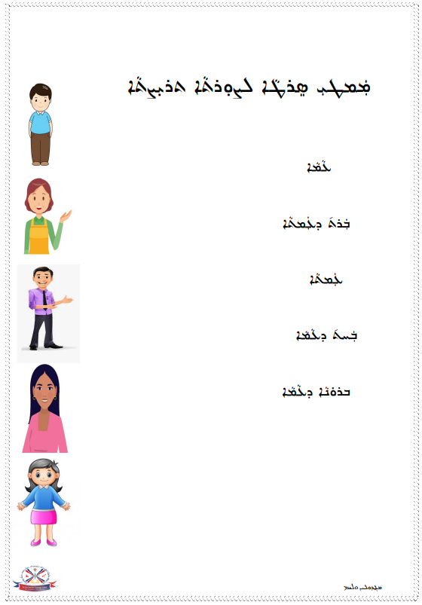
Resource E- My Relatives Worksheet
Resource E- My Relatives Worksheet
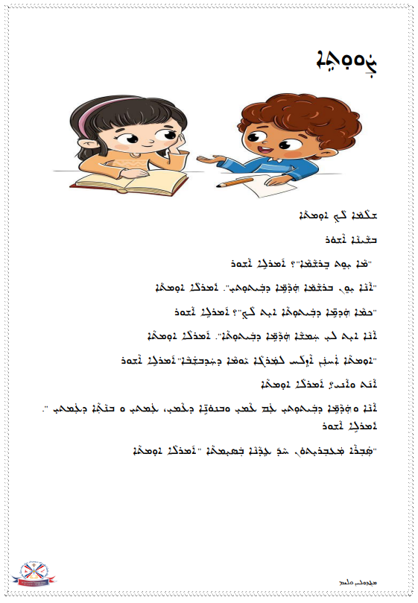
Resource E- My Relatives Worksheet
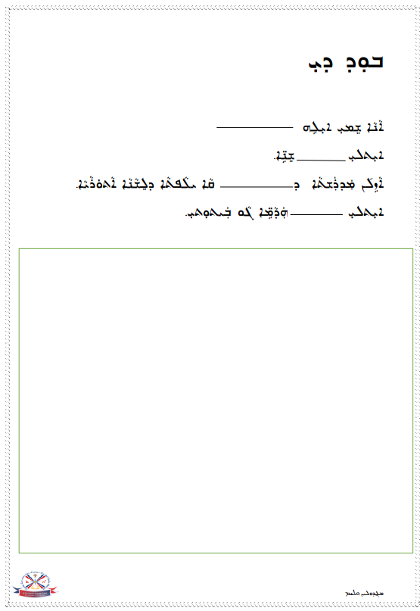
Resource E- My Relatives Worksheet
Resource E- My Relatives Worksheet
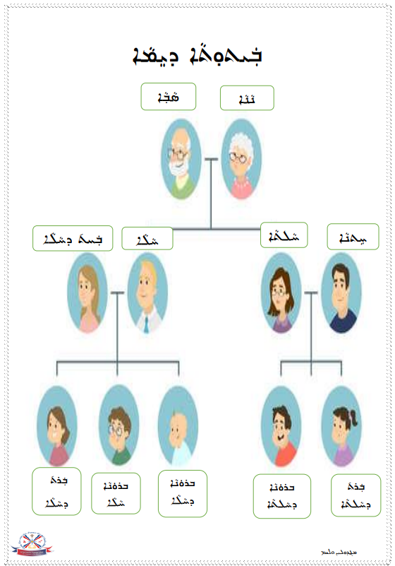
Resource F- My Relatives Extended Worksheet
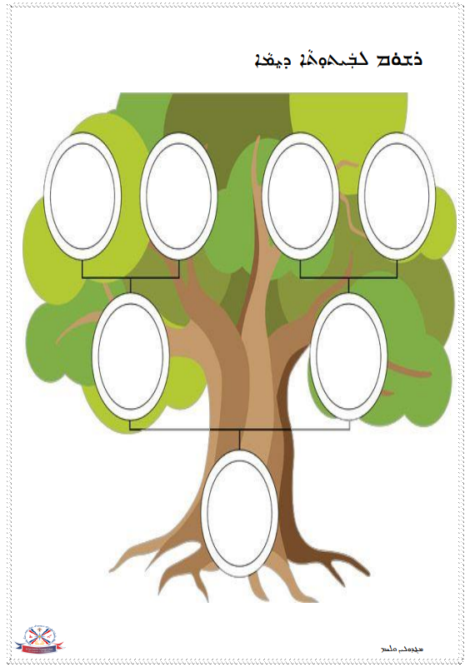
Resource F- My Relatives Extended Worksheet
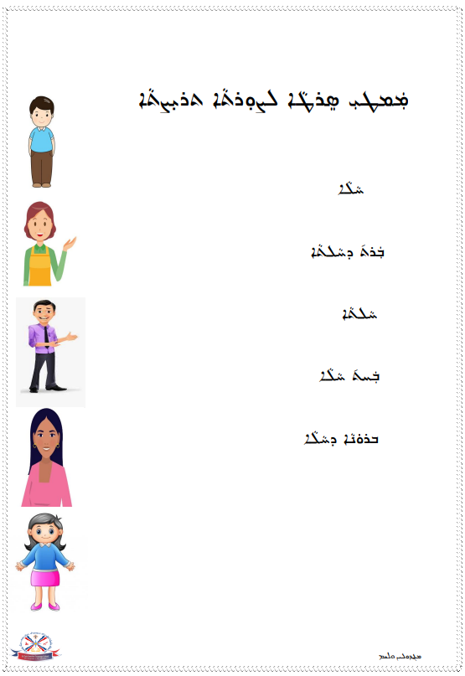
Resource F- My Relatives Extended Worksheet
Resource F- My Relatives Extended Worksheet
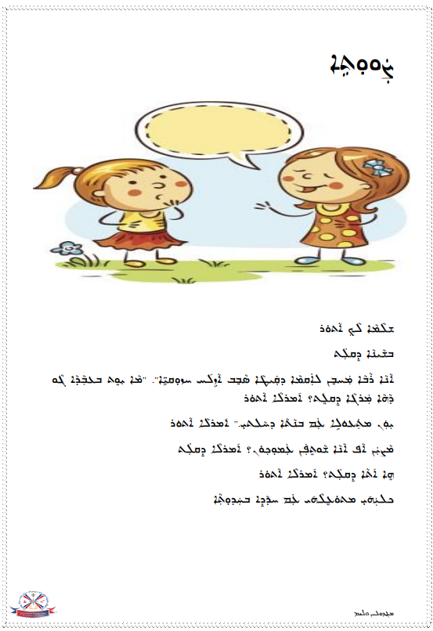
Resource F- My Relatives Extended Worksheet
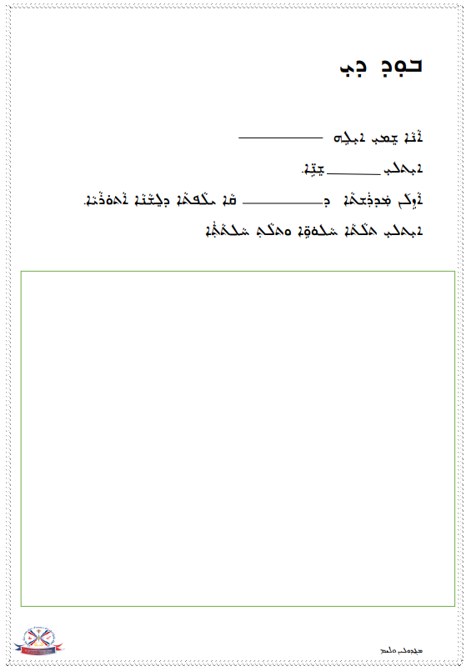
Resource F- My Relatives Extended Worksheet
Resource F- My Relatives Extended Worksheet
