Celebrations

Stage: 2 | Unit Duration: 8 lessons | Weeks: 1 2 3 4 5 6 7 8 9 10 | Terms: 1 2 3 4
Unit Description and Overview | All students will develop the knowledge about significant celebrations and social events that occur during the year. Students will also learn and use vocabulary from the Assyrian and Chaldean Language throughout the unit, including birthday, celebration, event, national day, cultural, Mother’s Day, Father’s Day, Easter, Christmas etc. Lessons will link and can be taught in any order, depending on the time of the year. Teaching and learning activities are designed to help students construct understanding for deeper learning. A variety of tasks will be included, both in theory and practice to ensure students get a mix of activities that cater to their needs.
Lesson Overview | 1. What is a celebration? What are some main celebrations?  2. What are some religious celebrations?  3. What are some cultural celebrations?  4. What is an Assyrian National celebration?  5. What is an Assyrian National celebration? (continued)  6. What are some school celebrations?  7. Celebrations Group Project  8. Celebrations Group Project (continued if needed)  9. Celebrations Post Assessment  (Teacher can use the end of the unit as opportunity for assessment)
Organisation | Lessons are designed to ensure teachers lead learning and content and students have opportunities to listen and respond. This will ensure all students are active participants of their learning.  All lessons will include:  Learning Intentions, Success Criteria, Vocabulary and Language, Warm Up Activities, Modelled Teaching, Independent tasks, group tasks, partner tasks, Think/Pair/Share, technology use, warm up activities, reflection etc.
Essential Questions | - What is a celebration?  - What are some main celebrations?  - Why do we celebrate events?  - Who do we celebrate?  - What do we do during celebrations?  - What are some celebrations at school?  - What are some cultural/ social/ religious celebrations?
Assessment | Teachers have assessment opportunities before and after the unit to track progress. Students may be assessed prior to the unit commencing to see how much knowledge they have. The assessment for learning is ongoing but is designed to be a group project for this unit.
Technology and Useful Websites | Teachers may use resources such as iPads and laptops to support students with their learning. Students should be exposed to a variety of songs, rhymes, books etc. to support their learning.  Some websites that may be helpful for teachers to visit before and during the unit for support include:  https://youtu.be/k5Gtb8Cr8Ag (Assyrian New Year 2021 Sydney)  https://www.wincalendar.com/Assyrian-New-Year (Assyrian New Year Facts)  https://www.harmony.gov.au/events/calendar (Cultural and Religious Dates)  https://www.venuereport.com/roundups/22-celebrations-of-culture-from-around-the-world/ (Celebrations around the World)
Celebrations

Year: Three Lesson Sequence: 1 of 8

Subject: Celebrations Topic: Social Celebrations

Learning Intention: We are learning about social celebrations in Assyrian/Chaldean Language.
Success Criteria: I will be successful if I can identify social celebrations in Assyrian/Chaldean.
Key words: Celebrations, social celebrations, birthday, Mother’s Day, Father’s Day etc.
Resources: PowerPoint, Social Celebrations worksheet (Resource A)

Starter:
- Class discussion
- Introduce the term ‘Celebration’ in Assyrian/Chaldean.
- Introduce the 6 key celebrations that will be learnt this term (social, religious, cultural, Assyrian National, Australian National and School celebrations)
Tell students for this lesson you will be focusing on social celebrations.
- Brainstorm three social celebrations
- Introduce the terms in Assyrian/Chaldean.
- Ask students to discuss each celebration in Assyrian/Chaldean

- Game: Guess the right celebration (like Charades)
- Teacher to divide the class into 3 groups and give each group a celebration and the groups. Each group will have a chance to come to the front and give clues each group will be given 2 minutes.
- Once all the groups have had their turn, the teacher will give the students a game card labelled group 1, group 2 and group 3 for each group. The groups to put down their answers and the teacher checks them the group that has them all correct will be the winning group and can be rewarded by the teacher.
Activity:
- Student will complete the Social Celebrations worksheet.

Wrap-up:
- Game – teacher to call out a celebration and each student to give one key word. Repeat the same for the other 2 celebrations.

Celebrations
Year: Three Lesson Sequence: 2 of 8

Subject: Celebrations Topic: Religious Celebrations

Learning Intention: We are learning about religious celebrations in Assyrian/Chaldean Language.
Success Criteria: I will be successful if I can identify religious celebrations in Assyrian/Chaldean.
Key words: religious celebrations, Easter and Christmas
Resources: PowerPoint and Religious Celebrations Worksheet (Resource B)

Starter:
Class discussion
- Revise the terms used in previous lesson.
- Introduce the term ‘Religious Celebration’ in Assyrian/Chaldean
- Introduce and brainstorm the two significant religious celebrations we celebrate (Easter and Christmas)
- Introduce the terms in Assyrian/Chaldean.
- Class discussion about each celebration in Assyrian/Chaldean

Activity:
- Student will complete the Religious Celebrations Worksheet.

Wrap-up:
- Teacher to divide the class into 2 groups and give each group a celebration. The class to do a short 3-minute drama on the celebration (allow the students to be creative).

Science – Australian Animals

Celebrations

Year: Three Lesson Sequence: 3 of 8

Subject: Celebrations Topic: Cultural Celebrations

Learning Intention: We are learning about Cultural celebrations in Assyrian/Chaldean Language.
Success Criteria: I will be successful if I can identify cultural Celebrations in Assyrian/Chaldean.
Key words: Cultural Celebrations, Assyrian New Year and Martyr’s Day
Resources: PowerPoint, Cultural Celebrations worksheet (Resource C)

Starter:
- Class discussion
- Revise the terms used in previous lesson.
- Introduce the term ‘Cultural Celebration’ in Assyrian/Chaldean
- Introduce and brainstorm the two significant cultural celebrations we celebrate (Assyrian New Year and Martyr’s Day)
- Introduce the terms in Assyrian/Chaldean.
- Class discussion about each celebration in Assyrian/Chaldean

Activity:
- Student will complete the Cultural Celebrations worksheet.
Wrap-up:
- Teacher to put students into groups and give each group a cultural celebration and students to create a PowerPoint slide presentation on their celebration with a short description.
- Students to present their PowerPoints to the class.

Celebrations

Year: Three Lesson Sequence: 4 of 8
Subject: Celebrations Topic: Assyrian National Celebrations

Learning Intention: We are learning about Assyrian National Celebrations in Assyrian/Chaldean Language.
Success Criteria: I will be successful if I can identify Assyrian National Celebrations in Assyrian/Chaldean
Key words: Assyrian National Celebrations, Saints’ Commemoration
Resources: PowerPoint, paper, coloured pencils etc.

Starter:
Class discussion
- Revise the terms used in previous lesson.
- Introduce the term ‘Assyrian National celebrations’ in Assyrian/Chaldean.
- Introduce and brainstorm significant Saints’ Commemoration Days.
- Introduce the terms in Assyrian/Chaldean.
- Class discussion about each saint in Assyrian/Chaldean

Activity: Creative thinking
- Students to be in pairs and choose a Saint and create a visual presentation on the Saint of their choice in Assyrian/Chaldean

Wrap-up:
- Students to present their visual work to their classmates.

Celebrations

Year: Three Lesson Sequence: 5 of 8

Subject: Celebrations Topic: Australian National Celebrations

Learning Intention: We are learning about Australian National celebration in Assyrian/Chaldean Language.
Success Criteria: I will be successful if I can identify Australian National Celebrations in Assyrian/Chaldean
Key words: Australian National celebrations, Australia Day and Anzac Day
Resources: PowerPoint, Australian National Celebrations worksheet (Resource D)

Starter:
- Class discussion
- Revise the terms used in previous lesson.
- Introduce the term ‘Australian National Celebrations’ in Assyrian/Chaldean
- Introduce and brainstorm the two significant Australian national celebrations we celebrate (Australia Day and Anzac Day)
- Introduce the terms in Assyrian/Chaldean.
- Class discussion about each celebration in Assyrian/Chaldean

Activity:
- Student will complete the Australian National Celebrations worksheet.
Wrap-up:
- Students in pairs to make a poster creating a symbol that represents Australia Day and Anzac Day and present their posters to the class.

Celebrations

Year: Three Lesson Sequence: 6 of 8

Subject: Celebrations Topic: School Celebrations

Learning Intention: We are learning about school celebrations in Assyrian/Chaldean Language.
Success Criteria: I will be successful if I can identify school celebrations in Assyrian/Chaldean
Key words: School celebrations, end of year presentation, hall, students, choir, certificates, music, drama, singing and speeches
Resources: A4 paper, crayons, paint, texters etc.

Starter:
- Class discussion
- Revise the terms used in previous lesson.
- Introduce the term ‘school Celebration’ in Assyrian/Chaldean
- Introduce and brainstorm the end of year celebration for the school
- Introduce the terms in Assyrian/Chaldean.
- Class discussion about the celebration in Assyrian/Chaldean

Activity:
- Teacher to give students an A4 paper and using the inspiration of the celebrations learnt this term students are to create a creative artwork. The best artwork can be rewarded by using it on the end of year presentation certificates that are given to students.
Wrap-up:
- Students to present their artworks to the class and give a 30 second talk about what inspired them in Assyrian/Chaldean.

Celebrations

Year: Three Lesson Sequence: 7 of 8

Subject: Celebrations Topic: Group Project

Learning Intention: We are learning about celebrations in Assyrian/Chaldean Language.
Success Criteria: I will be successful if I can identify celebrations in Assyrian/Chaldean
Key words: celebrations
Resources: PowerPoint

Starter:
- Class discussion
- Revise all the things learnt in the unit.
- Use PowerPoint to revise some key words and vocabulary.
- Students to brainstorm any new words they have learned and teacher to display in the class for future reference.

Activity:
- Students to form groups of 2 or 3 and create a PowerPoint or a video of a celebration of their choice in Assyrian/Chaldean which can be presented in a PowerPoint or video. Give students an opportunity to showcase their knowledge and what they have learned in their own unique way.
(This can take 1 to 2 lessons depending on how much time they have)

Wrap-up:
- Students in their groups to present PowerPoints to the class.

Celebrations
Year: Three Lesson Sequence: 8 of 8

Subject: Celebrations Topic: Assessment

Learning Intention: We are learning about celebrations in Assyrian/Chaldean Language.
Success Criteria: I will be successful if I can identify Celebrations in Assyrian/Chaldean
Key words: celebrations
Resources: PowerPoint, Assessment worksheet (Resource E)

Starter:

Class discussion
- A short revision and run through of all the topics covered throughout the unit.

Activity:
- Students to complete an assessment worksheet on the unit.

Wrap-up:
- Game: play a game of teachers/student choice that has been played during the unit.

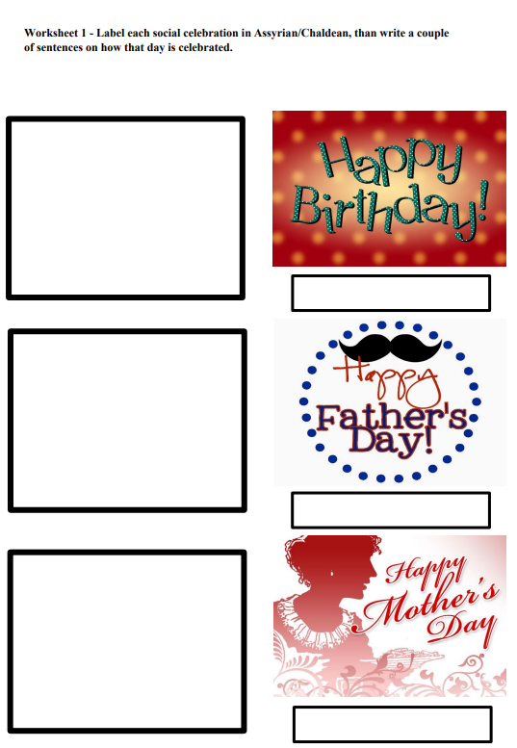
Resource A- Social Celebrations Worksheet
Resource B- Religious Celebrations Worksheet

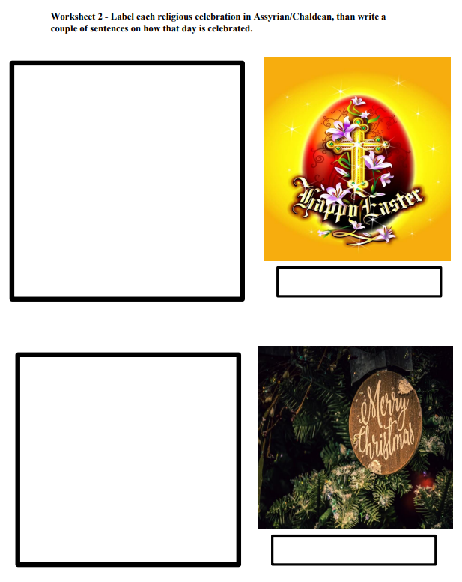

Resource C- Cultural Celebrations Worksheet

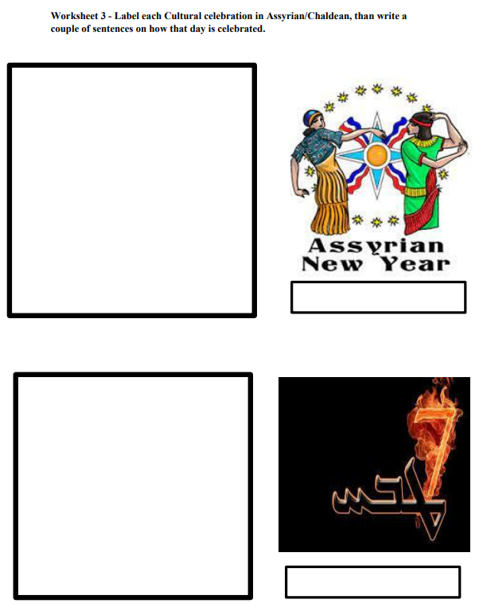

Resource D- Australian Nationals Celebrations Worksheet

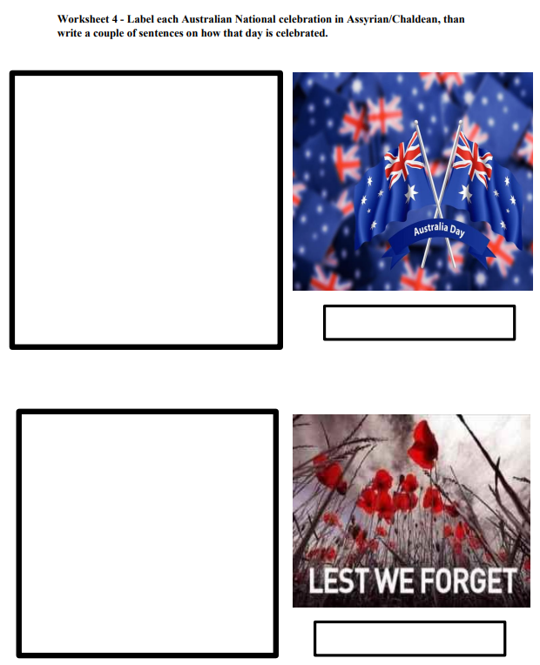

Resource E- Assessment Worksheet

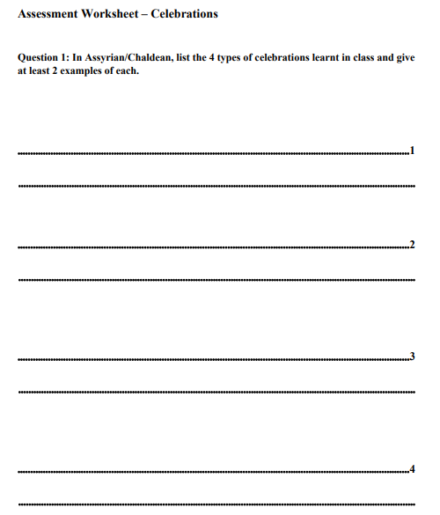

Resource E- Assessment Worksheet
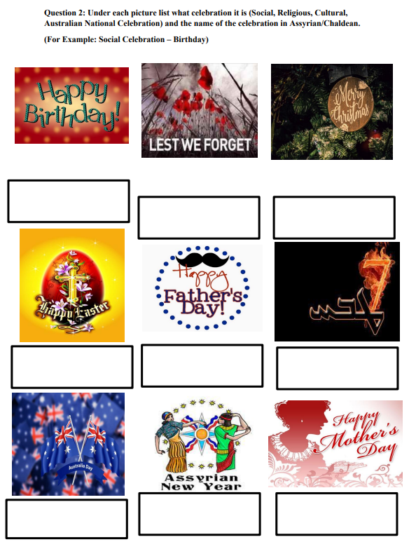

Resource E- Assessment Worksheet
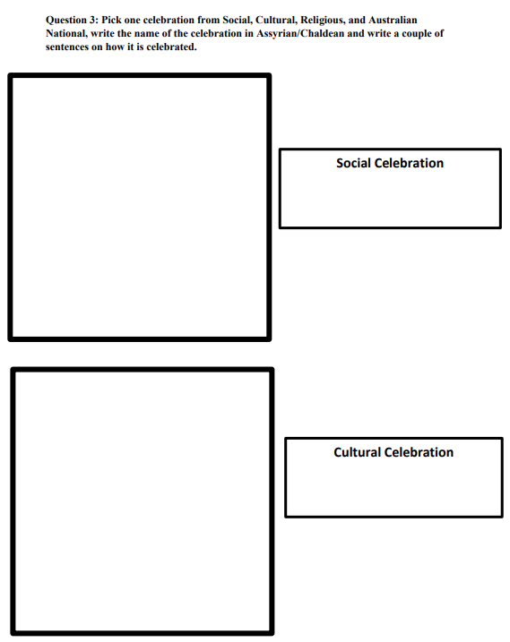

Resource E- Assessment Worksheet
