My School Unit of Work

Stage: 2 | Unit Duration: 8 lessons | Weeks: 1 2 3 4 5 6 7 8 9 10 | Terms: 1 2 3 4
Unit Description and Overview | All students will develop the knowledge about the school environment and the features within the classroom setting. Students will also learn and use vocabulary from the Assyrian and Chaldean Language throughout the unit, which they can use in other lessons.  Teaching and learning activities are designed to help students construct understanding for deeper learning. A variety of tasks will be included, both in theory and practice to ensure students get a mix of activities that cater to their needs.
Lesson Overview | 1. What are some classroom items?  2. What are some examples of classroom resources we use?  3. What are some examples of classroom resources we use? (continued)  4. What are some external areas in a school setting?  5. What are some activities and subjects taught at school?  6. What is the school dress code and uniform?  7. What are some key words about school?  8. School and Classroom Post Assessment.  (Teacher can use the end of the unit as opportunity for assessment)
Organisation | Lessons are designed to ensure teachers lead learning and content and students have opportunities to listen and respond. This will ensure all students are active participants of their learning.  All lessons will include:  Learning Intentions, Success Criteria, Vocabulary and Language, Warm Up Activities, Modelled Teaching, Independent tasks, group tasks, partner tasks, Think/Pair/Share, technology use, warm up activities, reflection etc.
Essential Questions | - What are some key features about school?  - Why do we attend school?  - What do we wear to school?  - What do we notice in the school environment?  - What are some classroom resources we use at school?  - What subjects are taught at school?
Assessment | Teachers have assessment opportunities before and after the unit to track progress. Students will recap all of their knowledge learned over the unit by completing an assessment at the end of the unit.
Technology and Useful Websites | Teachers may use resources such as iPads and laptops to support students with their learning. Students should be exposed to a variety of songs, rhymes, books etc. to support their learning.  Some websites that may be helpful for teachers to visit before and during the unit for support include:  https://kids.kiddle.co/Education_in_Australia (Education in Australia Facts)  https://www.australianexplorer.com/australian_school_systems.htm (Australian School System)  https://youtu.be/zCizmxQ7cGs (Assyrian Alphabet- School resource)  https://youtu.be/cA34BlBHRr0 (5 Little Ducks School Nursery Rhyme)  https://youtu.be/J6aS-65u7ZQ (Essential Classroom Supplies in Assyrian Schools)  https://youtu.be/WWotE7yBNU0 (Old Macdonald School Nursery Rhyme)  https://youtu.be/SSo-NYkWU_A (Vocabulary words in Assyrian Language)

My School

Year: Three Lesson Sequence: 1 of 8

Subject: My School Topic: In my classroom

Learning Intention: We are learning about my school in Chaldean/Assyrian Language.
Success Criteria: I will be successful if I can identify things in my classroom in Assyrian/Chaldean
Key words: window, light, clock, whiteboard, teacher, flowerpot, notebook, table, chair, shelves
Resources: Classroom Flash Cards (Resource A) PowerPoint, My Classroom Worksheet (Resource B)

Starter:
- Class discussion
- Introduce the term ‘my classroom’ in Assyrian/Chaldean.
- Brainstorm various things the students can see in the classroom in English.
- Introduce the things seen in the classroom in Assyrian/Chaldean.
- Ask students to describe what each object is used for in Assyrian/Chaldean.

- Game: Match the names with objects
- Teacher holds out a card of the object and student to read what the object says in Assyrian/Chaldean and matches it with the object seen in the classroom.

Activity:
- Student will complete the ‘my classroom’ worksheet.

Wrap-up:
- Game: teacher to show pictures on a PowerPoint and students to call out the correct term in Assyrian/Chaldean.

My School

Year: Three Lesson Sequence: 2 of 8

Subject: My School Topic: Things we use in class

Learning Intention: We are learning about my school in Chaldean/Assyrian Language.
Success Criteria: I will be successful if I can identify things we use in class in Assyrian/Chaldean
Key words: pen/pencil, book, rubber, sharpener, notebook, ruler, scissors, chalk/crayon
Resources: Things We Use Flash Cards (Resource C), PowerPoint, pencil case, objects in a pencil case, book, notebook, Things We Use Worksheet (Resource D)

Starter:
- Class discussion
- Revise the terms used in previous lesson.
- Brainstorm various things used in a classroom in English.
- Introduce the brainstormed words in Assyrian/Chaldean.
- Ask each student to describe what each is used for in Assyrian/Chaldean.

- Game: Match the words with the pictures on the board
- Teacher to divide the board into 2 where one side has the words and the other has the pictures and asks students to come up and match the words with the correct picture.
Activity:
- Student will complete the things we use worksheet about items in their classroom.

Wrap-up:
- Game: Teacher calls out an object and student to pull out and show the teacher. For example: teacher calls out book, student to put up and show their book etc.

Science – Australian Animals
My School

Year: Three Lesson Sequence: 3 of 8

Subject: My School Topic: My pencil case

Learning Intention: We are learning about my school in Chaldean/Assyrian Language.
Success Criteria: I will be successful if I can identify things in my pencil case in Assyrian/Chaldean
Key words: pen, sharpener, coloured pencils, scissors, glue, rubber, coloured markers, ruler
Resources: Things We Use Flash Cards (Resource C), PowerPoint, My Pencil Case Worksheet (Resource E)

Starter:
- Class discussion
- Teacher to open her pencil case and pull-out things from there and show it to the class.
- Students to call out what they see in English.
- Introduce the words in Assyrian/Chaldean.
- Game: pencil case points game
- Teacher to hand out points card for the game for students to complete.
- Students to open their pencil cases and wait for the teacher to call out items.
- Teacher to call out the things we see in pencil cases in Assyrian/Chaldean.
- Student with the most items and most points win the game and collects a prize.
Activity:
- Student will complete the ‘my pencil case’ worksheet.
Wrap-up:
- Teacher to divide the board into 2 where one side has the words and the other has the pictures and asks students to come up and match the words with the correct picture. Winning group is rewarded. For example: extra five minutes of playtime etc.

My School

Year: Three Lesson Sequence: 4 of 8
Subject: My School Topic: My school

Learning Intention: We are learning about my school in Chaldean/Assyrian Language.
Success Criteria: I will be successful if I can identify my school in Assyrian/Chaldean
Key words: school, library, administration, Teachers room, bubblers, playground, girls’ bathroom, boys’ bathroom, storeroom, kindergarten class
Resources: ‘My School’ Poster (Resource F), My School Worksheet (Resource G)

Starter:
- Class discussion
- Introduce the term ‘My school’ in Assyrian/Chaldean.
- Brainstorm various places in a school- areas other than the classroom, for example: library, bathrooms, offices, carparks etc.
- Introduce the names in Assyrian/Chaldean.
- Teacher to stick ‘My school’ poster on the board/wall.
- Teacher gives the words learnt and students to attach the correct label with the place in the school.

Activity:
- Student will complete the ‘My School’ worksheet.

Wrap-up:
- Teacher takes the students for a walk around the school grounds and asks the students to name the place in Assyrian/Chaldean. For example: bathrooms, school hall, classes, canteen etc.

My School

Year: Three Lesson Sequence: 5 of 8

Subject: My School Topic: school activities

Learning Intention: We are learning about my school in Chaldean/Assyrian Language.
Success Criteria: I will be successful if I can identify activities at school in Assyrian/Chaldean
Key words: writing, painting, drawing, cutting, and pasting and dictation
Resources: School Activities Flashcards (Resource H), PowerPoint, School Activities Worksheet (Resource I)

Starter:
- Class discussion
- Introduce the term school activities in Assyrian/Chaldean.
- Brainstorm various activities undertaken in class in English.
- Introduce the terms in Assyrian/Chaldean.
- Ask each student what their favourite activity is and why in Assyrian/Chaldean.

- Game: Match pictures of activities with their correct vocabulary
- Teacher asks student to read out the word on a flash card and match it with the correct picture.
- Teacher to shows the animals on a PowerPoint slide and students to call out the animal’s name in Assyrian/Chaldean.
Activity:
- Student will the ‘School Activities’ worksheet.

Wrap-up:

- Teacher to show the pictures of activities on a PowerPoint slide and students to call out the activity name in Assyrian/Chaldean.

Science – Australian Animals
My School

Year: Three Lesson Sequence: 6 of 8

Subject: My School Topic: School attire/uniform

Learning Intention: We are learning about my school in Chaldean/Assyrian Language.
Success Criteria: I will be successful if I can identify school attire/uniform in Assyrian/Chaldean
Key words: hat, necktie, shirt, dress, shorts, bag, belt, socks, shoelace, shoes
Resources: School Attire Poster (Resource J), PowerPoint, School Attire/Uniform Worksheet (Resource K)

Starter:
- Class discussion
- Introduce the term school attire/uniform in Assyrian/Chaldean.
- Brainstorm various school attire in English.
- Introduce the school attire/uniform vocabulary in Assyrian/Chaldean.

- Game: label the students attire on the poster
- Teacher asks a boy and girl to come to the front and gives the students written vocabulary on the cards and students to match it to the correct attire on the poster.
Activity:
- Student will complete the ‘School Attire/Uniform’ worksheet.

Wrap-up:
- Teacher to show the pictures of school attire/uniform on a PowerPoint slide and students to call out the name in Assyrian/Chaldean.

My School

Year: Three Lesson Sequence: 7 of 8

Subject: My School Topic: Revision on ‘my school’

Learning Intention: We are learning about my school in Chaldean/Assyrian Language.
Success Criteria: I will be successful if I can identify my school in Assyrian/Chaldean
Key words: my school, my pencil case, school uniform, school activities
Resources: Flash Cards from previous lessons, Posters from previous lessons, PowerPoint, laptops or iPads, Cardboard Paper, Coloured Pencils.

Starter:
- Class discussion
- Revise all the things learnt in the unit.
- Use flashcards to revise some key words and vocabulary.
- Students to brainstorm any new words they have learned and teacher to display in the class for future reference.

Activity:
- Students to form groups of 2 or 3 and create a short story of their school in Assyrian/Chaldean which can be presented in a PowerPoint, or they can do a video. Give students an opportunity to showcase their knowledge and what they have learned in their own unique way.
(This can take 1 to 2 lessons depending on how much time they have)

Wrap-up:
- Students in their groups to present PowerPoints to the class.

My School

Year: Three Lesson Sequence: 8 of 8

Subject: My School Topic: Assessment

Learning Intention: We are learning about my school in Chaldean/Assyrian Language.
Success Criteria: I will be successful if I can identify my school in Assyrian/Chaldean
Key words: my school, school activities, things used in class, school uniform
Resources: Flash Cards (from previous lessons), PowerPoint, My School Assessment Worksheet (Resource L)

Starter:

Class discussion
- A short revision and run through of all the topics covered throughout the unit.

Activity:
- Students to complete the ‘My School Assessment’ worksheet.

Wrap-up:
- Game: play a game of teachers/student choice that has been played during the unit.

Resource A- Classroom Flashcards
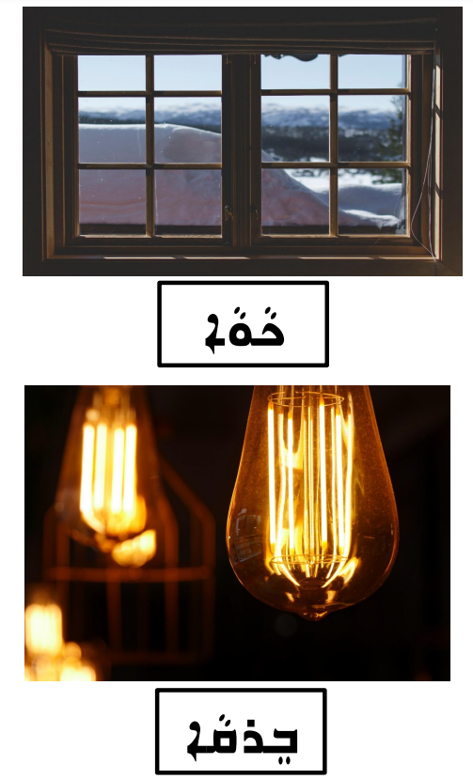

Resource A- Classroom Flashcards
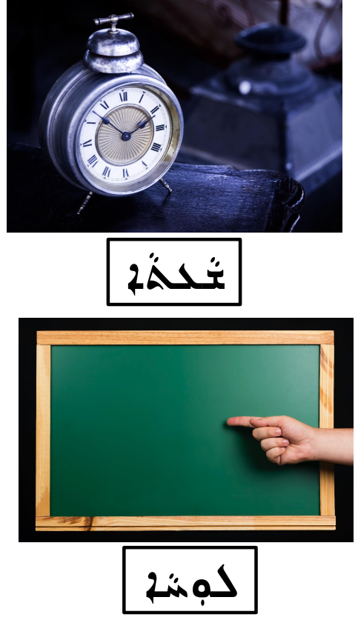

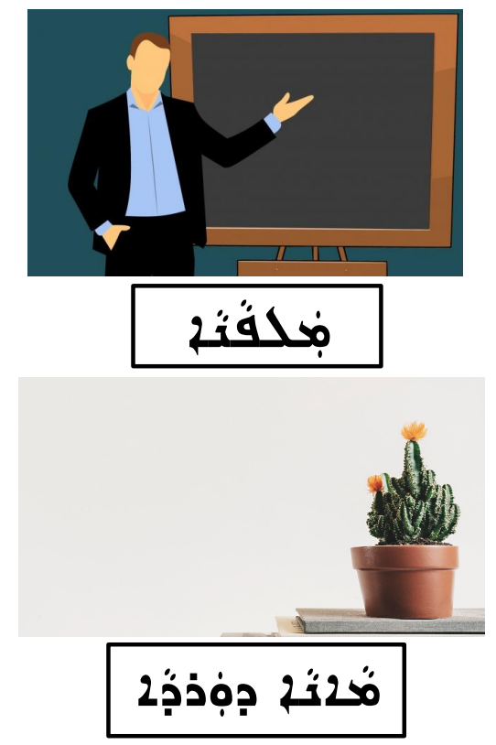
Resource A- Classroom Flashcards
Resource A- Classroom Flashcards

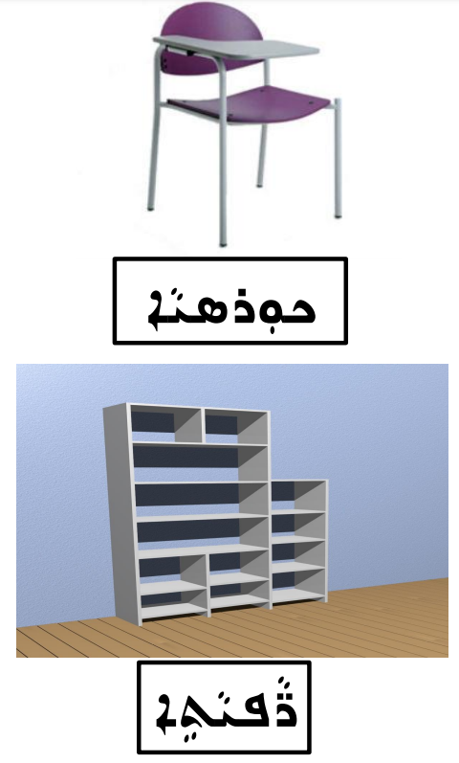

Resource A- Classroom Flashcards
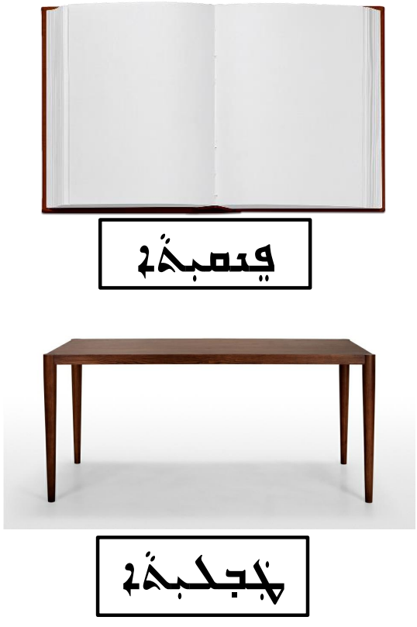
Resource B- My Classroom Worksheet

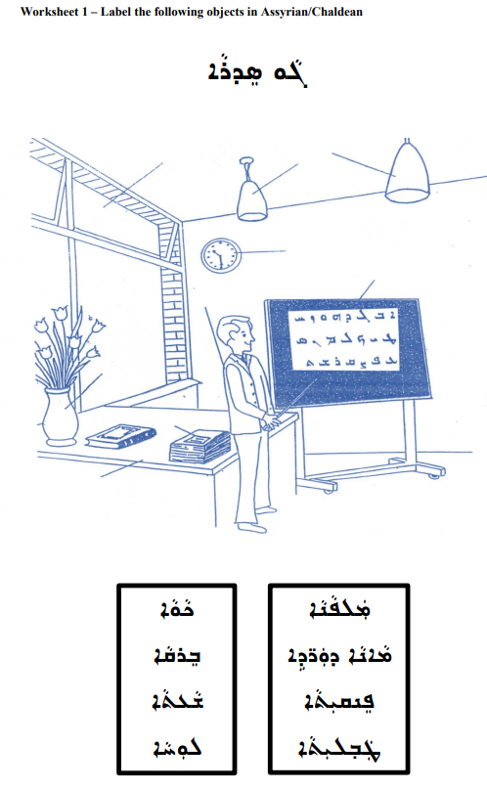

Resource C- Things We Use Flashcards

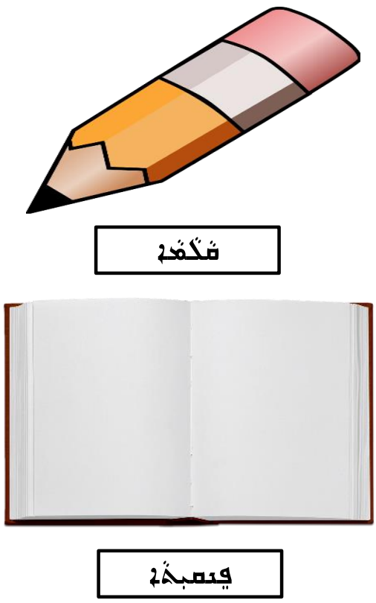

Resource C- Things We Use Flashcards
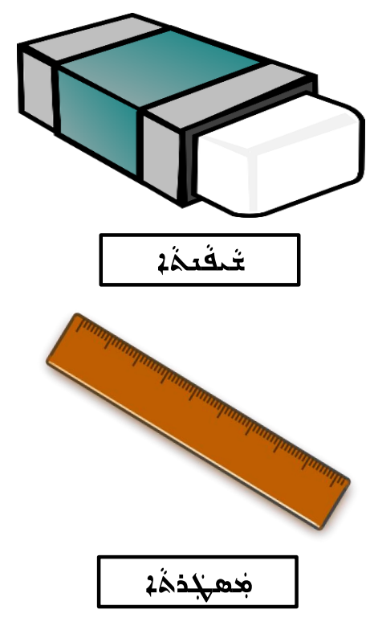

Resource C- Things We Use Flashcards
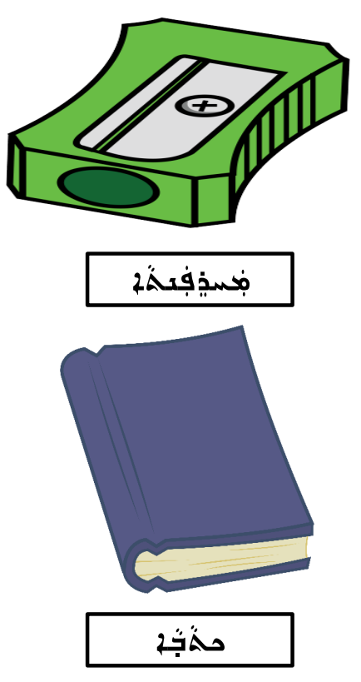

Resource C- Things We Use Flashcards
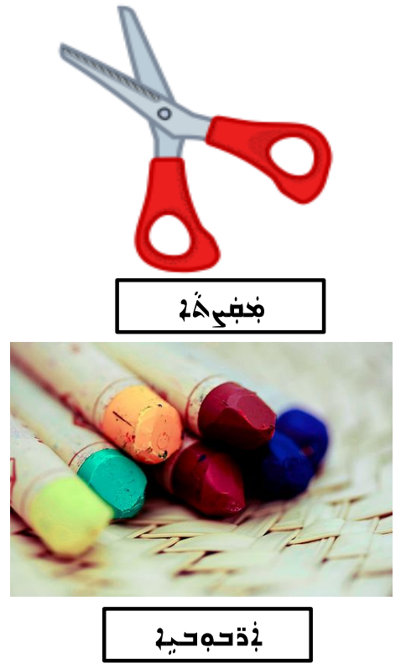

Resource C- Things We Use Flashcards
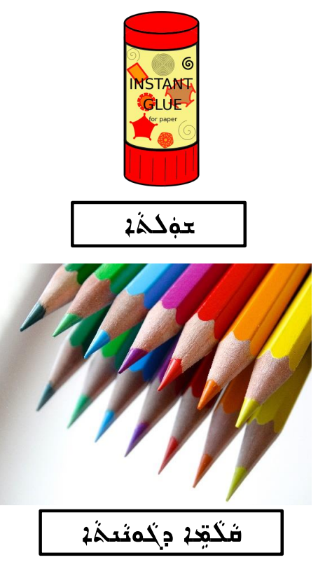

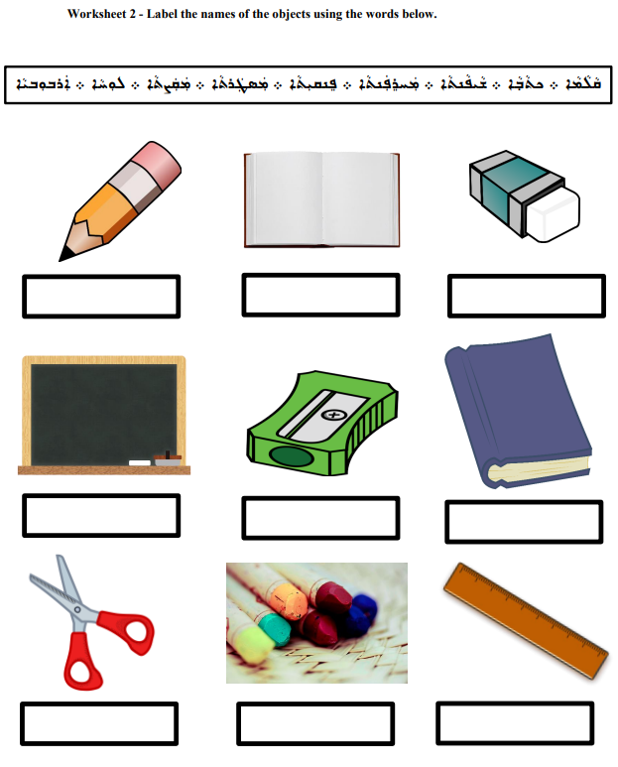
Resource D- Things We Use Worksheet

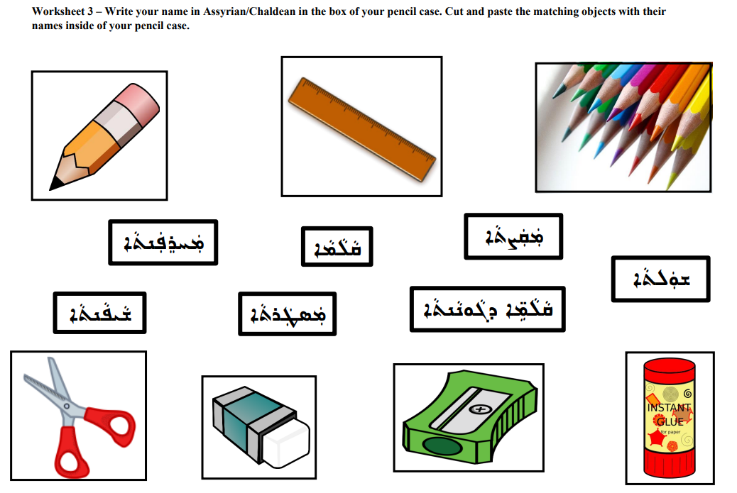
Resource E- My Pencil Case Worksheet

Resource E- My Pencil Case Worksheet

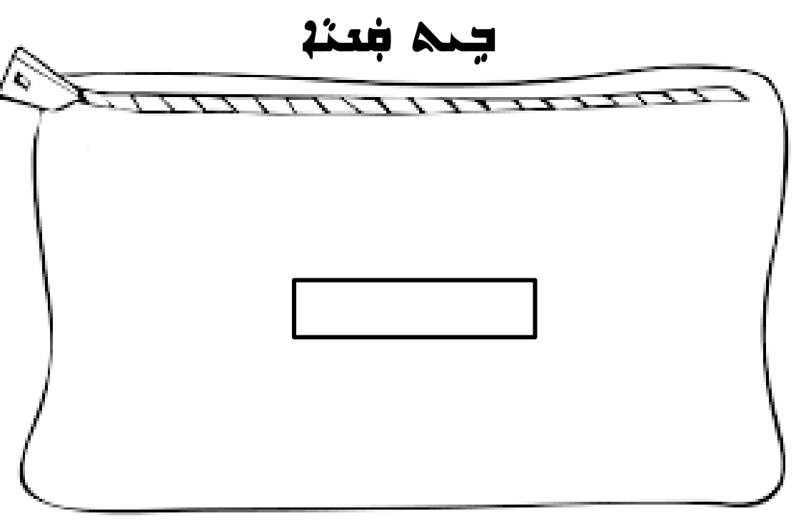

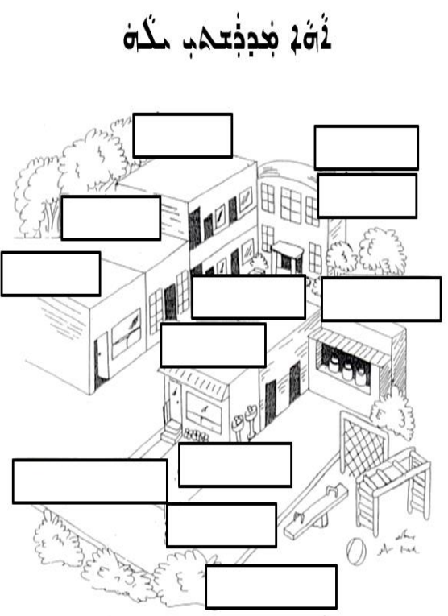
Resource F- My School Poster

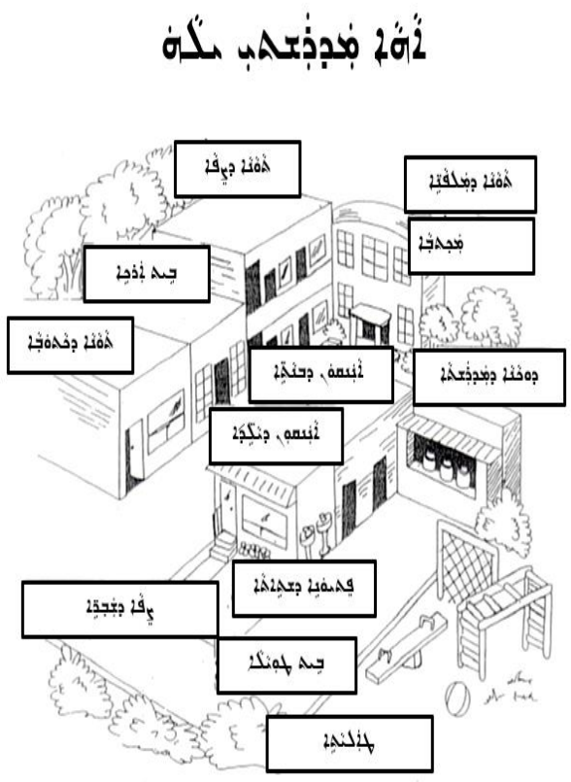
Resource F- My School Poster
Resource G- My School Worksheet
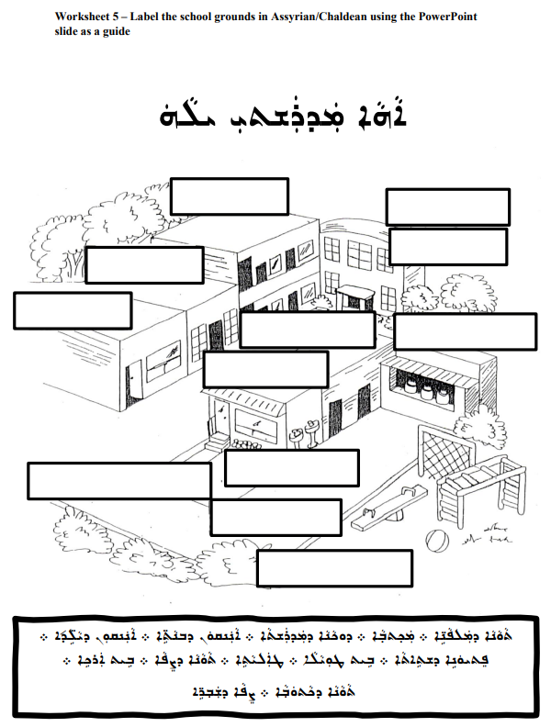

Resource G- School Activities Flashcards

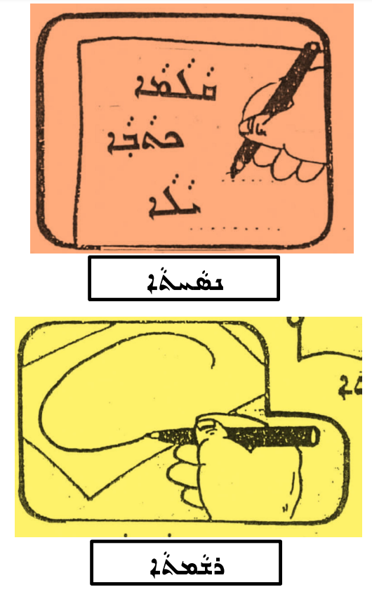

Resource G- School Activities Flashcards
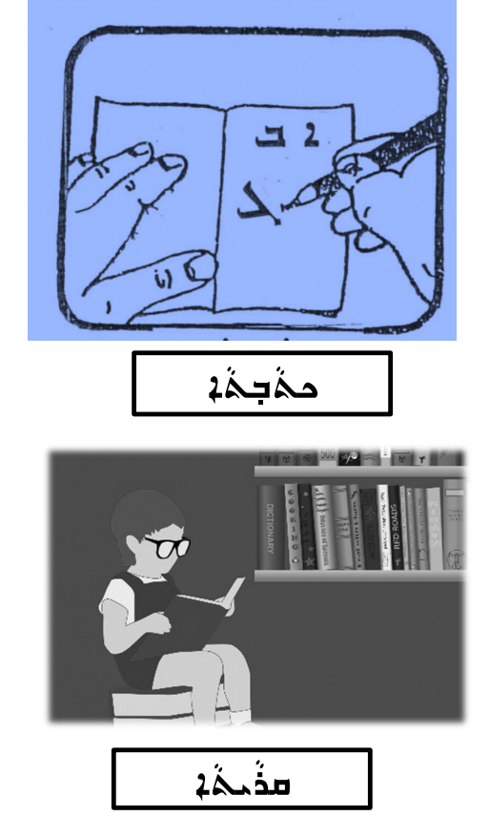

Resource G- School Activities Flashcards
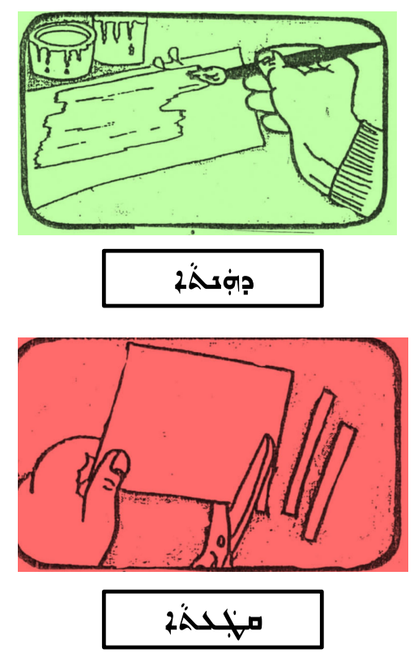

Resource G- School Activities Flashcards
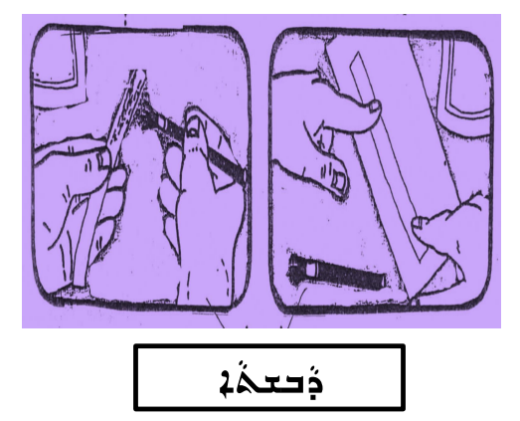

Resource I- School Activities Worksheet
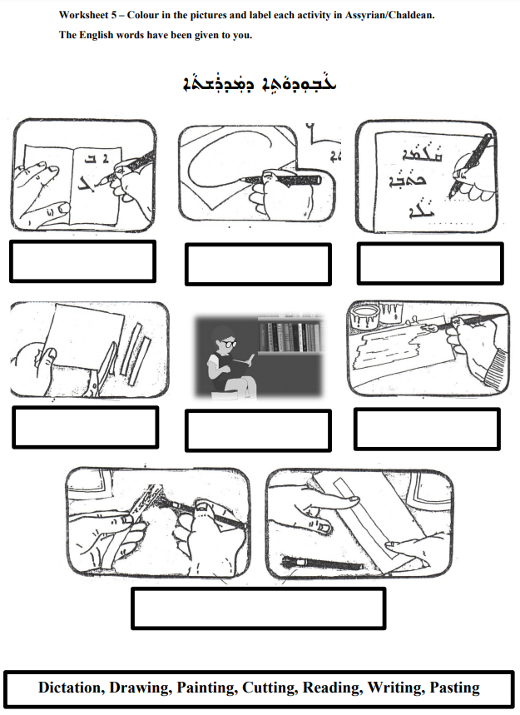
Resource J- School Attire Poster
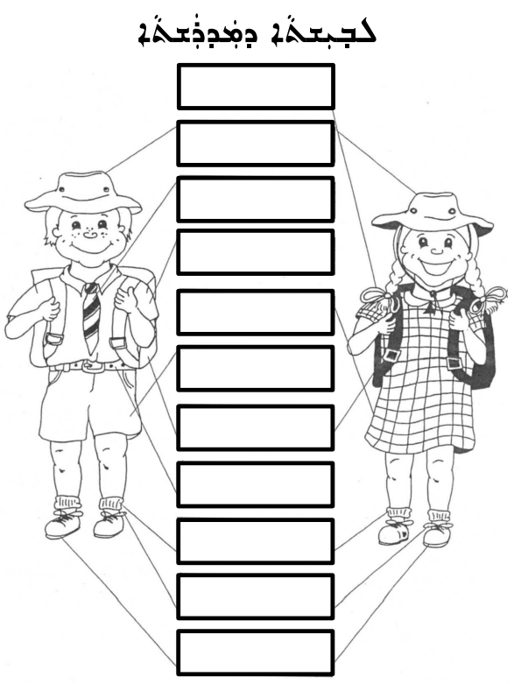

Resource J- School Attire Poster
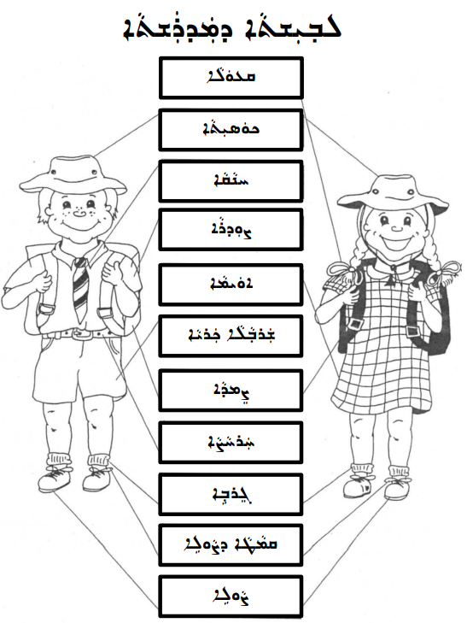

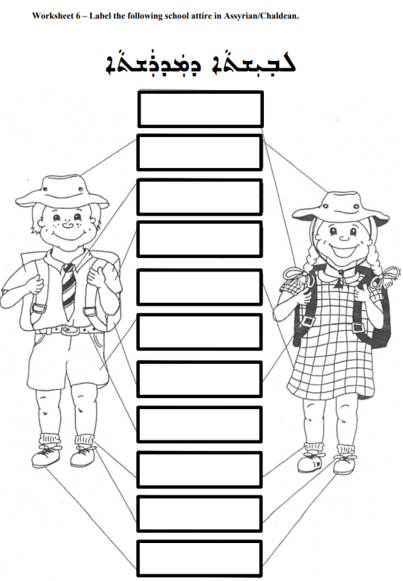
Resource K- School Attire/Uniform Worksheet
Resource L- My School Assessment Worksheet
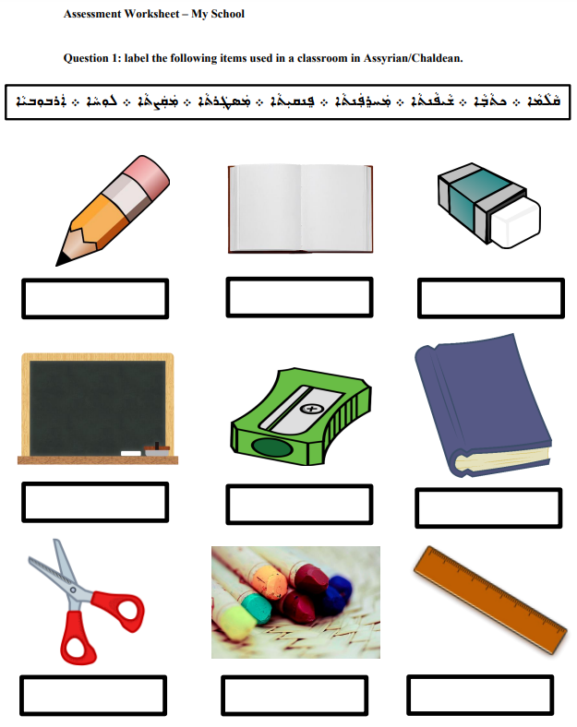

Resource L- My School Assessment Worksheet
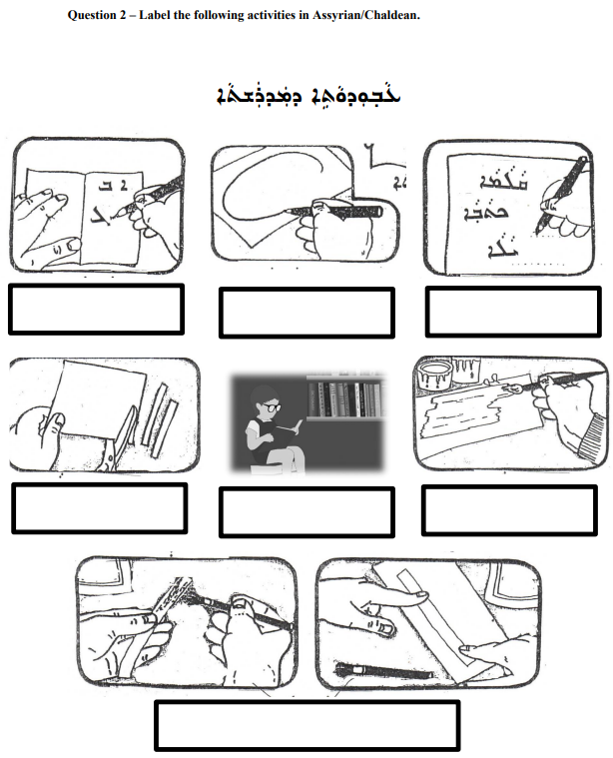

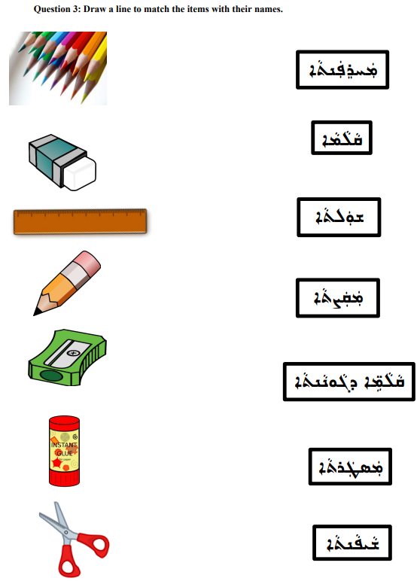
Resource L- My School Assessment Worksheet

