Science – Australian Animals

Stage: 3 | Unit Duration: 9 lessons | Weeks: 1 2 3 4 5 6 7 8 9 10 | Terms: 1 2 3 4
Unit Description and Overview | All students will develop the knowledge about various Australian native animals. Students will also learn and use vocabulary from the Assyrian and Chaldean Language throughout the unit, which they can use in other lessons.  Teaching and learning activities are designed to help students construct understanding for deeper learning. A variety of tasks will be included, both in theory and practice to ensure students get a mix of activities that cater to their needs.
Lesson Overview | 1. What are some examples of Australian Native Animals?  2. What are some examples of Australian Native Animals? (continued)  3. What are some external features of Australian Native Animals?  4. What are some adjectives used to describe Australian Native Animals?  5. What are some habitats that Australian Native Animals live in?  6. What is the diet of Australian Native Animals?  7. What are some facts about Australian Native Animals?  8. What are some facts about Australian Native Animals? (continued)  9. Australian Native Animals Post Assessment.  (Teacher can use the end of the unit as opportunity for assessment)
Organisation | Lessons are designed to ensure teachers lead learning and content and students have opportunities to listen and respond. This will ensure all students are active participants of their learning.  All lessons will include:  Learning Intentions, Success Criteria, Vocabulary and Language, Warm Up Activities, Modelled Teaching, Independent tasks, group tasks, partner tasks, Think/Pair/Share, technology use, warm up activities, reflection etc.
Essential Questions | - What are some examples of Australian Native Animals?  - What do these animals eat?  - How do these animals live?  - Where do these animals live?  - What makes these animals unique?
Assessment | Teachers have assessment opportunities before and after the unit to track progress. Students will recap all of their knowledge learned over the unit by completing an assessment at the end of the unit.
Technology and Useful Websites | Teachers may use resources such as iPads and laptops to support students with their learning. Students should be exposed to a variety of songs, rhymes, books etc. to support their learning.  Some websites that may be helpful for teachers to visit before and during the unit for support include:  https://youtu.be/5-z5WJ33uUw (Animals in Assyrian Language)  https://youtu.be/EVPelwsXXcM (Assyrian Animals Series)  https://youtu.be/TkCq54_ho-A (Australian Animals for Kids)  https://youtu.be/ZEfYWsagYWg (Australian Native Animals Song and Dance for Kids)  https://www.kids-world-travel-guide.com/animals-in-australia.html (Animals in Australia Information)  http://kiddopedia.net/australian-animals-kids/ (Australian Animals Facts)  https://youtu.be/i2SwMg0WM4s (Animal Sounds video)

Science – Australian Animals

Year: Five Lesson Sequence: 1 of 9

Subject: Science Topic: Australian Animals

Learning Intention: We are learning about Australian animals in Chaldean/Assyrian Language.
Success Criteria: I will be successful if I can identify the Australian animals in Assyrian/Chaldean
Key words: Australian Animals, Koala, Kangaroo, Kookaburra, Possum, Pelican, Dingo
Resources: Animals Flash cards (Resource A), Animals PowerPoint Slides (Resource B), Australian Animals Worksheet (Resource C)

Starter:
- Class discussion
- Introduce the term ‘Australian Animals’ in Assyrian/Chaldean.
- Brainstorm various Australian animals in English.
- Introduce the Australian animals in Assyrian/Chaldean
- Consolidate Australian animals’ vocabulary using flashcards and/or PowerPoint.
- Describe each animal in Assyrian/Chaldean.

- Game: Match pictures of Australian animals
- Teacher calls out the animals they have learned in Assyrian/Chaldean and one student at a time matches it to a picture.
- Teacher to shows the animals on a PowerPoint slide and students to call out the animal’s name in Assyrian/Chaldean.
Activity:
- Student will complete a worksheet on Australian animals.

Wrap-up:
- Game: Teacher sticks the animal flashcards around the class and calls out an animal name and students run to the correct animal. Last student remaining, wins a prize.

Science – Australian Animals
Science – Australian Animals

Year: Five Lesson Sequence: 2 of 9

Subject: Science Topic: Australian Animals Continued

Learning Intention: We are learning about Australian animals in Assyrian/Chaldean Language.
Success Criteria: I will be successful if I can identify the Australian animals in Assyrian/Chaldean
Key words: Emu, Snake, Echidna, Wombat, Parrot, magpie, Lizard, Platypus
Resources: Animals Flash cards (Resource A), PowerPoint, Australian Animals Part 2 worksheet (Resource D)

Starter:
- Class discussion
- Revise the animals from previous lesson.
- Introduce more Australian animals in Assyrian/Chaldean
- Consolidate Australian animals’ vocabulary using flashcards and/or PowerPoint.
- Describe each animal in Assyrian/Chaldean.

- Game: Match pictures of Australian animals
- Teacher calls out the animals they learnt in Assyrian/Chaldean and one student at a time matches it to a picture
- Teacher to shows the animals on a PowerPoint slide and students to call out the animal’s name in Assyrian/Chaldean
Activity:
- Student will complete a worksheet on Australian animals.

Wrap-up:
- Game: Teacher sticks the animal flashcards around the class and calls out an animal name and students run to the correct animal. Last student remaining, wins a prize.

Science – Australian Animals

Science – Australian Animals
Year: Five Lesson Sequence: 3 of 9

Subject: Science Topic: Australian Animals

Learning Intention: We are learning Australian animals in Chaldean/Assyrian Language.
Success Criteria: I will be successful if I can identify the Australian animals’ body coverings in Assyrian/Chaldean.
Key words: animal body covering – hair/fur, feathers, skin, and scales
Resources: Animals Flash cards (Resource A), Animals PowerPoint, Animal Coverings Worksheet (Resource E)

Starter:
- Class discussion
- Revise the names of the animals learnt in previous lessons
- Talk about types of animal coverings in English by relating the vocabulary of animals’ students have learnt.
- Introduce the Assyrian/Chaldean vocabulary of the different animal coverings and external features of the animals, including body parts, texture, fur, feathers, hair etc.
- Talk about each animal and what body covering it has in Assyrian/Chaldean.

Activity:
- Student will complete a worksheet on Australian animal coverings/external features.

Wrap-up:
- Ask each student to pick their favourite animal and provide a brief description of the animal in Assyrian/Chaldean and state why it is their favourite.

Science – Australian Animals

Science – Australian Animals
Year: Five Lesson Sequence: 4 of 9

Subject: Science Topic: Australian Animals

Learning Intention: We are learning Australian animals in Chaldean/Assyrian Language.
Success Criteria: I will be successful if I can identify the Australian animals and provide short descriptions in Assyrian/Chaldean.
Key words: Australian Animals, Koala, Kangaroo, Kookaburra, Possum, Pelican, Dingo, Lizard, Platypus, Emu, Snake, Echidna, Wombat, Parrot, magpie
Resources: Animals Flash cards (Resource A), Picture book - Brown Bear, Brown Bear, what do you see? Animal Sequence Activity (Resource F)

Starter:
- Class discussion
- Revise the vocabulary from previous lesson.
- Ask each student to identify an Australian animal and provide a short description in Assyrian/Chaldean.

- Picture book: Brown Bear, Brown Bear, What do you see?
- Teacher to read a picture book to the class.
- Talk about substituting Australian Animals for those in the story
based on the structure of the picture book created in a PowerPoint.
Activity:
- Animal Sequence Activity: Cut and sequence appropriately to create a short booklet of Australian animals.
- Students in pairs take turns in reading their booklet to each other.
Wrap-up:
- Game: teacher to spread the animal flashcard around the classroom. Teacher to describe an animal in Assyrian/Chaldean and student to run to the animal. Last student remaining wins a prize.

Science – Australian Animals
Year: Five Lesson Sequence: 5 of 9

Subject: Science Topic: Australian Animals

Learning Intention: We are learning Australian animals in Chaldean/Assyrian Language.
Success Criteria: I will be successful if I can identify the Australian animals and their habitats in Assyrian/Chaldean
Key words: ground, water, tree, grass, log, rock
Resources: Animals Flash cards (Resource A), Habitat flashcards (Resource G), Animal Habitats Worksheet (Resource H), A3 Coloured paper

Starter:
- Class discussion
- Revise the name of the Australian Animals
- Talk about where each animal lives most of the time using visual flashcards/PowerPoint of the habitats the animal may live in.
- Game: Match pictures of Australian animals with their habitats
- Teacher divides the class into small groups.
- Teacher calls out the name of the animal and students to place the animal in their habitat.
Activity:
- Animal Habitats Task: Student will complete a worksheet on Australian animals and their habitats.
- Students to use the internet/magazines to create a poster. Students to collect images of Australian animals and their habitats and create a poster.
Wrap-up:
- Students to present their posters to the class of their findings.

Science – Australian Animals

Year: Five Lesson Sequence: 6 of 9

Subject: Science Topic: Australian Animals

Learning Intention: We are learning Australian animals in Chaldean/Assyrian Language.
Success Criteria: I will be successful if I can identify the Australian animals in Assyrian/Chaldean and discuss what they eat (diet).
Key words: leaves, grass, rabbit, ants, and fish
Resources: Animals Flash cards (Resource A), habitat flashcards (Resource G), Animal Diet Worksheet (Resource I)

Starter:
- Class discussion
- Revise the names of Australian animals
- Discuss what they might eat, relating their food to their habitat and using visuals to assist them (For example, a picture of a koala in a tree).
- Construct sentences as a class by naming an animal followed by what they eat and discuss the different diets of animals.
- What are some similarities or differences students notice about what an animal eats and where they live?

Activity:
- Animal Diet Task: Student will complete a worksheet on Australian animals and what they eat.

Wrap-up:
Game: Match pictures of Australian animals with their habitats and what they eat.
- Teacher calls out the animals they learnt in Assyrian/Chaldean and one student at a time matches it to a picture

Science – Australian Animals

Year: Five Lesson Sequence: 7 of 9

Subject: Science Topic: Australian Animals

Learning Intention: We are learning Australian animals in Chaldean/Assyrian Language.
Success Criteria: I will be successful if I can identify the Australian animals in Assyrian/Chaldean and revise what has been learnt in lessons 1 to 6.

Key words: Australian Animals, animal coverings, habitats, food

Resources: Animals Flash cards (Resource A), Animal Coverings and Parts flashcards (Resource J), habitat flashcards (Resource G), Australian Animals Sentence Task (Resource K)

Starter:
- Class discussion
- Revise all the names of the Australian animals and describe their habitats, body covering, diet, lifestyle etc.

- Game: what animal am I?
- A student describes a feature or features of an animal in Assyrian/Chaldean and the others must guess the identity.

Activity:
- Australian Animals Sentence Task: Student to complete the provided worksheet as a revision for the topics learned throughout the unit.

Wrap-up:
- Students to complete a fun activity such as a find-a-word, colour-in worksheets of Australian animals.

Science – Australian Animals

Year: Five Lesson Sequence: 8 of 9

Subject: Science Topic: Australian Animals

Learning Intention: We are learning Australian animals in Chaldean/Assyrian Language.
Success Criteria: I will be successful if I can identify the Australian animals in Assyrian/Chaldean
Key words: Australian Animals, Koala, Kangaroo, Kookaburra, Possum, Pelican, Dingo, Lizard, Platypus, Emu, Snake, Echidna, Wombat, Parrot, magpie
Resources: PowerPoint, Unit Flash Cards (Resources attached to use)

Starter:
- Class discussion
- Revise all the things learnt throughout the unit.
- Brainstorm some key words learned as a whole class.
- Use flashcards to identify some key words and translate them to Assyrian/Chaldean.
- Share any interesting facts students may have learned because of the content taught.

Activity:
- Students to form groups of 2 or 3 and create a PowerPoint of all the Australian animals including description of the animal covering, their habitat and what they eat.
- Guide the students how to create their PowerPoint however, let them be creative and independent.
Wrap-up:
- Students in their groups to present PowerPoints to the class.

Science – Australian Animals

Year: Five Lesson Sequence: 9 of 9

Subject: Science Topic: Australian Animals

Learning Intention: We are learning Australian animals in Chaldean/Assyrian Language.
Success Criteria: I will be successful if I can identify the Australian animals in Assyrian/Chaldean and have achieved everything taught in lessons 1 to 8.
Key words: Australian Animals, Body coverings, habitats and what they eat.
Resources: Australian Animals Assessment worksheet (Resource L)

Starter:

- Class discussion
- A short revision and run through of Australian animals, habitats, body coverings and what they eat.

Activity:
- Students to complete an assessment worksheet on the unit.

Wrap-up:
- Game: play a game of teachers/student choice that has been played during the unit.

Resource A- Animals Flash Cards

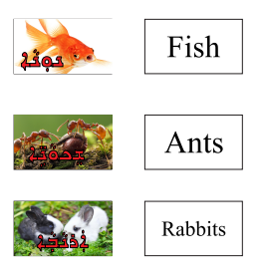

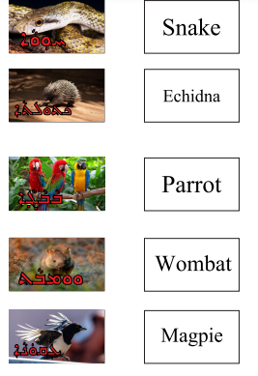
Resource A- Animals Flash Cards

Resource A- Animals Flash Cards
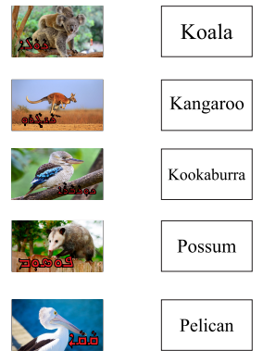
Resource A- Animals Flash Cards
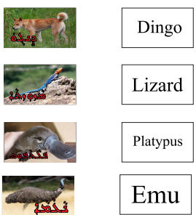

Resource B- Animals PowerPoint Slides

Resource B- Animals PowerPoint Slides

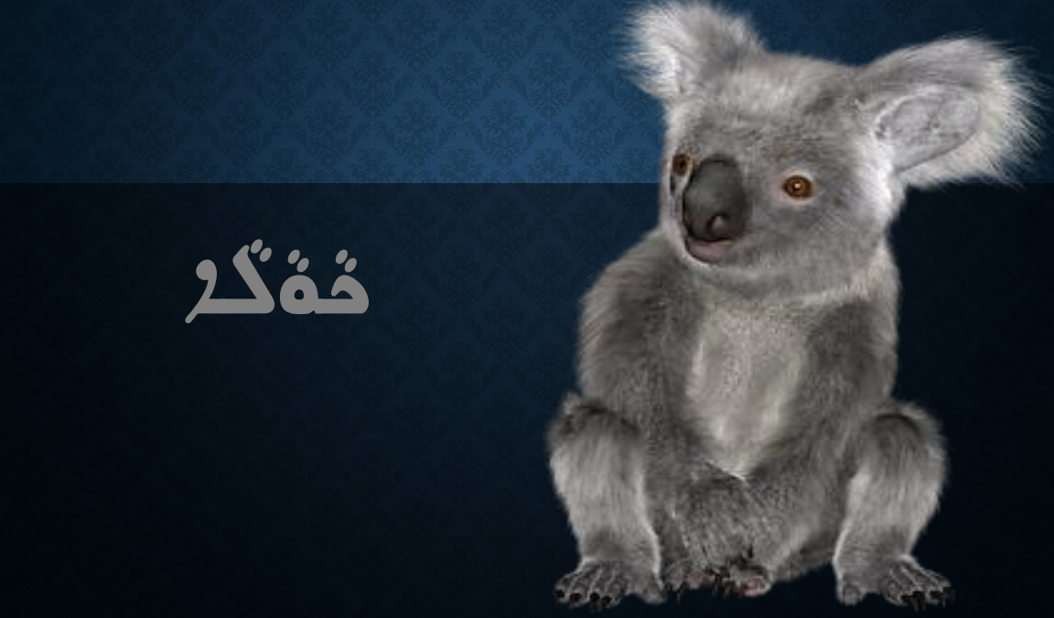
Resource B- Animals PowerPoint Slides

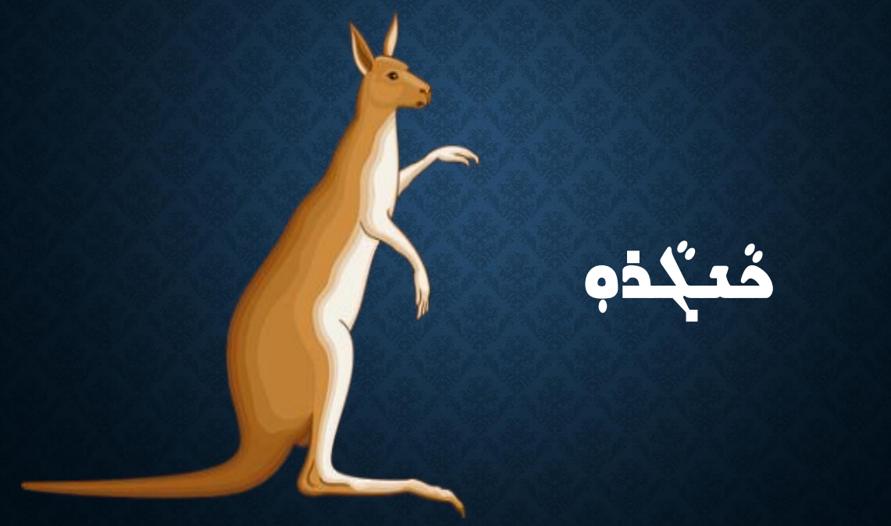
Resource B- Animals PowerPoint Slides

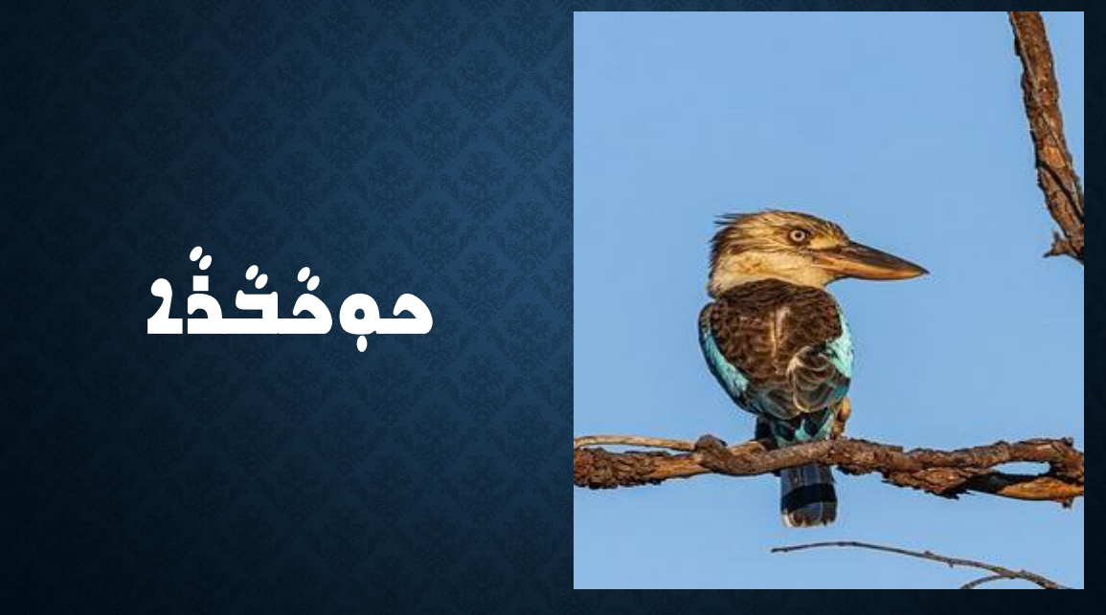
Resource B- Animals PowerPoint Slides

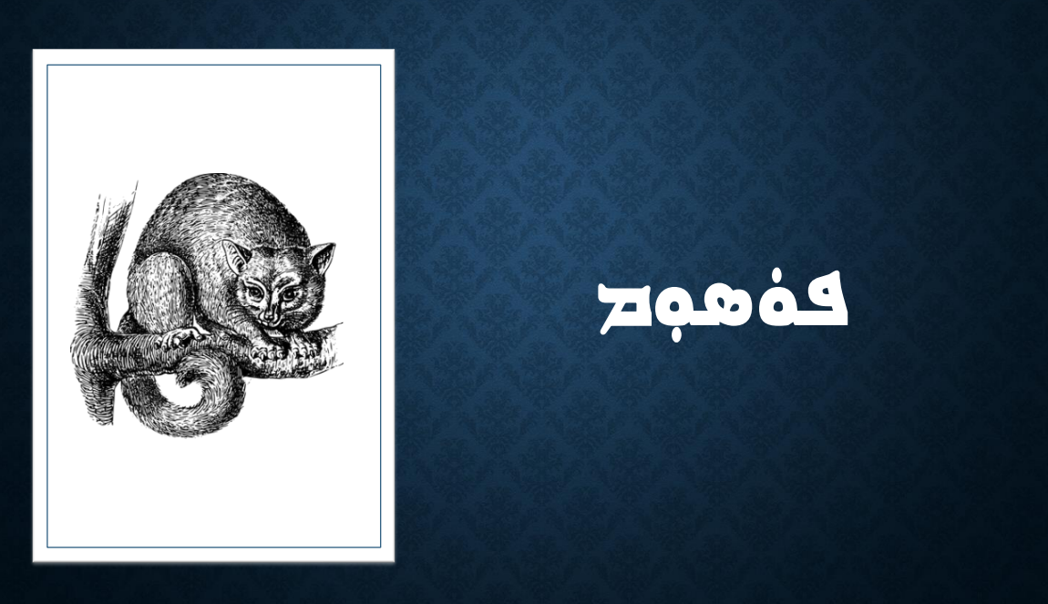
Resource B- Animals PowerPoint Slides

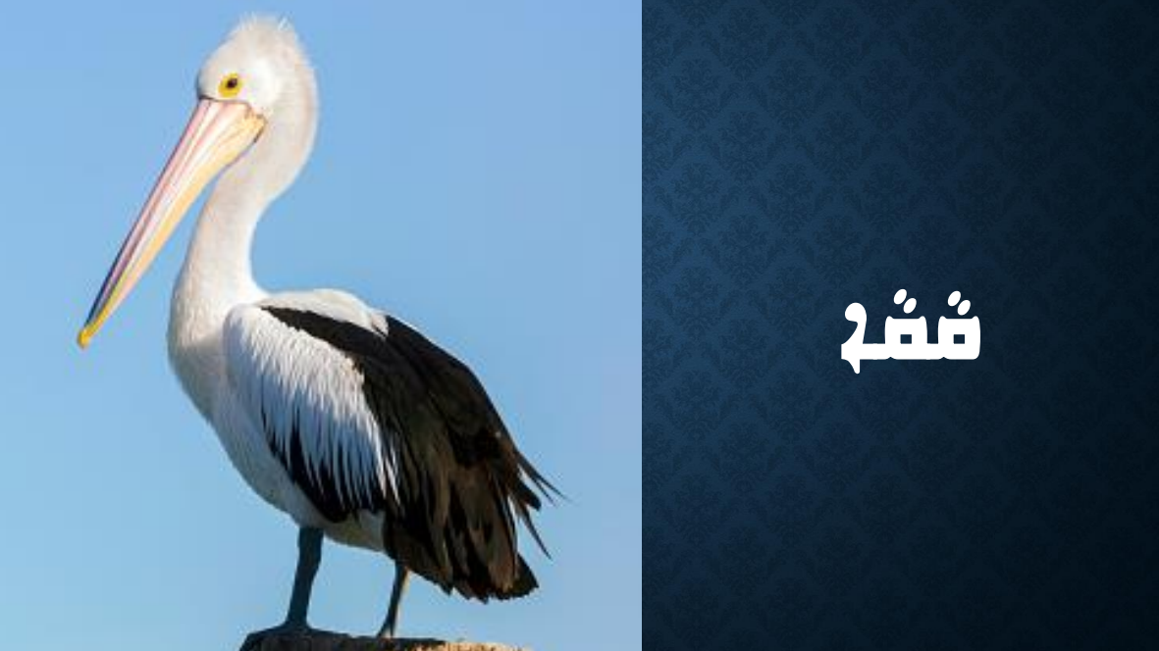
Resource B- Animals PowerPoint Slides

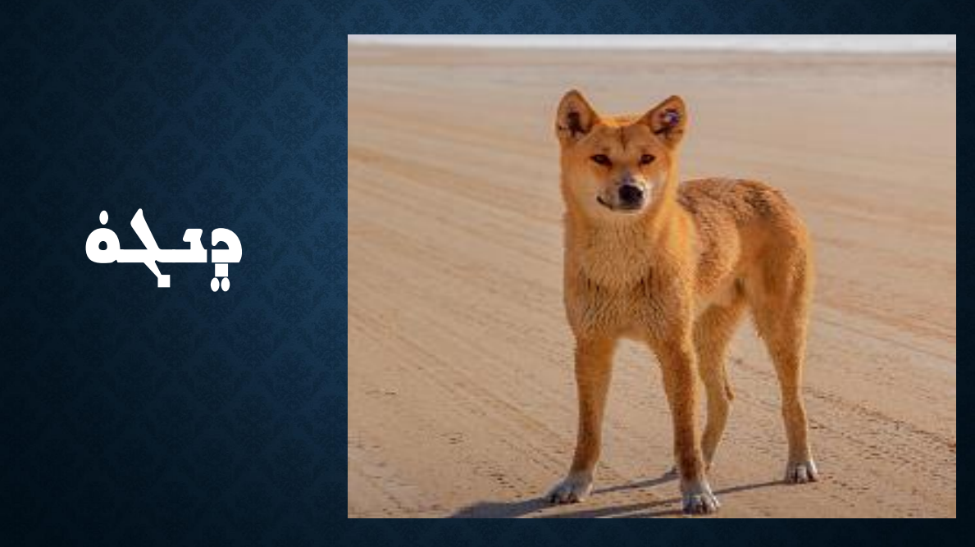
Resource B- Animals PowerPoint Slides

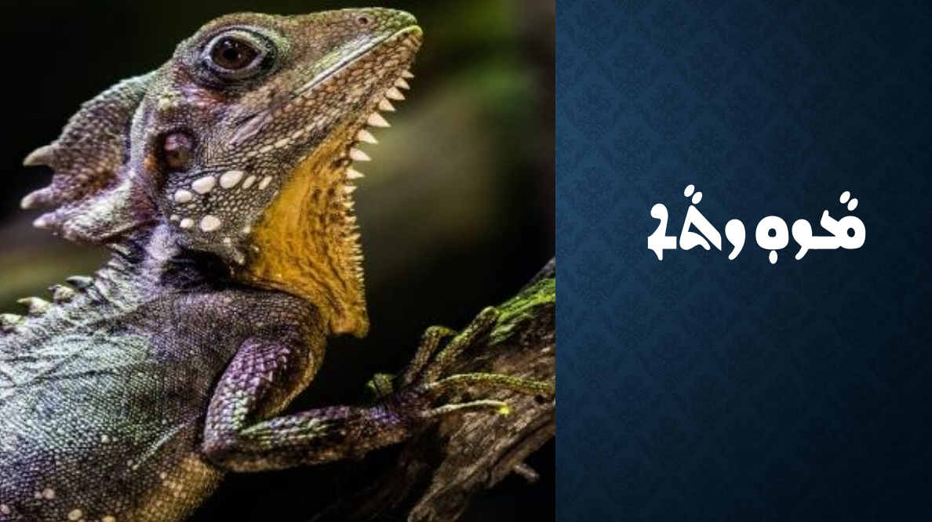
Resource B- Animals PowerPoint Slides

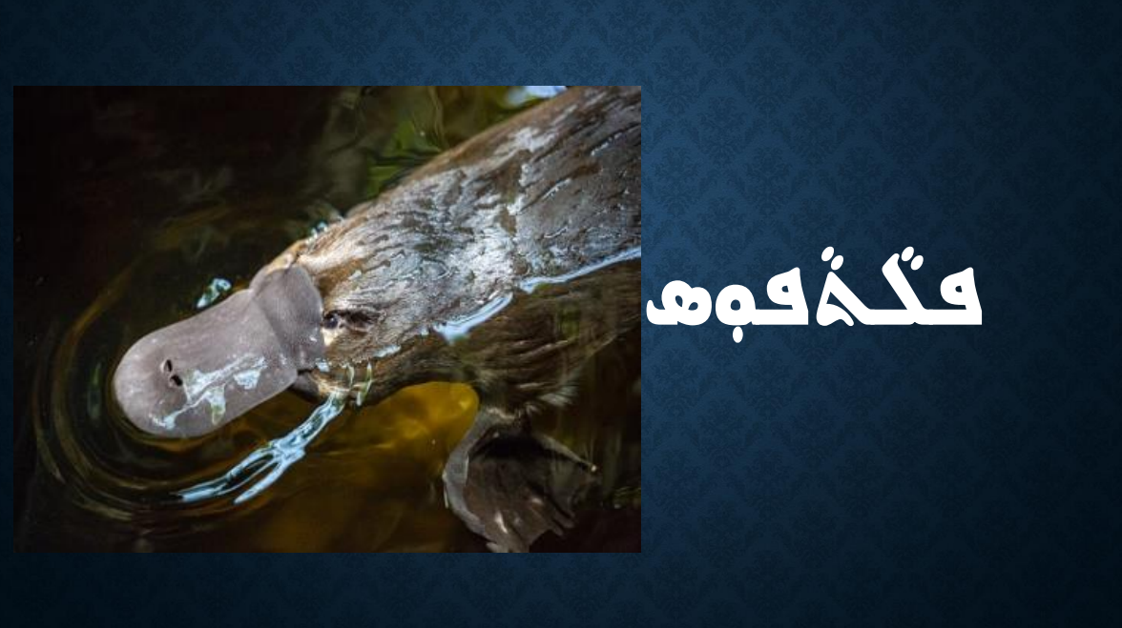
Resource B- Animals PowerPoint Slides

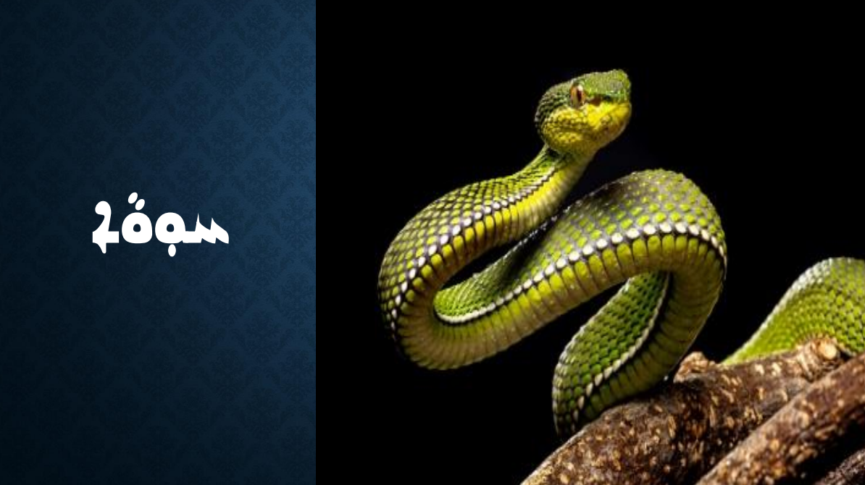
Resource B- Animals PowerPoint Slides

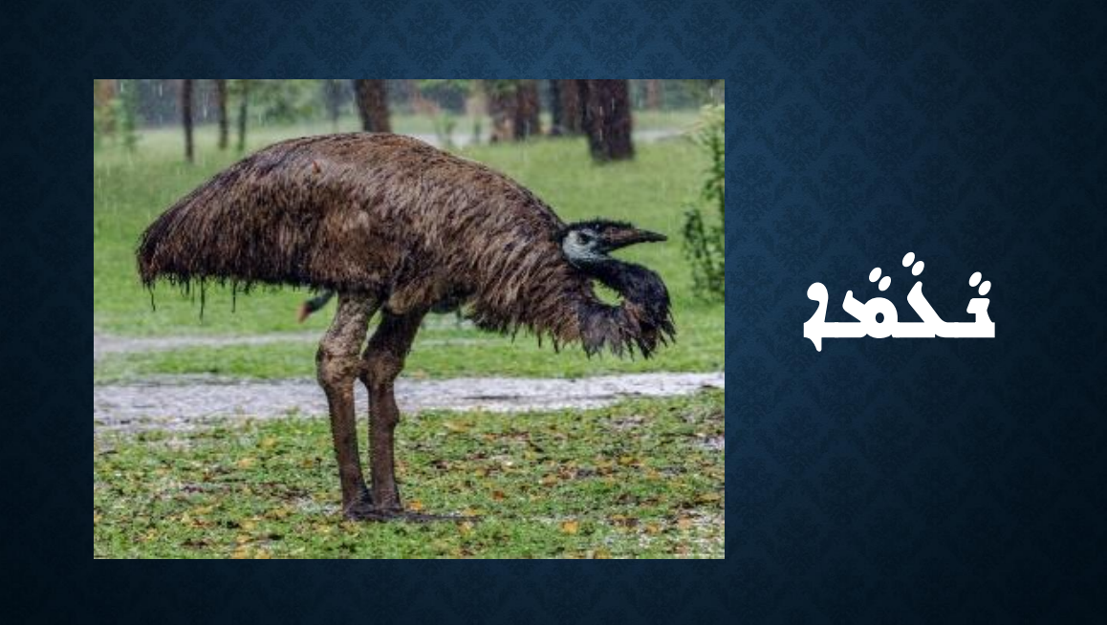
Resource B- Animals PowerPoint Slides

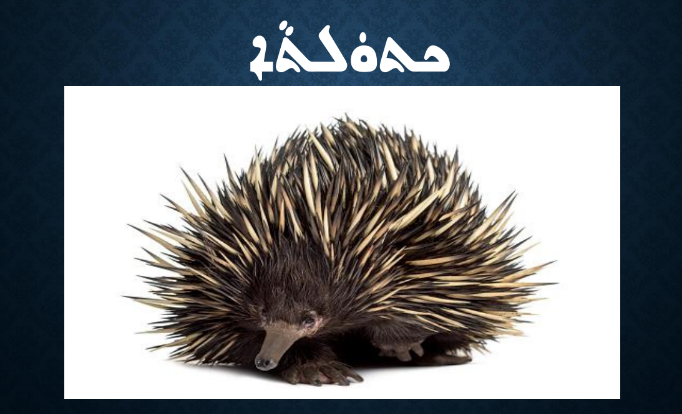
Resource B- Animals PowerPoint Slides

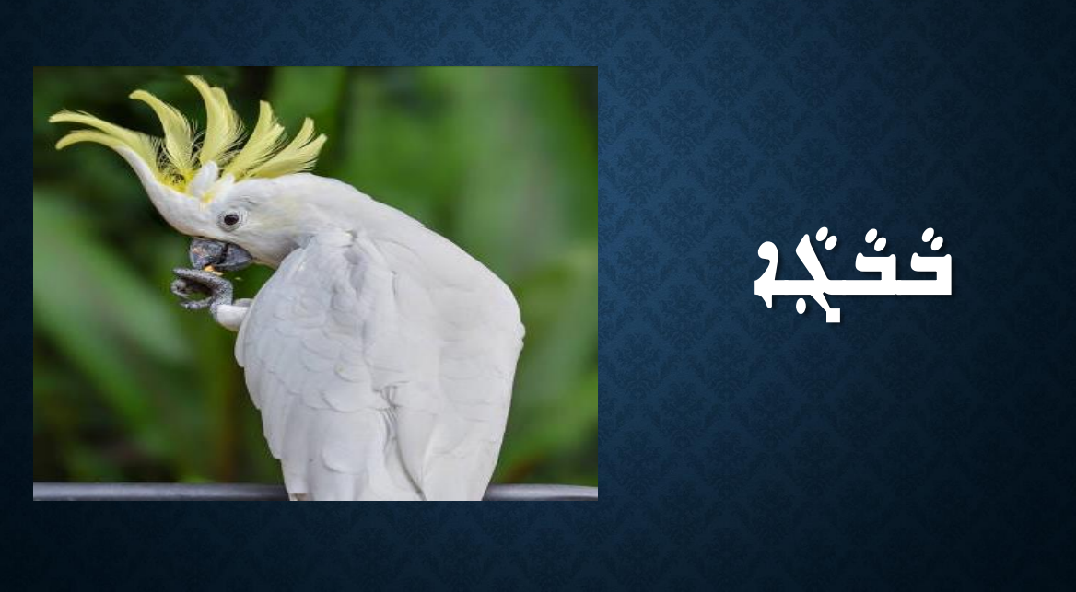
Resource B- Animals PowerPoint Slides

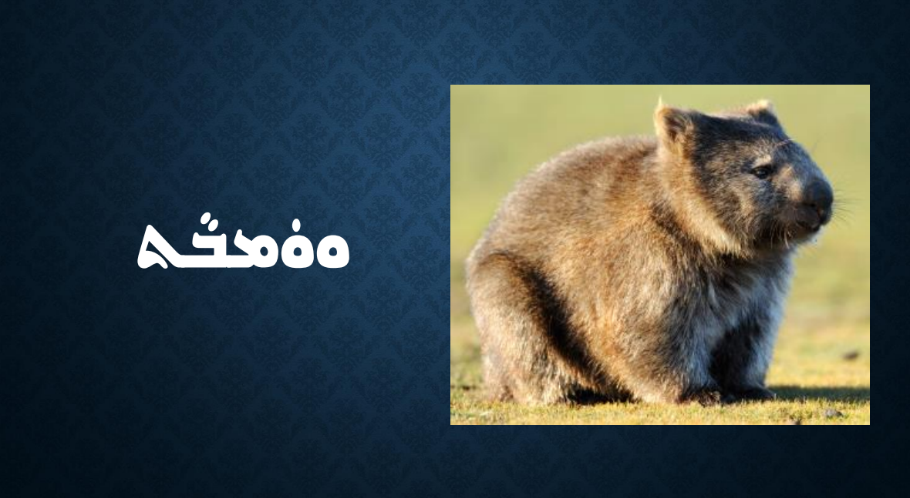
Resource B- Animals PowerPoint Slides

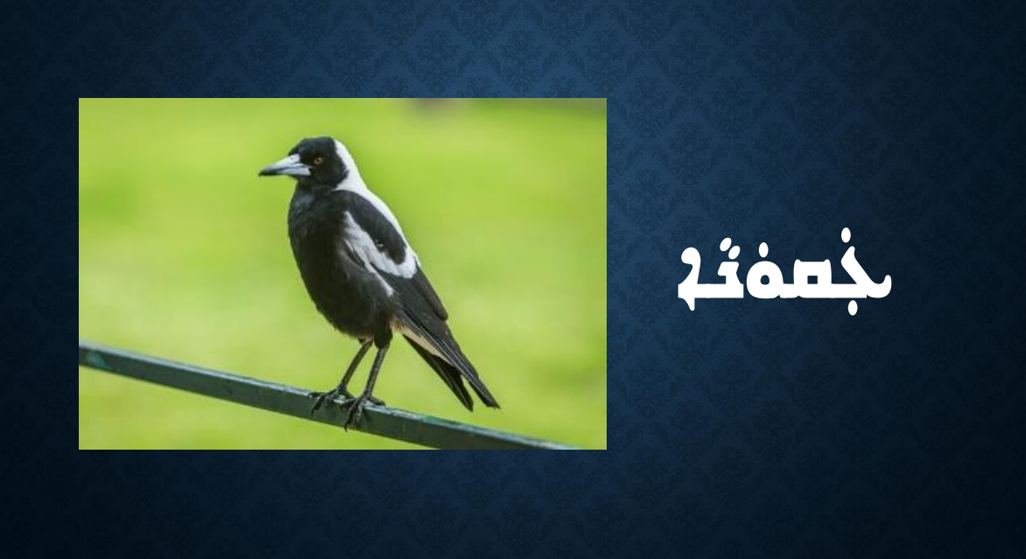
Resource C- Australian Animals Worksheet
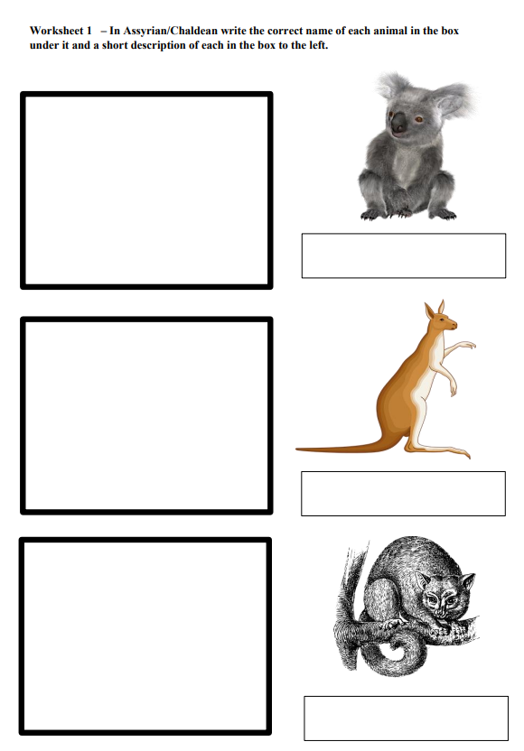
Resource C- Australian Animals Worksheet
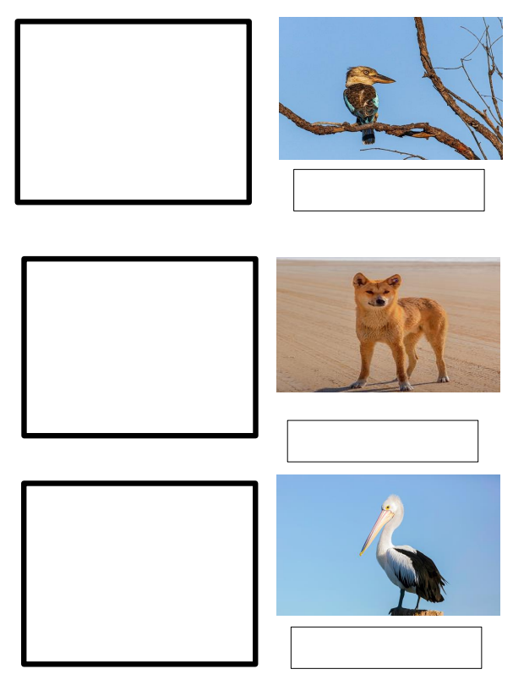

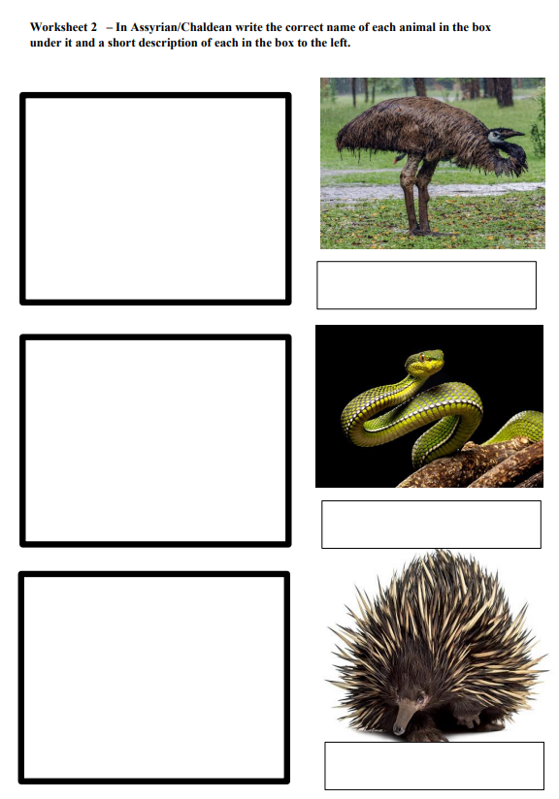
Resource D- Australian Animals Part 2 Worksheet
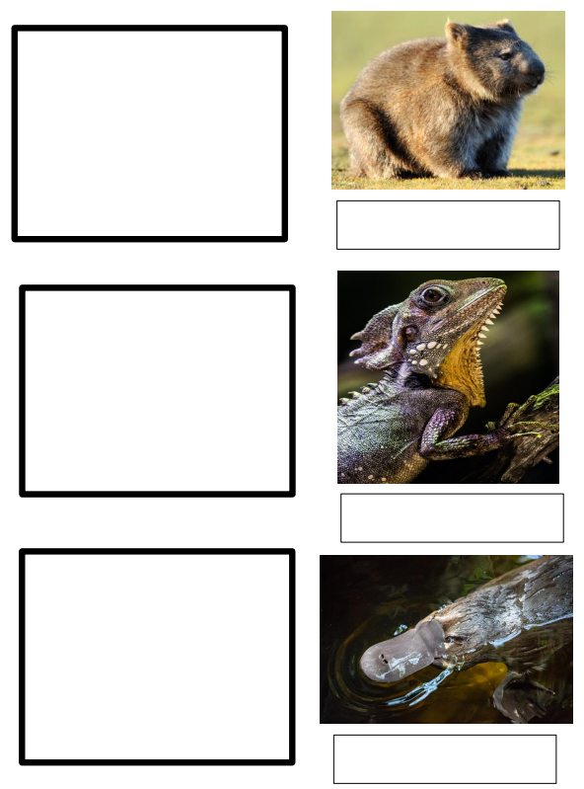
Resource D- Australian Animals Part 2 Worksheet

Resource D- Australian Animals Part 2 Worksheet
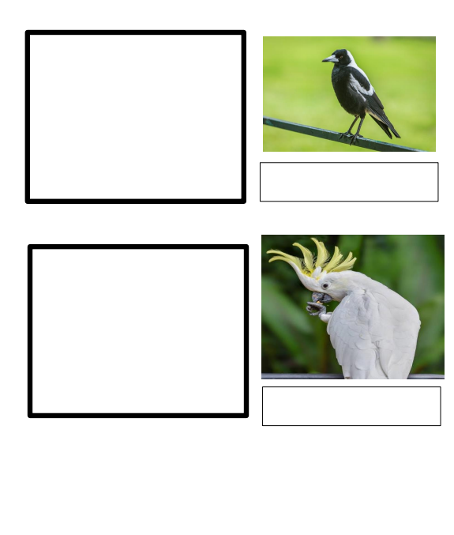
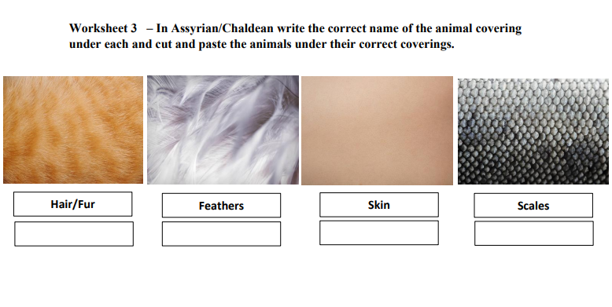
Resource E- Animal Coverings Worksheet

Resource E- Animal Coverings Worksheet

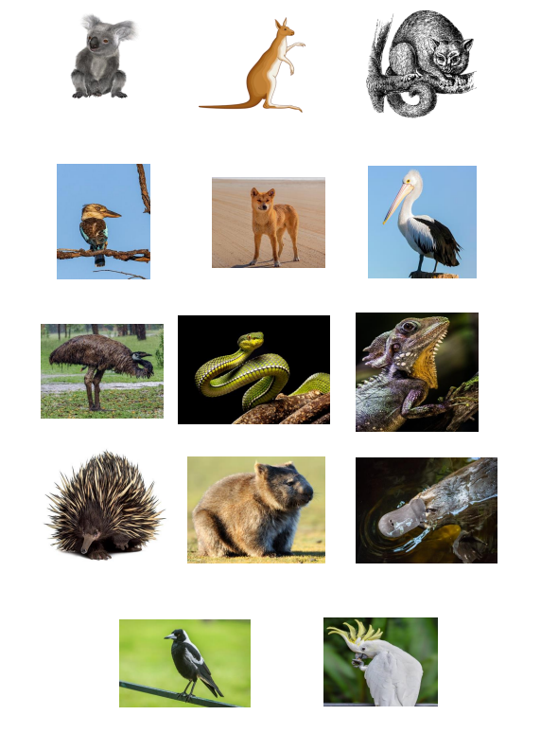
Resource F- Animal Sequence Activity
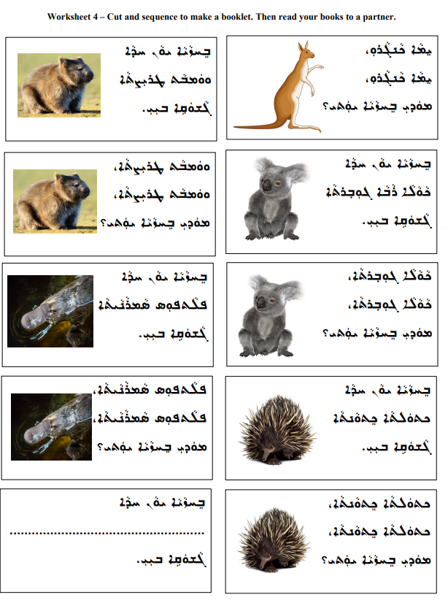
Resource G- Habitat Flashcards

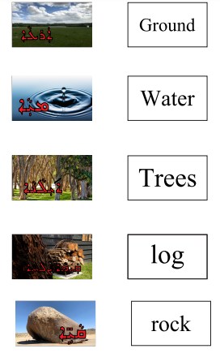
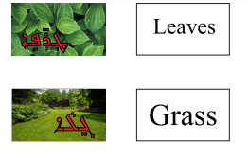
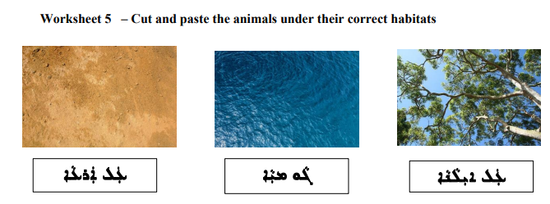
Resource H- Animal Habitats Worksheet

Resource H- Animal Habitats Worksheet
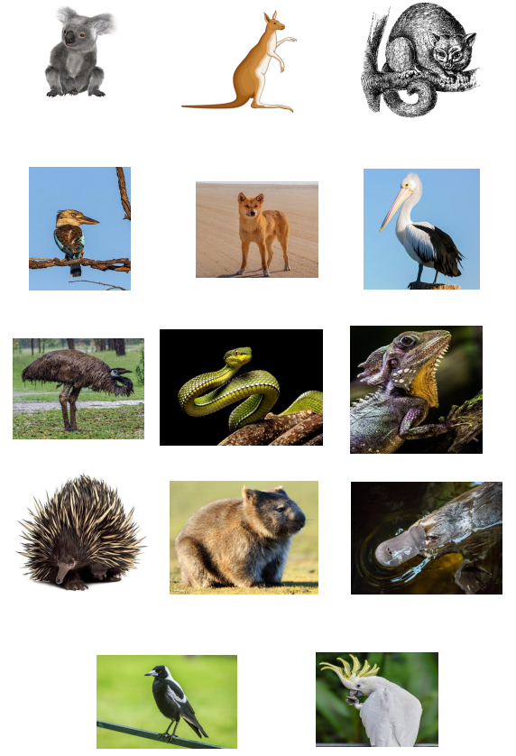
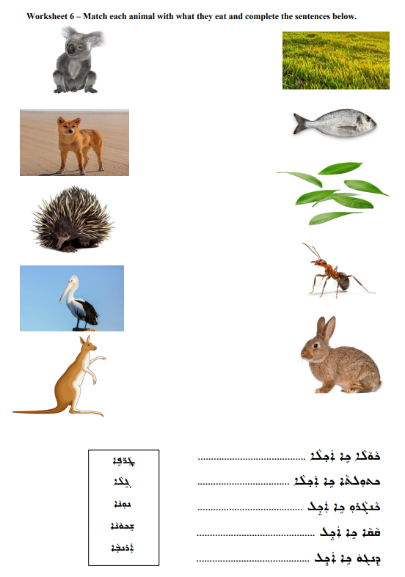
Resource I- Animal Diet Worksheet
Resource J- Animal Coverings and Parts Flashcards

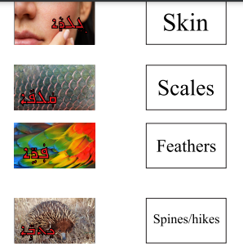

Resource J- Animal Coverings and Parts Flashcards

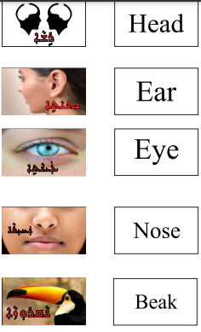

Resource J- Animal Coverings and Parts Flashcards

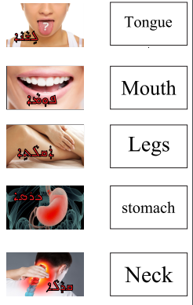

Resource J- Animal Coverings and Parts Flashcards

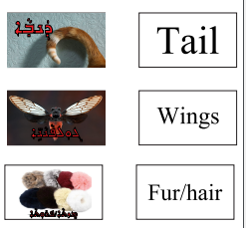

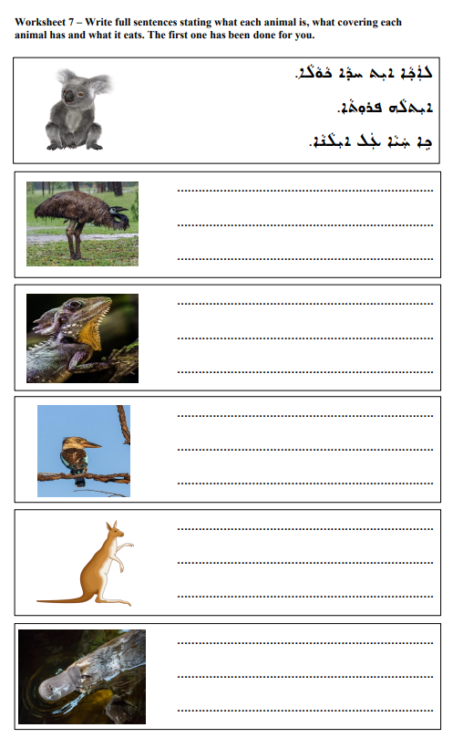
Resource K- Australian Animals Sentence Task
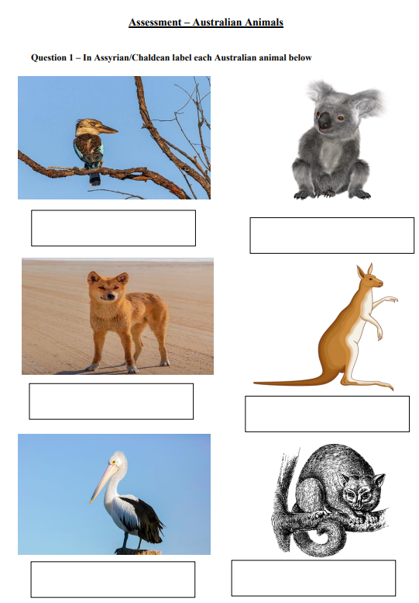
Resource L- Australian Animals Assessment
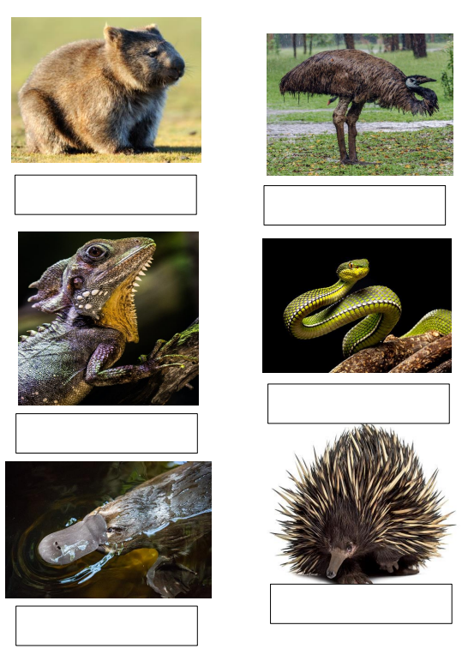
Resource L- Australian Animals Assessment
Resource L- Australian Animals Assessment
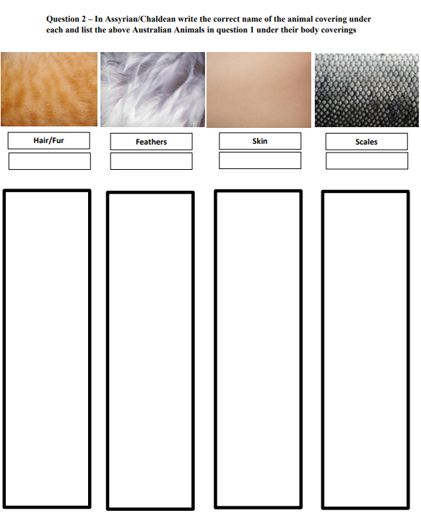

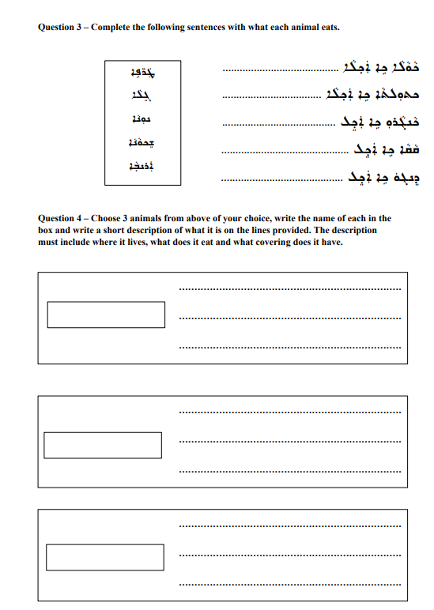
Resource L- Australian Animals Assessment

