PDHPE – Healthy Food

Stage: 3 | Unit Duration: 7 lessons | Weeks: 1 2 3 4 5 6 7 8 | Terms: 1 2 3 4
Unit Description and Overview | All students will develop the knowledge about healthy food including different types of food groups (food pyramid).  Students will also explore the importance of having a balanced diet and the relationship between the food and culture.  Students will also learn and use vocabulary from the Assyrian and Chaldean Language throughout the unit, which they can use in other lessons.  Teaching and learning activities are designed to help students construct understanding for deeper learning. A variety of tasks will be included, both in theory and practice to ensure students get a mix of activities that cater to their needs.
Lesson Overview | 1. What is healthy food?  2. Identify and name different types of fruit  3. Identify and name different types of vegetables  4. Identify and name different types of dairy products  5. Identify and name different types of oils and sweets  6. Identify and name different types of grains  7. Identify and name different types of meat, fish and poultry  8. Assessments
Organisation | All lessons are designed to ensure teachers lead learning and content and students have opportunities to listen and respond. This will ensure all students are active participants of their learning.  All lessons will include:  - Learning Intentions, Success Criteria, Vocabulary and Language, Warm Up and Wrap Up Activities.  - Modelled Teaching, Independent tasks, group tasks, partner tasks, Think/Pair/Share, technology use and reflection etc.
Essential Questions | - What is a healthy food?  - Can you identify and name different types of fruit?  - Can you identify and name different types of vegetables?  - Can you identify and name different types of dairy products?  - Can you identify and name different types of oils and sweets?  - Can you identify and name different types of grains?  - Can you identify and name different types of fish, meat and poultry?
Assessment | Teachers have assessment opportunities before and after the unit to track progress. Students can verbally identify food groups to show their understanding before the unit commences and after. The assessment for learning is ongoing.
Technology and Useful Websites | Teachers may use resources such as iPads and laptops to support students with their learning. Students should be exposed to a variety of songs, rhymes, books etc. to support their learning.  Some websites that may be helpful for teachers to visit before and during the unit for support include:  https://www.youtube.com/watch?v=9wLiqyqbDVc (Assyrian song on fruit)
PDHPE – Healthy Food

Year: 5 Lesson Sequence: 1 of 7

Subject: Healthy Food Topic: Food Pyramid

Learning Intention: We are learning about different food groups in Assyrian/Chaldean language.

Success Criteria: I will identify different food groups in Assyrian/Chaldean language.

Key words: Fruit, Vegetable, Dairy, Grains, Meat, oils, sweets and poultry.

Resources: food flash cards / poster in Assyrian and Chaldean, Healthy Foods worksheets (Resource A), Australian Guide to Healthy Eating Poster (Resource B) Whiteboard, Magazines, Scissors and glue.

Starter:
- Class discussion:
- Ask students to name as many types of different food in Assyrian/Chaldean language.
- Which food is healthy and which one is unhealthy for you and why?
- Which food group we need to eat less?
- Which food group we need to eat more?
- What is the Australian Guide to Healthy Eating? Have you seen it before? What does it suggest for our diets?

- Song: Fruit song in Assyrian version https://www.youtube.com/watch?v=9wLiqyqbDVc
- Display a food pyramid poster on the board and ask students to identify or repeat the names of the food groups in Chaldean/Assyrian.
- Show and display Australian Guide to Healthy Eating Poster in class for reference and refer to it throughout the unit.

Activity:
- In group of 4-6, students will be given a printout of food pyramid and a magazine.
- As a team, students will be asked to place each piece of food in its correct spot on the pyramid.

Wrap-up:
- Design and label a healthy plate for dinner in Chaldean/Assyrian language.

PDHPE – Healthy Food

Year: 5 Lesson Sequence: 2 of 7

Subject: Healthy Food Topic: Fruit

Learning Intention: We are learning about Fruit in Assyrian/Chaldean language.

Success Criteria: I can identify this Fruit in Assyrian/Chaldean language.

Key words: apple, banana, orange, watermelon, rock melon, grapes, pear and lemon.

Resources: Fruits Flash Cards (Resource C), food magazines, glue, scissors etc.

Starter:
- Class discussion:
- Revise what a healthy food is in Chaldean/Assyrian language.
- Revise the names of food groups in Chaldean/Assyrian language.
- Introduce the question: what is fruit?
- Introduce the answer structure:
This is a ………. (fruit name).
- Brainstorm the colour and the shape of the fruit.
- What do we call this Fruit? point to the poster in Assyrian/Chaldean language.
- Talk to your partner about your favoured fruit.
- Which Fruit are the healthiest?
- Which Fruit has least Sugar?
- Which Fruit has most Sugar?
- Which Fruit has most Vitamins?

- Song: Fruit song in Assyrian version https://www.youtube.com/watch?v=9wLiqyqbDVc

Activities:
- Student make a Fruit Salad collage from magazines.

Wrap-up:
- Student play celebrity heads using flash cards.

PDHPE – Healthy Food
Year: 5 Lesson Sequence: 3 of 7

Subject: Healthy Food Topic: Vegetables

Learning Intention: We are learning about vegetables in Assyrian/Chaldean language.

Success Criteria: I can identify this vegetable in Assyrian/Chaldean language.

Key words: Carrot, Cabbage, cucumber, potato, Garlic, onion, lemon, spinach and tomato.

Resources: vegetables flash cards (Resource D), poster in Assyrian/Chaldean, iPads or laptops.

Starter:
- Class discussion:
- Revise the vocabulary from the previous lesson.
- Introduce the word ‘vegetables’ in Chaldean/Assyrian
- Brainstorm what do we call these vegetables in Assyrian /Chaldean language?
- What is your favourite vegetable?
- Which vegetable is the healthiest?
- Why do need vegetables in our daily diet?
- Students tell the class their favourite vegetables and why?

Activity:
- Students create a PowerPoint about 5 vegetables and their benefits.

Wrap-up:
- Students play ‘what am I’ game using flash cards.

PDHPE– Healthy Food
Year: 5 Lesson Sequence: 4 of 7

Subject: Healthy Food Topic: Dairy Products

Learning Intention: We are learning about dairy products in Assyrian/Chaldean language.

Success Criteria: I can identify these dairy products in Assyrian/Chaldean language.

Key words: milk, cheese, butter, yogurt and Ice cream.

Resources: dairy products flash cards, poster in Assyrian/Chaldean, food magazines, glue, scissors etc.

Starter:
- Class discussion:
- Revise the vocabulary from the previous lesson.
- Brainstorm what do they know about dairy products.
- Brainstorm what do we call these dairy products in Assyrian /Chaldean language?
- Brainstorm a list of products that are made from milk and name them in Assyrian/Chaldean language.
- Why is milk good for you?
- What is your favoured dairy product?
- Display a dairy products poster on the board and discuss.
- Call out the words and point to the pictures.
- Students repeat the words individually.

- Song: Fruit song in Assyrian version
https://www.youtube.com/watch?v=9wLiqyqbDVc

Activity:
- In a group of 2-3, student get a piece of paper, glue, and scissors.
- Let them cut out pictures of items that are made from milk to make a dairy product collage.

Wrap-up:
- Student choose their favoured dairy product and write the ingredients.

PDHPE– Healthy Food

Year: 5 Lesson Sequence: 5 of 7

Subject: Healthy Food Topic: Oil and Sweet

Learning Intention: We are learning about oil and sweet in Assyrian/Chaldean language.

Success Criteria: I can identify oil and sweet Assyrian/Chaldean language.

Key words: oil, cakes and biscuits.

Resources: oils and sweets flash cards, poster in Assyrian/Chaldean, food magazines, glue, scissors, iPads or laptops.

Starter:
- Class discussion:
- Revise the vocabulary from the previous lesson.
- Brainstorm what do they about oil and sweet.
- Introduce the word ‘oil and sweet’ in Chaldean/Assyrian language.
- Talk about why these come on the top of the Pyramid.
- Where do we gets oils from?
- What are some examples of fats and oils?
- What are some examples of sweets?
- Which type of fat is healthy?
- What is fatty food to avoid?
- Display a poster on the board and talk about fats and sweets.
- Call out the words and point to the pictures.
- Students repeat the words individually.

- Song: Fruit song in Assyrian version
https://www.youtube.com/watch?v=9wLiqyqbDVc

Activity:
- Students will be given a A4 paper, glue, magazine and scissors.
- Students will copy the words and glue a picture to match.

Wrap-up:
- Play Kahoot game.

PDHPE – Healthy Food
Year: 5 Lesson Sequence: 6 of 7

Subject: Healthy Food Topic: Grain

Learning Intention: We are learning about grains in Assyrian/Chaldean language.

Success Criteria: I can identify grains Assyrian/Chaldean language.

Key words: Bread, rice, cereal and pasta.

Resources: grains flash cards, poster in Assyrian/Chaldean, Healthy Foods worksheets (Resource A).

Starter:
- Class discussion:
- Revise the vocabulary from the previous lesson.
- Brainstorm the word ‘grains’.
- Introduce the word ‘grains’ in Chaldean/Assyrian language.
- Talk about grains in Assyrian /Chaldean language.
- Name some grains.
- Display a poster on the board and talk about grains.
- Call out the words and point to the pictures.
- Students repeat the words individually.

- Song: Fruit song in Assyrian version
https://www.youtube.com/watch?v=9wLiqyqbDVc

Activity:
- Students work on a worksheet:
- match the words to the pictures.
- unjumble the words.

Wrap-up:
- Put your student into groups to play ‘what am I’ game using flash cards.

PDHPE – Healthy Food
Year: 5 Lesson Sequence: 7 of 7

Subject: Healthy Food Topic: Meat, Fish & Poultry

Learning Intention: We are learning about fish meat and poultry in Assyrian/Chaldean language.

Success Criteria: I can identify fish meat and poultry Assyrian/Chaldean language.

Key words: beef, lamb, fish, chicken and eggs.

Resources: meats flash cards, poster in Assyrian/Chaldean, Healthy Foods worksheets (Resource A).

Starter:
- Class discussion:
- Revise the vocabulary from the previous lesson
- Where do we get meat from?
- What kind of meat do you like?
- Why do we need to eat meet?
- Is fish good for you?
- Display a poster on the board and talk about meat, fish and poultry.
- Call out the words and point to the pictures.
- Students repeat the words individually.

- Song: Fruit song in Assyrian version
https://www.youtube.com/watch?v=9wLiqyqbDVc

Activity:
- Find a word activity sheet.

Wrap-up:

- Play Kahoot game.

Resource A- Healthy Foods Worksheets

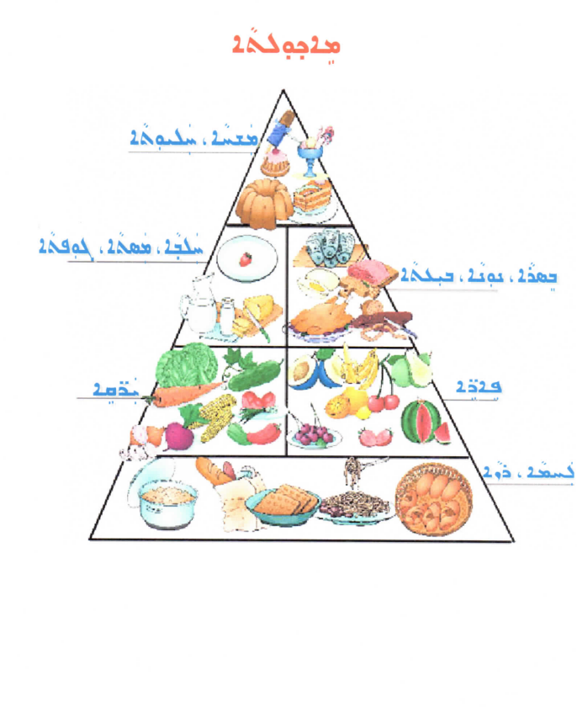
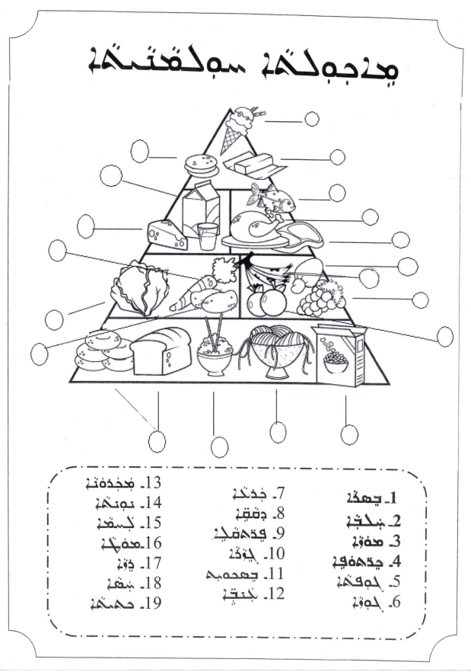
Resource A- Healthy Foods Worksheets
Resource A- Healthy Foods Worksheets
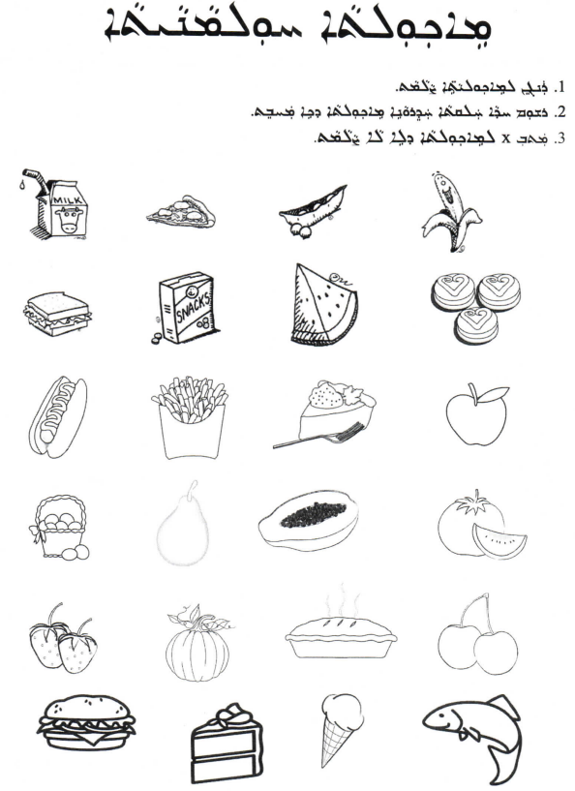
Resource A- Healthy Foods Worksheets
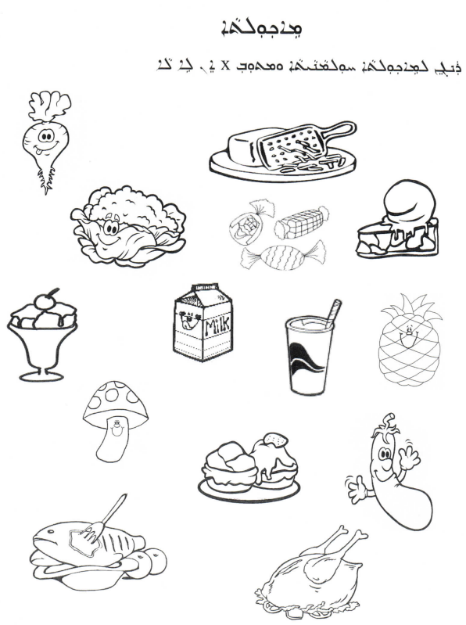

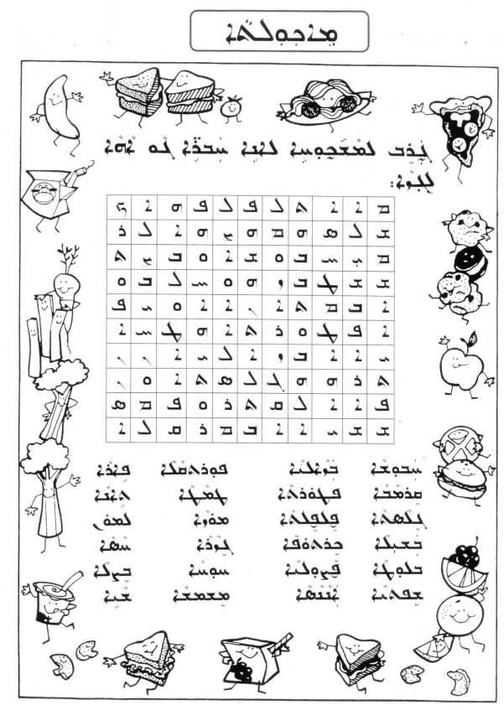
Resource A- Healthy Foods Worksheets
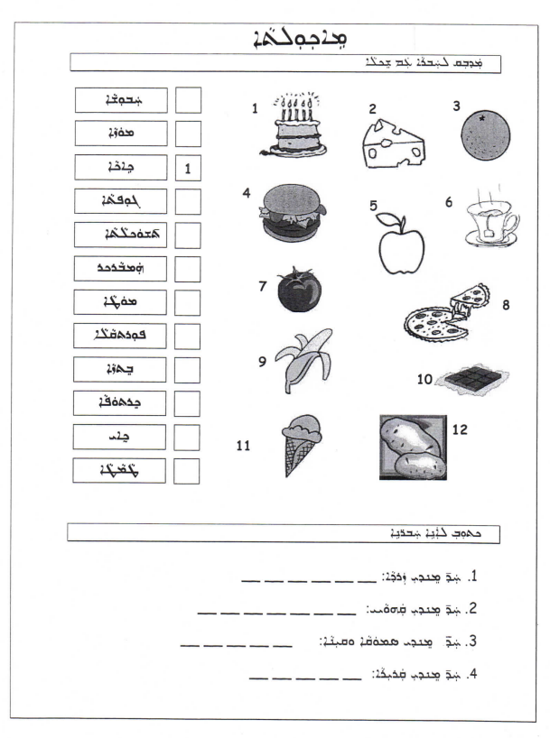
Resource A- Healthy Foods Worksheets
Resource A- Healthy Foods Worksheets
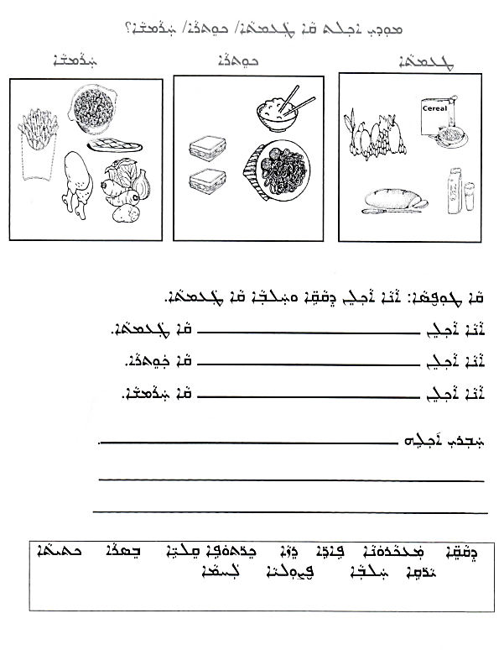
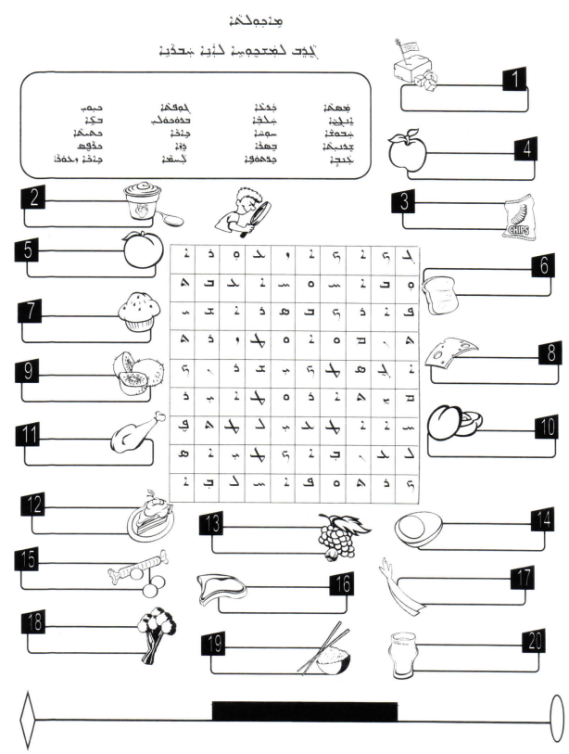
Resource A- Healthy Foods Worksheets
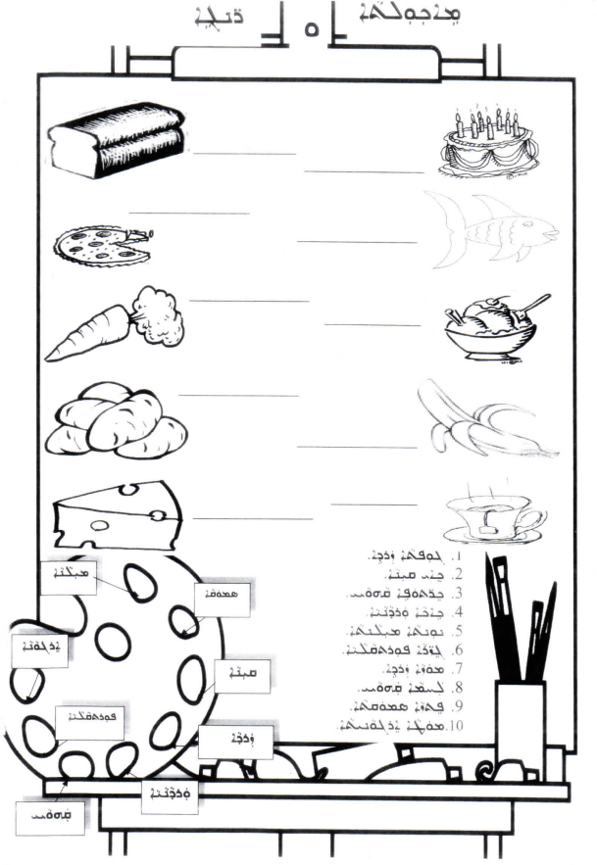
Resource A- Healthy Foods Worksheet
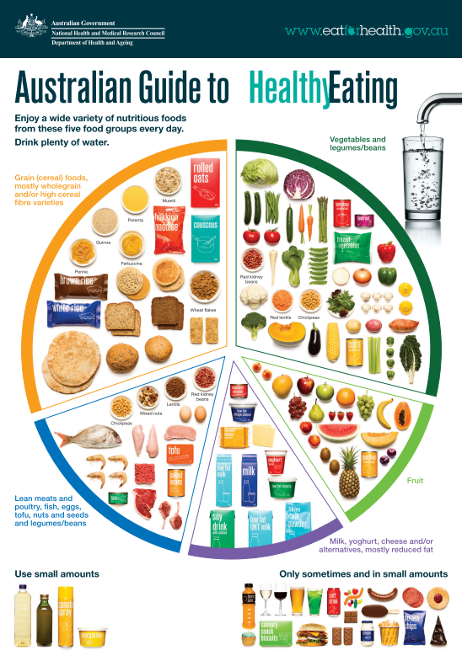
Resource B- Australian Guide to Healthy Eating Poster
Resource C- Fruits Flash Cards
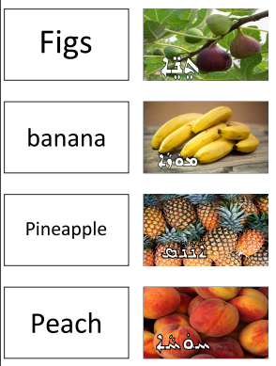
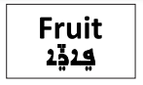
Resource C- Fruits Flash Cards

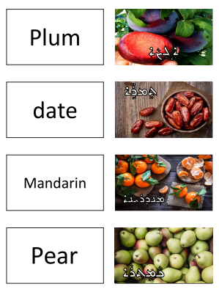

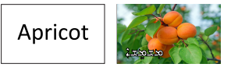

Resource C- Fruits Flash Cards

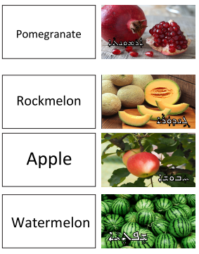

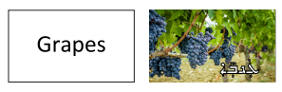

Resource C- Fruits Flash Cards

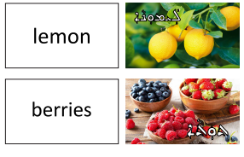

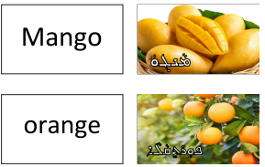

Resource D- Vegetables Flash Cards
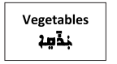

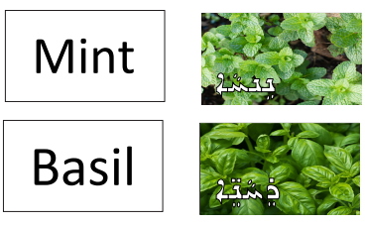

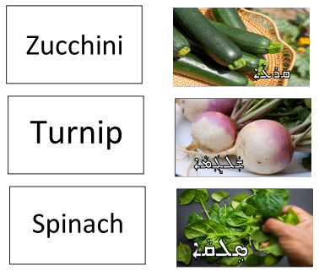
Resource D- Vegetables Flash Cards

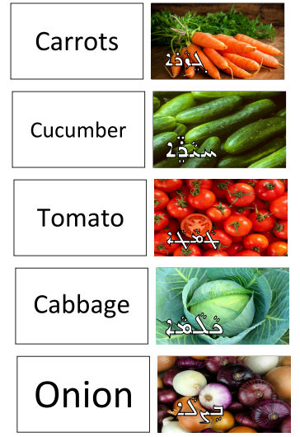
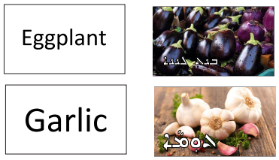
Resource D- Vegetables Flash Cards
