Unit of Work
Language: Turkish Year: 3 | Duration: 10 weeks (2hrs per week)
Unit description  Sustainable food/ paddock to plate  This unit is about how food is sustained and how food brings people together. Food culturally is a very important basis in Turkish culture and has very importance in bringing people together whether that be at a restaurant or a family dinner gathering. There is always much to be talked about and always fond memories created through smell, feel and taste. Students will have many engaging activities through role play, demonstrations, creating and making own cultural foods and will develop their interview skills with their families. Students will demonstrate an understanding of the influence of culture on how people obtain, prepare, serve, and consume food. | Key concept(s)  Where does our food come from?  What are our cultural foods?  Why is it important for food to be produced sustainably?  Why is food an important aspect in Turkish culture?
Learning intentions  Where does our food come from?  What is sustainability?  Where do we go to eat food?  What are the cultural foods we eat for breakfast, lunch and dinner?  Which states in Turkey do certain foods grow?  Why is it important to have rules in a kitchen?  Learn the simple steps in writing a procedure in Turkish | Success criteria (goals)  Students will be able to:  - List key words about farms in Turkish and that will assist with sustainability.  - Define what sustainability is  - Role play and write a conversation about how to speak in a restaurant  - List the different foods eaten at different times of the day.  - Use language like sweet, sour, bitter, and spicy to describe food  - Read, locate and illustrate where certain fruits and vegetables come from, in Turkey  - Write up simple procedure in Turkish about a cultural food.  - Create a recipe book on authentic Turkish cuisine  - Create a cooking show, demonstration or interview that will assist with using sustainable food.
Objectives and outcomes (Syllabus)

LTU3-1C uses Turkish to interact with others to exchange information and opinions, and to participate in classroom activities
LTU3-2C obtains and processes information in texts, using contextual and other clues
LTU3-4C composes texts in Turkish using a series of sentences
LTU3-5U applies key features of Turkish pronunciation and intonation
LTU3-6U demonstrates understanding of Turkish grammatical structures
LTU3-8U makes connections between cultural practices and language use
ST3-4LW-S examines how the environment affects the growth, survival and adaptation of living things
ST3-5LW-T explains how food and fibre are produced sustainably in managed environments for health and nutrition
Suggested vocabulary  Verbs that are used in kitchen - Yemek pişirme fiilleri  add: eklemek  bake: fırında pişirmek  blend: karıştırmak  boil: haşlamak  broil: kavurmak, kızartmak  chop: doğramak  cut: kesmek  dip: una bulamak  fry: kızartma  grate: ızgara yapmak  melt: eritmek  mix: karıştırmak  scramble: yumurta çırpmak  serve: servis etmek  pour: dökmek  roast: kızartmak  simmer: kaynatma  slice: dilimlemek  spread: yaymak  stir: karıştırmak  taste: tatmak  squeeze: sıkmak  peel: soymak  strain: süzmek  drain: süzmek | Sentence structures  Simple and complicated sentence structuring using Turkish verbs in their procedure writing.
Resources  See program for details | YouTube clips related to the concept  Websites  Online vocabulary quizzes  Worksheets and exercises  Flashcards, pictures and posters  Interactive whiteboard (IWB) activities  Templates for graphic organisers, eg Think/Pair/Share, Venn diagram

Suggested sequence of teaching learning and assessment activities

Week 1  Find out what students already know about farms and forests.  Encourage them to TELL, WRITE or DRAW their ideas.  DISPLAY these for future reference.  BRAINSTORM ideas about all the different ways people might define a farm.  Guesstimate ‘before views’ about:  - What farms and forests look like, sound like and feel like?  - Whether all farms and forests are the same in size?  - If all farms produce the same things?  - Whether all farms have animals?  - If all farms produce large crops?  - Whether all farms are in the country?  As a class LIST key words about farms, the different types, where they are located, what they produce.  DISPLAY these.  DISCUSS how someone might define a place that grows: fish, timber, grapes, sheep, fruit, cattle, cotton, chickens, alpacas, dairy cows, vegetables, oranges, nuts, bees, seafood, goats, herbs.  As a class, DISCUSS the word ‘connections’. Ask questions like:  - What does the word mean?  - How do we use it in everyday speech?  - Who are you connected to?  - Are you connected to any places?  As a class, DISCUSS about your connections to farms and forests and what they produce. ASK questions like:  - How are we connected to farms and forests?  - Where might we get our food from?  - Who likes eating fresh fruit and vegetables?  - Where might they come from?  - Where might the timber used for our doors and window frames come from?  - Where might the fish we eat come from?  - Where might the milk we drink come from?  Magic circle  PLACE incomplete statements on cards and place them in a box:  - I have a connection with a salmon farm because we eat ...  - I have a connection with a cotton farm because I wear cotton …  - I have a connection with the plantation forest because the paper we write on comes from ...  - I have a connection with the plantation forest and its trees ...  - I have a connection with the cattle and sheep farm because my family eats ...  - The different types of trees in the forest are …  - Tuna in the sea ...  Students can sit in groups and take turns to select a card. READ these and ask students to complete and then DISCUSS the statement in groups. Students REPORT back some of the information gained.  RECORD the class ideas on the class display that can be edited throughout the unit.  As a whole class, DEFINE what is sustainable and why it is important in Turkish. Display in room.  DISCUSS with the class about how we have foods that is produced in Australia and food that is imported from other countries.  ASK students to bring along one food item from home that has a label or packaging which shows the words ‘Made in...’ or ‘Product of...’ or ‘Produced in...’ or ‘Grown in...’ or ‘Handmade in...’.  READ labels on tins, packets, and bottles and discover the different countries that produce the foods we eat. Using a globe or map, help students to TRACE the journey from each country found on a label to Australia.  RECORD the countries and the products produced. For example: Turkey – Dried Apricots. | Resources  See resources attached to this program  Titled - Phase Cards
Week 2  Where do we go to eat food?  List and record places students have been to and ask about their experiences with the people at these places?  - What language did you use?  - How did you ask questions about the menu?  - How do we say menu in Turkish?  - Show samples of menus in Turkish.  - Are the students familiar with the foods on the menu?  Have the students listen to the dialogue and test their listening skills about at a Turkish restaurant. https://www.youtube.com/watch?v=VO2G6FGvbMg  Next have the students listen and test their knowledge about how to order at a Turkish restaurant.  https://www.youtube.com/watch?v=kupCNl-G6Fs  As a whole class write a role play about being in a Turkish restaurant by interaction, e.g. by greeting, Merhaba, akşam yemeği için üç kişilik masa ayırtmıştım, yemek çok nefisti, servis çok hızlıydı. Also include what you would order etc.  Have some students perform a role play in front of the class using the whole script.  https://www.youtube.com/watch?v=OqdGoygKuWA  Assessment: Students could then make small groups and write up their own scripts about a Turkish restaurant and what they would order from the menu. Each group then will perform in front of the class their script. | 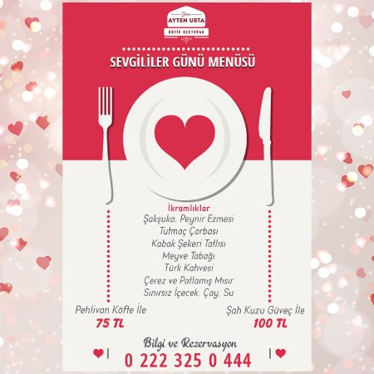  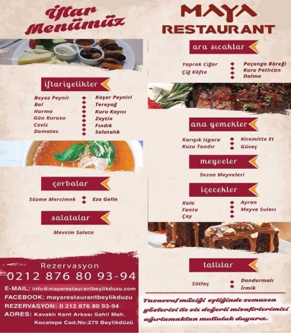
Week 3  What are your traditional foods?  Students will draw 3 columns that will include Breakfast, lunch and dinner.  Have the students list as many cultural foods they eat for each session and then share with the class.  Would you describe these foods as sweet, sour, bitter or spicy? Write these next to all the foods listed.  Have students watch these traditional Turkish breakfast, lunch and dinner menus to expand their cultural food knowledge.  https://www.youtube.com/results?search_query=traditional+turkish+breakfast  https://www.youtube.com/watch?v=0aM6dPvX7A0  https://www.youtube.com/watch?v=SY2-aqETeX0  As a whole class list all the different foods under the headings breakfast, lunch and dinner and display as a cultural food wall.  Students will next look at snacks.  Do you have snacks in between? What are some popular Turkish snacks?  How are these foods healthy or unhealthy? Top 21 Turkish foods – Istanbul food guide  https://www.youtube.com/watch?v=GCkMRrQIXPM  Assessment: Students create a poster in small groups on canva https://www.canva.com/ about Turkish street food and publish these posters to hang in the room. | https://www.youtube.com/watch?v=GCkMRrQIXPM
Week 4  During this week students will be looking at sustainable fruits and vegetables in the different regions and states of Turkey. PDF file has all the information on fruit and where it comes from. Students will be using their higher order thinking skills and translate each paragraph given to them in English. They will read it aloud first in Turkish then what they translated.  Students will then locate these fruits and vegetables on a large map of Turkey (displayed in the classroom) with the Turkish name of the food and pin it for everyone to see. | See PDF file on Fruits and vegetables in Turkish  Titled – Meyveler sebzeler konuşuyor

Week 5  Kitchen rules  Quiz the students on what are the safety rules to use in a kitchen. Write them down and display in class. Flash cards. Show the students the different names of the items found in the kitchen. Have them read these words aloud in small groups and test each other’s knowledge. Alternatively, a communicative game describing the items in Turkish could be played. Instructions are as follows:  Have two people sit back-to-back. Person A has an object and must describe it (without explicitly saying what the object is) to person B. Person B must then draw it based on person A’s description.  This game is effective for finding new ways to communicate around barriers. It also helps build problem-solving skills and effective communication strategies.  Play a game of Bingo using these terms. ( https://myfreebingocards.com/)  Verbs to use in Turkish  Watch various videos of recipes and read some.  What language is being used? What are the verbs used in some of the sentences?  Identify and write a list of these.  Headings Utensils or ingredients and Steps (Aletler, Malzemeler Hazırlama) | See Flash cards PDF file on Kitchen items  Titled – Mutfak esya kartları  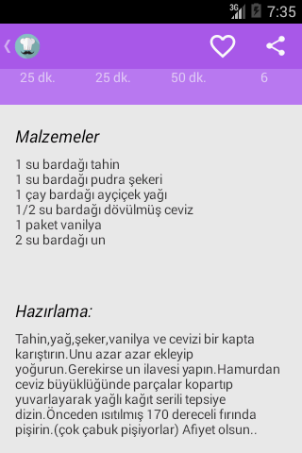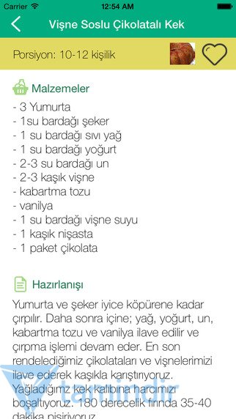  See verb sheets attached to this program  See Bingo PDF file attached to this program  Titled – Mutfakta neler var bingo
Week 6
Assessment: Students will write up 2 traditional recipes using the internet which we will comprise and make a Turkish cookbook to share in our school library

Week 7
Teacher will do a demonstration on cultural food.

Assessment: Students will then independently write a procedure in Turkish using the headings they have learnt from the previous lesson on the demonstration that the teacher did.

Weeks 8-10  Students will work on 2 projects in the next couple of weeks. 1 will be in class the other at home.  Assessment: They will plan, design and produce a healthy meal, for example: (Demonstrate in class)  - a traditional cultural meal  - dessert  - salad  Cook off (iMovie) and or Interview using a parent or family member cooking a traditional food and ingredients they use and step by step guide on how it is cooked using iMovie. | Show some student samples from previous years.
Evaluation
This could include:
- Teacher reflection on Unit
- Was there sufficient time for all activities/learning intentions?
- Were students able to demonstrate achievement of the outcomes?
- Were the activities/tasks engaging and effective?
- Were the resources relevant and stimulating?
- Were students interested in the learning?
- What worked well? What didn’t work well?
- What would I change for next time?
- Student self-assessment (Use success criteria as a check list)

