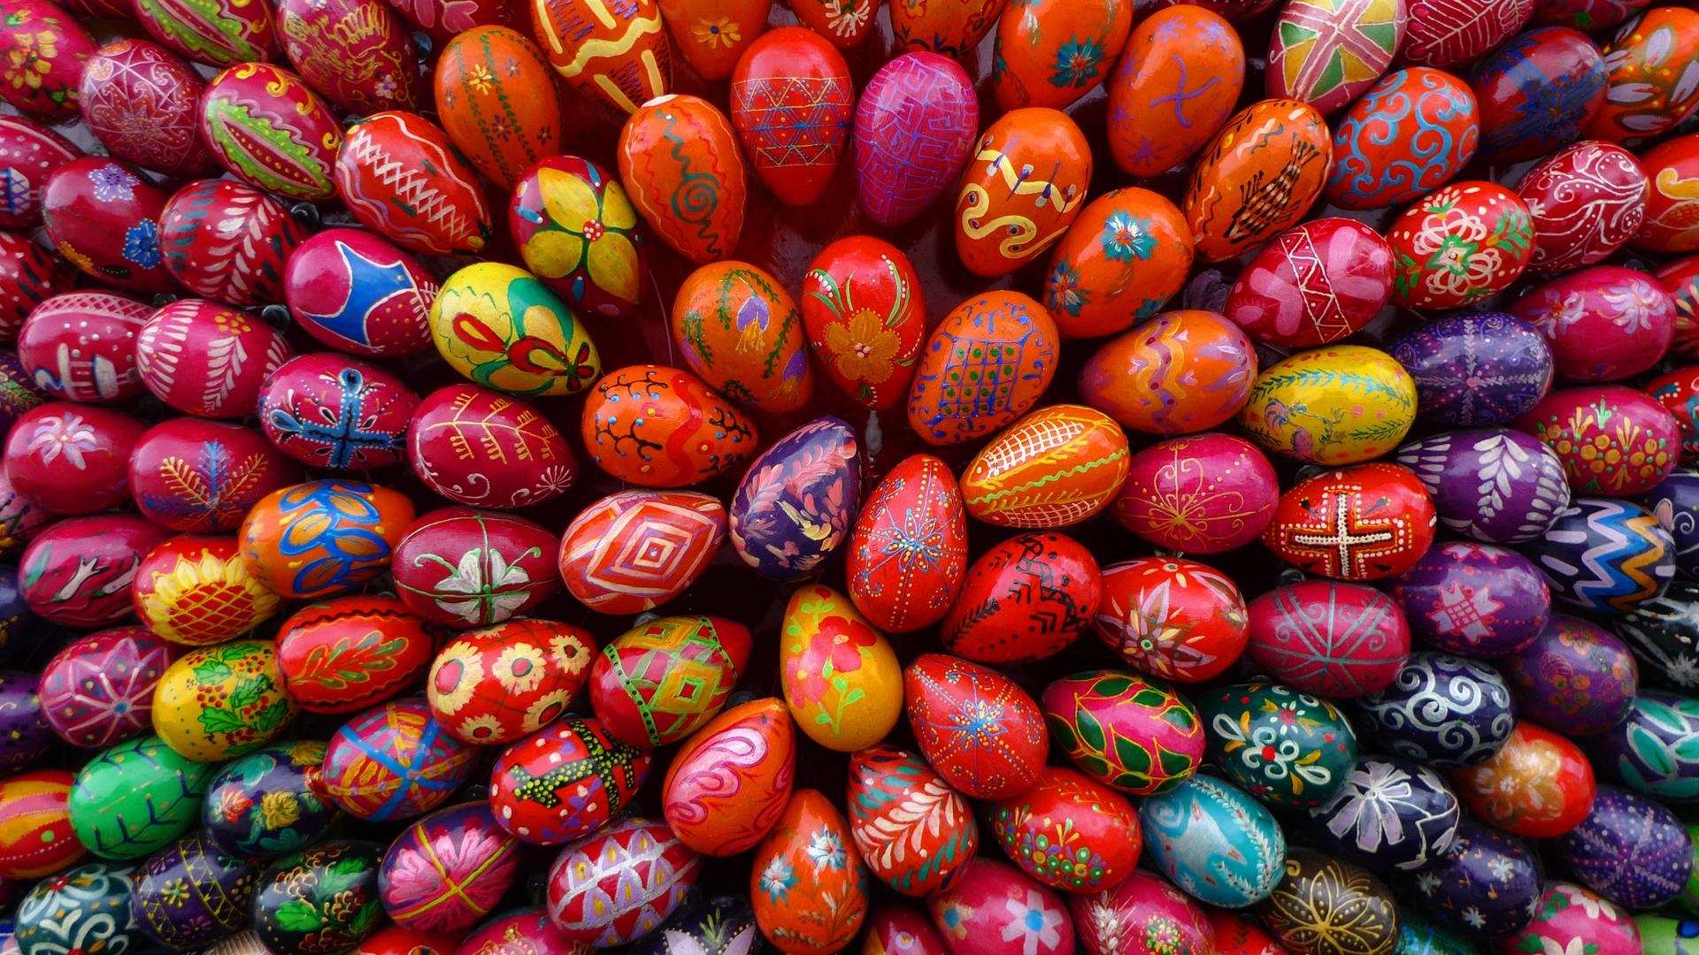
Τι μου θυμίζει η λέξη «Πάσχα»
Charoulla Themistocleous 2017

