**Revision Booklet**

**Επαναληπτικό Βιβλιαράκι**

Β β

Α α

Ε ε

Ζ ζ

Δ δ

Γ γ

Ω ω

Ψ ψ

Χ χ

Φ φ

Υ υ

Τ τ

Σσς

Ρ ρ

Π π

Ο ο

Ξ ξ

Ν ν

Μ μ

Λ λ

Κ κ

Ι ι

Θ θ

Η η

**In the Greek alphabet we have 7 vowels (loud letters)**

**Δ δ**

**Ρ ρ**

**Π π**

**Θ θ**

**Μ μ**

**Λ λ**

**Κ κ**

**Ζ ζ**

**Γ γ**

**Γ γΓ**

**Γ γ**

**Ν ν**

**Β β**

**The rest of the letters are called consonants**

**Υ υ**

**Ω ω**

**Ε ε**

**Ο ο**

**Η η**

**Ι ι**

**Α α**

**Ξ ξ**

**Ψ ψ**

**Χ χ**

**Φ φ**

**Τ τ**

**Σσς**

**Letter combinations**

o

oυ

οο

o

ει

ee

οι

ee

ι

ι

ε

αι

eh

α

ι

υ

ευ

ev, ef

αυ

av, af

ε

υ

α

υ

τσ

ch

τ

σ

μπ

b

μ

π

ντ

d

τ

ν

**Connect the word to the picture**

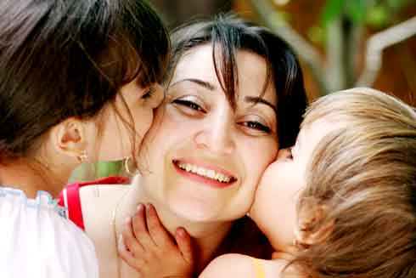

Κορίτσι

Μάτι

Μητέρα

Γιαγιά και παππούς

Ψάρι

Γάτα

Νάνι

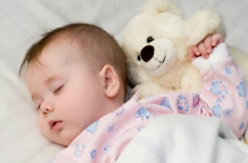

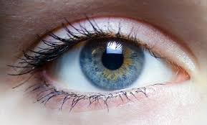

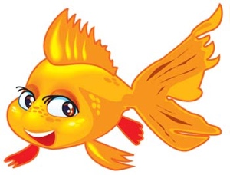

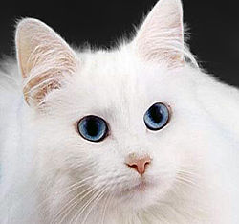

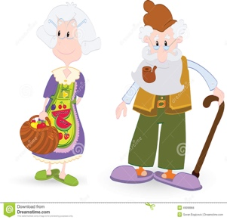

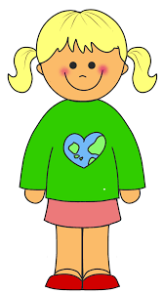

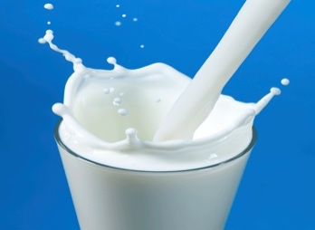



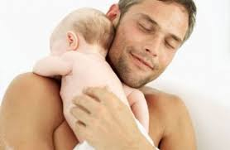

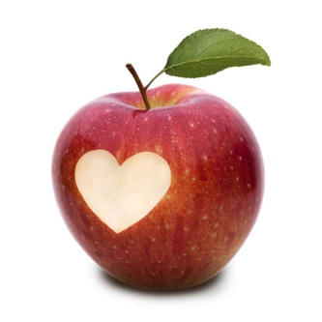

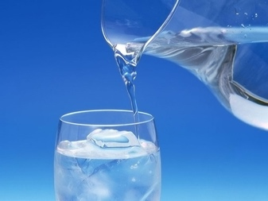

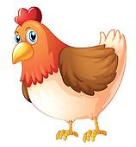

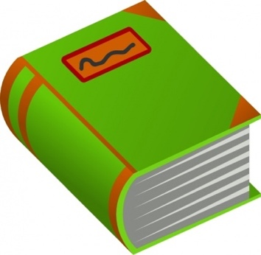

**Choose between ο, η, το**

o - is for boys

η - is for girls

τo - is for no gender or things

Example: η κότα

______ μαμά _______ μάτι ______ ψάρι

______ φύλλο _______ μπαμπάς ______ παππούς

______ γάτα ________ γατάκι _______ παιδί

______ ζώο _______ βιβλίο _______ τυρί



**Draw the face and label all body parts that you have learnt.**

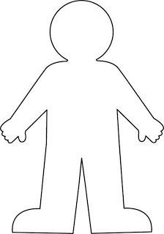

Unjumble the words of the body parts

|  |  |
| --- | --- |
| μτηύ ____________ |  |
| λαμλιά ____________ |  |
| χρέια _____________ |  |
| ιτάμ ______________ |  |
| Ασότμ_____________ |  |
| τυαιά _____________ |  |
| δόπια_____________ |  |
|  |  |

Can you circle μικρό and underline μεγάλο ?

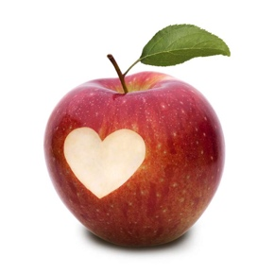 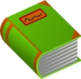 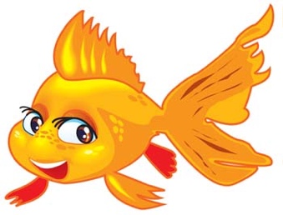 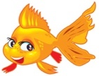 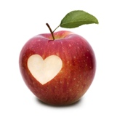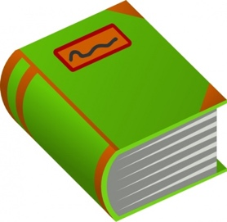

Fill in the missing letters from the colours;

|  |  |
| --- | --- |
| Κ__κκ___νο |  |
| Κ__τ____ινο |  |
| Πρά____ιν__ |  |
| Γα___ανό |  |
| Μ_λ____ |  |
| Μα____ρο |  |
| Ά__πρ_____ |  |

|  |  |
| --- | --- |
| Τι είναι αυτό;  What is this? | Αυτό είναι ένα βιβλίο.  This is a book. |
| Τι είναι αυτό; | Αυτό είναι ένα ___________. |
| Τι είναι αυτό; | Αυτό είναι ένα __________. |
| Τι είναι αυτό; | __________________________  __________________________  __________________________. |
| Τι είναι αυτό; | __________________________  __________________________  __________________________. |
| Τι είναι αυτό; | _________________________  _________________________  _________________________. |

How many can you see?

Write the number like in the example.

|  |  |
| --- | --- |
|  | δύο |
|  |  |
|  |  |
|  |  |
|  |  |
|  |  |
|  |  |
|  |  |
|  |  |
|  |  |

What am I doing in the following pictures?

|  |  |
| --- | --- |
| I drink a glass of water. | Πίνω ένα ποτήρι νερό. |
| I drink a glass of milk. |  |
| I eat one apple. | Τρώω ένα μήλο. |
| I eat bread. |  |
| I eat one fish. |  |

How do you say the following in Greek?

|  |  |
| --- | --- |
|  |  |
|  |  |
|  |  |
|  |  |

Draw as many drops as the number in the clouds.

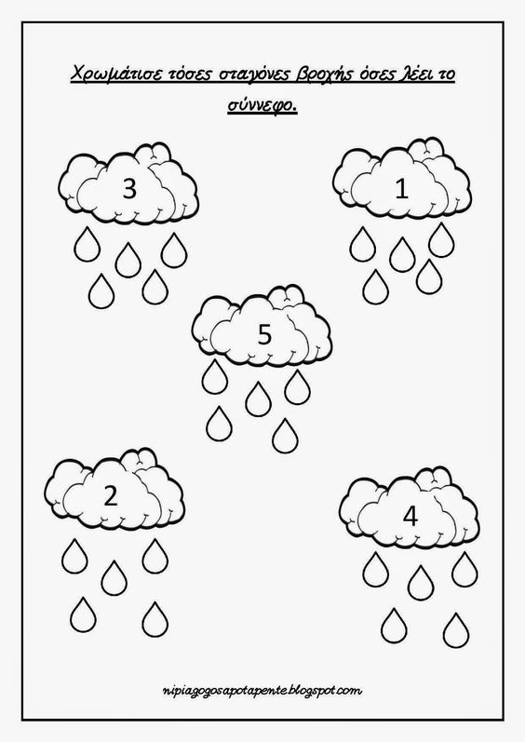



Write the low case (small) or capital letter (big) that is missing.

|  |  |  |
| --- | --- | --- |
| Α ___  Β ___  ___ γ  ___ δ  ___ ε  Ζ ___  ___ η  Θ ___ | ___ ι  Κ ___  ___ λ  Μ ___  ___ ν  Ξ ___  ____ ο  Π ___ | ___ ρ  Σ ___ ____  ___ τ  Υ ___  ___ φ  Χ ___  ___ ψ  Ω ____ |