**Kelime Eşleştirme**

Isim: ___________________________ Tarih: ____/____/________

Ayakkabı

Anahtar

Ayı

Araba

Arı

Ayak

[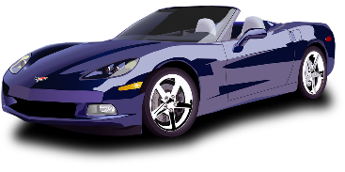](https://www.google.com.au/url?sa=i&rct=j&q=&esrc=s&source=images&cd=&ved=0ahUKEwjgw6K_zqXSAhWCqlQKHSLSD6AQjRwIBw&url=https://pixabay.com/en/photos/car/&bvm=bv.147448319,d.amc&psig=AFQjCNFy1D8G0Tn6bLmiTU45xvFyGUDcmg&ust=1487918405993105&cad=rjt)

[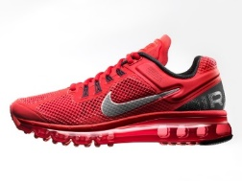](https://www.google.com.au/url?sa=i&rct=j&q=&esrc=s&source=images&cd=&cad=rja&uact=8&ved=0ahUKEwis8pqe0qXSAhUHj1QKHeHXAZAQjRwIBw&url=http://www.popularmechanics.com/adventure/sports/g1101/the-evolution-of-athletic-shoe-tech/&bvm=bv.147448319,d.amc&psig=AFQjCNHoRBV12HGlYrsNCcAnroJJznNgjA&ust=1487919440560901)

[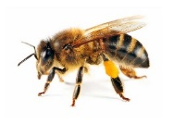](https://www.google.com.au/url?sa=i&rct=j&q=&esrc=s&source=images&cd=&cad=rja&uact=8&ved=0ahUKEwj0z96CzqXSAhXKr1QKHQTBB4sQjRwIBw&url=http://honisoit.com/2015/04/bees-dogs/&bvm=bv.147448319,d.amc&psig=AFQjCNFZswg15MKDQkeqd3I1IVfaal5LYg&ust=1487918362207445)

[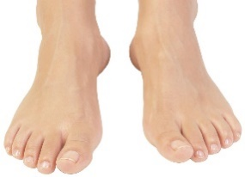](https://www.google.com.au/url?sa=i&rct=j&q=&esrc=s&source=images&cd=&cad=rja&uact=8&ved=0ahUKEwi1ye_L0aXSAhUKslQKHd7rBrcQjRwIBw&url=https://www.pinterest.com/coolgorillacrea/female-foot/&bvm=bv.147448319,d.amc&psig=AFQjCNF37NfwHK5UmMk4CBCacyceMF54BA&ust=1487919316180859)

[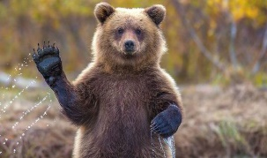](https://www.google.com.au/url?sa=i&rct=j&q=&esrc=s&source=images&cd=&cad=rja&uact=8&ved=0ahUKEwi8-6el0aXSAhVIjlQKHfkWBcQQjRwIBw&url=https://unagb.wordpress.com/tag/bears/&bvm=bv.147448319,d.amc&psig=AFQjCNGqFBPx1yFftfsDnOwpSDPjFRTQ3g&ust=1487919244550731)

[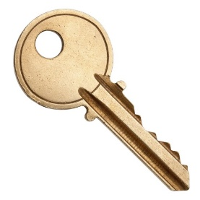](https://www.google.com.au/url?sa=i&rct=j&q=&esrc=s&source=images&cd=&cad=rja&uact=8&ved=0ahUKEwjM-MXmkqfSAhXDw7wKHWDnAJAQjRwIBw&url=http://dreamicus.com/key.html&psig=AFQjCNH1sQKr6jaSX_7mIfaVNaf5J2MQJQ&ust=1487971191751062)