**Kelime Eşleştirme**

Isim: ___________________________ Tarih: ____/____/________

Böcek

Bir

Balon

Balerin

Balık

Biber

[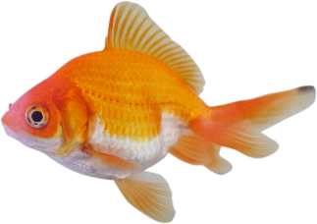](https://www.google.com.au/url?sa=i&rct=j&q=&esrc=s&source=images&cd=&cad=rja&uact=8&ved=0ahUKEwiRpuro27jSAhXBn5QKHUK2D-0QjRwIBw&url=http://www.firstaidforfree.com/what-does-fish-shaped-stand-for-in-first-aid/&psig=AFQjCNFxTgqwWRVP8UanNUyOp20Nplrojw&ust=1488574861289892)

[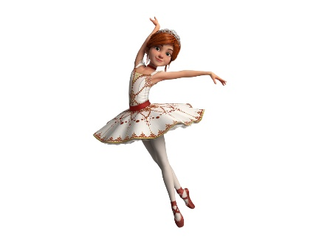](https://www.google.com.au/url?sa=i&rct=j&q=&esrc=s&source=images&cd=&cad=rja&uact=8&ved=0ahUKEwjopZus3bjSAhWFkZQKHU7BAfgQjRwIBw&url=http://variety.com/t/ballerina/&bvm=bv.148747831,d.dGo&psig=AFQjCNFmw1-np8NMFGtC6zMFh5ubf3Tc0Q&ust=1488575309238060)

[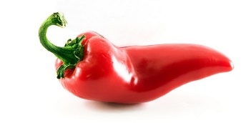](https://www.google.com.au/url?sa=i&rct=j&q=&esrc=s&source=images&cd=&cad=rja&uact=8&ved=0ahUKEwj3qtqz3LjSAhVHGZQKHcSdCw0QjRwIBw&url=https://www.bebeksofrasi.net/sebzeler/kirmizi-biber-6-ay/&bvm=bv.148747831,d.dGo&psig=AFQjCNHTIvMXy85x-y2lBEQNzVmM_x-btg&ust=1488575061609032)

[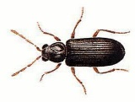](https://www.google.com.au/url?sa=i&rct=j&q=&esrc=s&source=images&cd=&cad=rja&uact=8&ved=0ahUKEwisxYLz3bjSAhUCjJQKHZcOBtcQjRwIBw&url=https://kadikoyhasereilaclama.wordpress.com/2015/05/20/kadikoyde-en-cok-gordugunuz-bocek/&bvm=bv.148747831,d.dGo&psig=AFQjCNFI1ASFWa9eOD7R5eOts23jCKwy0w&ust=1488575437174051)

1

[](https://www.google.com.au/url?sa=i&rct=j&q=&esrc=s&source=images&cd=&cad=rja&uact=8&ved=0ahUKEwi2wNra3LjSAhXFJpQKHV-tDEUQjRwIBw&url=http://tholokun.blogspot.com/2015_05_01_archive.html&bvm=bv.148747831,d.dGo&psig=AFQjCNGVP7vJwOfY8xKI4DtGTgLzCCo2ew&ust=1488575112380404)