Fruits and Vegetables- Activities - Set 2
- Activity 1
Purpose:
1- To demonstrate understanding of the story
2- To recognise vocabulary related to fruit and vegetables
Instructions:
1-Students to sequence the pictures in the correct order.( we can use more pictures from the book later in an more advanced level)
2-Students to fill in the gaps with the correct name of fruits/veggies on the left side circle.
3-Students have to match the name of the fruit with the picture (Taken from page 5 of the book)

(The same can be done for the vegetables on page 9 )

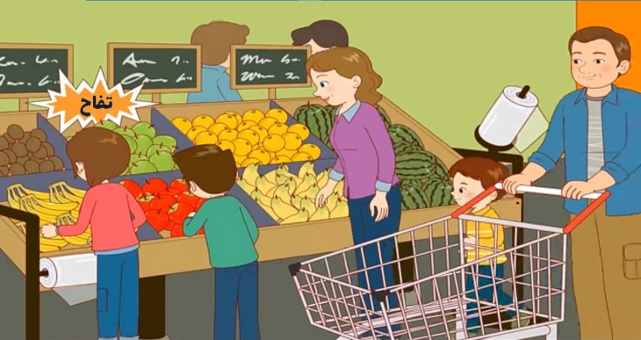
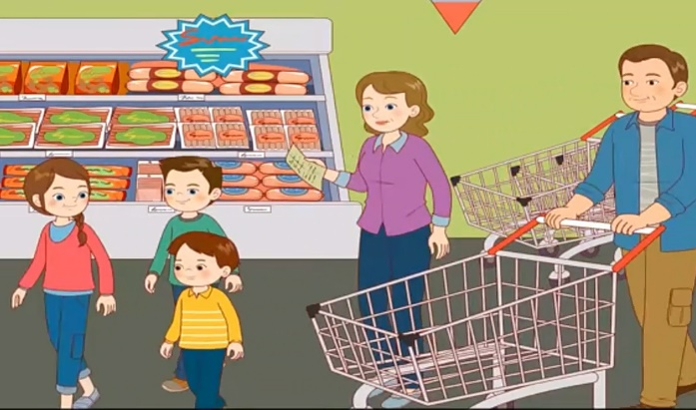
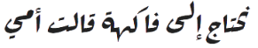
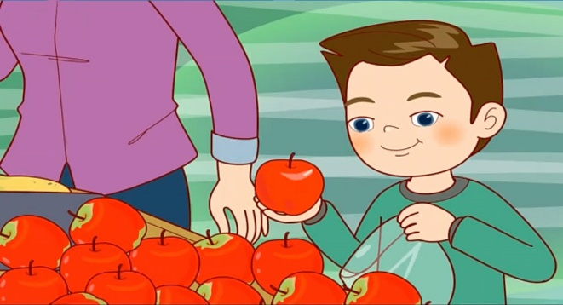
….
….

….

- Activity 2

Purpose:

- To recognise and read vocabulary taught

Instructions:

Students have to:
1-sound out the words
2-connect the words with the pictures

- تين
- إجاص
- أَفوكادو
- مانجو

- Activity 3
Purpose:
1-To develop student’s understanding of the story
2- To effectively use the interrogative form
3-To improve oral communication skills

Instructions:
1-The students will have the pictures in sequence, we can use more picture from the book later in an more advanced level
2-They have to ask the questions inspired by the picture
3-This is a list of questions that the student could ask for each picture with a question sample. They have to come up with other questions to each picture.
4-They can play it in groups or 2 at a time.
5-They cut the 2 sets of pictures and questions
  - 1st group will show the pictures to the 2nd group who will have to come up with questions relating to the pictures.
  - And vice versa, 2nd group will show the picture and the 1st one have to guess/come up with questions.

- ماذا قالت أمي؟ (What did my Mom said?)
- ماذا نحتاج؟ (What do we need?)
- من يوجد في الصورة؟ (Who is in the picture?)
