اردو (Urdu)
An integrated Urdu literacy session for learners at different literacy levels.
Session Overview: This literacy session can be modified and differentiated according to student’s literacy level in Urdu Language and student’s own special needs.
Cross Curriculum links: HSIE (Environment), Mathematics (Number)
Students with prior learning and/or experience
Students with prior learning and experiences in Cultural Language and other KLAs could advance and broaden their Vocabulary, grammar, and language conventions by applying these language skills to other KLAs. For example, a child with advanced vocabulary and knowledge in Mathematics is not limited to recalling and naming numerals in their Cultural Language but can perform and explain simple operations e.g., addition and subtraction in their cultural language.

Outcomes
- interacts with others to share information and participate in classroom activities in [Language] LXX1-1C
- locates and classifies information (Language)in texts LXX2-1C
- responds to spoken and visual texts in (Language) Lxxe-3c
- composes texts in [Language] using modelled language LXX2-4C
- recognises pronunciation and intonation patterns of [Language] LXXe-5U
- demonstrates understanding of basic [Language] writing conventions LXX2-6U
- demonstrates understanding of elements of [Language] grammar in familiar language patterns LXX2-7U

All outcomes referred to in this session come from Languages K-10 Framework © NSW Education Standards Authority (NESA) for and on behalf of the Crown in right of the State of New South Wales, 2018.
Content: Numbers 1-100, Days of the week, Names of Months, and Seasons. Colours in their immediate surrounding and environment, Weather vocabulary, time of the day e.g., morning or afternoon, anything special about toady e.g., someone’s birthday, a national celebration.
Resources: Children’s’ names written on flesh cards, Urdu Alphabet chart, Flesh cards with alphabets and sounds , Number grid, weather vocabulary chart, suggested songs, interactive videos, computer with internet connection.
Start the session by greeting children in Urdu and asking to appropriately respond back. Initiate a whole class talk on how different greetings can be used by people depending on the dialects, special occasions, and time of the day.
Focus: Encouraging students to engage with each other in Urdu. Alphabet familiarisation and phonics practice for reading and responding to spoken and written texts including visuals.
Now read through the alphabet chart as a whole class.

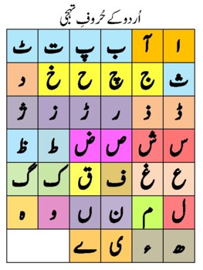

For students at beginning level, focus on word families, such as alif and alif mad -aa. Students can name and draw some common words starting with first two alphabets.
اسکول استاد آسٹریلیا
School, teacher, Australia.
Think, pair share: students are given flesh cards with their names written in Urdu. Ask students to say, sing or and write /copy or trace their name in Urdu. (Students identify alphabets in their name, guess the alphabets in their friend’s name and check for the phonics as a name may have a silent alphabet or two alphabets with similar sound)
e.g., Fatima فاطمہ Amir عامر د1نيالDaniel
Focus: Phonics, children read through the chart and identify alphabets with similar sounds.

Suggested Song: Urdu phonics https://www.youtube.com/watch?v=MRVCzTk98ts

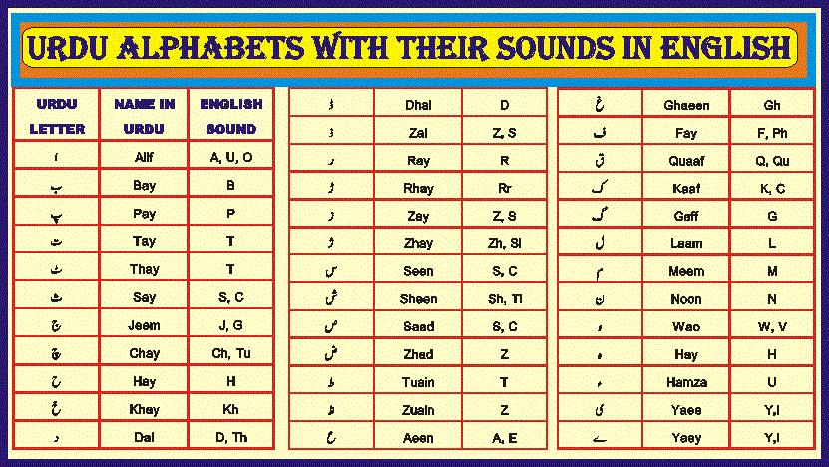

Focus: Days of the week, asking and answering questions using correct words and complete sentences with correct grammar and language conventions.

Name of the Days in Urdu and English
Sunday | Saturday | Friday | Thursday | Wednesday | Tuesday | Monday
اتوار | ھفتہ | جمعہ | جمعرات | بدھ | منگل | پیر

Suggested Song https://www.youtube.com/watch?v=WgCKIogtSL4
Direct instruction: let us check for today, what is the name of the Day?
Teacher models writing the name of the day, identifying the individual alphabets, and joining methods for composing words.
Today is Saturday.
Yesterday was Friday.
Tomorrow will be Sunday.
It is a Special day; Founder of Pakistan was born on this day where Urdu is the National language Christians celebrate this day as “Christmas” with exchanging gifts and gathering with friends and family. It is a national holiday in most countries including Australia.
Focus- Days before and after, reading and responding .
Today is ---Saturday--------. Yesterday was---Friday--------- and tomorrow it will be--Sunday—
Focus: Numbers, go through the number chart in Urdu. Depending on students’ level read through the chart e.g., level 1 can do up to 30 and level 5 up to 100.
Resource: Numbers in Urdu 1-100 https://www.youtube.com/watch?v=b8nbhJcTxXs&ab_channel=Kahaniclub-kidslearning
Ask -What’s the day and date today. Let us say and write the long and short date in Urdu. (Differentiation- Children can say, write the short or and long date depending upon their level)
e.g.,25/12/21
Saturday 25th December,2021
Focus: Numbers before and after, adding and subtracting, asking, and answering questions using a complete sentence with correct grammar and language conventions. For example, what is the date today,
Today is ----25---------. Yesterday was----24------- and tomorrow it will be----26th----------

Focus: Months of the year and seasons asking and answering questions using complete sentence with correct grammar, punctuation, and language conventions.
There are twelve months in a year. After every three months we enter a different season. Children can also learn about any special celebrations and significance of the months, seasons in Northern and Southern Hemisphere in different times of the year and time zones, in their place of heritage.

Let us learn about these seasons.
Names of the Months and Seasons in Urdu and English.
Summer گرمی | Springبہار | Winterسردی | Autumn خزاں
December دسمبر | Septemberستمبر | Juneجون | Marchمارچ
Januaryجنوری | Octoberاکتوبر | July جولائ | Aprilاپریل
Februaryفروری | Novemberنومبر | Augustاگست | May میء

Teacher Lead: Let us write together
My birthday comes in ------------(insert name of the month and the season)
Focus: Colours representing seasons e.g., winter is cold and is shown by blue colour, spring is represented by green colour.
Think, Pair, share: Children can talk about their birthday month, season and can relate it to favourite colour, warm and cool colours and trace or write their name in their favourite colour, name colours in a rainbow. Other children can say and practice: primary and secondary colours.
Small group: Children identify and name colours in each other’s clothing, skin colour, eyes, and their immediate environment. Children choose correct vocabulary and write words or complete sentences about the colours they like and share their findings with whole class.
Example: Black – I have black hair and charcoal black eyes. At night it gets dark and black. My teacher is wearing a black shirt.
Focus: Weather conditions, using appropriate vocabulary to make weather predictions.
Let us be a “weather person” and check the weather for today.
It is ------- today. Yesterday it was ----------, probably tomorrow it will be-----------------.
Weather Forecast (a vocabulary list can be used, children at an early stage can be introduced to Day, Night, afternoon, evening and at an advance level can learn and apply vocabulary about wind and air pressure, rainfall, solar and lunar eclipse, full moon, or any other special weather event happening during night or day)
Below are Some words and symbols which can be modified, and children can draw, say, and write in a word or a complete sentence to make weather prediction.
Whole Class: Teacher can go through some weather words and pictures for daily forecast., e.g., sunny, windy, overcast and can also use numerals to write temperature. Students learn and practice the vocabulary for making weather predictions.
Rain | Thunderstorm | Sunny | Fog
Temperature | Hailstorm | windy | Smog
Strong winds | Cold wave | Rainy | Floods
Hail | Freezing | Overcast | Bushfires
Sunrise | Sunset | Day-morning, afternoon, evening | Night

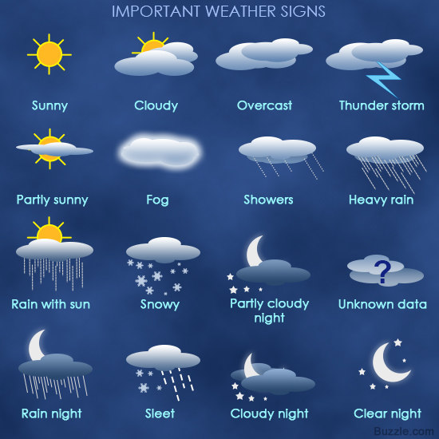
This Photo by Unknown Author is licensed under CC BY-SA-NC

Session closure: Confidence building in communicating in second language is encouraged throughout the session, and feedback can be achieved by engaging children in sharing their learning experience during the session. Children take turns in sharing their experience of learning language and evaluate the session by sharing a positive, and interesting new learning experience in the session. This language can be modified according to age group, for example for Early stage 1, kids can use appropriate words and gestures for various parts of the session.

Assessment opportunities: children’s oral participation and expression in introducing themselves, greetings, writing their name, predicting numbers before and after. Written record of their name, month and season for their birthday, weather record and favourite colours.
Reflection and Evaluation: This session caters for all three language levels. Teachers’ expertise in planning and executing is required to make modifications and offer differentiated instruction according to Language proficiency and Individualised student learning plans.
Integration of other KLAS enables students to broaden their everyday vocabulary in other strands, which can help them to become a proficient speaker. It however can be time consuming and demanding to address and teach links to other KLAS, such as recording and describing phases of moon , and explaining mathematical operations in their cultural language.

