Science - Farm Animals

Stage: Kindergarten | Unit Duration: 10 lessons | Weeks: 1 2 3 4 5 6 7 8 9 10 | Terms: 1 2 3 4
Unit Description and Overview | All students will develop the knowledge about a farm (what it looks like), farmer (his family and duties) and various farm animals and their physical features (their babies, colour and size), sounds they make, diet and where they live.  Students will also learn and use vocabulary from the Assyrian and Chaldean Language throughout the unit, which they can use in other lessons.  Teaching and learning activities are designed to help students construct understanding for deeper learning. A variety of tasks will be included, both in theory and practice to ensure students get a mix of activities that cater to their needs.
Lesson Overview | 1. What is a farm?  2. What is a farmer?  3. What is a cow? (What it looks like, where it lives, what it eats, what humans use it for)  4. What is a duck? (What it looks like, where it lives, what it eats, what humans use it for)  5. What is a sheep? (What it looks like, where it lives, what it eats, what humans use it for)  6. What is a hen? (What it looks like, where it lives, what it eats, what humans use it for)  7. What is a cat? (What it looks like, where it lives, what it eats, what humans use it for)  8. What is a dog? (What it looks like, where it lives, what it eats, what humans use it for)  9. What is a horse? (What it looks like, where it lives, what it eats, what humans use it for)  10. What is a pig? (What it looks like, where it lives, what it eats, what humans use it for)
Organisation | All lessons are designed to ensure teachers lead learning and content and students have opportunities to listen and respond. This will ensure all students are active participants of their learning.  All lessons will include:  Learning Intentions, Success Criteria, Vocabulary and Language, Warm Up and Wrap Up Activities, Modelled Teaching, Independent tasks, group tasks, partner tasks, Think/Pair/Share, technology use and reflection etc.
Essential Questions | - What is a farm?  - Who lives in a farm?  - What are some farm animals?  - Why do we need farm animals?  - Describe a day in a farm.
Assessment | Teachers have assessment opportunities before and after the unit to track progress. Students can verbally identify some farm animals to show their understanding before the unit commences and after. The assessment for learning is ongoing.
Technology and Useful Websites | Teachers may use resources such as iPads and laptops to support students with their learning. Students should be exposed to a variety of songs, rhymes, books etc. to support their learning.  Some websites that may be helpful for teachers to visit before and during the unit for support include:  https://www.youtube.com/watch?v=hewioIU4a64 (names and sounds of farm animals)  https://www.youtube.com/watch?v=GibudTRgU3Y (names of farm animals)  https://www.youtube.com/watch?v=WWotE7yBNU0 (Assyrian song on farm animals)  https://easyscienceforkids.com/fun-facts-for-kids-video (fun facts about farm animals)

Science - Farm Animals

Year: Kindergarten Lesson Sequence: 1 of 10

Subject: Science Topic: Farms and farm animals

Learning Intention: We are learning about a farm (what it looks like) in Chaldean/Assyrian Language.

Success Criteria: I will be successful if I can identify the features of a farm in Chaldean/Assyrian.

Key words: farm, field, trees, fence, lakes, animals, grass, plants etc.

Resources: Old Macdonald Song, Animals flash cards / poster in Chaldean/Assyrian (Resource A), farm animals’ worksheet (Resource B), pencils, glue sticks and scissors

Starter:
- Class discussion:
- Brainstorm what a farm is in English.
- Introduce the word ‘Farm’ in Chaldean/Assyrian.
- Brainstorm what is found at a farm.
- Brainstorm various farm animals in English.
- Introduce the farm animals in Chaldean/Assyrian.
- Consolidate farm animal’s vocabulary using flashcards.

- Song: Old McDonald had a farm-https://www.youtube.com/watch?v=WWotE7yBNU0
- Sing the song together as a class. Replace some English words with Assyrian/Chaldean words.
- Display a farm animal poster on the board and ask students to identify or repeat the names of the animals in Chaldean/Assyrian.

- Game: Match pictures of farm animals
- Teacher calls out the animals they learnt in Chaldean/Assyrian and one student at a time matches it to a picture.
- A whole class game - the teacher plays/imitates the sound of a farm animal and students guess the name of the animal in Chaldean/Assyrian.
Activity:
- Student will draw/colour in the farm worksheet and match the pictures that belong to the farm independently.
Wrap-up:
- Teacher reads ‘Wolf and Rabbit’ in Chaldean/Assyrian
- Students retell the story.

Science - Farm Animals

Year: Kindergarten Lesson Sequence: 2 of 10

Subject: Science Topic: A Farmer’s Job

Learning Intention: We are learning about a farmer (what does he do) in Chaldean/Assyrian Language.

Success Criteria: I will be successful if I can identify a farmer and his duties in Chaldean/Assyrian.

Key words: farm, farmer, duties and family.

Resources: Old MacDonald song - In Eastern Syriac, a toy farmer, The Farmer Worksheet in Chaldean/Assyrian (Resource C), A4 paper, pencils, glue sticks and scissors, Farm Animals Activity (optional) (Resource L)

Starter:
- Class discussion:
- Brainstorm what a farmer is in English.
- Introduce the word ‘farmer’ in Chaldean/Assyrian.
- Where does a farmer live?
- What does a farmer do?
- What does a farmer take care of?
- What does a farmer drive?

- Song: Old McDonald had a farm-https://www.youtube.com/watch?v=WWotE7yBNU0
- Display a farm poster on the board and ask students to identify or repeat the names of the animals in Chaldean/Assyrian.

Activity:
- Students will draw a farmer on a piece of A4 paper. Then, they must label the features of the famer (clothes, tools, equipment etc).

Wrap-up:
- Teacher read ‘The Farmer and The Lazy Rooster’ in Chaldean/Assyrian.
- Students retell the story.

Science - Farm Animals
Year: Kindergarten Lesson Sequence: 3 of 10

Subject: Science Topic: Farm Animals (Cow)

Learning Intention: We are learning about a cow, (what it looks like, its baby, where it lives, what it eats, what humans use it for) in Chaldean/Assyrian Language.

Success Criteria: I will be successful if I can identify a cow and its features in Chaldean/Assyrian.

Key words: cow, calf, colour, big, small, use, diet, lifestyle, habitat, body part, life cycle etc.

Resources: Old MacDonald song - In Eastern Syriac, a toy cow, cow flash card in Chaldean/Assyrian, Cow worksheet (Resource D), pencils, glue sticks and scissors.

Starter:
- Class discussion:
- Revise the vocabulary from the previous lesson
- Introduce a picture of a ‘cow’.
- Introduce the word ‘cow’ in Chaldean/Assyrian.
- Where does a cow live?
- Using adjectives/ colours, discuss the colours of a cow.
- Display a picture of a ‘calf ‘
- Introduce the word ‘calf’ in Chaldean/Assyrian.
- What does a cow eat?
- What does a cow do and what sound does it make?
- Stick a cow’s poster or a flash card on the board and talk about the body parts and label them. Students repeat the vocabulary in Chaldean/Assyrian
- Song: Old McDonald had a farm-https://www.youtube.com/watch?v=WWotE7yBNU0
- Display a farm poster on the board and ask students to identify or repeat the names of the animals in Chaldean/Assyrian.
- Stick a poster of a cow or a flash card on the board and talk about the body parts and label them. Students repeat the vocabulary in Chaldean/Assyrian.
Activity:
- Using A4 paper, students will independently draw a picture of a cow and label is features- including body parts, what it eats, where it lives, sound it makes etc.

Wrap-up:
- Students sit in a circle and share their drawing with the class and talk about it.
- Students ask questions and answer them.

Science - Farm Animals
Year: Kindergarten Lesson Sequence: 4 of 10

Subject: Science Topic: Farm Animals (Duck)

Learning Intention: We are learning about a duck, (what it looks like, its baby, where it lives, what it eats, what humans use it for) in Chaldean/Assyrian Language.

Success Criteria: I will be successful if I can identify a duck and its features in Chaldean/Assyrian.

Key words: duck, duckling, colour, big, small, habitat, feathers, diet, life cycle etc.

Resources: Old MacDonald song - In Eastern Syriac, a toy duck, duck flash card in Chaldean/Assyrian, Duck worksheet (Resource E), pencils, glue sticks and scissors.

Starter:
- Class discussion:
- Revise the vocabulary from the previous lesson
- Introduce a picture of a ‘duck’
- Introduce the word ‘duck’ in Chaldean/Assyrian
- Where does a duck live?
- Using adjectives/ colours, discuss the colours of a duck.
- Display a picture of a ‘duckling ‘
- Introduce the word ‘ducking’ in Chaldean/Assyrian.
- Discuss a ducks’ family.
- What does a duck eat?
- What does a duck do and what sound does it make?
- Stick a duck’s poster or a flash card on the board and talk about the body parts and label them. Students repeat the vocabulary in Chaldean/Assyrian
- Song: Old McDonald has a farm-https://www.youtube.com/watch?v=WWotE7yBNU0
- Display a farm poster on the board and ask students to identify or repeat the names of the animals in Chaldean/Assyrian.
- Stick a poster of a duck or a flash card on the board and talk about the body parts and label them. Students repeat the vocabulary in Chaldean/Assyrian.

Activity:
- Using A4 paper, students will independently draw a picture of a duck and label is features- including body parts, what it eats, where it lives, sound it makes etc.

Wrap-up:
- Teacher reads ‘five little ducks went out one day’ in Chaldean/Assyrian.
- Students retell the story and ask questions and answer them.

Science - Farm Animals
Year: Kindergarten Lesson Sequence: 5 of 10

Subject: Science Topic: Farm Animals (Sheep)

Learning Intention: We are learning about a sheep, (what it looks like, its baby, where it lives, what it eats, what humans use it for) in Chaldean/Assyrian Language.

Success Criteria: I will be successful if I can identify a sheep and its features in Chaldean/Assyrian.

Key words: sheep, lamb, colour, big, small, diet, habitat, sound, life cycle, body part etc.

Resources: Old MacDonald song - In Eastern Syriac, a toy sheep, sheep flash card in Chaldean/Assyrian, Sheep worksheet (Resource F), pencils, glue sticks and scissors.

Starter:
- Class discussion:
- Revise the vocabulary from the previous lesson
- Introduce a picture of a ‘sheep’
- Introduce the word ‘sheep’ in Chaldean/Assyrian.
- Where does a sheep live?
- Using adjectives/ colours, discuss the colours of a sheep.
- Display a picture of a ‘sheep’.
- Introduce the word ‘lamb’ in Chaldean/Assyrian.
- Discuss a sheep’s’ family
- What does a sheep eat?
- What does a sheep do and what sound does it make?
- Stick a sheep’s poster or a flash card on the board and talk about the body parts and label them. Students repeat the vocabulary in Chaldean/Assyrian.
- Song: Old McDonald has a farm-https://www.youtube.com/watch?v=WWotE7yBNU0
- Display a farm poster on the board and ask students to identify or repeat the names of the animals in Chaldean/Assyrian.
- Stick a sheep’s poster or a flash card on the board and talk about the body parts and label them. Students repeat the vocabulary in Chaldean/Assyrian.

Activity:
- Using A4 paper, students will independently draw a picture of a sheep and label is features- including body parts, what it eats, where it lives, sound it makes etc.

Wrap-up:
- Students sit in a circle and share their drawing with the class and talk about it.
- Students ask questions and answer them.

Science - Farm Animals
Year: Kindergarten Lesson Sequence: 6 of 10

Subject: Science Topic: Farm Animals (Hen)

Learning Intention: We are learning about a hen, (what it looks like, its baby, where it lives, what it eats, what humans use it for) in Chaldean/Assyrian Language.

Success Criteria: I will be successful if I can identify a hen and its features in Chaldean/Assyrian.

Key words: hen, chick, colour, big, small, diet, habitat, sound, life cycle, body part etc.

Resources: Old MacDonald song - In Eastern Syriac, a toy hen, hen flash card in Chaldean/Assyrian, Hen worksheet (Resource G), pencils, glue sticks and scissors.

Starter:
- Class discussion:
- Revise the vocabulary from the previous lesson
- Introduce a picture of a ‘hen’.
- Introduce the word ‘hen’ in Chaldean/Assyrian.
- Where does a hen live?
- Using adjectives/ colours, discuss the colours of a hen.
- Display a picture of a ‘chick ‘
- Introduce the word ‘chick’ in Chaldean/Assyrian.
- Discuss a hen’s family members.
- What does a hen eat?
- What does a hen do and what sound does it make?
- Stick a hen’s poster or a flash card on the board and talk about the body parts and label them. Students repeat the vocabulary in Chaldean/Assyrian.
- Song: Old McDonald has a farm-https://www.youtube.com/watch?v=WWotE7yBNU0
- Display a farm poster on the board and ask students to identify or repeat the names of the animals in Chaldean/Assyrian.
- Stick a hen’s poster or a flash card on the board and talk about the body parts and label them. Students repeat the vocabulary in Chaldean/Assyrian.

Activity:
- Using A4 paper, students will independently draw a picture of a hen and label is features- including body parts, what it eats, where it lives, sound it makes etc.

Wrap-up:
- Teacher reads ‘The Little Smart Red Hen’
- Students retell and review the story in an open class discussion.
- Students sit in a circle, share their drawing with the class and talk about it.

- to each other etc.

Science - Farm Animals
Year: Kindergarten Lesson Sequence: 7 of 10

Subject: Science Topic: Farm Animals (Cat)

Learning Intention: We are learning about a cat, (what it looks like, its baby, where it lives, what it eats, what humans use it for) in Chaldean/Assyrian Language.

Success Criteria: I will be successful if I can identify a cat and its features in Chaldean/Assyrian.

Key words: cat, kitten, colour, big, small, diet, habitat, sound, life cycle, body part etc.

Resources: Old MacDonald song - In Eastern Syriac, a toy cat, cat flash card in Chaldean/Assyrian, Cat worksheet (Resource H), pencils, glue sticks and scissors.

Starter:
- Class discussion:
- Revise the vocabulary from the previous lesson
- Introduce a picture of a ‘cat’.
- Introduce the word ‘cat’ in Chaldean/Assyrian.
- Where does a cat live?
- Using adjectives/ colours, discuss the colours of a cat.
- Display a picture of a ‘kitten’
- Introduce the word ‘kitten’ in Chaldean/Assyrian.
- Discuss a cat’s family members.
- What does a cat eat?
- What does a cat do and what sound does it make?
- Stick a cat’s poster or a flash card on the board and talk about the body parts and label them. Students repeat the vocabulary in Chaldean/Assyrian.
- Song: Old McDonald has a farm-https://www.youtube.com/watch?v=WWotE7yBNU0
- Display a farm poster on the board and ask students to identify or repeat the names of the animals in Chaldean/Assyrian.
- Stick a cat’s poster or a flash card on the board and talk about the body parts and label them. Students repeat the vocabulary in Chaldean/Assyrian.
Activity:
- Using A4 paper, students will independently draw a picture of a cat and label is features- including body parts, what it eats, where it lives, sound it makes etc.

Wrap-up:
- Students sit in a circle and share their drawing with the class and talk about it.
- Students ask questions and answer them.

Science - Farm Animals
Year: Kindergarten Lesson Sequence: 8 of 10

Subject: Science Topic: Farm Animals (Dog)

Learning Intention: We are learning about a dog, (what it looks like, its baby, where it lives, what it eats, what humans use it for) in Chaldean/Assyrian Language.

Success Criteria: I will be successful if I can identify a dog and its features in Chaldean/Assyrian.

Key words: dog, puppy, colour, big, small, diet, habitat, sound, life cycle, body part etc.

Resources: Old MacDonald song - In Eastern Syriac, a toy dog, dog flash card in Chaldean/Assyrian, Dog worksheet (Resource I), pencils, glue sticks and scissors.

Starter:
- Class discussion:
- Revise the vocabulary from the previous lesson
- Introduce a picture of a ‘dog’
- Introduce the word ‘dog’ in Chaldean/Assyrian.
- Where does a dog live?
- Using adjectives/ colours, discuss the colours of a dog.
- Display a picture of a ‘puppy ‘
- Introduce the word ‘puppy’ in Chaldean/Assyrian.
- Discuss a dog’s family.
- What does a dog eat?
- What does a dog do and what sound does it make?
- Stick a dog’s poster or a flash card on the board and talk about the body parts and label them. Students repeat the vocabulary in Chaldean/Assyrian
- Song: Old McDonald has a farm-https://www.youtube.com/watch?v=WWotE7yBNU0
- Display a farm poster on the board and ask students to identify or repeat the names of the animals in Chaldean/Assyrian.
- Stick a dog’s poster or a flash card on the board and talk about the body parts and label them. Students repeat the vocabulary in Chaldean/Assyrian.
Activity:
- Using A4 paper, students will independently draw a picture of a dog and label is features- including body parts, what it eats, where it lives, sound it makes etc.

Wrap-up:
- Students sit in a circle and share their drawing with the class and talk about it.
- Students ask questions and answer them.

Science - Farm Animals
Year: Kindergarten Lesson Sequence: 9 of 10

Subject: Science Topic: Farm Animals (Horse)

Learning Intention: We are learning about a horse, (what it looks like, its baby, where it lives, what it eats, what humans use it for) in Chaldean/Assyrian Language.

Success Criteria: I will be successful if I can identify a horse and its features in Chaldean/Assyrian.

Key words: horse, foal, colour, big, small, diet, habitat, sound, life cycle, body part etc.

Resources: Old MacDonald song - In Eastern Syriac, a toy horse, horse flash card in Chaldean/Assyrian, Horse worksheet (Resource J), pencils, glue sticks and scissors.

Starter:
- Class discussion:
- Revise the vocabulary from the previous lesson
- Introduce a picture of a ‘horse’
- Introduce the word ‘horse’ in Chaldean/Assyrian.
- Where does a horse live?
- Using adjectives/ colours, discuss the colours of a horse.
- Display a picture of a ‘foal’
- Introduce the word ‘foal’ in Chaldean/Assyrian.
- Discuss a horses’ family.
- What does a horse eat?
- What does a horse do and what sound does it make?
- Stick a horse’s poster or a flash card on the board and talk about the body parts and label them. Students repeat the vocabulary in Chaldean/Assyrian.
- Song: Old McDonald has a farm-https://www.youtube.com/watch?v=WWotE7yBNU0
- Display a farm poster on the board and ask students to identify or repeat the names of the animals in Chaldean/Assyrian.
- Stick a horse’s poster or a flash card on the board and talk about the body parts and label them. Students repeat the vocabulary in Chaldean/Assyrian.
Activity:
- Using A4 paper, students will independently draw a picture of a horse and label is features- including body parts, what it eats, where it lives, sound it makes etc.

Wrap-up:
- Students sit in a circle and share their drawing with the class and talk about it.
- Students ask questions and answer them.

Science - Farm Animals
Starter:
- Class discussion:
- Revise the vocabulary from the previous lesson
- Introduce a picture of a ‘pig’.
- Introduce the word ‘pig’ in Chaldean/Assyrian.
- Where does a pig live?
- Using adjectives/ colours, discuss the colours of a pig.
- Display a picture of a ‘piglet ‘.
- Introduce the word ‘piglet’ in Chaldean/Assyrian.
- Discuss a pigs’ family.
- What does a pig eat?
- What does a pig do and what sound does it make?
- Stick a pig’s poster or a flash card on the board and talk about the body parts and label them. Students repeat the vocabulary in Chaldean/Assyrian.
- Song: Old McDonald has a farm-https://www.youtube.com/watch?v=WWotE7yBNU0
- Display a farm poster on the board and ask students to identify or repeat the names of the animals in Chaldean/Assyrian
- Stick a pig’s poster or a flash card on the board and talk about the body parts and label them. Students repeat the vocabulary in Chaldean/Assyrian
Activity:
- Using A4 paper, students will independently draw a picture of a pig and label is features- including body parts, what it eats, where it lives, sound it makes etc.

Wrap-up:
- Students sit in a circle and share their drawing with the class and talk about it.
- Students ask questions and answer them.

Learning Intention: We are learning about a pig, (what it looks like, its baby, where it lives, what it eats, what humans use it for) in Chaldean/Assyrian Language.

Success Criteria: I will be successful if I can identify a pig and its features in Chaldean/Assyrian.

Key words: pig, piglet, colour, big, small, diet, habitat, sound, life cycle, body part etc.

Resources: Old MacDonald song - In Eastern Syriac, a toy pig, pig flash card in Chaldean/Assyrian, Pig worksheet (Resource K), pencils, glue sticks and scissors.

Year: Kindergarten Lesson Sequence: 10 of 10

Subject: Science Topic: Farm Animals (Pig)

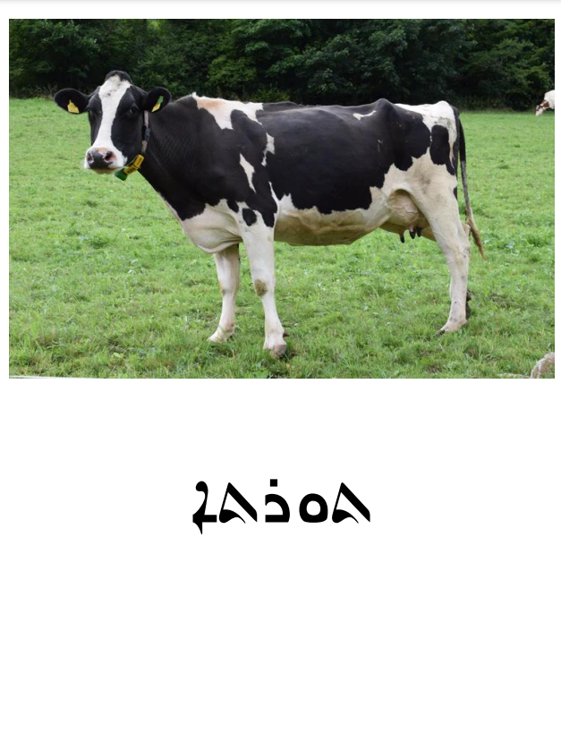
Resource A- Animal’s flash cards / poster in Chaldean/Assyrian

Resource A- Animal’s flash cards / poster in Chaldean/Assyrian
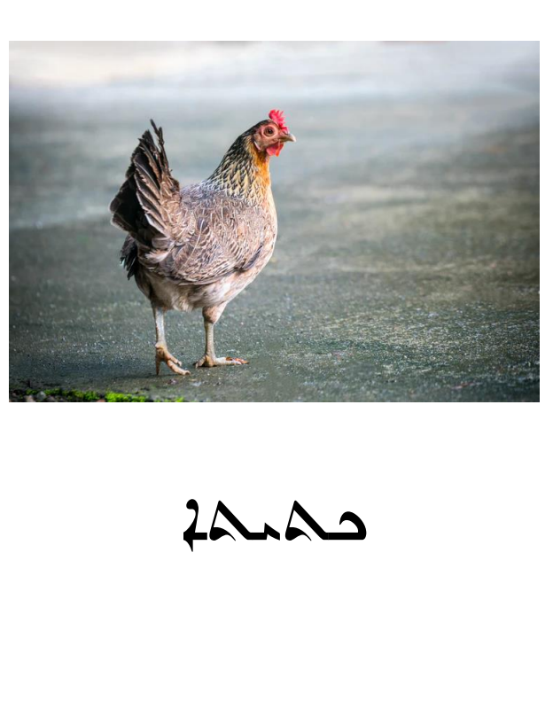

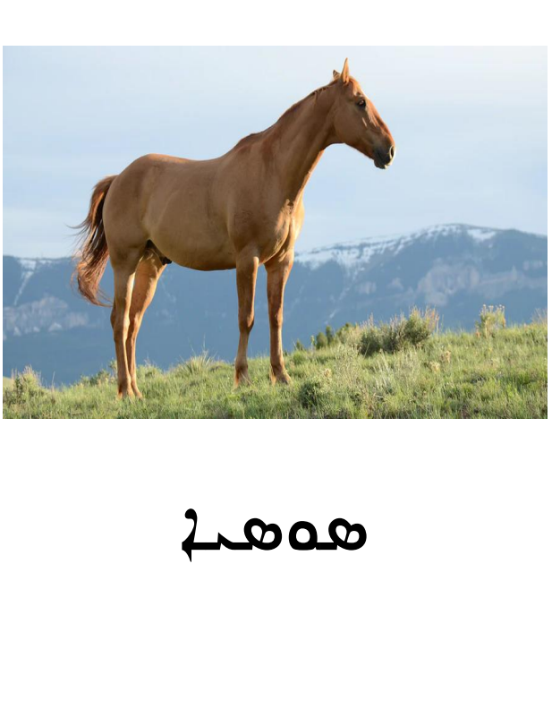
Resource A- Animal’s flash cards / poster in Chaldean/Assyrian

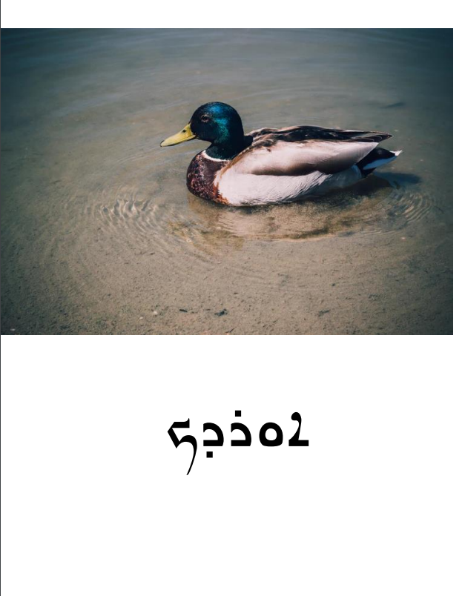
Resource A- Animal’s flash cards / poster in Chaldean/Assyrian

Resource A- Animal’s flash cards / poster in Chaldean/Assyrian
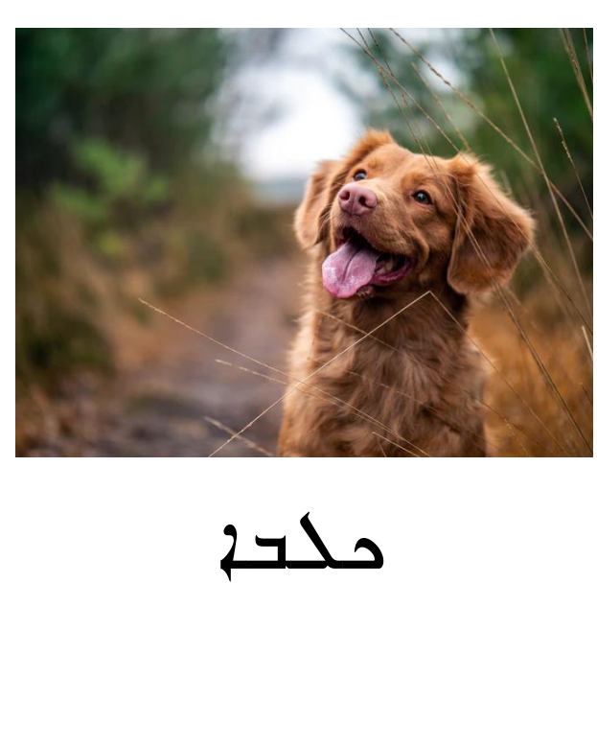

Resource A- Animal’s flash cards / poster in Chaldean/Assyrian
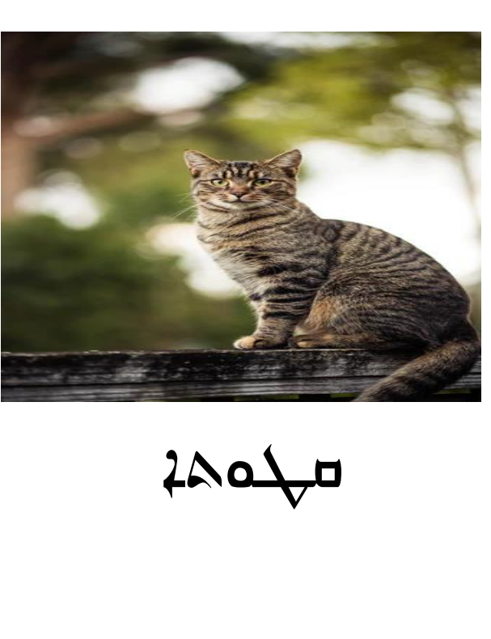

Resource A- Animal’s flash cards / poster in Chaldean/Assyrian
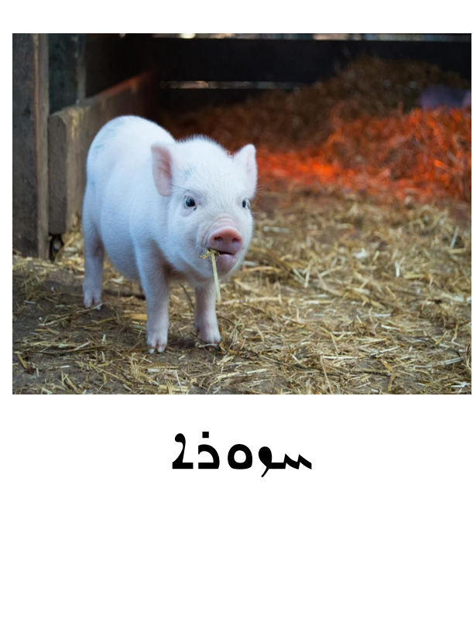

Resource A- Animal’s flash cards / poster in Chaldean/Assyrian
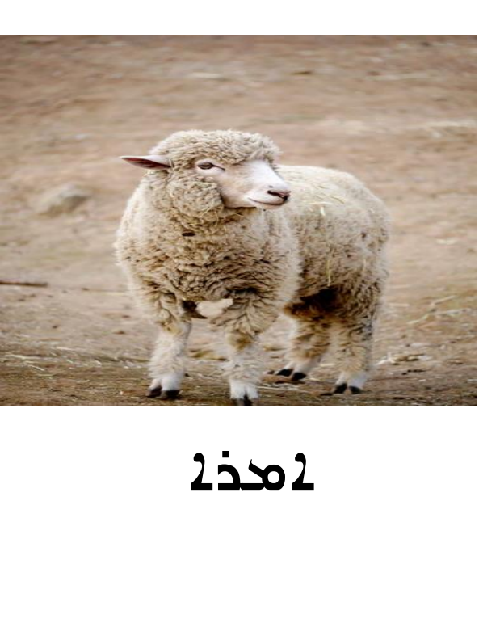
Resource A- Animal’s flash cards / poster in Chaldean/Assyrian

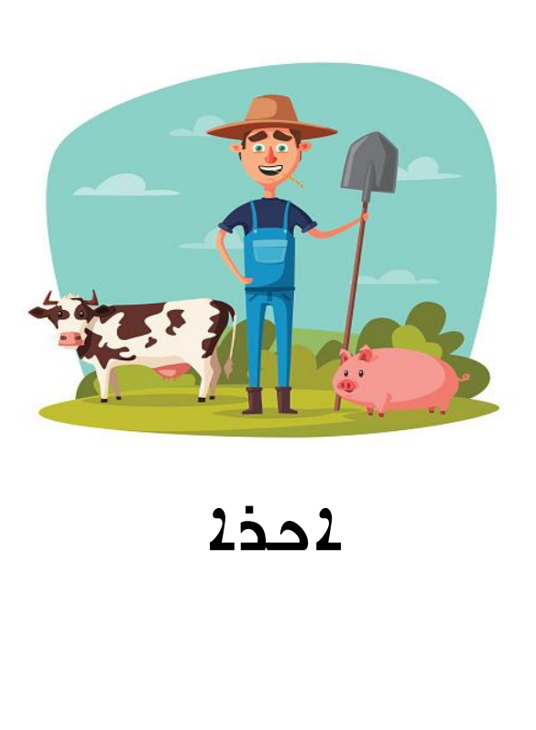
Resource A- Animal’s flash cards / poster in Chaldean/Assyrian

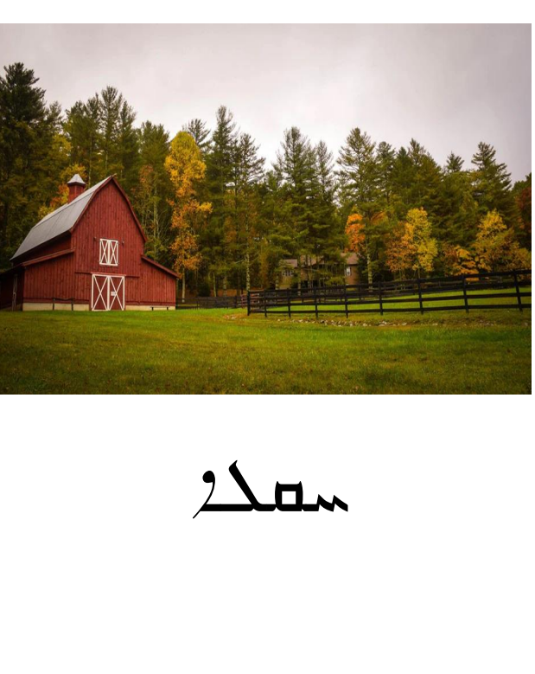

Resource A- Animal’s flash cards / poster in Chaldean/Assyrian
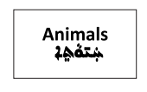
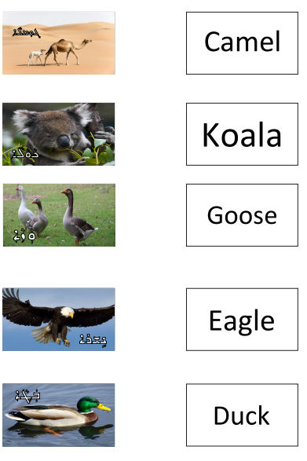
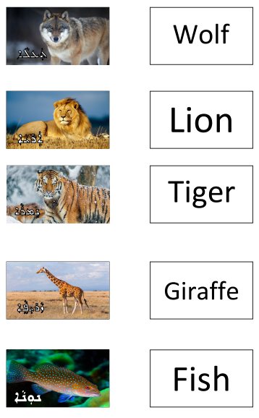
Resource A- Animal’s flash cards / poster in Chaldean/Assyrian

Resource A- Animal’s flash cards / poster in Chaldean/Assyrian
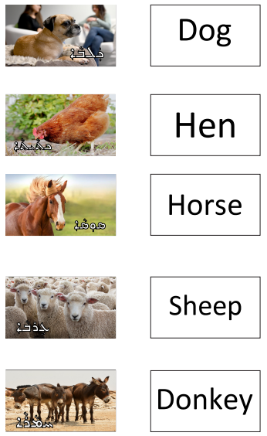

Resource A- Animal’s flash cards / poster in Chaldean/Assyrian

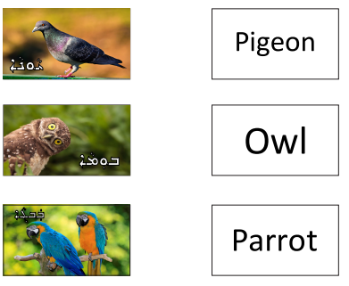
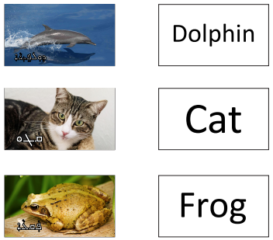
Resource A- Animal’s flash cards / poster in Chaldean/Assyrian

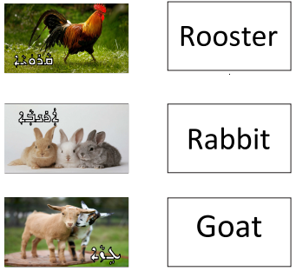
Resource A- Animal’s flash cards / poster in Chaldean/Assyrian

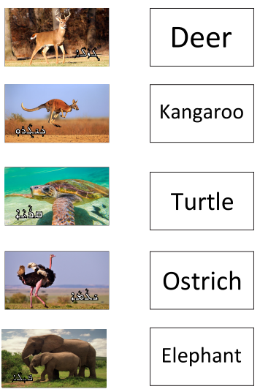
Resource A- Animal’s flash cards / poster in Chaldean/Assyrian

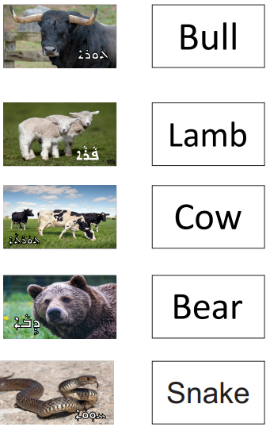
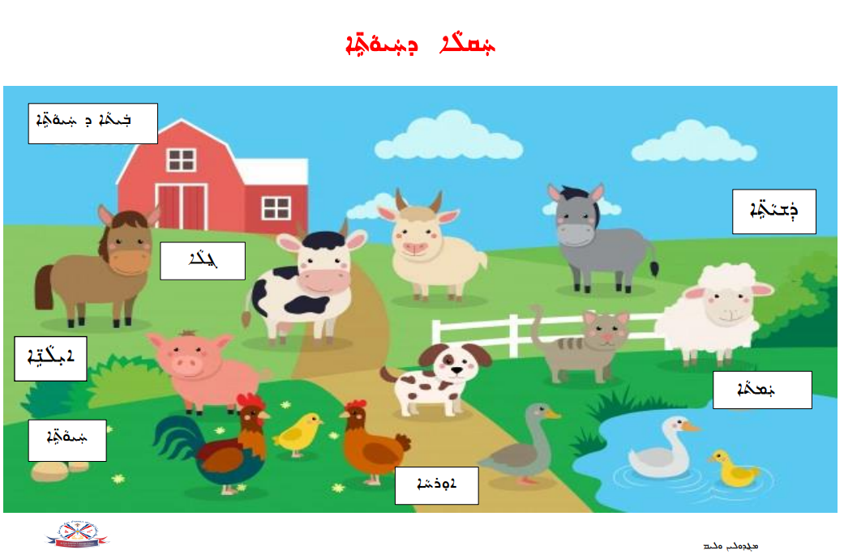
Resource B- Farm Animals Worksheet

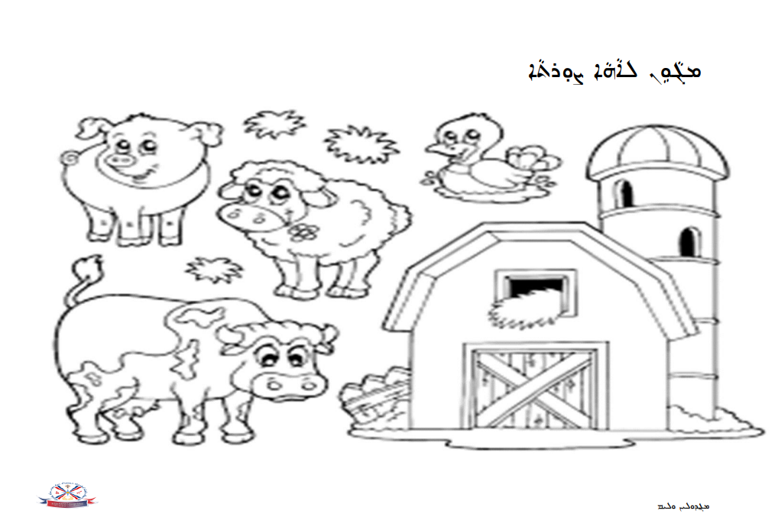
Resource B- Farm Animals Worksheet
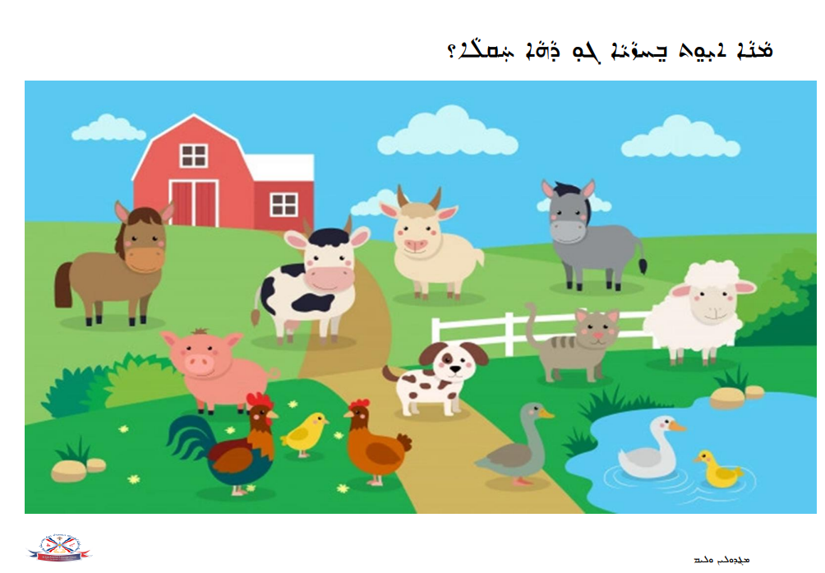
Resource B- Farm Animals Worksheet

Resource C- The Farmer Worksheet in Chaldean/Assyrian
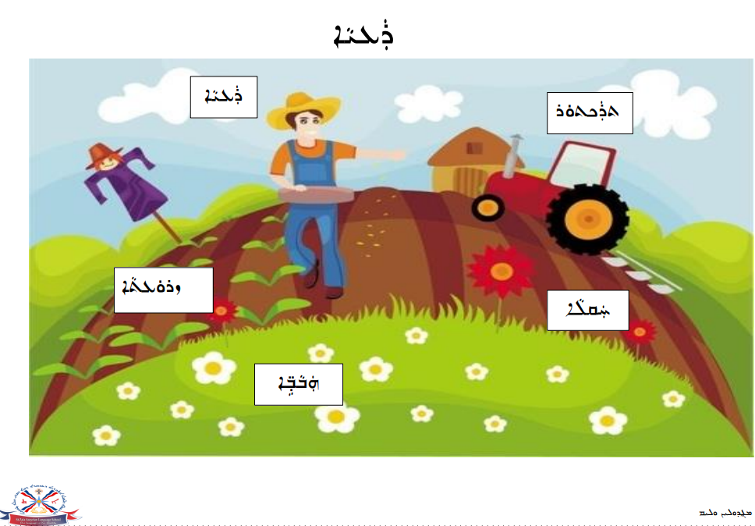
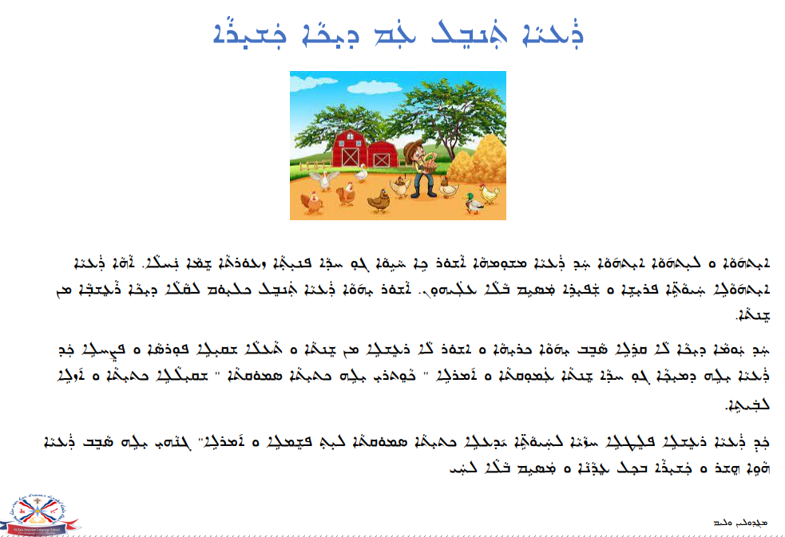
Resource C- The Farmer Worksheet in Chaldean/Assyrian
Resource C- The Farmer Worksheet in Chaldean/Assyrian
Resource C- The Farmer Worksheet in Chaldean/Assyrian

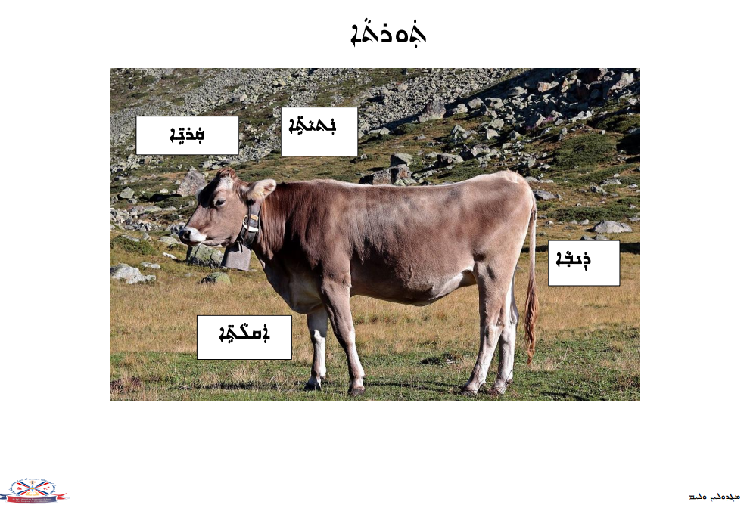
Resource D- Cow Worksheet
Resource D- Cow Worksheet
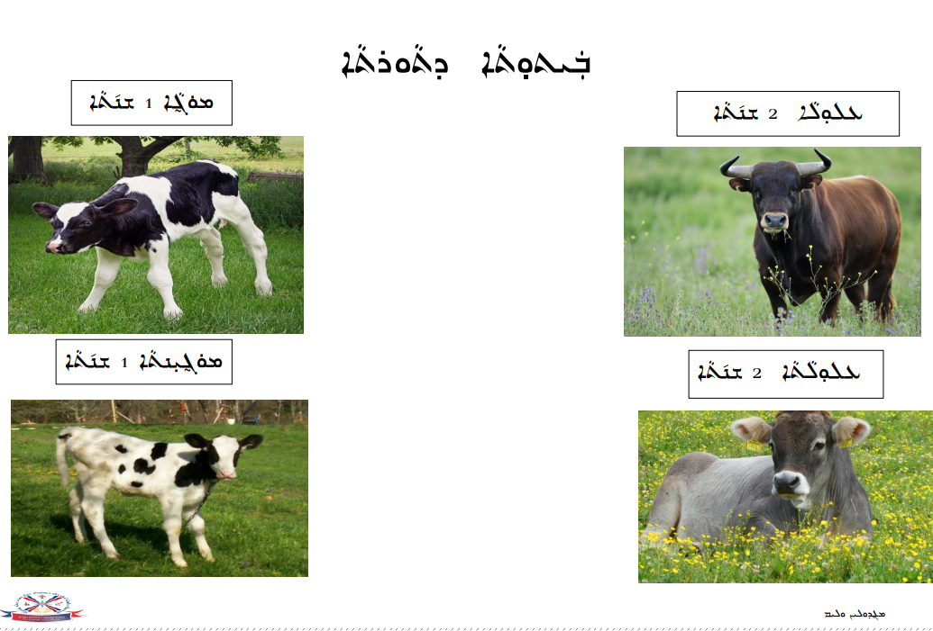
Resource D- Cow Worksheet
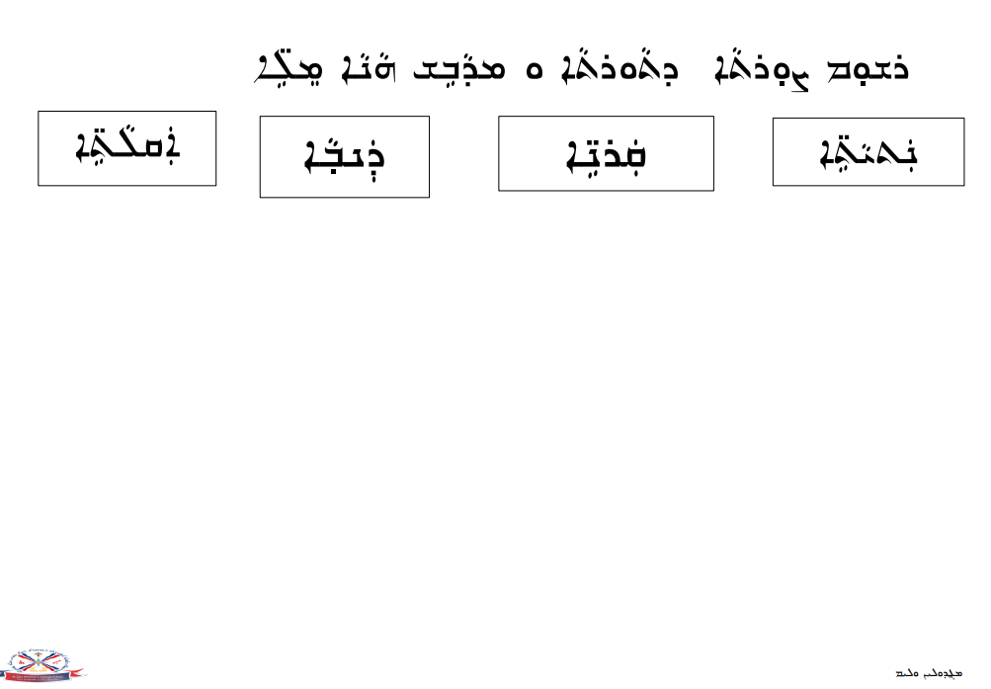
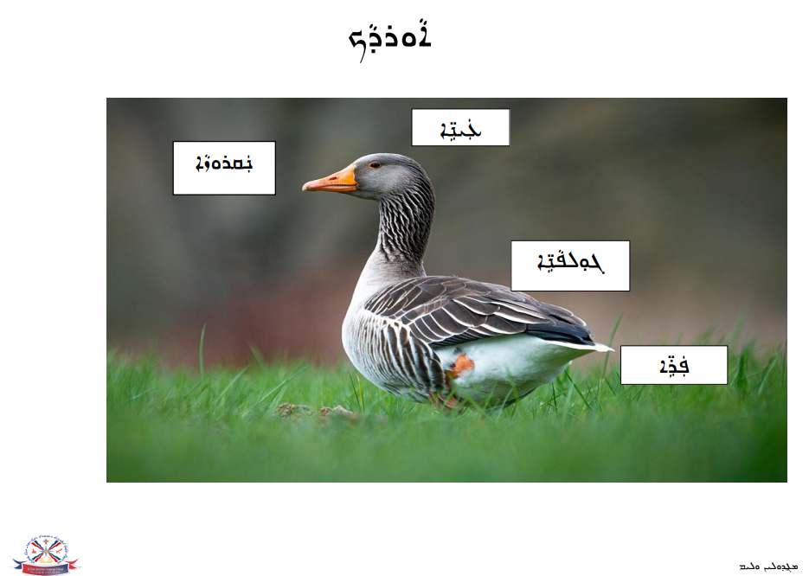
Resource E- Duck Worksheet
Resource E- Duck Worksheet
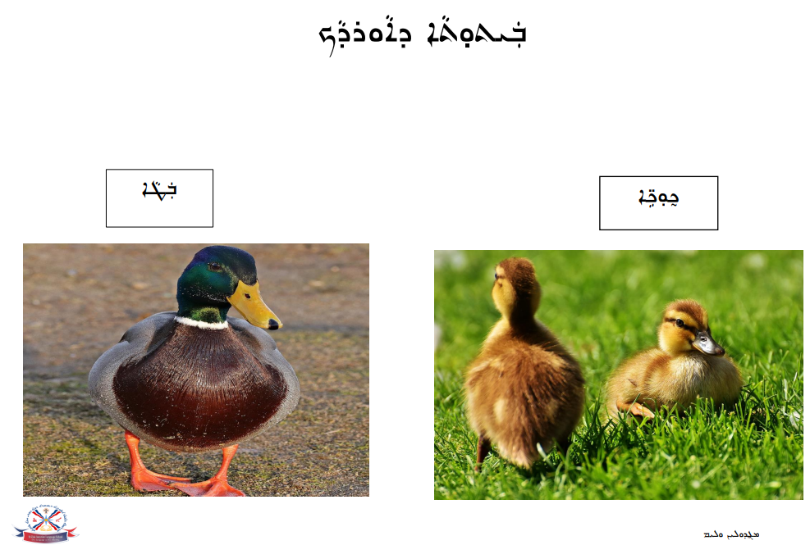
Resource E- Duck Worksheet
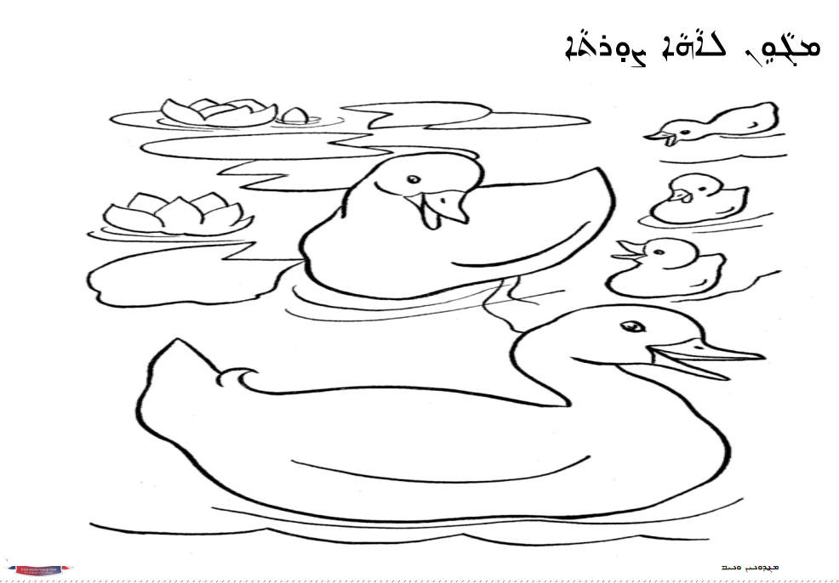
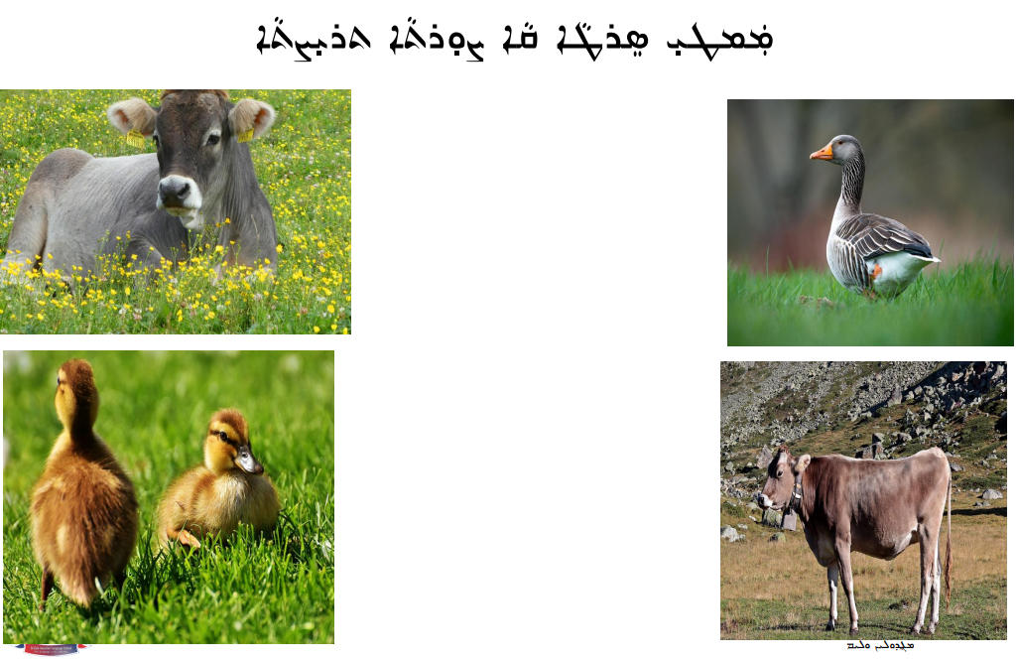
Resource E- Duck Worksheet
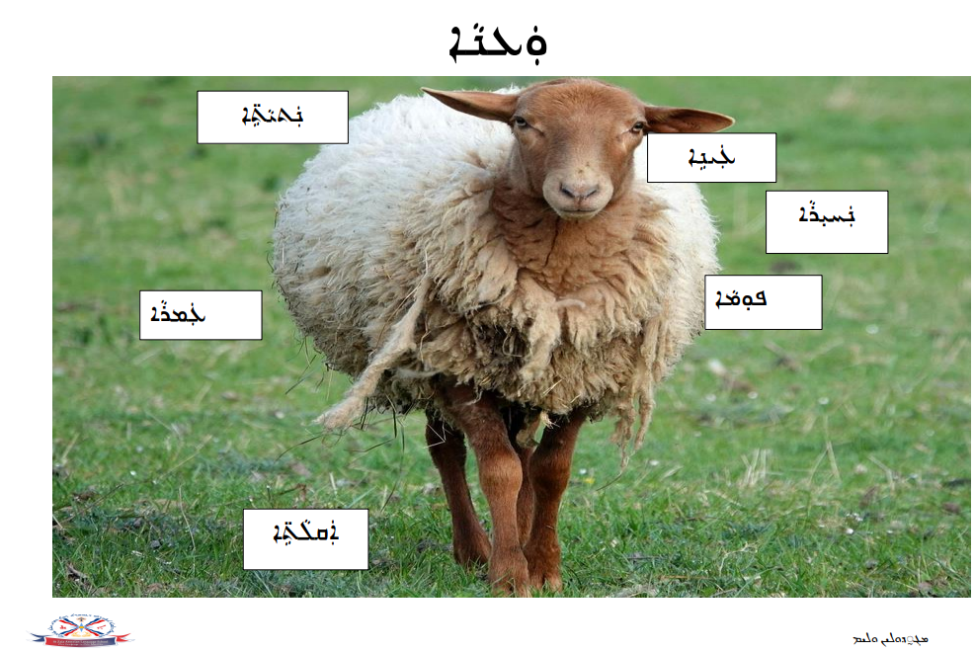
Resource F - Sheep Worksheet
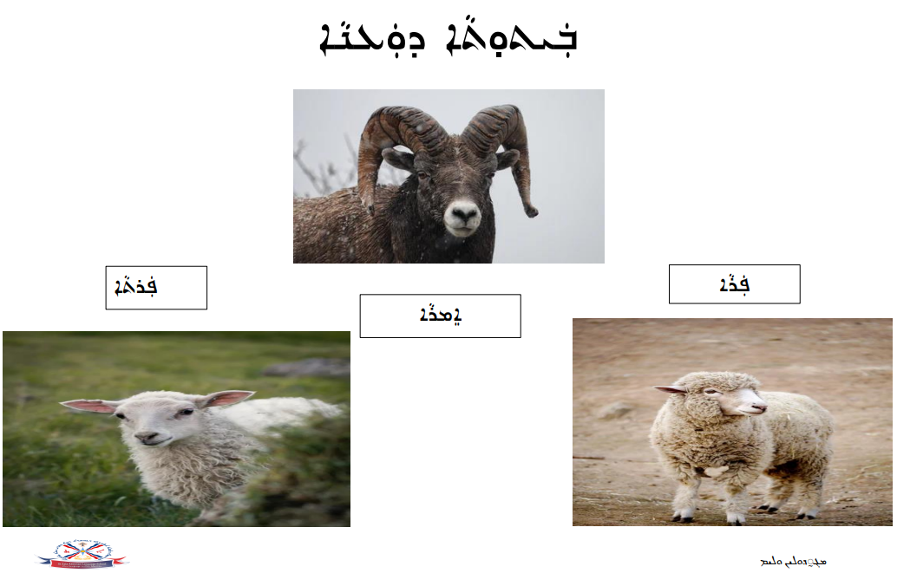
Resource F - Sheep Worksheet
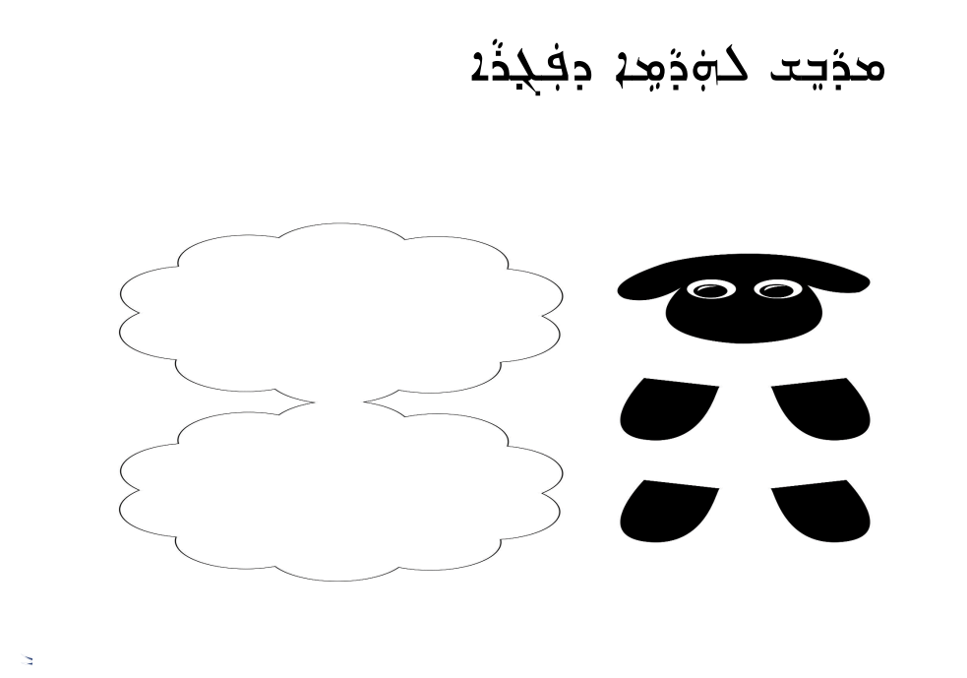
Resource F - Sheep Worksheet

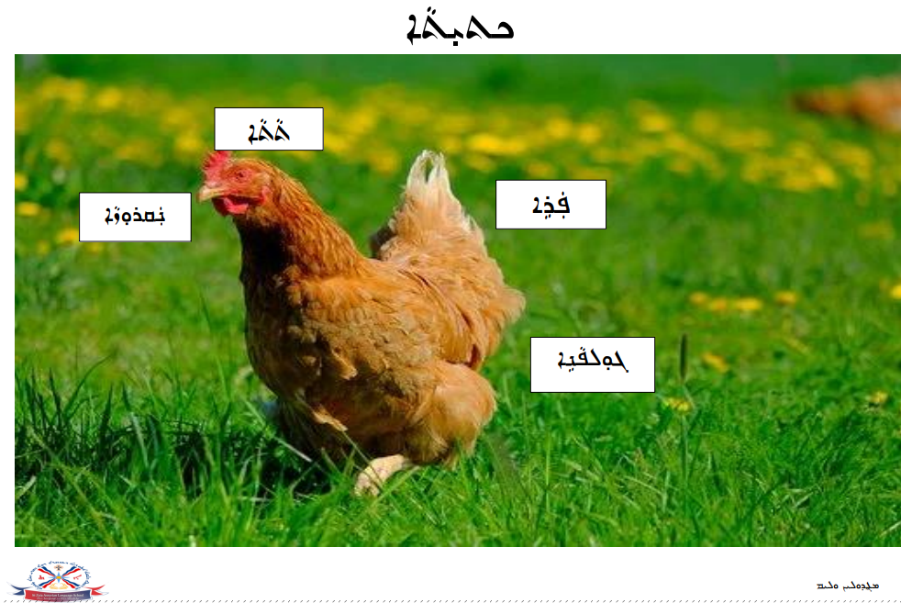
Resource G - Hen Worksheet
Resource G - Hen Worksheet
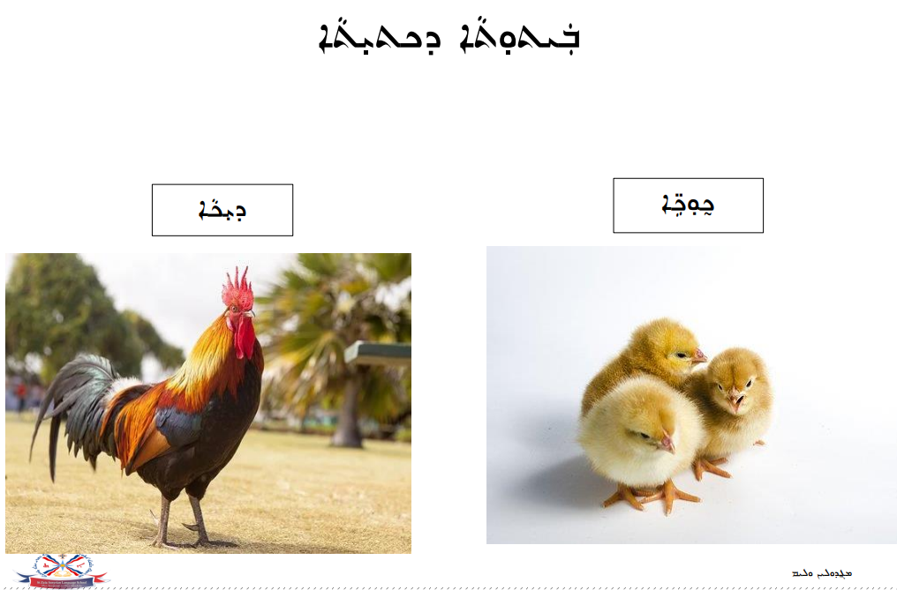
Resource G - Hen Worksheet

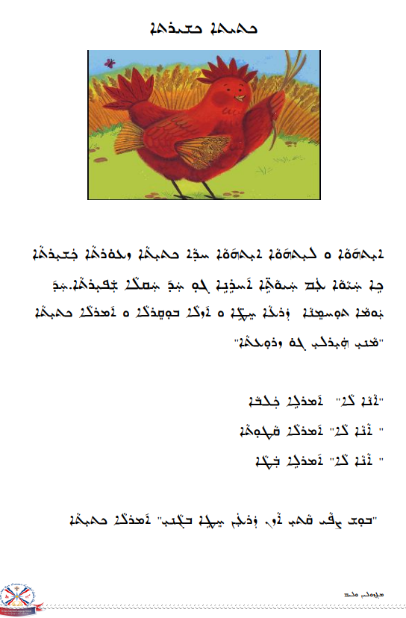
Resource G - Hen Worksheet

Resource G - Hen Worksheet

Resource G - Hen Worksheet
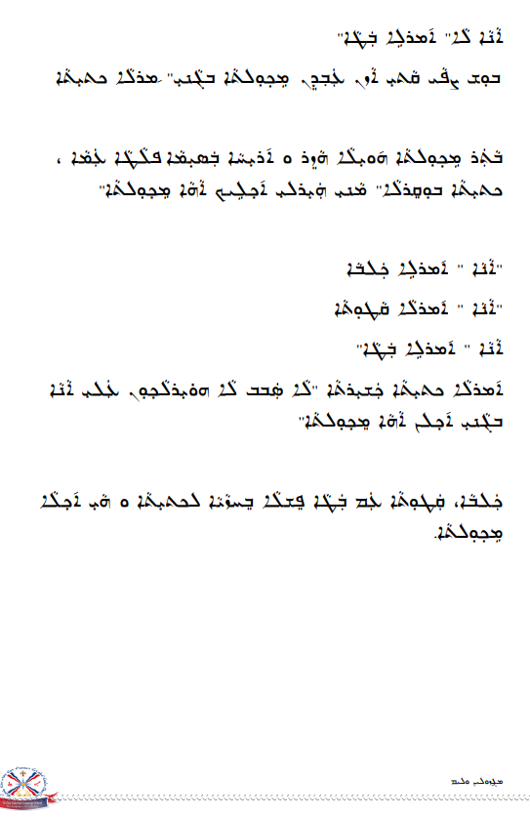
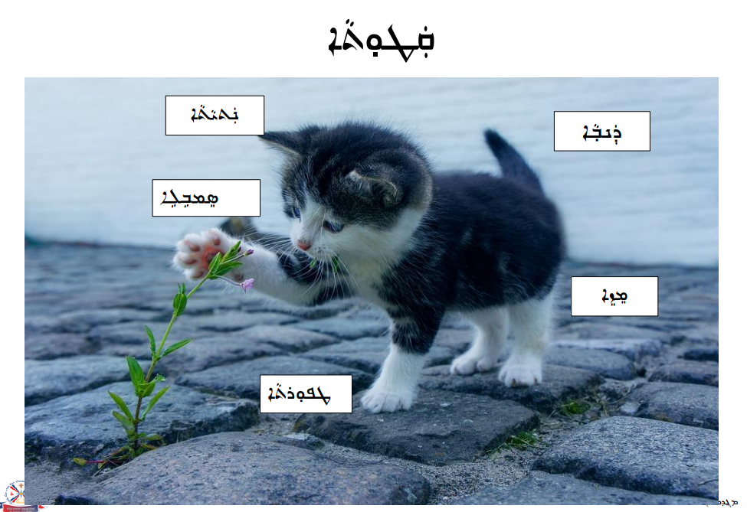
Resource H – Cat Worksheet
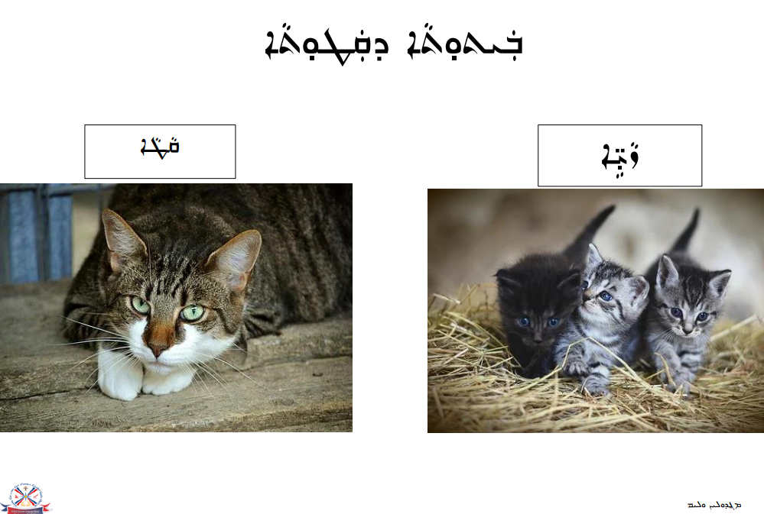
Resource H – Cat Worksheet
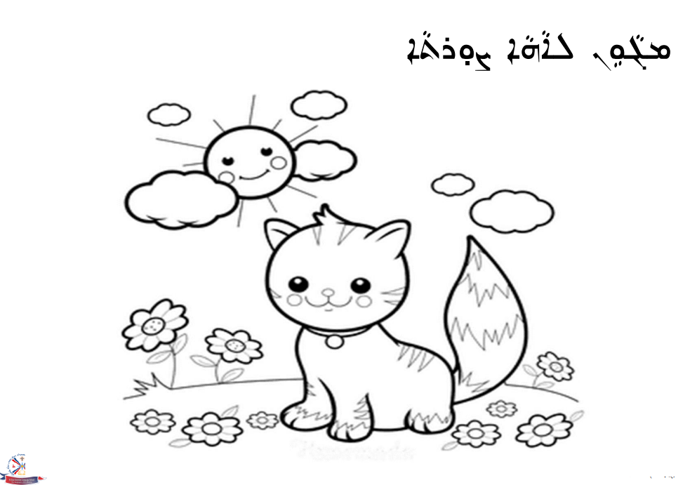
Resource H – Cat Worksheet

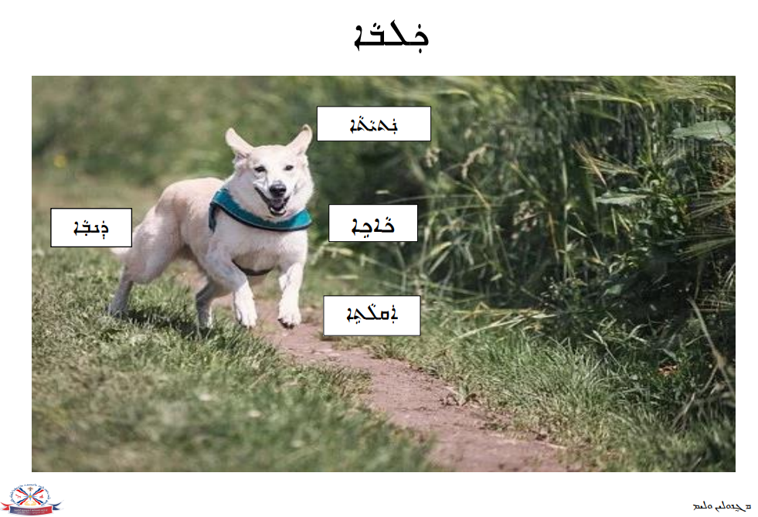
Resource I – Dog Worksheet
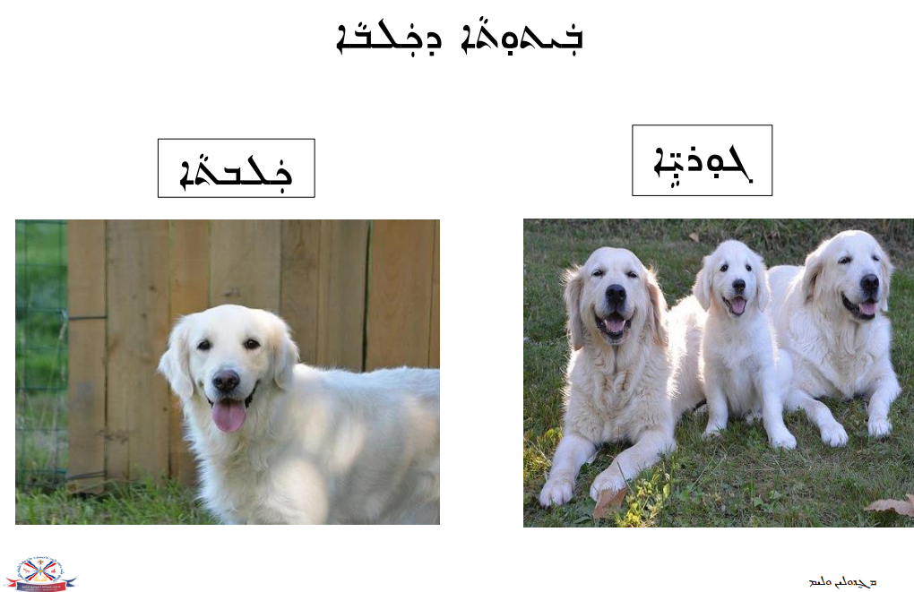
Resource I – Dog Worksheet
Resource I – Dog Worksheet

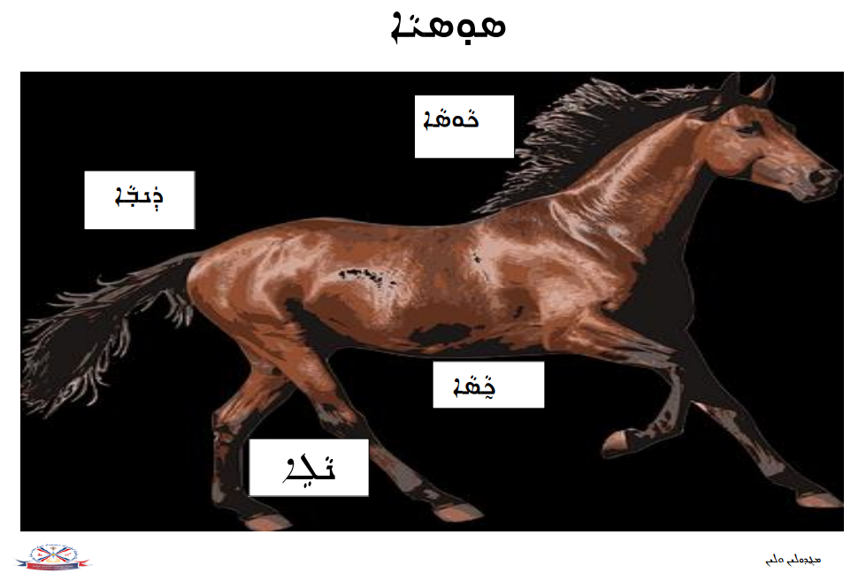
Resource J – Horse Worksheet
Resource J – Horse Worksheet

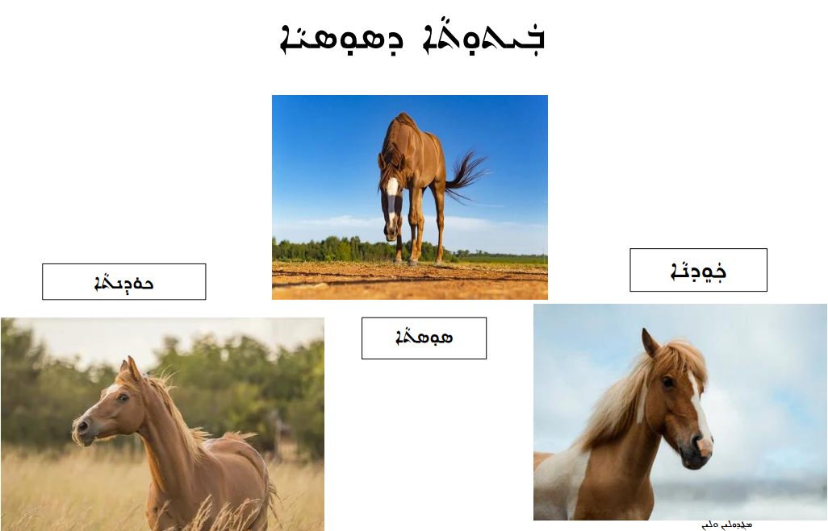
Resource J – Horse Worksheet

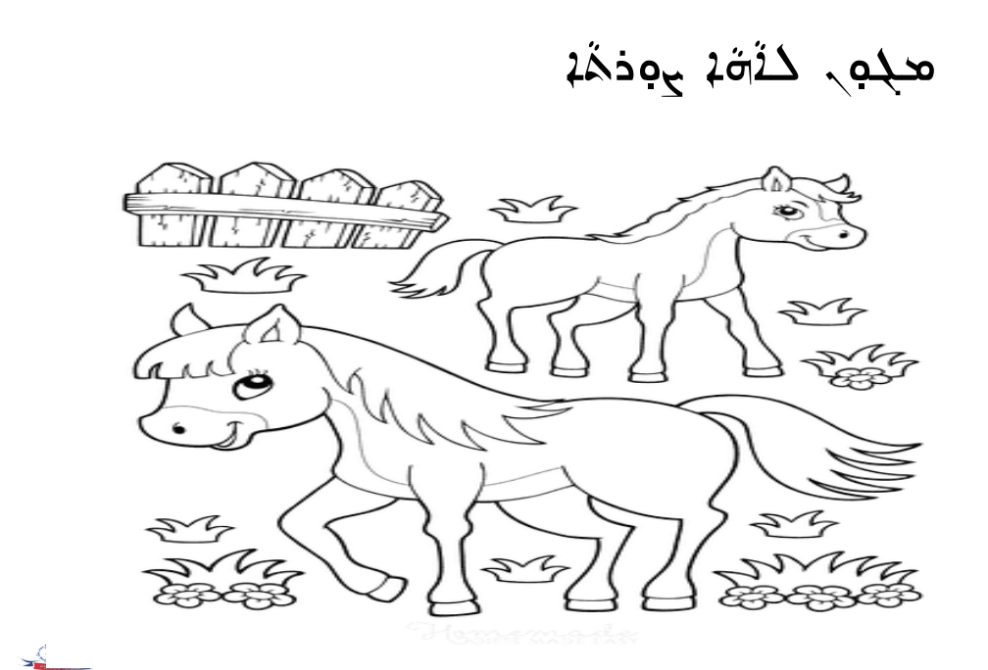
Resource J – Horse Worksheet

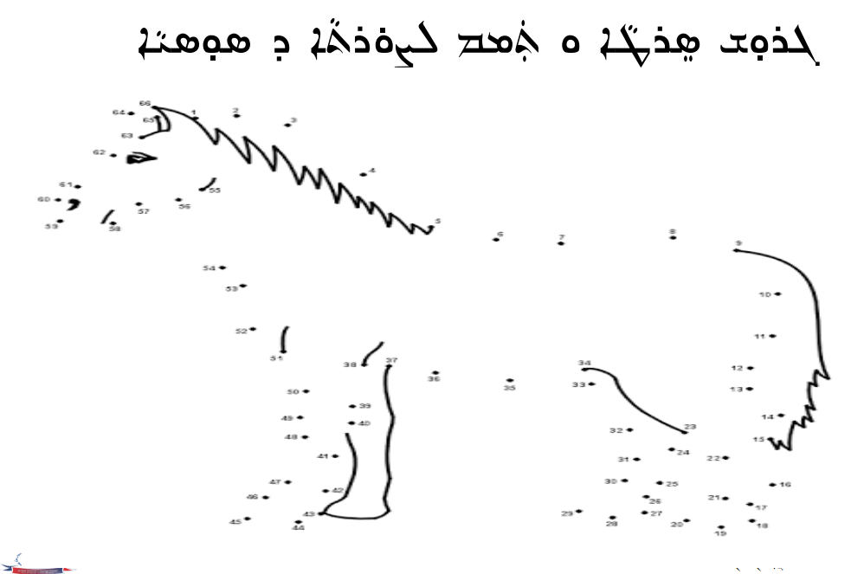
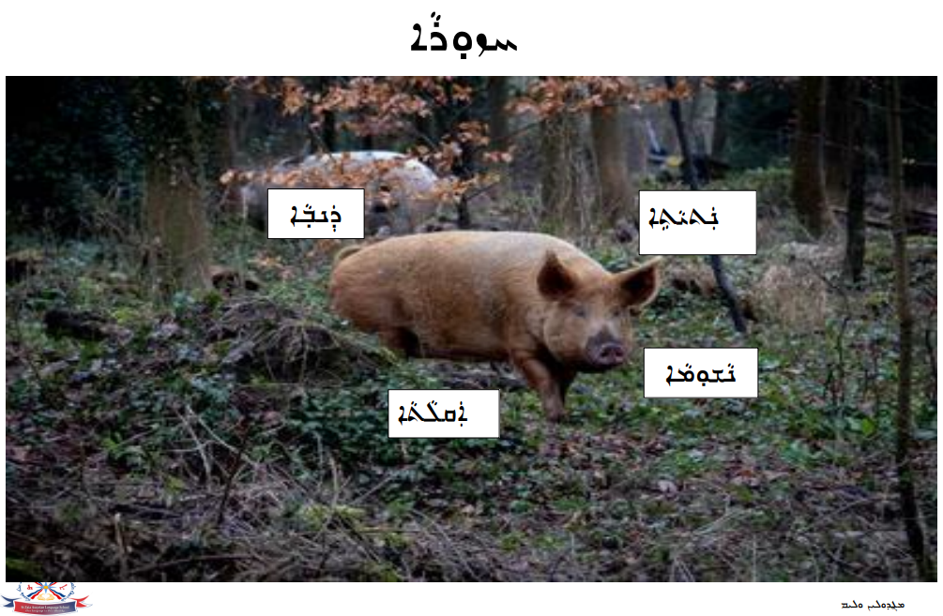
Resource K – Pig Worksheet
Resource K – Pig Worksheet
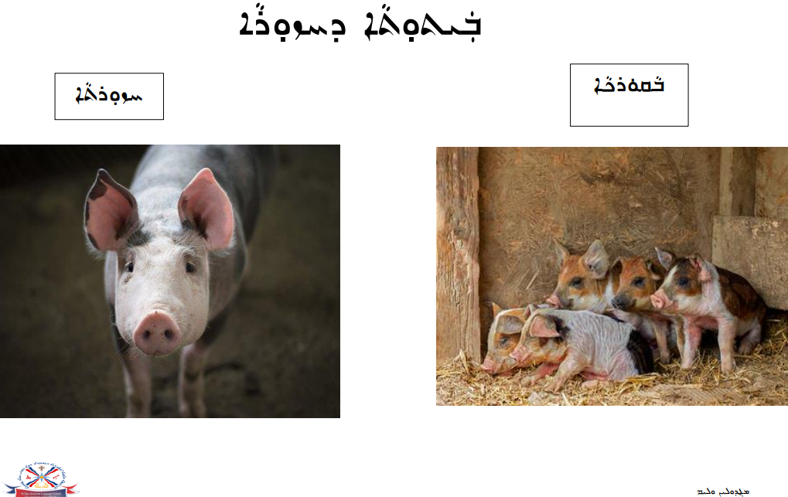
Resource K – Pig Worksheet
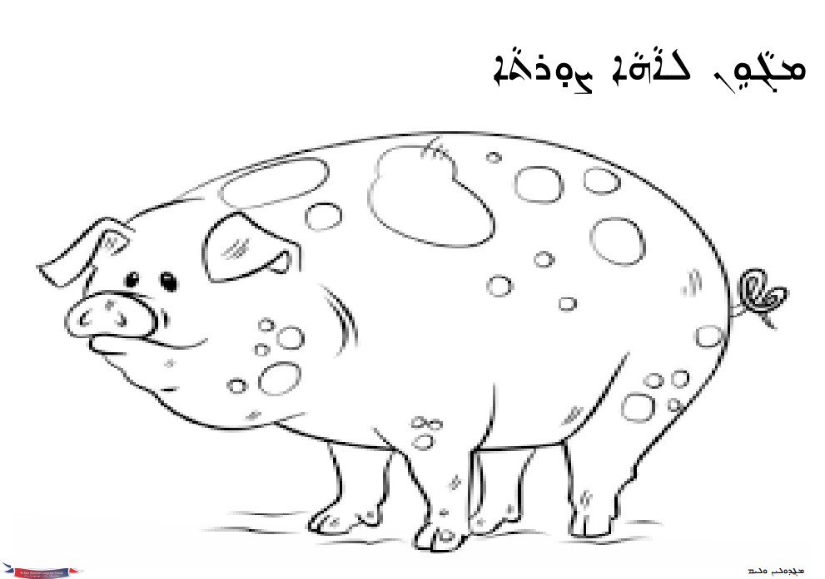
Resource L – Farm Animals Activity
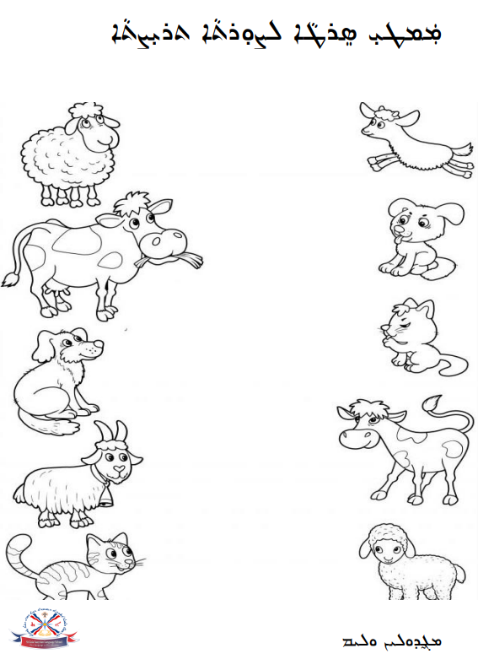
Resource L – Farm Animals Activity
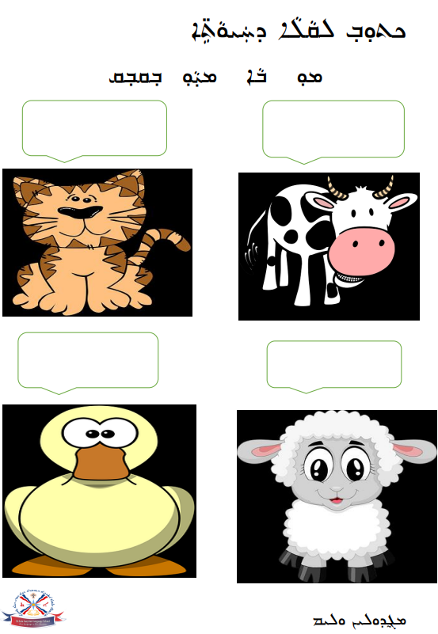
Resource L – Farm Animals Activity
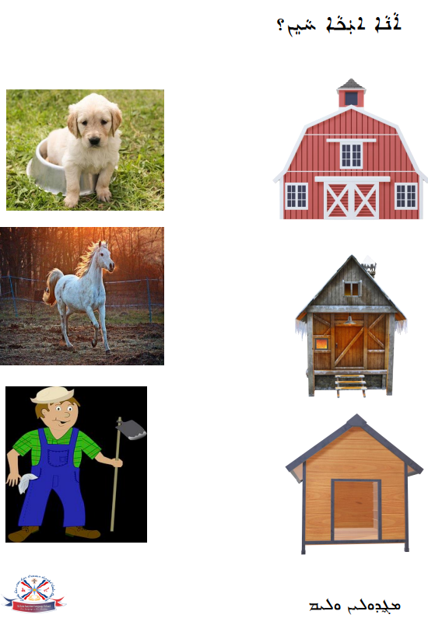
Resource L – Farm Animals Activity

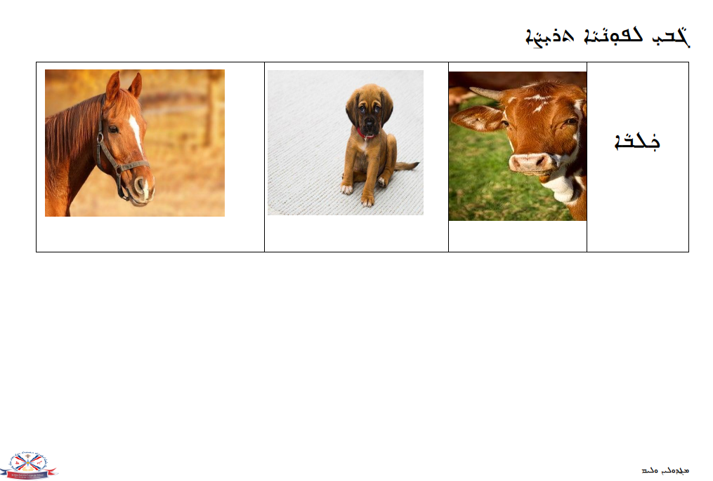
Resource L – Farm Animals Activity
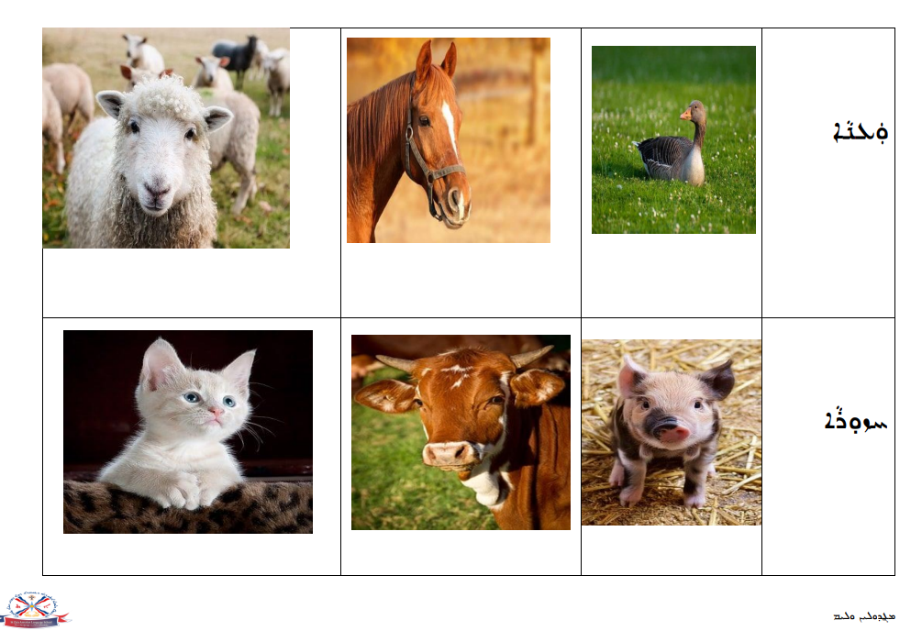
Resource L – Farm Animals Activity
