Mathematics- Numbers

Stage: 1 | Unit Duration: 9 lessons | Weeks: 1 2 3 4 5 6 7 8 9 10 | Terms: 1 2 3 4
Unit Description and Overview | All students will develop the knowledge about numbers and how they are read and written. Students will also learn and use vocabulary from the Assyrian and Chaldean Language throughout the unit, which they can use in other lessons.  Teaching and learning activities are designed to help students construct understanding for deeper learning. A variety of tasks will be included, both in theory and practice to ensure students get a mix of activities that cater to their needs.
Lesson Overview | 1. Identifying Numbers  2. Numbers 1-10  3. Numbers 11-20  4. Sequencing Numbers  5. Number Patterns  6. Counting in Collections  7. Connecting Numbers  8. Numbers Bingo  9. Numbers Assessment  (Lessons may take more than one week)
Organisation | Lessons are designed to ensure teachers lead learning and content and students have opportunities to listen and respond. This will ensure all students are active participants of their learning.  All lessons will include:  Learning Intentions, Success Criteria, Vocabulary and Language, Warm Up Activities, Modelled Teaching, Independent tasks, group tasks, partner tasks, Think/Pair/Share, technology use, warm up activities, reflection etc.
Essential Questions | - How do I read numbers in Assyrian/Chaldean?  - How do I write numbers in Assyrian/Chaldean?  - What patterns do I notice in the numbers?  - How do I represent numbers?
Assessment | Teachers have assessment opportunities before and after the unit to track progress. Students can number an empty template to show their understanding before the unit commences and after. The assessment for learning is ongoing.
Technology and Useful Websites | Teachers may use resources such as iPads and laptops to support students with their learning. Students should be exposed to a variety of songs, rhymes, books etc. to support their learning.  Some websites that may be helpful for teachers to visit before and during the unit for support include:  https://bingobaker.com/view/2287347 (Bingo)  https://youtu.be/eOTEA5CzAX8 (Numbers in Assyrian)  https://youtu.be/REfR0tiBzWo (Numbers Song in Assyrian)  https://youtu.be/4-bKHR0A2ZM (Once I Caught a Fish Alive in Assyrian)  https://youtu.be/v9pFCKI4V8c (Counting 1-10 in Assyrian)

Mathematics- Numbers
Year: 1 Lesson Sequence: 1 of 9

Subject: Mathematics Topic: Identifying Numbers

Learning Intention: We are learning to identify numbers in our environment.

Success Criteria: I will be successful if I can identify numbers in an environment.

Key words: number, environment, symbol, word, digit, letters etc.

Resources: Paper, pencils, cardboard, books.

Starter:
- Class discussion:
- What are numbers? (Numbers are words or symbols, known s digits that we use in counting to tell someone how many. E.g., 5 ducks or three pencils.
- Where do we see numbers? (In the environment, for example a letter box).
- What is the connection between numbers on the clock and the Assyrian/Chaldean Alphabet?
- Make a class list of all the places students see numbers in their everyday life and brainstorm them on cardboard for future reference. Some examples include on houses, on buildings, in books, on clothes, on cars, when watching television, on a clock, on a calendar etc.
- Discuss how we can see numbers everywhere and they are a part of everyday life.

Activity:
- As a class, go on a number hunt around the school. Record some numbers that you see in your environment.
- Students may like to label a clock with the number and corresponding Assyrian alphabet letter.

Wrap-up:
- Students sit in a circle. They take turns to give examples of numbers they’ve seen in various settings such as: shops, school, classroom, cinemas, clock, calendar etc.

Mathematics- Numbers
Year: 1 Lesson Sequence: 2 of 9

Subject: Mathematics Topic: Numbers 1-10

Learning Intention: We are learning to read and write numbers 1-10 in Chaldean/Assyrian Language.

Success Criteria: I will be successful if I can read and write numbers 1-10 in my language.

Key words: number, digit, letter, sequence, order, represent etc.

Resources: Whiteboard, whiteboard markers, Alphabet flashcards (Resource A), Number flashcards (Resource B), books.

Starter:
- Teacher to flash number cards 1-10 (alphabet flashcards may be used here to show the link) to students and have students call out the name of the number.
- Explain that numbers can be sequenced in order, and we use symbols to represent a number.
- Discuss how the Chaldean/Assyrian alphabet letters are used to represent numbers. For example, ‘Alep is 1 etc.’
- Model how to draw and write numbers 1-10 by using the alphabet letters to represent the numbers on a whiteboard. Students can copy these in their books. Discuss how we say them in Assyrian/Chaldean e.g., Kha, Tre, Tlata etc.

Activity:
- Students practice writing numbers 1-10 in their books.

Wrap-up:
- Numbers Race Game: 2 students will stand at the front of a whiteboard. The teacher will say a number (between 1-10) in Chaldean/Assyrian and the two students must quickly pick up a whiteboard marker and write it on the board. The quickest student will get a point. At the end, the student with the most point wins.

Mathematics- Numbers

Year: 1 Lesson Sequence: 3 of 9

Subject: Mathematics Topic: Numbers 11-20.

Learning Intention: We are learning to read and write numbers 11-20 in Chaldean/Assyrian Language.

Success Criteria: I will be successful if I can read and write numbers 11-20 in my language.

Key words: number, digit, letter, sequence, order, combine, represent etc.

Resources: Whiteboard, whiteboard markers, Alphabet flashcards (Resource A), Number flashcards (Resource B), books.

Starter:
- Teacher to flash number cards 11-20 (alphabet flashcards may be used here to show the link) to students and have students call out the name of the number.
- Revise that numbers can be sequenced in order, and we use symbols to represent a number.
- Discuss how the Chaldean/Assyrian alphabet letters are used to represent numbers and we can combine them to make 2-digit numbers. E.g., we use the letters for 1 and 10 to create 11.
- Model how to draw and write numbers 11-20 by using the alphabet letters to represent the numbers on a whiteboard. Students can copy these in their books. Discuss how we say them in Assyrian/Chaldean e.g., Isrih oh Kha, Isrih oh Tre, etc.

Activity:
- Students practice writing numbers 11-20 in their books.

Wrap-up:
- Numbers Race Game: 2 students will stand at the front of a whiteboard. The teacher will say a number (between 11-20) in Chaldean/Assyrian and the two students must quickly pick up a whiteboard marker and write it on the board. The quickest student will get a point. At the end, the student with the most point wins.

Mathematics- Numbers

Year: 1 Lesson Sequence: 4 of 9

Subject: Mathematics Topic: Sequencing Numbers.

Learning Intention: We are learning to sequence numbers 1-20.

Success Criteria: I will be successful if I can correctly sequence numbers 1-20.

Key words: number, digit, sequence, order, smallest, largest, pattern, skip, forwards, backwards etc.

Resources: Whiteboard, whiteboard markers, 20 puzzle template worksheet (Resource C).

Starter:
- Discuss what sequencing means. Sequencing is when you make a list of things in order. We can sequence numbers and use them in counting.
- Ask students:
- How can we sequence numbers forwards? (e.g., 1, 2, 3, 4 etc.)
- How can we sequence numbers backwards? (e.g., 10, 9, 8, 7 etc.)
- How can we sequence numbers in patterns? How? (e.g., 10, 20, 30 etc.)
- Do we have to start at 0 to count? No, we can start at any number and even skip count to get to an answer. E.g., 2, 4, 6, 8, 10.
- Teacher to write down some number words in Assyrian/Chaldean on the board that are not in order. As a class, work together to put them in order from smallest to largest or largest to smallest. Read the names/numbers in Assyrian/Chaldean.

Activity:
- Sequence Puzzle: Students draw numbers 1-20 in Chaldean/Assyrian on the puzzle template provided. Then, they cut the pieces and put the puzzle together to sequence numbers correctly.

Wrap-up:
- Students sit in a circle and count forwards, backwards, skip count etc. in Assyrian/Chaldean.
- Extend students to numbers up to 30, 50 or 100 in future lessons depending on abilities.

Mathematics- Numbers

Year: 1 Lesson Sequence: 5 of 9

Subject: Mathematics Topic: Number Patterns.

Learning Intention: We are learning about number patterns.

Success Criteria: I will be successful if I can count numbers in different orders to create patterns.

Key words: pattern, number, forwards, backwards, skip, song, rhyme etc.

Resources: Whiteboard, whiteboard markers, Links to YouTube songs on front page.

Starter:
- Revise how we can say numbers in order. E.g., 1, 2, 3 etc. When you say a number in a certain order, you create a pattern.
- Ask students:
- What other patterns do you know?
- How do our multiplication tables help us to explore number patterns? E.g., 10, 20, 30, 40 or 2, 4, 6, 8 etc.
- What is happening to numbers when we say them like this?
- What songs or rhymes do you know that help you count?
- Teacher to write down some number words in Assyrian/Chaldean on the board in different patterns, e.g., 10, 11, _, 14 or 2, 4, _, 8 etc. As a class, fill in the examples with the correct numbers. Read the names/numbers in Assyrian/Chaldean.

Activity:
- Teacher to sing a song that has counting in it. Example: 5 little ducks, 1, 2, 3, 4, 5, Once I caught a fish alive’, ‘Ten in the bed’ etc. Links on YouTube provided on unit outline. Teachers may like to use Chaldean/Assyrian when singing.
- Students to work together to create their own song in Chaldean/Assyrian for numbers 1-5, 1-10 or 1-20. Write the songs down for future reference.

Wrap-up:
- Groups to perform their songs to the class.

Mathematics- Numbers

Year: 1 Lesson Sequence: 6 of 9

Subject: Mathematics Topic: Counting in Collections.

Learning Intention: We are learning about counting in collections.

Success Criteria: I will be successful if I can count objects in collections and represent the collection with a number.

Key words: count, collection, quantity, total, skip count etc.

Resources: whiteboard, whiteboard markers, plastic cups, textas, counters, rocks, marbles etc.

Starter:
- Discuss how a number can be represented. We can use a symbol or a collection of objects. When counting, we must only count that object once and when we finish counting all the objects, that is the total.
- Teacher to draw a variety of collections on the board (example, draw 3 fish).
- Ask students: how many in each collection? How did you find the total? Is there an easier way to count instead of counting by ones?

Activity:
- Students to work in partners or small groups to count objects such as counters, rocks, marbles etc. and put them in a plastic cup and label them with the correct Assyrian/Chaldean symbol for the number using textas.

Wrap-up:
- Students to walk around and count cups from other groups to check if they have counted the collection correctly and written the correct symbol on the cup.

Mathematics- Numbers

Year: 1 Lesson Sequence: 7 of 9

Subject: Mathematics Topic: Connecting Numbers.

Learning Intention: We are learning about how to connect a number to its name, symbol and collection.

Success Criteria: I will be successful if I can connect a number to its name or quantity.

Key words: number, quantity, name, digit, symbol, collection, count etc.

Resources: Number Arrows Worksheet (Resource D), whiteboard, whiteboard markers

Starter:
- Revise how we can represent a number.
- Ask students
- How can we represent a number? By its name, symbol or collection of items. We can also use the word ‘quantity’ for collection.

Activity:
- Teacher to say a number in Chaldean/Assyrian. Students need to write in their books how to say that number (name e.g., khaa is 1 or tre is 2), how to write that number (Assyrian/Chaldean letter symbol) and one way to represent it (drawing, e.g., 4 stars make 4). Do some other examples as a whole class.
- Students use the Number Arrows Worksheet to create three ways to say a number. One arrow will have the symbol in Chaldean/Assyrian, one will have how to say it and the other will have a picture of a collection of items representing that number.

Wrap-up:
- Display the arrows around the class in sequence.
- Refer to displays in future lessons when looking at numbers and how they are represented.

Mathematics- Numbers

Year: 1 Lesson Sequence: 8 of 9

Subject: Mathematics Topic: Numbers Bingo

Learning Intention: We are learning how play bingo using Assyrian/Chaldean numbers.

Success Criteria: I will be successful if I can identify numbers in Assyrian/Chaldean.

Key words: letter, number, symbol, represent, bingo.

Resources: Bingo Template from https://bingobaker.com/view/2287347 or example from (Resource E), counters, stopwatch.

Starter:
- Teacher to revise what symbols in Chaldean/Assyrian are used to represent numbers.
- Students to sit in a circle. Teacher to give a student an object e.g., pencil. They must pass the pencil around in a circle until the teacher, who is not looking, says ‘stop’ and calls a number in English. The student who is holding the object has to say the number in Assyrian/Chaldean.

Activity:
- Students get into teams of 2-4 and pick a bingo card from the templates provided.
- The teacher will show the card or call out the name in Assyrian/Chaldean to challenge the students.
- The students will put a counter on the symbol if they have it.
- The first group to have counters on a whole line or whole card wins.

Wrap-up:
- Students can play the game in different ways, for example: with a timer, first group to get two rows or two columns, saying the name of the symbol only or the number only etc.

Mathematics- Numbers

Year: 1 Lesson Sequence: 9 of 9

Subject: Mathematics Topic: Numbers Assessment

Learning Intention: We are learning how to fill out a template with missing Chaldean/Assyrian Numbers.

Success Criteria: I will be successful if I can correctly fill out the template with Assyrian/Chaldean number symbols.

Key words: missing, letter, symbol, represent, sequence, order etc.

Resources: Numbers Assessment Worksheet (Resource F)

Starter:
- Play a game of Buzz Off Hairy Legs. Students stand in a circle and count to a certain number in Assyrian/Chaldean. When the number reaches a student, the next student says ‘Buzz’, then ‘Off’, then ‘Hairy’, then ‘Legs’. Whoever is after the word ‘legs’ is out. Students play until there is a winner at the end.

Activity:
- Students fill in the Assessment worksheet with the correct Assyrian/Chaldean symbol for numbers 1-20.
- Teacher may like to extend the capable students by giving them a template up to 50 or 100.

Wrap-up:
- Teacher to mark assessments and hand them out.
- Students should get a chance to practice their incorrect answers in future lessons.

Resource A- Alphabet Flashcards
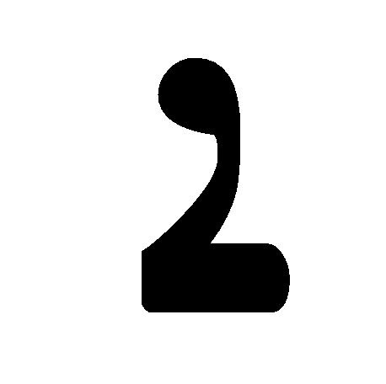  Alap | 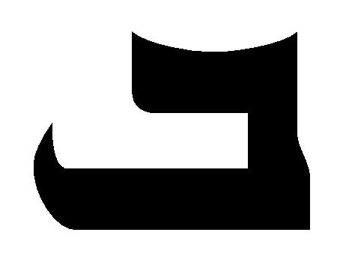  Beth
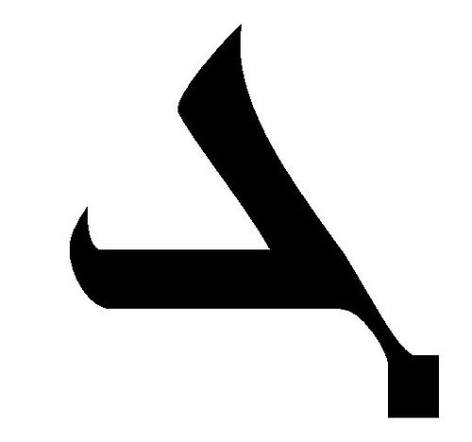  Gamal | Dalath
Resource A- Alphabet Flashcards
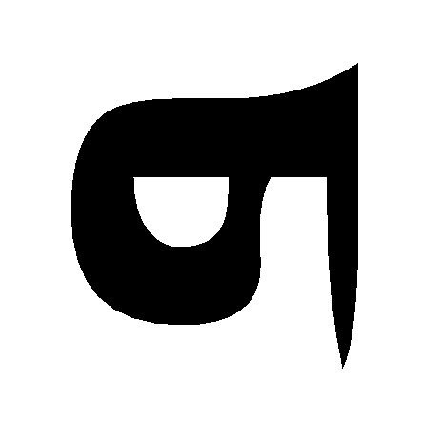  He | Waw
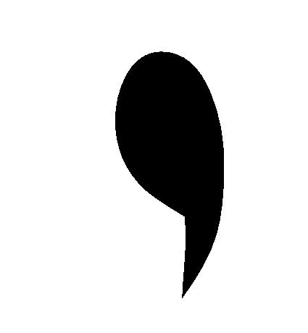  Zein | Heth
Resource A- Alphabet Flashcards
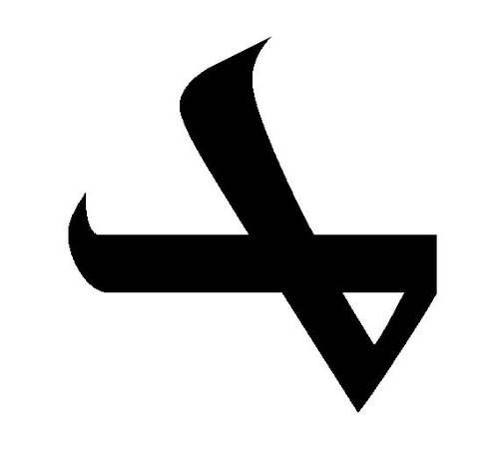  Teth | Yooth
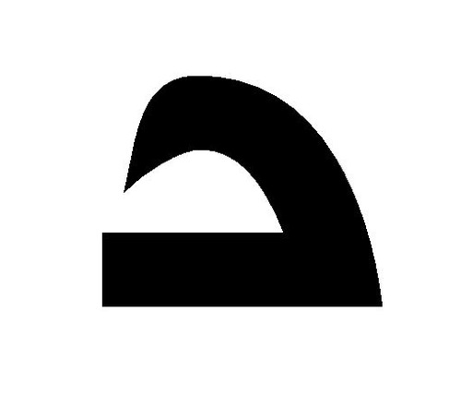  Kap | 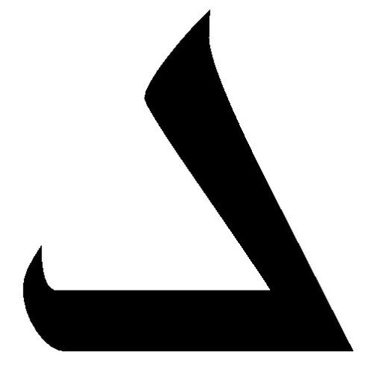  Lamath
Resource A- Alphabet Flashcards
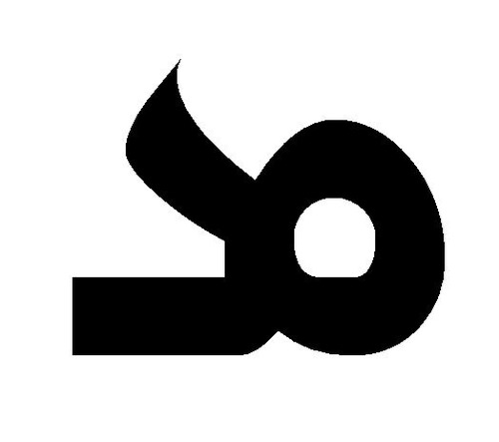  Teth  Meem | Noon
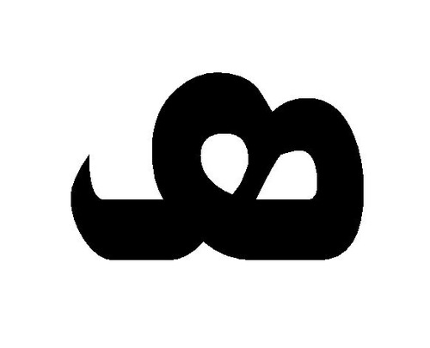  Simkat | 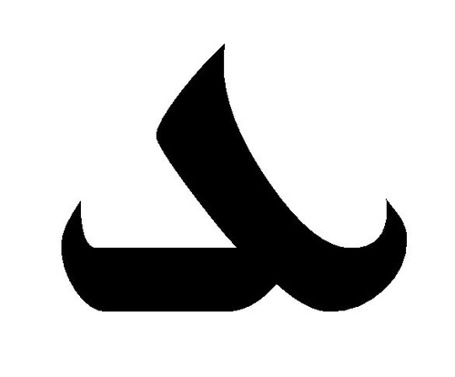  Eh
Resource A- Alphabet Flashcards
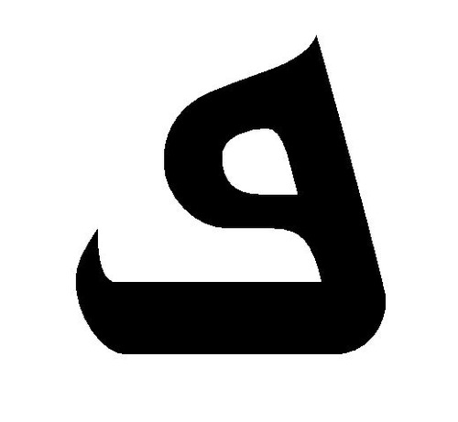  Peh  Teth  Peh | 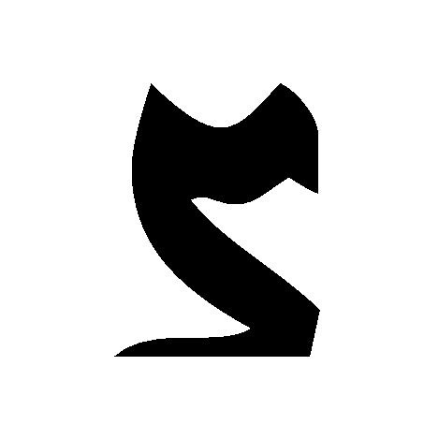  Sadeh
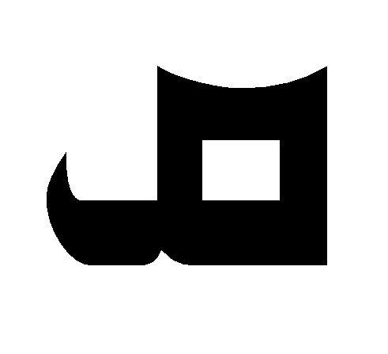  Qop | 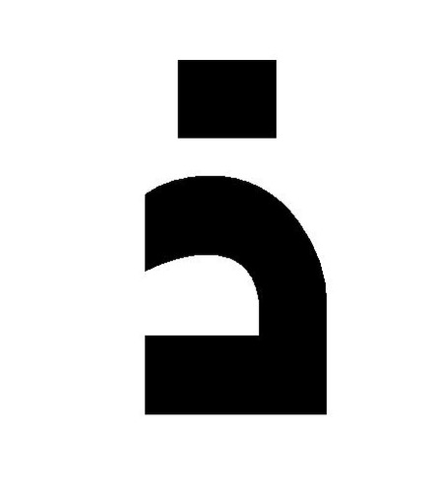  Resh
Resource A- Alphabet Flashcards
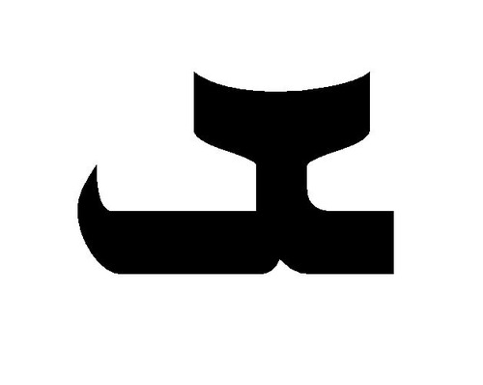  Teth  Sheen | Taw
Resource B- Number Flashcards

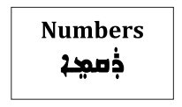

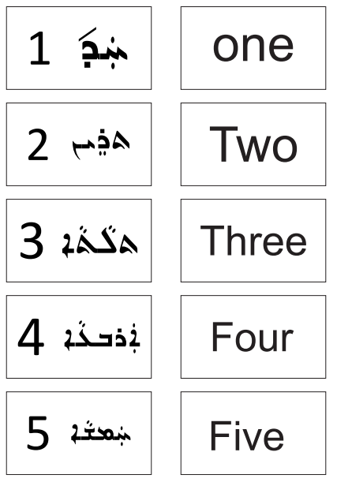

Resource B- Number Flashcards

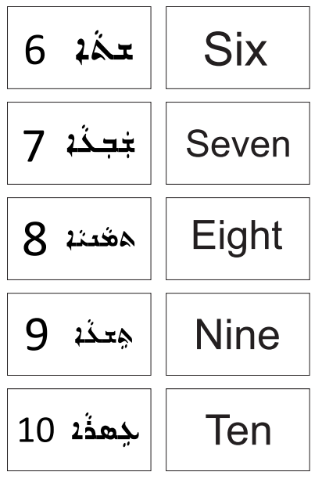

Resource B- Number Flashcards

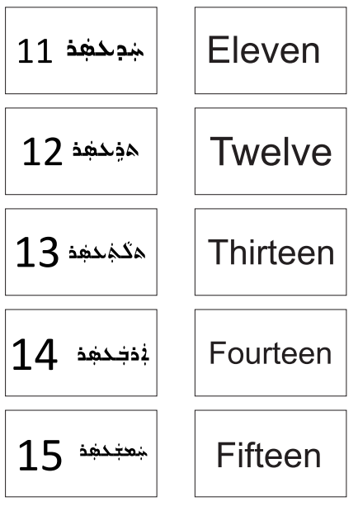

Resource B- Number Flashcards
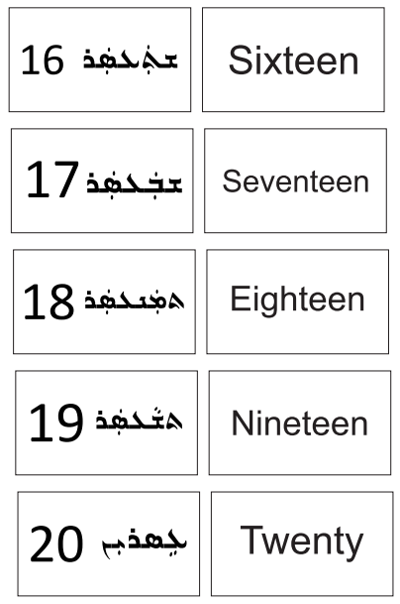

Resource C- 20 puzzle template worksheet
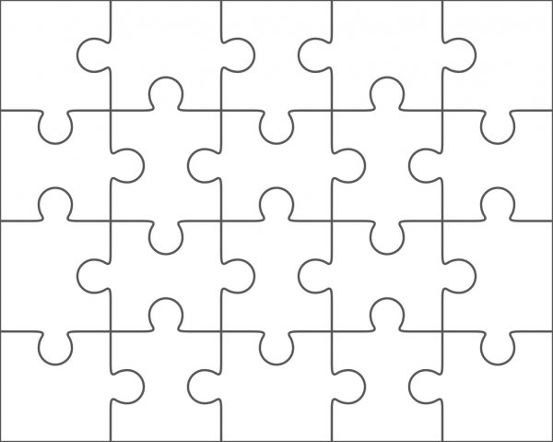

Resource D- Number Arrows worksheet

Resource E- Bingo Template Example

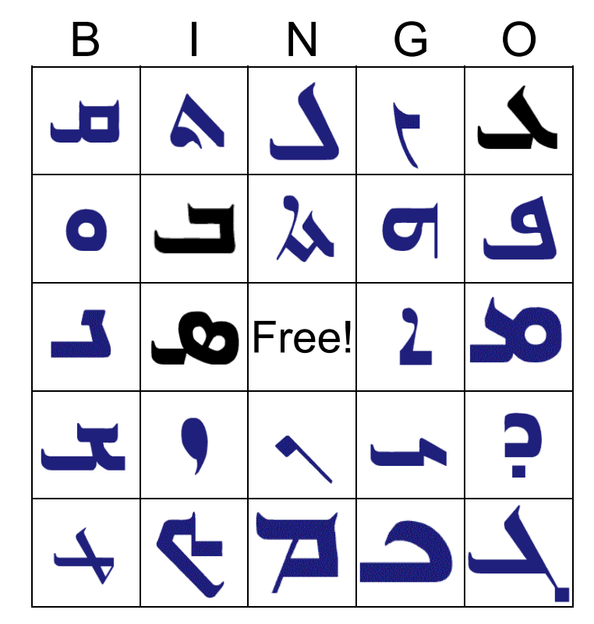

Resource F- Numbers Assessment Worksheet

Numbers Assessment
1-20

Resource F- Numbers Assessment Worksheet

Numbers Assessment
1-50

Resource F- Numbers Assessment Worksheet

Numbers Assessment
1-100.

