The Four Seasons

Stage: 1 | Unit Duration: 9 lessons | Weeks: 1 2 3 4 5 6 7 8 9 10 | Terms: 1 2 3 4
Unit Description and Overview | All students will develop the knowledge about the four main seasons- Summer, Autumn, Winter and Spring. Students will also learn and use vocabulary from the Assyrian and Chaldean Language throughout the unit, including days of the week, months, weather, fruits, clothing, lifestyle etc. The four seasons will be covered in one lesson plan; however, many activities can be completed from that lesson, and it may take longer than one session. The lessons may also be taught in different order, depending on the situation. Teaching and learning activities are designed to help students construct understanding for deeper learning. A variety of tasks will be included, both in theory and practice to ensure students get a mix of activities that cater to their needs.
Lesson Overview | 1. What are the Four Seasons?  2. What are the months of the year?  3. What are the days of the week?  4. What are some examples of fruits and vegetables?  5. What happens during Summer?  6. What happens during Autumn?  7. What happens during Winter?  8. What happens during Spring?  9. Seasons Post Assessment  (Teacher can use the end of the unit as opportunity for assessment)
Organisation | Lessons are designed to ensure teachers lead learning and content and students have opportunities to listen and respond. This will ensure all students are active participants of their learning.  All lessons will include:  Learning Intentions, Success Criteria, Vocabulary and Language, Warm Up Activities, Modelled Teaching, Independent tasks, group tasks, partner tasks, Think/Pair/Share, technology use, warm up activities, reflection etc.
Essential Questions | - What are the Days of the Week?  - What are the four seasons?  - What is the weather like during the four seasons?  - What is special during Summer?  - What is special during Autumn?  - What is special during Winter?  - What is special during Spring?
Assessment | Teachers have assessment opportunities before and after the unit to track progress. Students can label an empty template to show their understanding before the unit commences and after. The assessment for learning is ongoing.
Technology and Useful Websites | Teachers may use resources such as iPads and laptops to support students with their learning. Students should be exposed to a variety of songs, rhymes, books etc. to support their learning.  Some websites that may be helpful for teachers to visit before and during the unit for support include:  https://youtu.be/ZqSSLvyB4Ko (Days of the Week song in Assyrian)  https://youtu.be/uWWBwml-4oo (Seasons song in Assyrian)  https://youtu.be/0xCgxXQDYqM (Months of the year in Assyrian)  https://youtu.be/9wLiqyqbDVc (Fruits in Assyrian)
The Four Seasons
Year: 2 Lesson Sequence: 1 of 9

Subject: Geography Topic: The Four Seasons

Learning Intention: We are learning about the four main seasons during the year.

Success Criteria: I will be successful if I can identify the four seasons and some features of each season.

Key words: season, time, food, clothing, weather, lifestyle, nature, flowers, events, months etc.

Resources: Seasons Worksheets and Activities (Resource A), pencils, black paper, coloured pencils etc.

Starter:
- Class discussion:
- What are the four seasons called?
- How are the four seasons spread out during the months of the year?
- What do we notice in each season with the weather?
- How do we say the four seasons in the Assyrian language?

Activity:
- Seasons Worksheets and Activities
- Students complete a range of worksheets- labelling the seasons with Assyrian words, discussing vocabulary of the weather, labelling the weather with the correct Assyrian word, tracing vocabulary words, writing task etc.

Wrap-up:
- Weather Vocabulary Game
- Students all receive an A4 piece of paper. They draw a line horizontally and vertically to create 4 boxes. Each box will be labelled with a season- Summer, Autumn, Winter and Spring. They have 1 minute to write down some new vocabulary words they have learned in each box.

The Four Seasons
Year: 2 Lesson Sequence: 2 of 9

Subject: Geography Topic: Months of the Year.

Learning Intention: We are learning about the months of the year in Assyrian.

Success Criteria: I will be successful if I can identify the months of the year and link them to the correct season.

Key words: time, month, year, season, calendar, etc.

Resources: Months Worksheets and Activities (Resource B), pencils, coloured pencils etc.

Starter:
- Class discussion:
- Revise what the four seasons are called.
- What are the months of the year?
- How do we say the months of the year in Assyrian?
- Why is it important to know the months of the year?
- When do we use the calendar in everyday life?
- What is the relationship between the months of the year and the seasons?
- Watch the YouTube clip about the months of the year in Assyrian to build vocabulary: https://youtu.be/0xCgxXQDYqM

Activity:
- Months Worksheets and Activities
- Students complete a range of worksheets- labelling the months of the year with Assyrian words, discussing vocabulary, labelling the correct months with the correct Assyrian word, tracing vocabulary words, writing task etc.

Wrap-up:
- Months of the Year Label Task
- Teacher to show students a flashcard with a month of the year written in English. Students must write down the word in Assyrian. The student with the most correct words wins.

The Four Seasons
Year: 2 Lesson Sequence: 3 of 9

Subject: Geography Topic: Days of the Week

Learning Intention: We are learning about the days of the week in Assyrian.

Success Criteria: I will be successful if I can identify the days of the week.

Key words: day, week, month, Monday, Tuesday, Wednesday, Thursday, Friday, Saturday, Sunday, time, event, calendar etc.

Resources: Days of the Week Worksheets and Activities (Resource C), pencils, coloured pencils etc.

Starter:
- Class discussion:
- What are the days of the week?
- How do we say the days of the week in Assyrian?
- How many weeks in a month?
- How many months in a year?
- What are some events that happen during certain days of the week?
- Watch the YouTube clip about the days of the week in Assyrian to build vocabulary: https://youtu.be/ZqSSLvyB4Ko

Activity:
- Days of the Week Worksheets and Activities
- Students complete a range of worksheets- labelling the days of the week with Assyrian words, discussing vocabulary, labelling the correct days with the correct Assyrian word, tracing vocabulary words, writing task etc.

Wrap-up:
- Days of the Week Race
- 2 students stand at the front of the whiteboard. When the teacher says a day of the week in English, the student has to run to the board and correctly write it in Assyrian. Students take turns until there is a winner who wrote the most correct words.

The Four Seasons
Year: 2 Lesson Sequence: 4 of 9

Subject: Geography Topic: Fruits and Vegetables

Learning Intention: We are learning to identify various fruits and vegetables in Assyrian.

Success Criteria: I will be successful if I can identify fruits and vegetables in the Assyrian language.

Key words: fruit, vegetable, apple, banana, pear, mango, orange, season etc.

Resources: Fruits Worksheets and Activities (Resource D), pencils, coloured pencils, plastic fruits and vegetables etc.

Starter:
- Class discussion:
- What are some examples of fruits?
- What are some examples of vegetables?
- How do we say these fruits and vegetables in the Assyrian language?
- When do we usually eat these fruits and vegetables?
- In what seasons do some fruits and vegetables grow in?
- Watch the YouTube clip about the fruits Assyrian to build vocabulary: https://youtu.be/9wLiqyqbDVc
- Teacher to show students a range of plastic fruits and vegetables and discuss some features such as size, colour, where and when it grows etc.

Activity:
- Fruits Worksheets and Activities
- Students complete a range of worksheets- labelling the fruits with Assyrian words, discussing vocabulary, labelling the correct fruits with the correct Assyrian word, tracing vocabulary words, writing task, colouring worksheet etc.

Wrap-up:
- Fruit Music Vocabulary Game
- Students sit around in a circle. A fruit is passed around the circle of students and when the music stops, the student holding the fruit must say its name in Assyrian.

The Four Seasons
Year: 2 Lesson Sequence: 5 of 9

Subject: Geography Topic: Summer

Learning Intention: We are learning about the season of Summer.

Success Criteria: I will be successful if I can explain some characteristics of Summertime.

Key words: season, summer, months, food, clothes, weather, lifestyle, colours etc.

Resources: Summer Worksheets and Activities (Resource E), pencils, coloured pencils, etc.

Starter:
- Class discussion:
- What is Summer called in Assyrian?
- What months do we have Summer in Australia?
- What are some pieces of clothing we wear during Summer?
- What is the weather like during Summer?
- What are some places we go to during Summer?
- What happens during summertime in Australia?
- What foods do we eat during Summer?
- What are the colours associated with Summer?
- What are some events that happen during Summer in Australia?

Activity:
- Summer Worksheets and Activities
- Students complete a range of worksheets- reading text about Summer, tracing vocabulary words, matching summer vocabulary words, colouring sheets etc.

Wrap-up:
- Summer Arts and Craft Activity
- Students complete a range of arts and crafts with the theme of Summer. For example: drawing and labelling a beach, designing a beach ball, designing a tee shirt, shell art, drawing different foods eaten during Summer, building sandcastles, making ice cream designs using paint etc.
- Teachers may like to do a cooking class for foods we eat during Summer (if possible).

The Four Seasons
Year: 2 Lesson Sequence: 6 of 9

Subject: Geography Topic: Autumn

Learning Intention: We are learning about the season of Autumn.

Success Criteria: I will be successful if I can explain some characteristics of Autumn time.

Key words: season, Autumn, months, food, clothes, weather, lifestyle, colours etc.

Resources: Autumn Worksheets and Activities (Resource F), pencils, coloured pencils, etc.

Starter:
- Class discussion:
- What is Autumn called in Assyrian?
- What months do we have Autumn in Australia?
- What are some pieces of clothing we wear during Autumn?
- What is the weather like during Autumn?
- What are some places we go to during Autumn?
- What happens during Autumn in Australia?
- What foods do we eat during Autumn?
- What are the colours associated with Autumn?
- What are some events that happen during Autumn in Australia?

Activity:
- Autumn Worksheets and Activities
- Students complete a range of worksheets- reading text about Autumn, tracing vocabulary words, matching Autumn vocabulary words, colouring sheets etc.

Wrap-up:
- Autumn Arts and Craft Activity
- Students complete a range of arts and crafts with the theme of Autumn. For example: leaf painting and designing, finger painting using Autumn colours, leaf stamping and painting, designing a tree using Autumn colours etc.
- Teachers may like to do a cooking class for foods we eat during Autumn (if possible).

The Four Seasons
Year: 2 Lesson Sequence: 7 of 9

Subject: Geography Topic: Winter

Learning Intention: We are learning about the season of Winter.

Success Criteria: I will be successful if I can explain some characteristics of Wintertime.

Key words: season, Winter, months, food, clothes, weather, lifestyle, colours etc.

Resources: Winter Worksheets and Activities (Resource G), pencils, coloured pencils, etc.

Starter:
- Class discussion:
- What is Winter called in Assyrian?
- What months do we have Winter in Australia?
- What are some pieces of clothing we wear during Winter?
- What is the weather like during Winter?
- What are some places we go to during Winter?
- What happens during Winter in Australia?
- What foods do we eat during Winter?
- What are the colours associated with Winter?
- What are some events that happen during Winter in Australia?

Activity:
- Winter Worksheets and Activities
- Students complete a range of worksheets- reading text about Winter, tracing vocabulary words, matching Winter vocabulary words, colouring sheets etc.

Wrap-up:
- Winter Arts and Craft Activity
- Students complete a range of arts and crafts with the theme of Winter. For example: snowflake art, snow on trees art, designing trees using Winter colours, Christmas tree art, Christmas baubles designing, Christmas globe arts and craft etc.
- Teachers may like to do a cooking class for foods we eat during Winter (if possible).

The Four Seasons
Year: 2 Lesson Sequence: 8 of 9

Subject: Geography Topic: Spring

Learning Intention: We are learning about the season of Spring.

Success Criteria: I will be successful if I can explain some characteristics of Springtime.

Key words: season, Spring, months, food, clothes, weather, lifestyle, colours etc.

Resources: Spring Worksheets and Activities (Resource H), pencils, coloured pencils, etc.

Starter:
- Class discussion:
- What is Spring called in Assyrian?
- What months do we have Spring in Australia?
- What are some pieces of clothing we wear during Spring?
- What is the weather like during Spring?
- What are some places we go to during Spring?
- What happens during Spring in Australia?
- What foods do we eat during Spring?
- What are the colours associated with Spring?
- What are some events that happen during Spring in Australia?

Activity:
- Spring Worksheets and Activities
- Students complete a range of worksheets- reading text about Spring, tracing vocabulary words, matching Spring vocabulary words, colouring sheets etc.

Wrap-up:
- Spring Arts and Craft Activity
- Students complete a range of arts and crafts with the theme of Winter. For example: butterfly art, designing flower art, making flowers using paper, painting flowers, designing flowerpots etc.
- Teachers may like to do a cooking class for foods we eat during Spring or grow some flowers (if possible).

The Four Seasons
Year: 2 Lesson Sequence: 9 of 9

Subject: Geography Topic: Seasons Post Assessment

Learning Intention: We are learning about the four main seasons during the year.

Success Criteria: I will be successful if I can produce a collage of a season.

Key words: season, time, food, clothing, weather, lifestyle, nature, flowers, events, months etc.

Resources: A3 paper, pencils, magazines, newspapers, glue, scissors, Weather Flashcards (Resource I) etc.

Starter:
- Class Revision and Discussion:
- What are the four seasons called?
- How are the four seasons spread out during the months of the year?
- What do we notice in each season with the weather?
- How do we say the four seasons in the Assyrian language?
- What do we notice during the seasons?
- What are some Assyrian vocabulary words you have learned about some seasons?

Activity:
- Seasons Collage Activity
- Students each receive an A3 piece of paper. They must pick one of the four seasons- Summer, Autumn, Winter or Spring. They then design a collage that reflects all the things they have learned during the unit of work about that season. They should write vocabulary words in Assyrian to show their knowledge. Also, they can draw pictures, cut images out of newspapers and magazines etc.

Wrap-up:
- Students share their collages with the rest of their classmates.
- Teachers may display the collages in the classroom for future reference.

Resource A- Seasons Worksheets and Activities

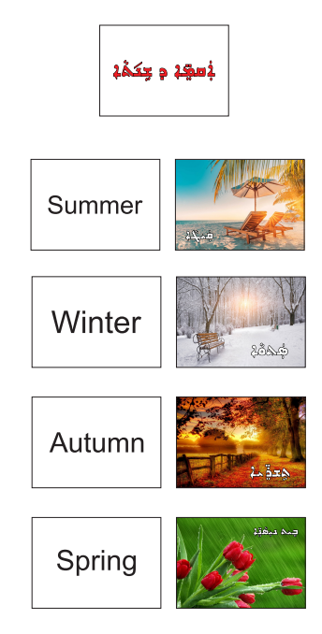

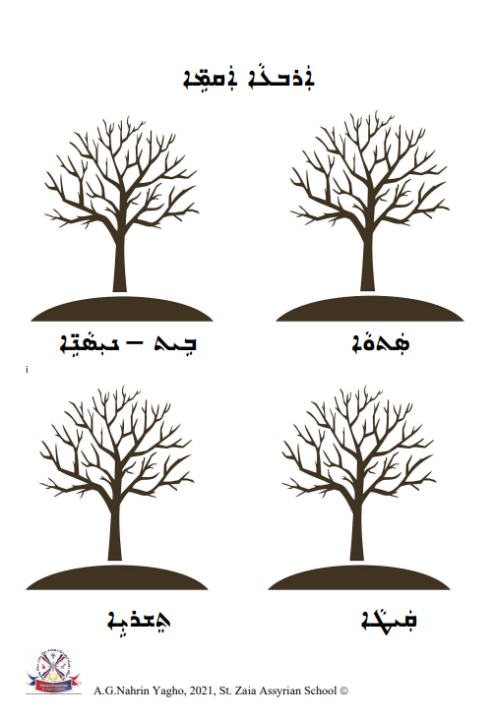
Resource A- Seasons Worksheets and Activities

Resource A- Seasons Worksheets and Activities
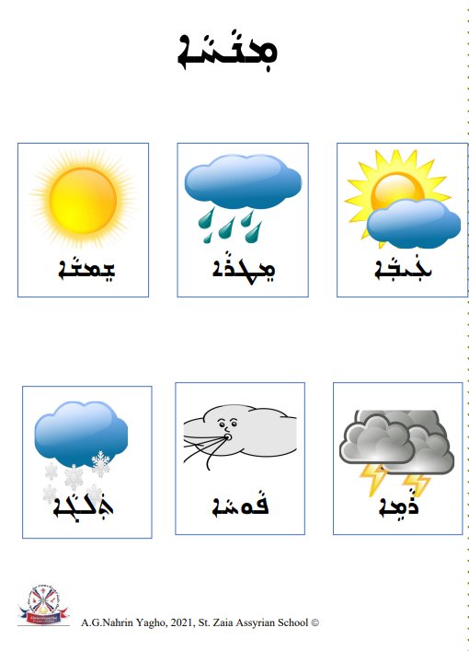
Resource A- Seasons Worksheets and Activities
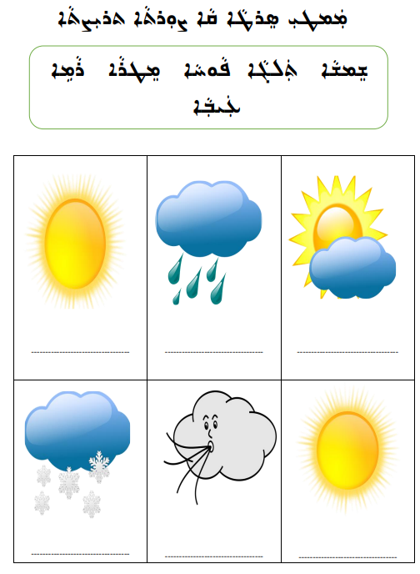

Resource A- Seasons Worksheets and Activities
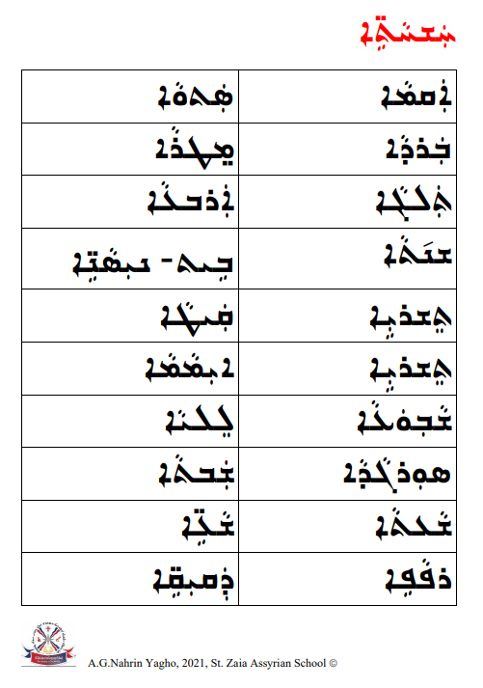

Resource A- Seasons Worksheets and Activities
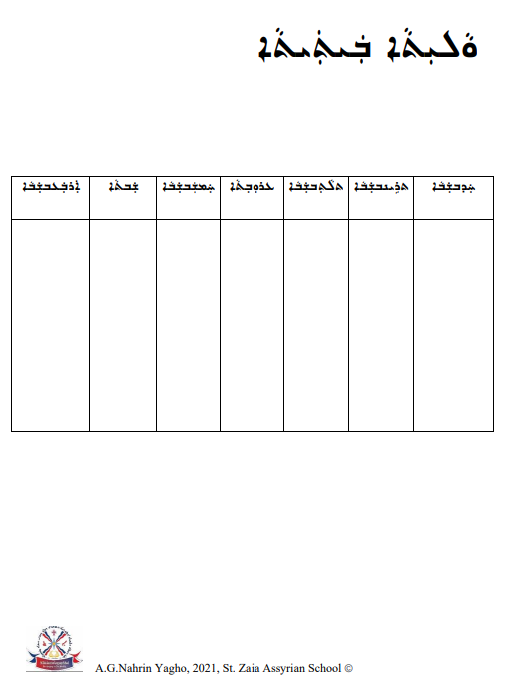
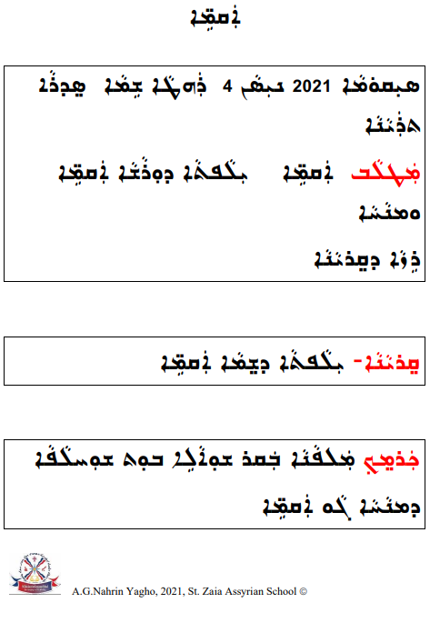
Resource A- Seasons Worksheets and Activities

Resource A- Seasons Worksheets and Activities

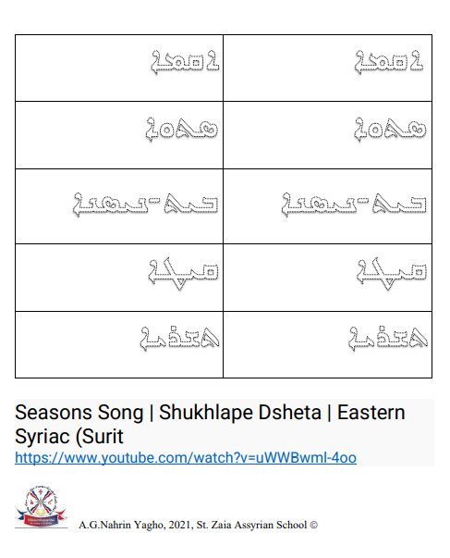

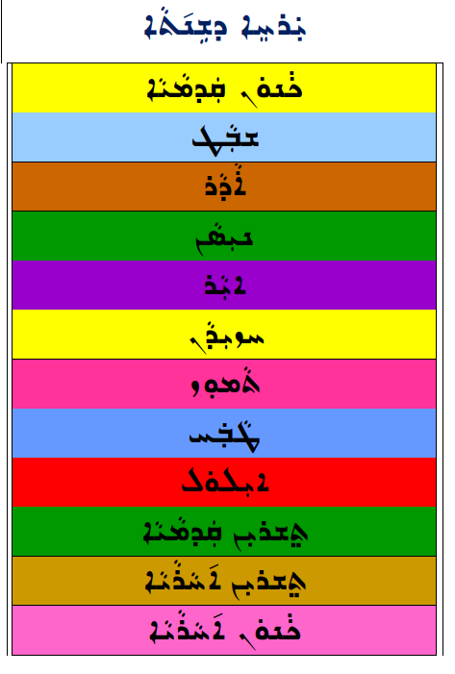
Resource B- Months Worksheets and Activities
Resource B- Months Worksheets and Activities

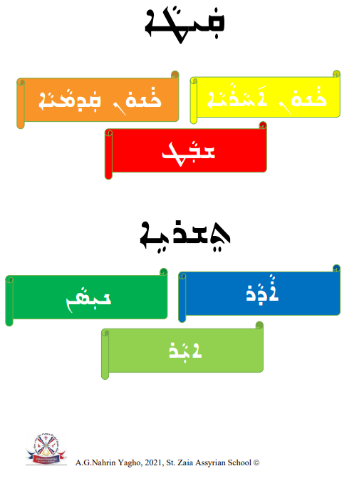

Resource B- Months Worksheets and Activities
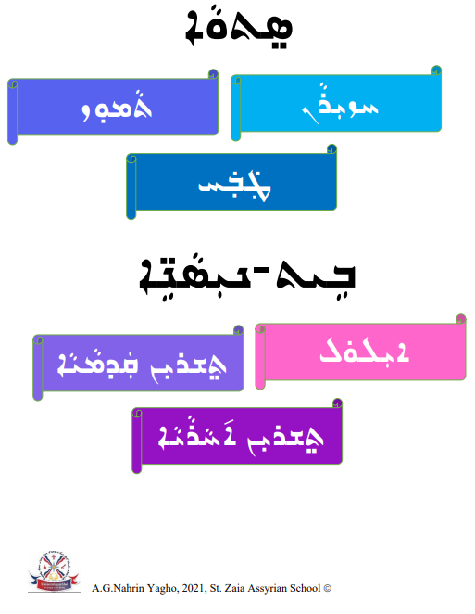

Resource B- Months Worksheets and Activities
Resource B- Months Worksheets and Activities

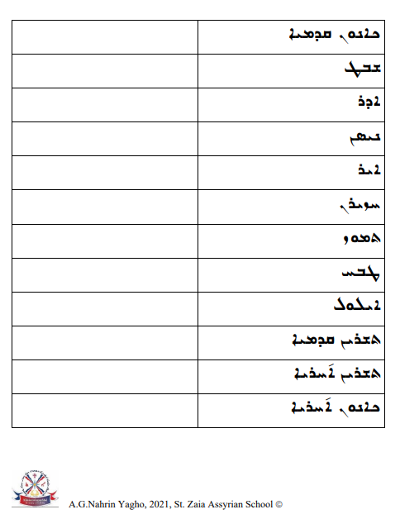

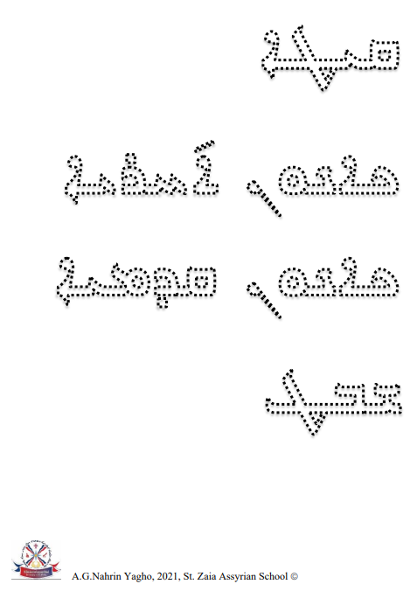
Resource B- Months Worksheets and Activities

Resource B- Months Worksheets and Activities

Resource B- Months Worksheets and Activities

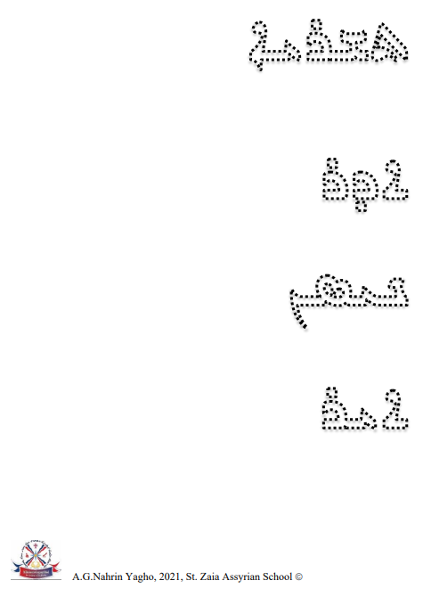

Resource B- Months Worksheets and Activities
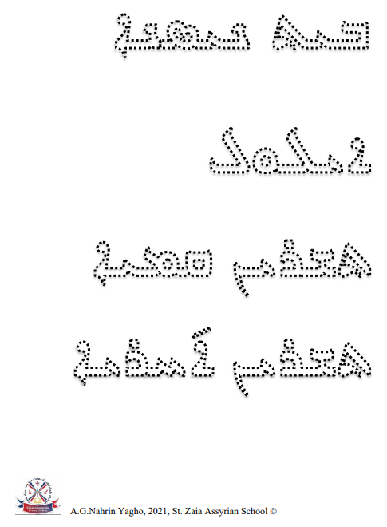

Resource B- Months Worksheets and Activities

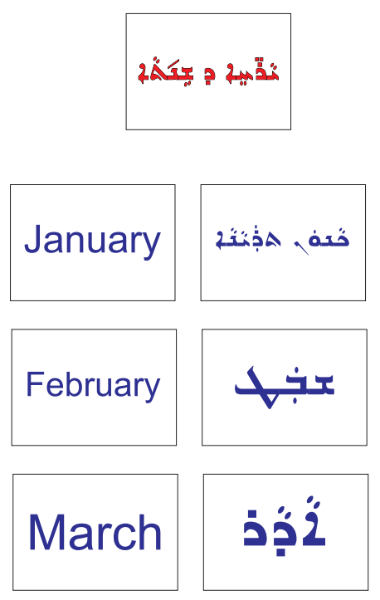

Resource B- Months Worksheets and Activities

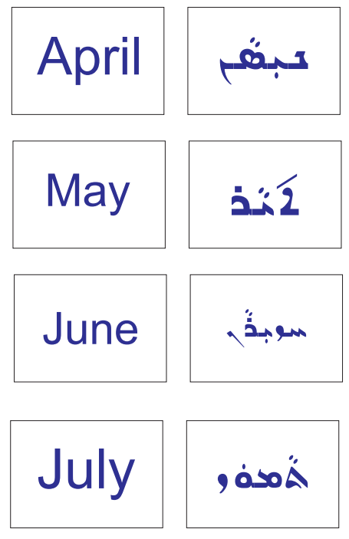

Resource B- Months Worksheets and Activities

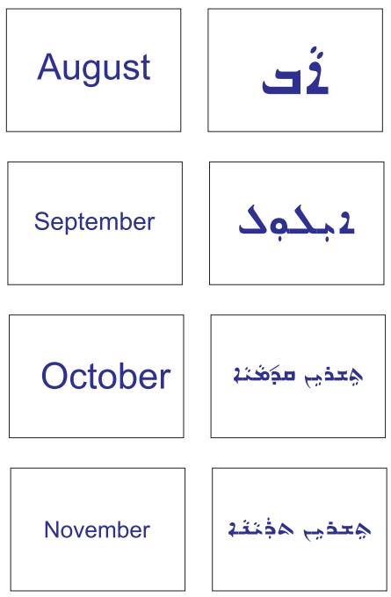

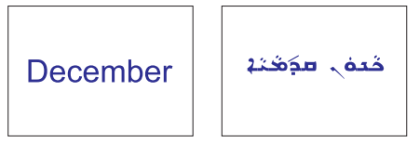

Resource B- Months Worksheets and Activities

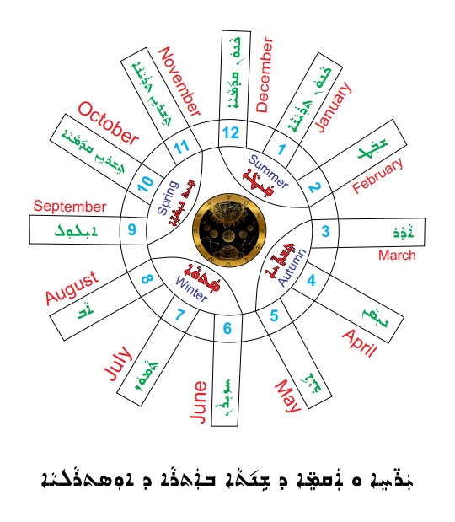

Resource C - Days of the Week Worksheets and Activities

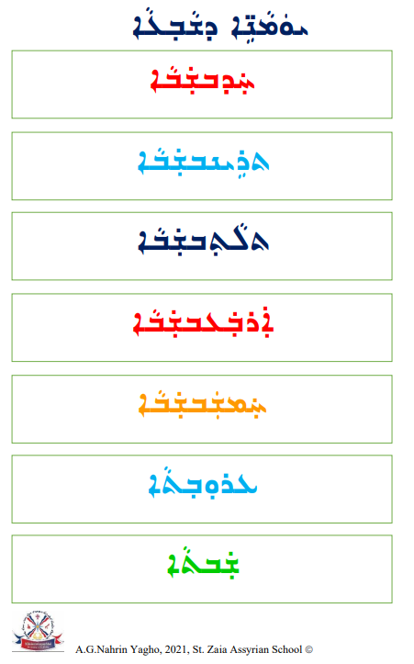

Resource C - Days of the Week Worksheets and Activities
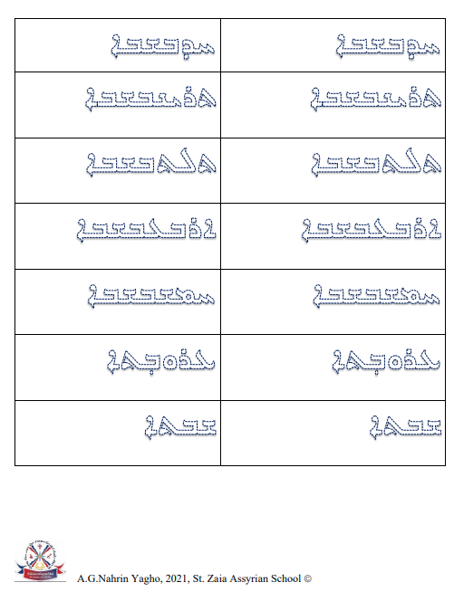

Resource C - Days of the Week Worksheets and Activities
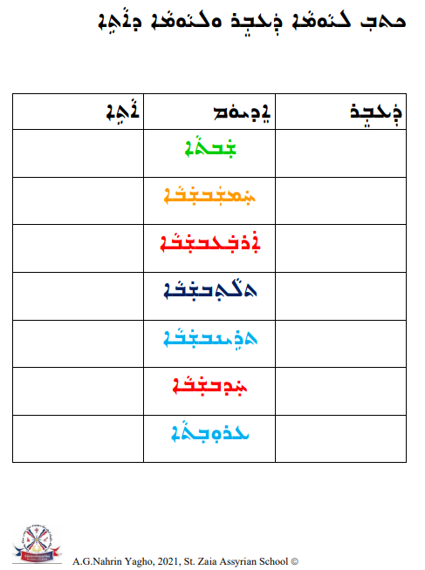

Resource C - Days of the Week Worksheets and Activities

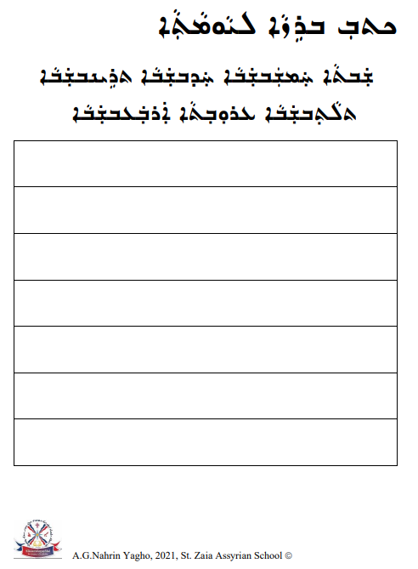

Resource C - Days of the Week Worksheets and Activities

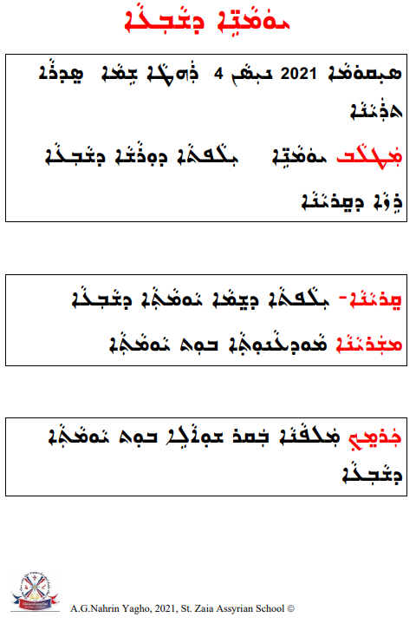

Resource C - Days of the Week Worksheets and Activities

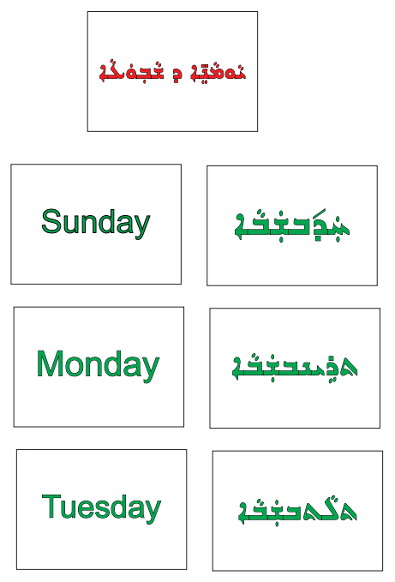

Resource C - Days of the Week Worksheets and Activities
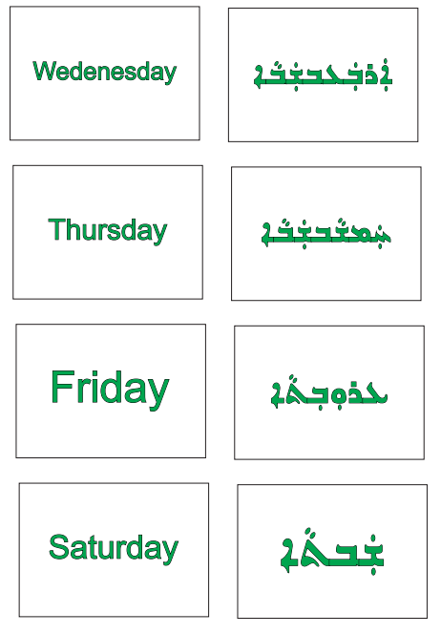
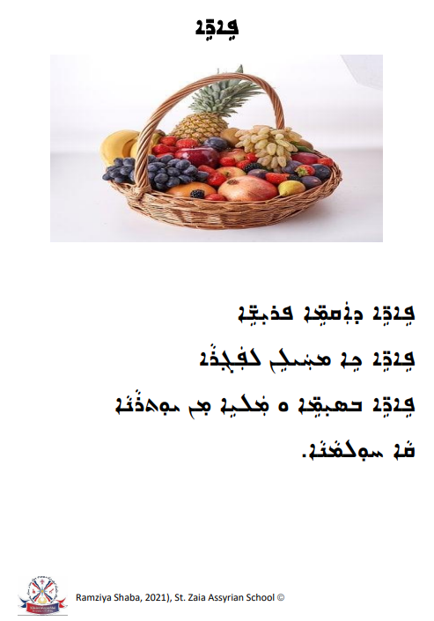
Resource D- Fruits Worksheets and Activities

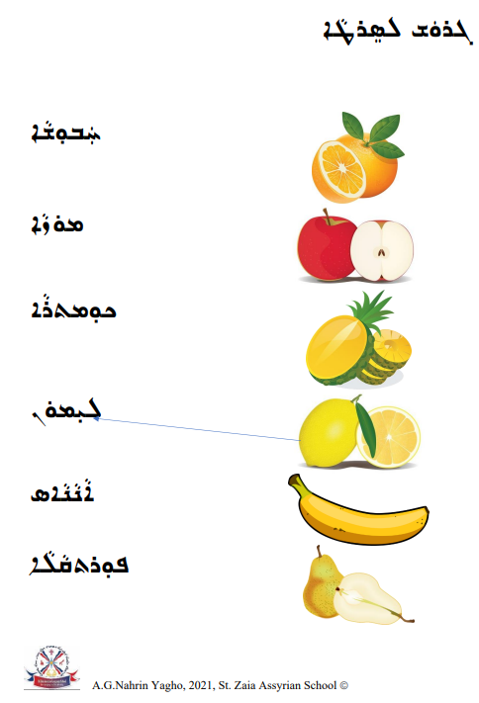
Resource D- Fruits Worksheets and Activities

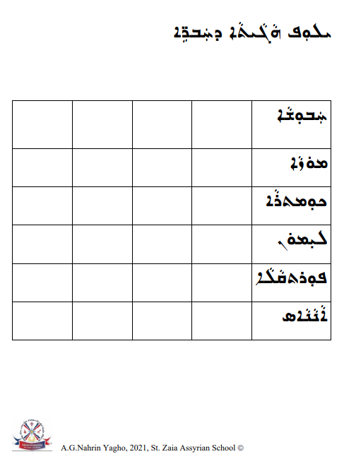
Resource D- Fruits Worksheets and Activities

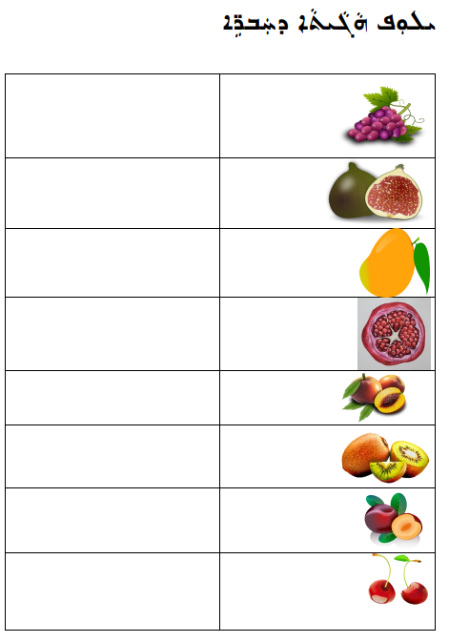
Resource D- Fruits Worksheets and Activities
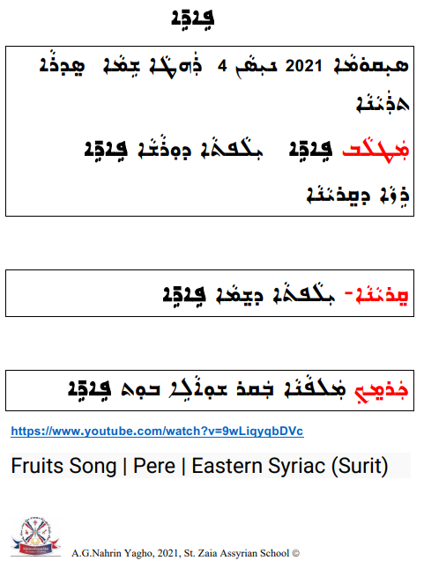
Resource D- Fruits Worksheets and Activities

Resource D- Fruits Worksheets and Activities

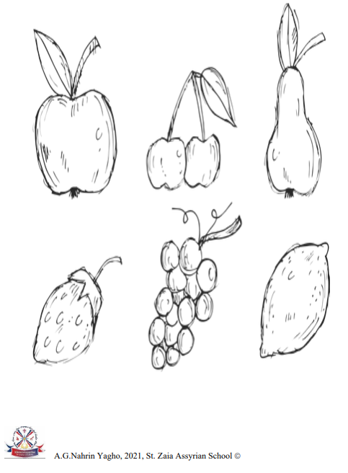

Resource E- Summer Worksheets and Activities
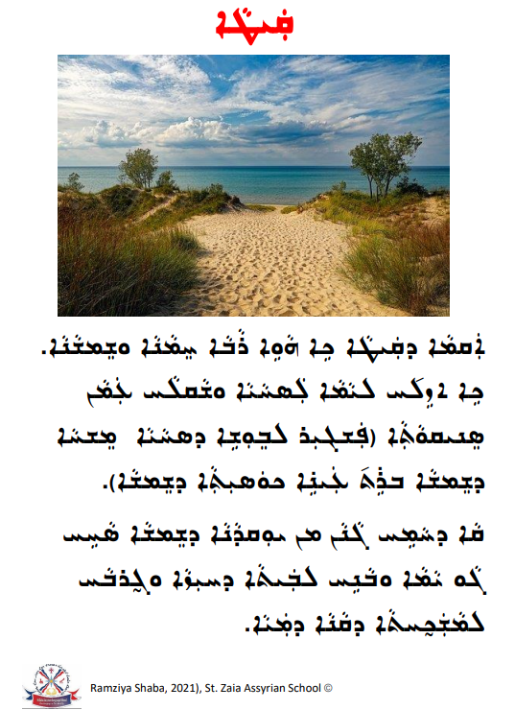

Resource E- Summer Worksheets and Activities

Resource E- Summer Worksheets and Activities
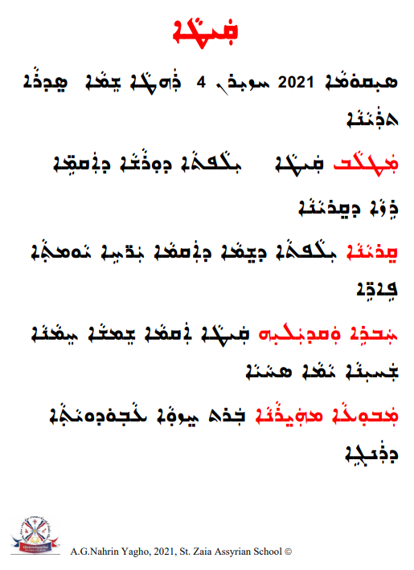

Resource E- Summer Worksheets and Activities

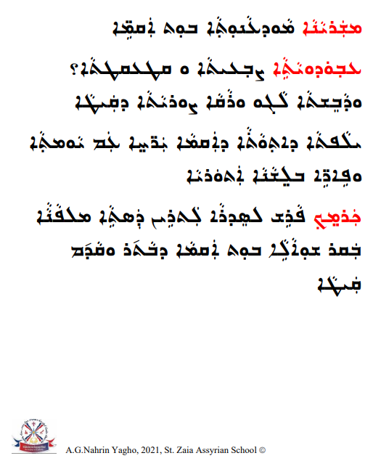

Resource E- Summer Worksheets and Activities

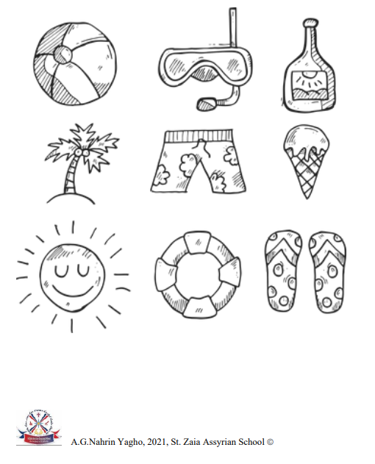

Resource E- Summer Worksheets and Activities

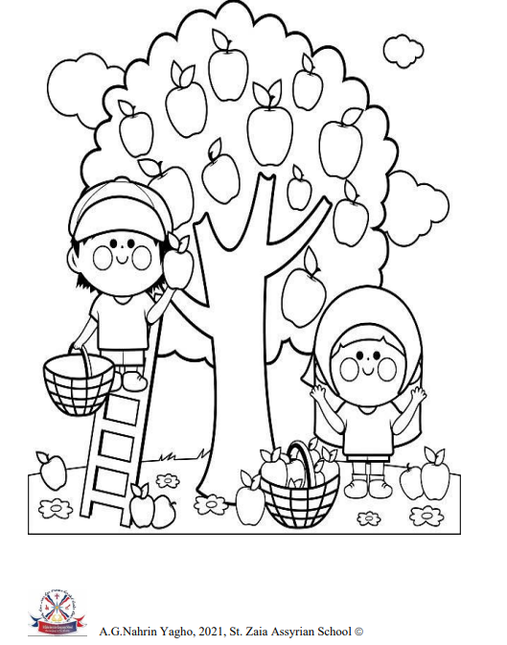

Resource E- Summer Worksheets and Activities

Resource E- Summer Worksheets and Activities

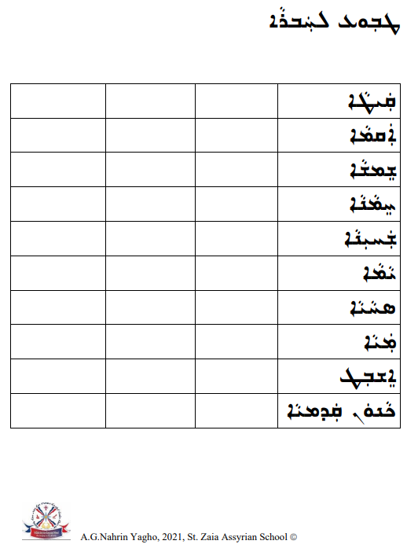

Resource F- Autumn Worksheets and Activities
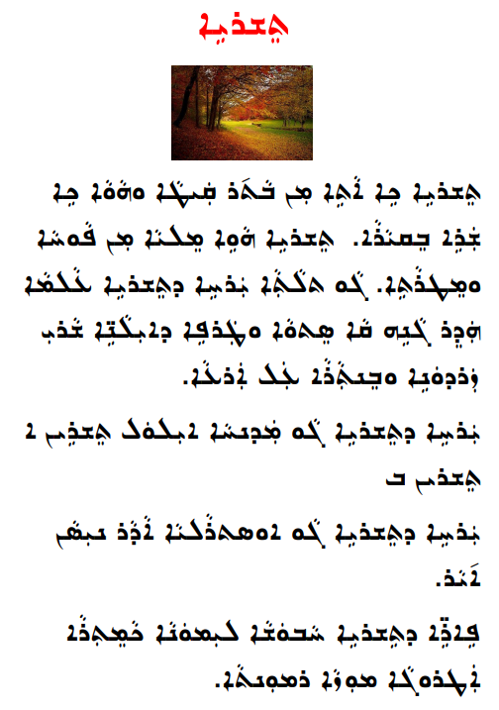

Resource F- Autumn Worksheets and Activities
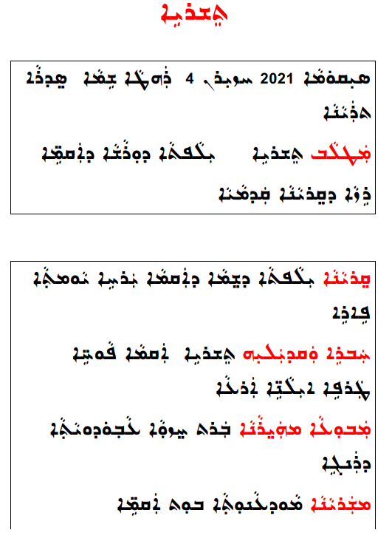

Resource F- Autumn Worksheets and Activities
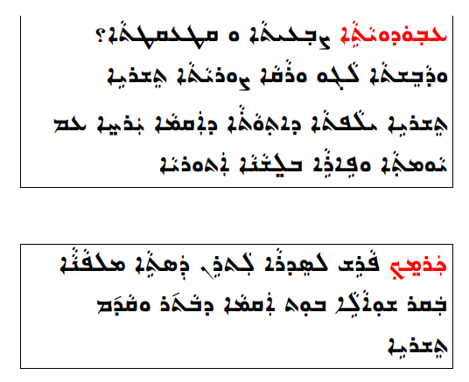

Resource F- Autumn Worksheets and Activities
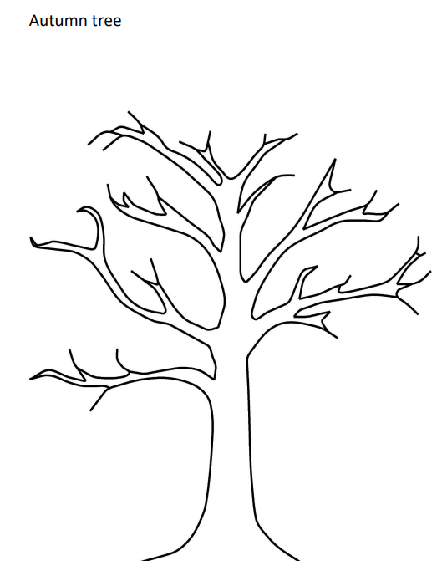

Resource F- Autumn Worksheets and Activities
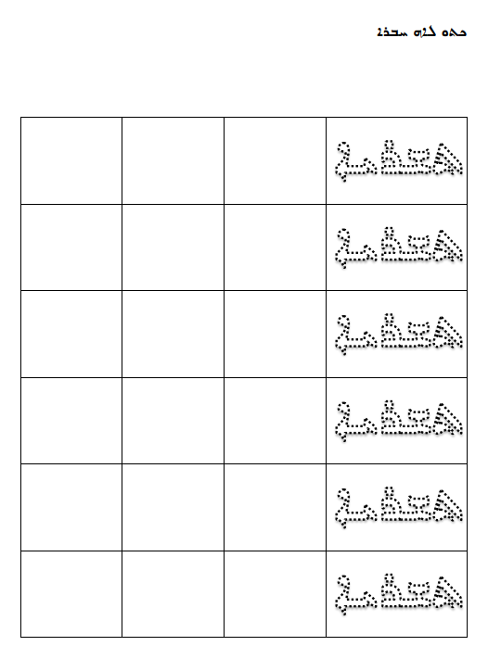

Resource F- Autumn Worksheets and Activities

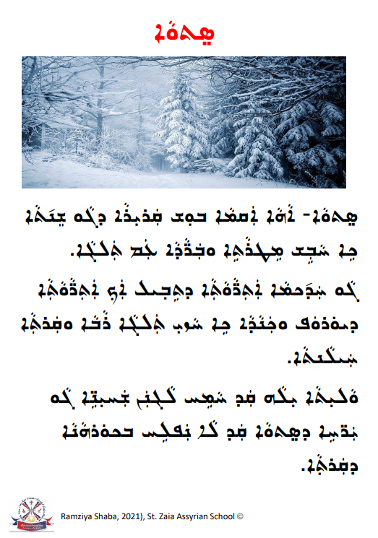
Resource G- Winter Worksheets and Activities
Resource G- Winter Worksheets and Activities
Resource G- Winter Worksheets and Activities
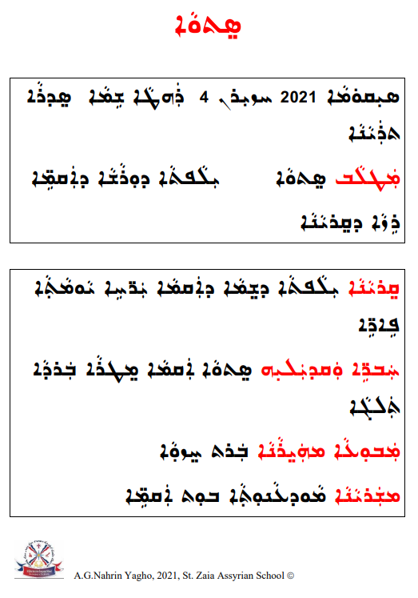

Resource G- Winter Worksheets and Activities
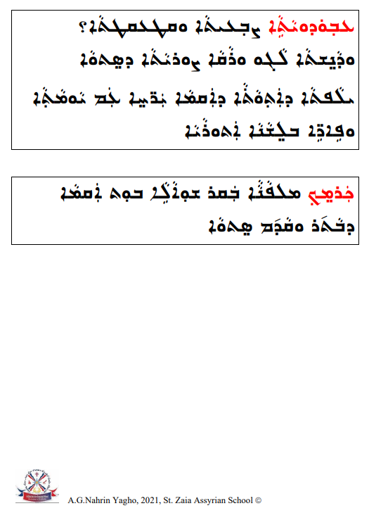

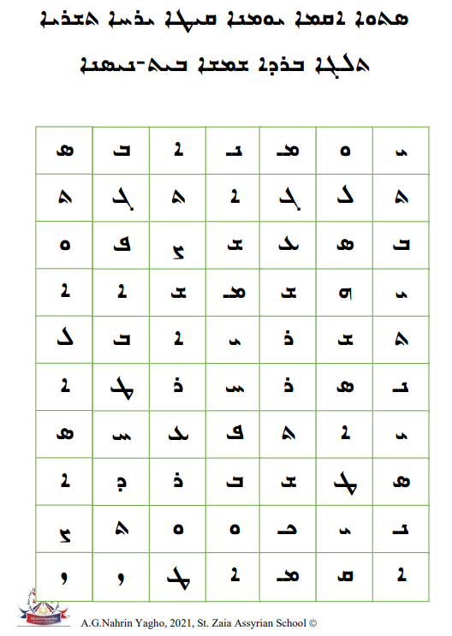
Resource G- Winter Worksheets and Activities

Resource G- Winter Worksheets and Activities

Resource G- Winter Worksheets and Activities

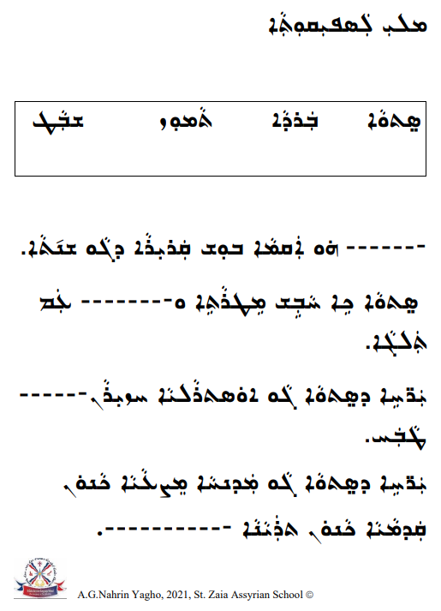

Resource G- Winter Worksheets and Activities

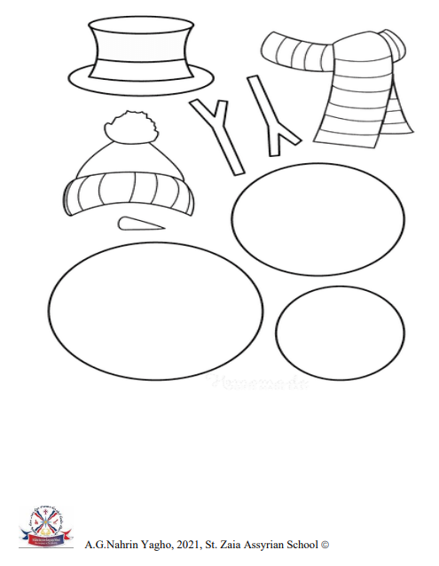

Resource G- Winter Worksheets and Activities
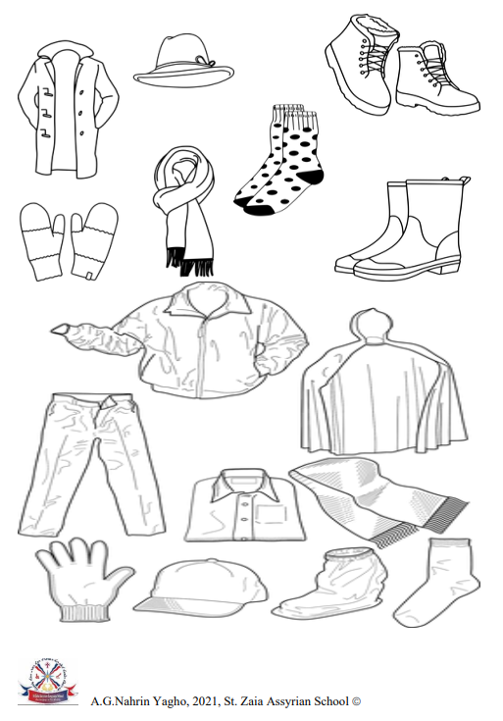
Resource H- Spring Worksheets and Activities
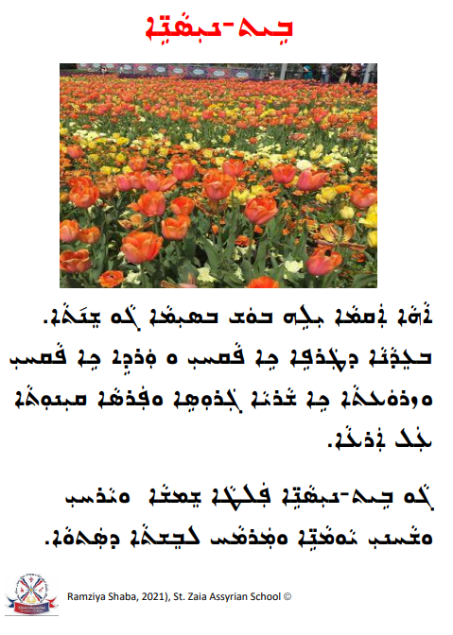

Resource H- Spring Worksheets and Activities

Resource H- Spring Worksheets and Activities
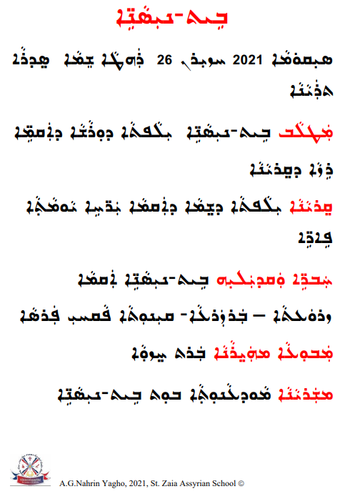
Resource H- Spring Worksheets and Activities
Resource H- Spring Worksheets and Activities

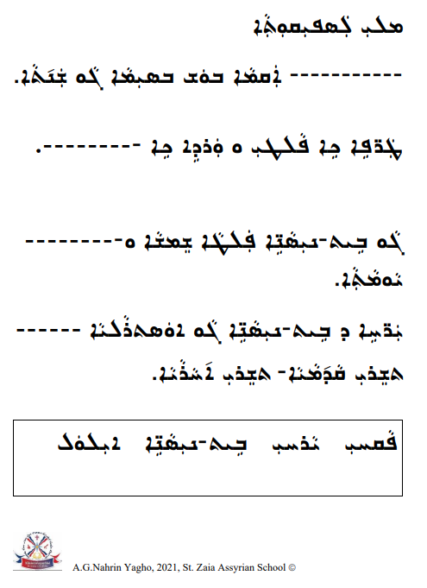

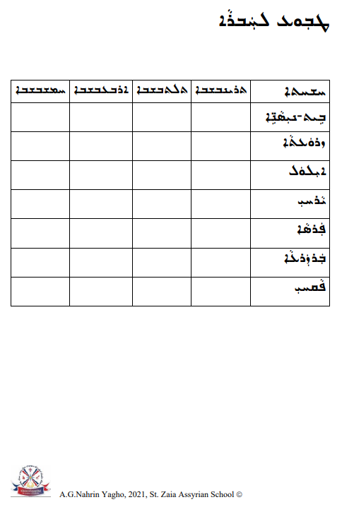
Resource H- Spring Worksheets and Activities
Resource I- Weather Flashcards

