History- Heritage

Stage: 3 | Unit Duration: 9 lessons | Weeks: 1 2 3 4 5 6 7 8 9 10 | Terms: 1 2 3 4
Unit Description and Overview | All students will develop the knowledge about indigenous Iraqi people- the Assyrian people and the cultures, traditions, practices, dances, events, celebrations, music that they are involved in. Students will also learn and use vocabulary from the Assyrian and Chaldean Language throughout the unit, which they can use in other lessons.  Teaching and learning activities are designed to help students construct understanding for deeper learning. A variety of tasks will be included, both in theory and practice to ensure students get a mix of activities that cater to their needs.
Lesson Overview | 1. Who are Iraq’s Indigenous people?  2. What are some cultural and traditional practices?  3. What are some homeland cities and locations?  4. What is the national flag and its features?  5. What are some celebrations?  6. Who are famous Assyrian Kings and Empires?  7. What is the national flower?  8. What are some examples of arts and dance?  9. How much information have I learned?  (Teacher can use the end of the unit as opportunity for assessment)
Organisation | Lessons are designed to ensure teachers lead learning and content and students have opportunities to listen and respond. This will ensure all students are active participants of their learning.  All lessons will include:  Learning Intentions, Success Criteria, Vocabulary and Language, Warm Up Activities, Modelled Teaching, Independent tasks, group tasks, partner tasks, Think/Pair/Share, technology use, warm up activities, reflection etc.
Essential Questions | - What are the Indigenous Iraqi’s?  - What are some cultural practices and traditions held by Assyrians and Chaldeans?  - What are some examples of flowers, dances, art, flags of Assyrians and Chaldeans?  - Why is heritage important to Assyrian/Chaldean people?
Assessment | Teachers have assessment opportunities before and after the unit to track progress. Students can present all of the information they have learned throughout the unit at the end. They can pick a topic and research it, presenting it on collage, PowerPoint presentation, storytelling, videos, roleplays, art etc.
Technology and Useful Websites | Teachers may use resources such as iPads and laptops to support students with their learning. Students should be exposed to a variety of songs, rhymes, books etc. to support their learning.  Some websites that may be helpful for teachers to visit before and during the unit for support include:  https://en.wikipedia.org/wiki/List_of_Assyrian_kings (Assyrian empires information)  https://youtu.be/7pa54hWROpQ (Assyrian Empire video)  https://youtu.be/s4lM-jEHD0o (Assyrian history lesson)  https://www.worldhistory.org/assyria/ (information about Assyria)  https://www.khanacademy.org/humanities/ancient-art-civilizations/ancient-near-east1/assyrian/a/assyrian-art-an-introduction (information on Assyrian Art)  https://www.pinterest.ca/edmapscom/historical-maps-of-assyria/ (historical maps of Assyria)  https://www.auaf.us/blog/the-history-and-meaning-behind-the-assyrian-flag/ (Assyrian flag and meaning)
History- Heritage

Year: 6 Lesson Sequence: 1 of 9

Subject: History Topic: Indigenous People

Learning Intention: We are learning about Iraq’s indigenous people.

Success Criteria: I will be successful if I can identify Iraq’s main cultures/who lived in Iraq.

Key words: cities, countryside, language, indigenous peoples, ethnic, etc.

Resources: Computer/Laptops, pictures of Assyrians, Indigenous Assyrians Worksheet (Resource A)

Starter:
- Class discussion:
- Who are the Indigenous peoples of Iraq?
- Where did they live?
- How did families live together?
- How was life back then, compared to nowadays?
- What were some jobs that they did?
- Display some pictures on the board of Indigenous Assyrians.
- What do you notice about these people? Their location? Their outfits? Etc.

Activity:
- Work with a partner to answer the questions on the worksheet provided.

Wrap-up:
- Divide your students into groups and ask them to discuss what they learned from the topic for 10 minutes.
- Have each group present their findings in front of the class.

History- Heritage
Year: 6 Lesson Sequence: 2 of 9

Subject: History Topic: Culture and Tradition

Learning Intention: We are learning about the cultural practices and traditions of Assyrians.

Success Criteria: I will be successful if I can identify some examples of cultural practices, traditions and dress.

Key words: culture, ethnic, dress, costume, language, traditional clothes, events etc.

Resources: Computer/Laptops, pictures of Assyrians, Cultures and Traditions Worksheet (Resource B)

Starter:
- Display some pictures of Assyrian peoples and have a class discussion:
- What do you notice about what the people are wearing?
- What are the names of the traditional costumes?
- Who wore these costumes?
- When do we wear these costumes? (Then and now)
- Discuss the importance of tradition and what it means to people, families and communities.

Activity:
- Work with a partner to answer the questions on the worksheet provided.

Wrap-up:
- Students to brainstorm some names (In English and Assyrian) of costume pieces and traditional dresses.

History- Heritage

Year: 6 Lesson Sequence: 3 of 9

Subject: History Topic: Homeland Cities and Locations.

Learning Intention: We are learning about Assyrian’s homeland cities and their locations on the map.

Success Criteria: I will be successful if I can identify main cities in Beth-Nahrain with their old names in Assyrian.

Key words: map, city, homeland, location, compass, Assyria, capital city etc.

Resources: Computer/Laptops, Map of Assyria, Assyria Worksheet (Resource C).

Starter:
- Display some pictures of the map of Assyria and its cities and have a class discussion:
- What do you notice about the map?
- What are some main cities?
- What are some locations on the map using compass locations? (North, south, east and west)
- What would the climate be in the city? How do you know?

Activity:
- Work with a partner to answer the questions on the worksheet provided.

Wrap-up:
- Divide your students into groups and ask them to discuss what they learned from the topic for 10 minutes.
- Have each group present their findings in front of the class.

History- Heritage

Year: 6 Lesson Sequence: 4 of 9

Subject: History Topic: National Flag

Learning Intention: We are learning about the main flags (Assyrian/Chaldean).

Success Criteria: I will be successful if I can recognise some features of the flags.

Key words: flag, colours, nation, pride, symbols, represent, adjectives etc.

Resources: image of Assyrian/Chaldean Flag, Flag Worksheet (Resource D), A4 paper, coloured pencils etc.

Starter:
- Display a picture of the Assyrian and Chaldean flag.
- Class discussion:
- What do you notice about the flags?
- Why are flags important to a nation?
- What do flags represent?
- What are some symbols you notice?
- What are the colours you notice?

Activity:
- Flag Art Activity. Students to draw the Assyrian/Chaldean flag on a piece of paper.
- Students to complete Flag Worksheet activities if time permits.

Wrap-up:
- Students to present their flag artwork and have an open-ended conversation with the rest of the class about the flag, its features and the importance of the flag to its peoples.

History- Heritage

Year: 6 Lesson Sequence: 5 of 9

Subject: History Topic: Celebrations

Learning Intention: We are learning about Assyrian New Year and Assyrian Language Day

Success Criteria: I will be successful if I can explain what the celebrations are.

Key words: music, poems, celebration, date, candles, prayers, costumes etc.

Resources: Pictures of Assyrian New Year, Assyrian New Year Worksheet (Resource E) workbooks, coloured pencils etc.

Starter:
- Class discussion:
- What are celebrations?
- How do people celebrate events?
- What is Assyrian New Year? When do we celebrate it? Why do we celebrate it?
- Have you been to this celebration? What did you do? Who did you see?
- What is Assyrian Language Day?
- What date do we celebrate these two events?
- Teacher to write the dates for both events separately for students to record in their books.
- Teacher to display some pictures of Assyrian New Year and discuss what is happening in the images and complete worksheets provided.

Activity:
- Students to explain what the two celebrations are and what happens during them by drawing and labelling (pictures and words) in their books.

Wrap-up:
- Ask students questions about the information they have learned using: Who, What, When, Where, Why and How.

History- Heritage

Year: 6 Lesson Sequence: 6 of 9

Subject: History Topic: Assyrian Kings and Empires

Learning Intention: We are learning about the Assyrian Empire and famous kings.

Success Criteria: I will be successful if I can identify some kings from the Assyrian Empire.

Key words: King, queen, empire, monarchy, Shamiram, Gilgamesh, Ashurbanipal

Resources: Pictures of Assyrian Kings and Empires, Assyrian Kings and Empires Worksheet (Resource F), pencils, laptops/computers.

Starter:
- Introduce the topic of Assyrian Kings and Empires hundreds of years ago.
- Class discussion:
- What are some examples of Assyrian Kings and Queens?
- What time did they rule the country Iraq?
- What were some empire names?
- What were they famous for?
- What were their strengths and weaknesses?
- Display some images of Assyrian Kings and Queens for students. Discuss their features and what they are wearing etc.

Activity:
- Students work in pairs to read the text provided.
- Students answer the comprehension questions about the text to demonstrate knowledge and understanding on the worksheets provided.

Wrap-up:
- Students use laptops/computers to research 10 facts about Assyrian Empires and the Kings and Queens of the time.
- They can write their information in Assyrian language.

History- Heritage

Year: 6 Lesson Sequence: 7 of 9

Subject: History Topic: The National Flower

Learning Intention: We are learning about the Assyrian National Flower.

Success Criteria: I will be successful if I can discuss its importance.

Key words: flower, colour, meaning, growth, area, civilization, panel stone, Ishtar’s gates, beauty, victory etc.

Resources: Image of national flower, National Flower Worksheet (Resource G) A4 paper, coloured pencils.

Starter:
- Introduce the topic of the Assyrian national flower.
- Class discussion:
- What is the purpose of this flower?
- What does it represent?
- What is its relationship with the Assyrian Civilization?
- Where can it be found?
- Which parts of Assyria can it be located?
- What would the flower be used for?
- Display an image of the national flower and discuss its features and use.

Activity:
- Students draw the Assyrian National Flower on A4 paper and label it’s colours using worksheets provided.

Wrap-up:
- Students use laptops/computers to research some information about the flower and answer these questions:
- What are some cities the flower can be found in?
- Why is it an important symbol?
- They can write their information in Assyrian language.

History- Heritage

Year: 6 Lesson Sequence: 8 of 9

Subject: History Topic: Art and Dance

Learning Intention: We are learning about some art and dances in the Assyrian culture.

Success Criteria: I will be successful if I can identify some art/music instruments and dances in the Assyrian culture.

Key words: carving panel stones, musical instrument, rules, types, dance, music, art

Resources: images of Assyrian art, Art and Dance Worksheet (Resource H)

Starter:
- Introduce the topic of Assyrian dances, art types, musical instruments etc.
- Display some images of traditional Assyrian art, carve paintings, instruments etc.
- Class discussion:
- What are some features of the cave paintings?
- What are some themes we notice? (Soldiers, victories, hunting, lions, achievements, prisoners etc.)
- What did artists use to make these paintings?
- What type of musical instruments do Assyrians use?
- Where might we find these resources and tools (museums)?
- When do Assyrian’s dance?
- What are some names of traditional dances?

Activity:
- Students work in groups to read a text of information on worksheets provided.
- Teacher to ask questions to each group to clarify understanding.

Wrap-up:
- Students use laptops/computers to research some facts about Assyrian dances, musical instruments and artworks.

History- Heritage

Year: 6 Lesson Sequence: 9 of 9

Subject: History Topic: Assyrian Culture Assessment

Learning Intention: We are learning about all the different aspects of the Assyrian Culture.

Success Criteria: I will be successful if I can display my knowledge on a collage.

Key words: dance, dress, flag, empire, king, queen, music, heritage, cities etc.

Resources: cardboard paper, coloured pencils, computers/laptops etc.

Starter:
- Teacher to tell students that they will present all the information that they have learned about the Assyrian culture during the unit in a creative way.

Activity:
- Students work in small groups to design a collage about one aspect of the Assyrian culture.
- They can use the internet to research some information and will need pictures, words, sentences etc. using the following headings:
- Lifestyle (then and now)
- Assyria and its cities
- Empires and Kings/Queens
- Traditional Dress/costumes
- Music and Dance
- Interesting Facts

Wrap-up:
- Students to present their collage to the whole class and discuss some of the information they have found.
- Display the posters in the classroom for future reference.

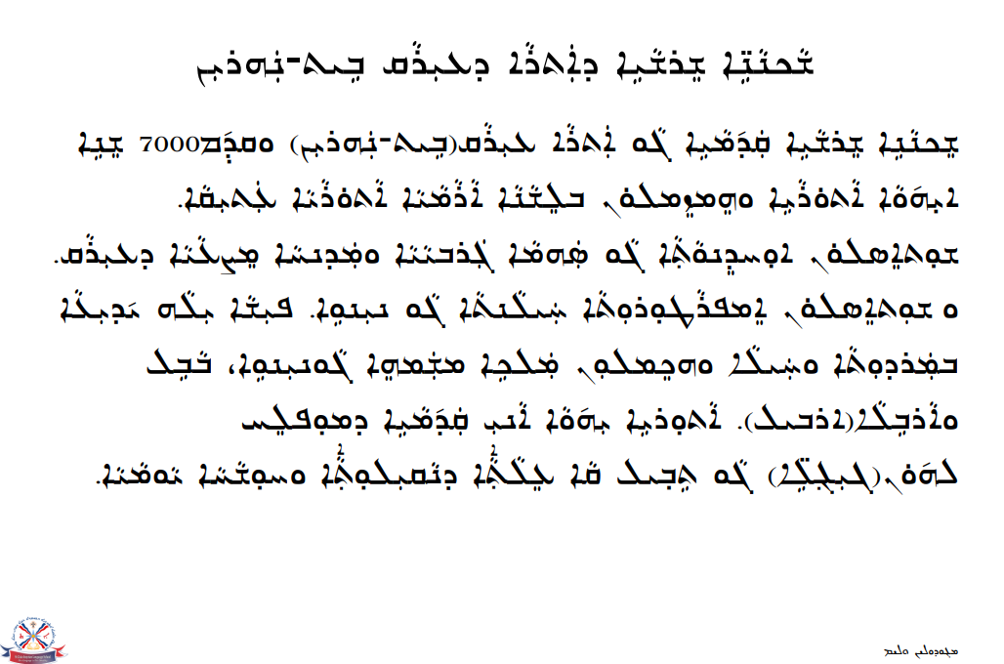
Resource A- Indigenous Australians Worksheet

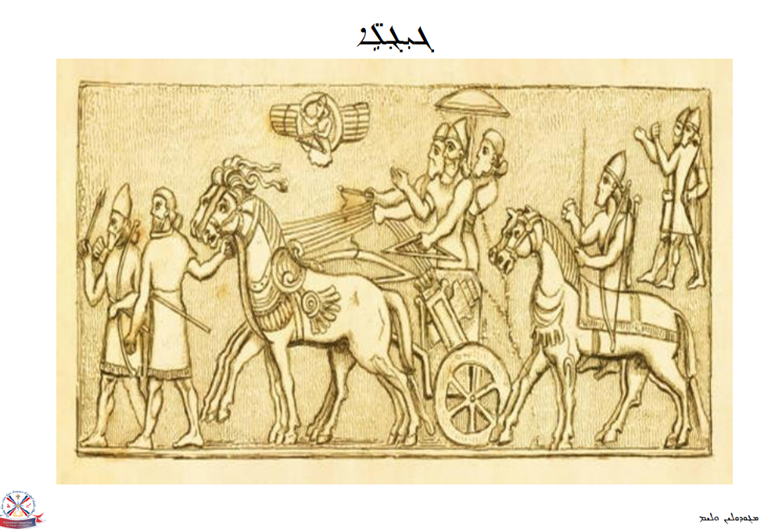
Resource A- Indigenous Australians Worksheet
Resource A- Indigenous Australians Worksheet
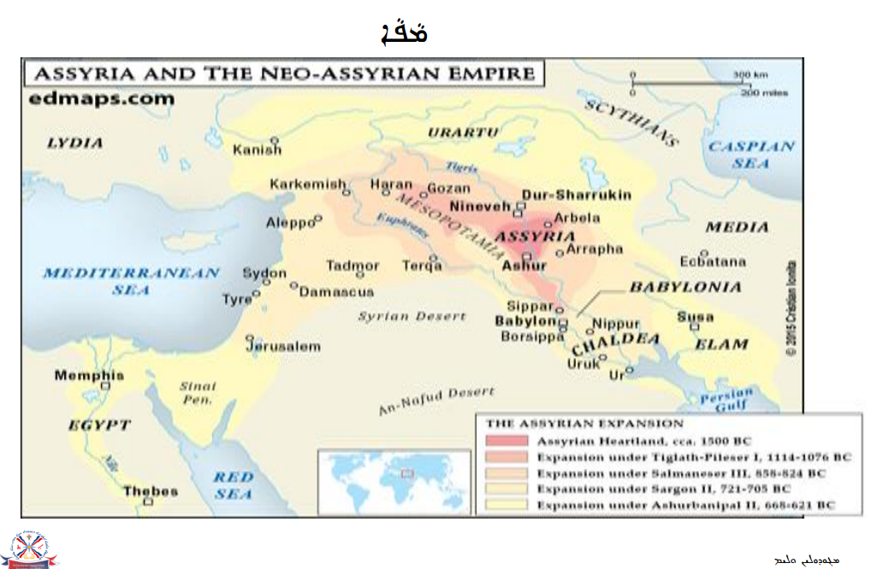
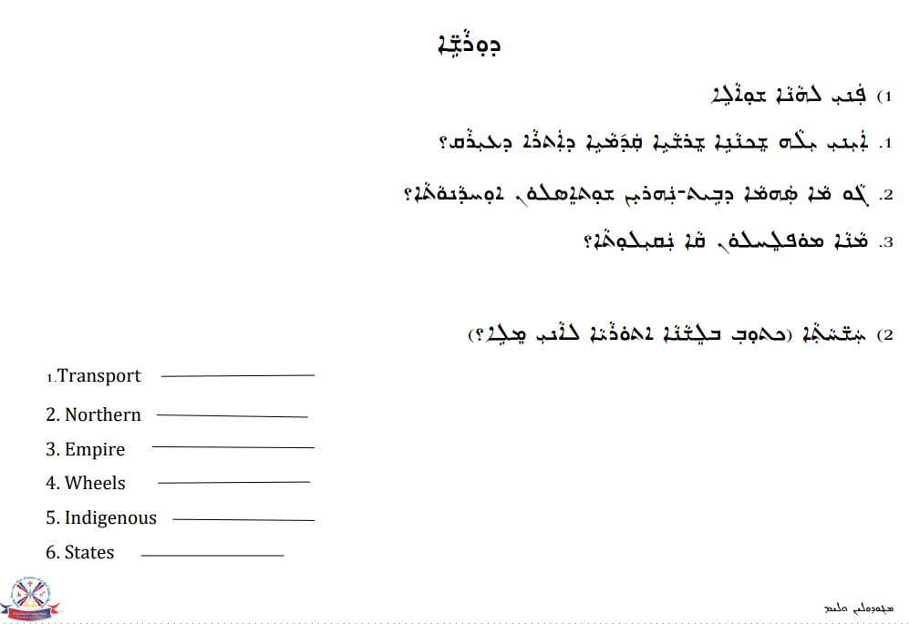
Resource A- Indigenous Australians Worksheet
Resource A- Indigenous Australians Worksheet
Resource B- Cultures and Traditions Worksheet
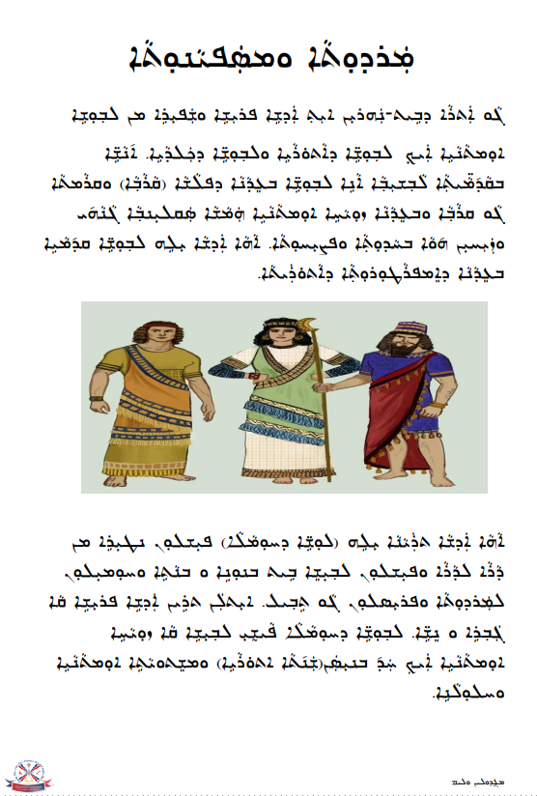
Resource B- Cultures and Traditions Worksheet
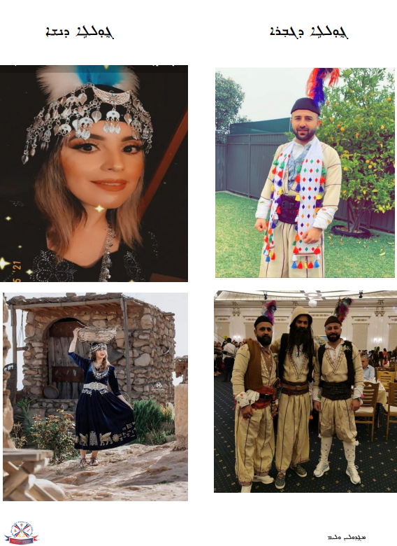
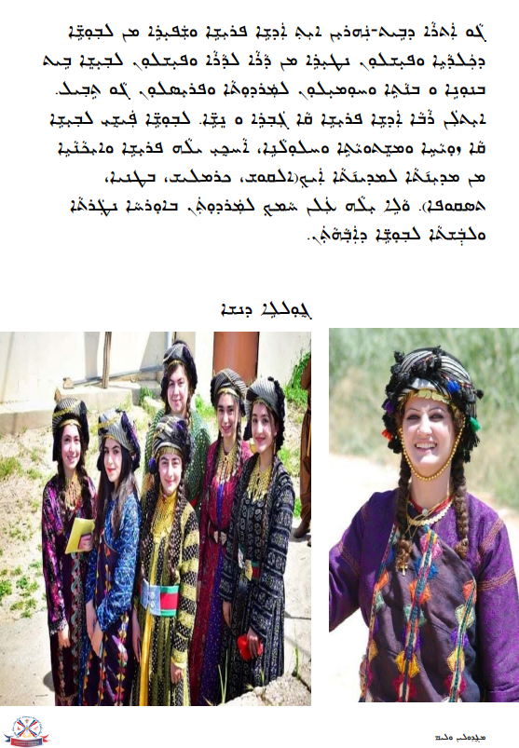
Resource B- Cultures and Traditions Worksheet
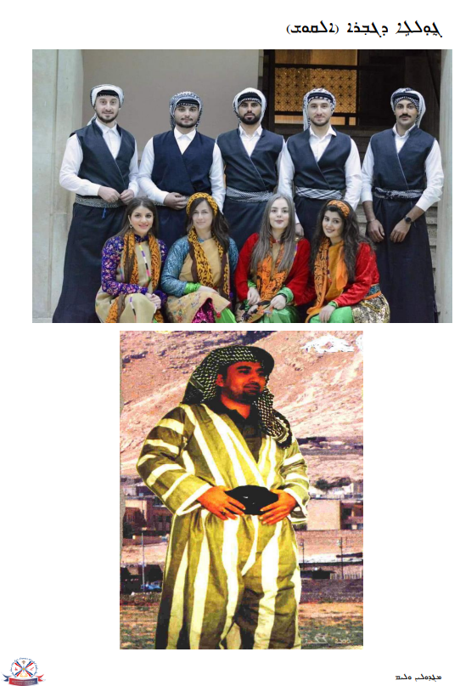
Resource B- Cultures and Traditions Worksheet
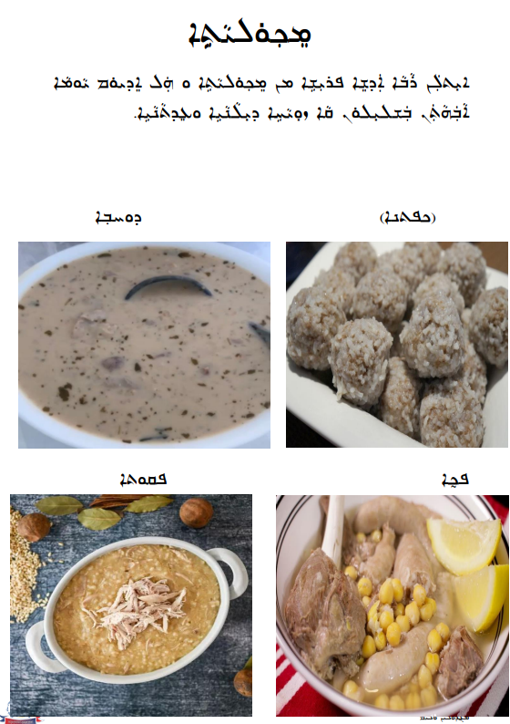
Resource B- Cultures and Traditions Worksheet
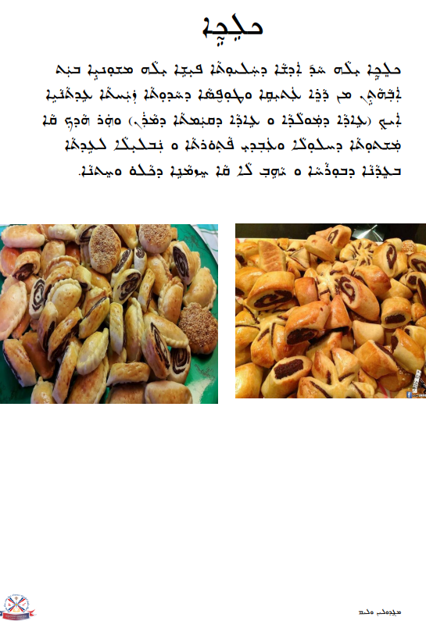
Resource B- Cultures and Traditions Worksheet
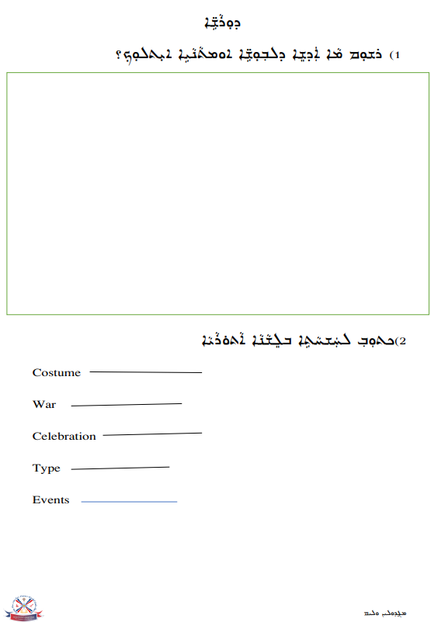
Resource B- Cultures and Traditions Worksheet
Resource B- Cultures and Traditions Worksheet
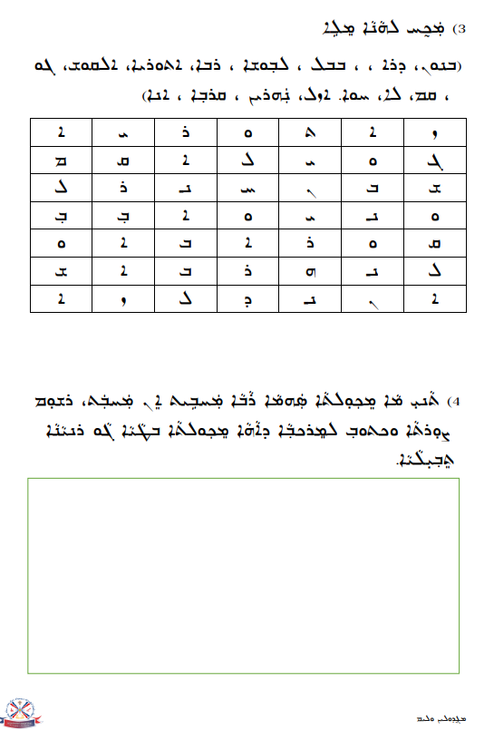
Resource B- Cultures and Traditions Worksheet

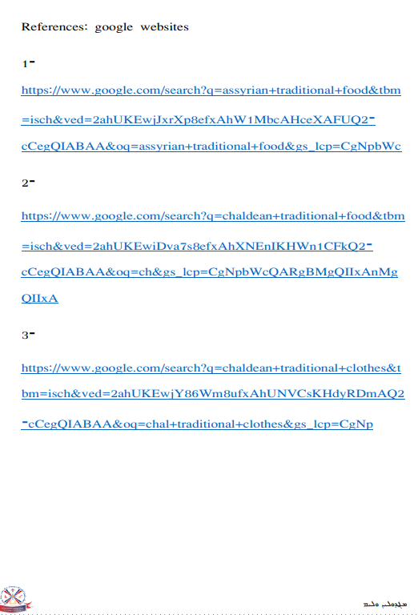

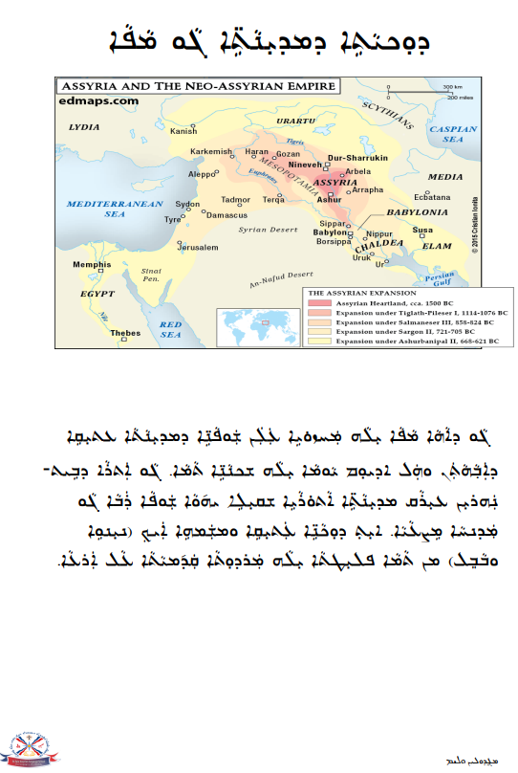
Resource C- Assyria Worksheet
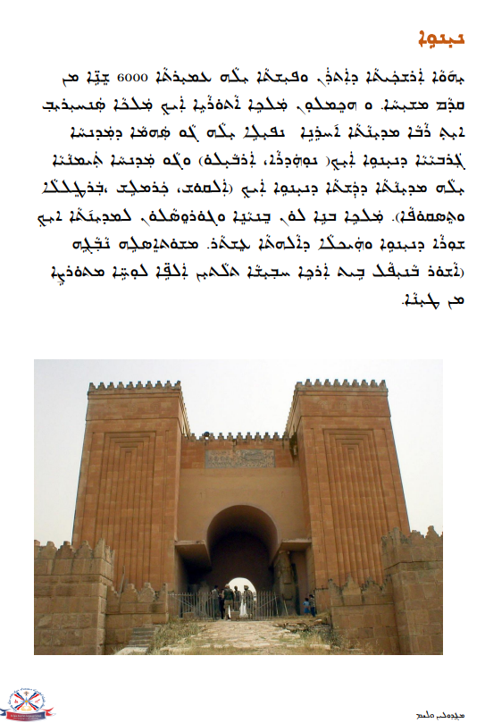
Resource C- Assyria Worksheet
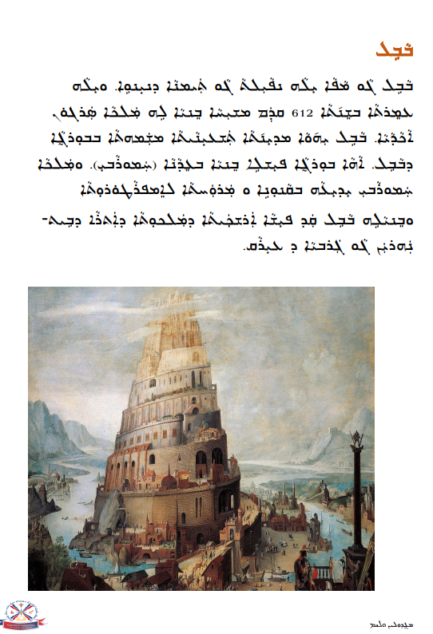
Resource C- Assyria Worksheet

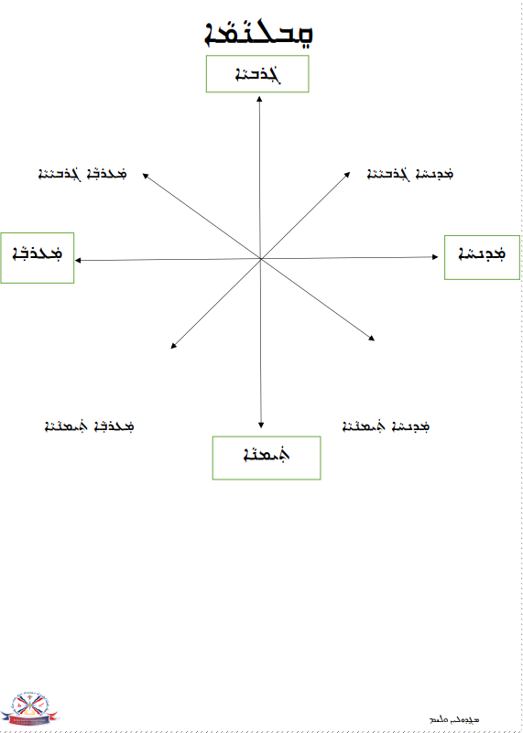
Resource C- Assyria Worksheet
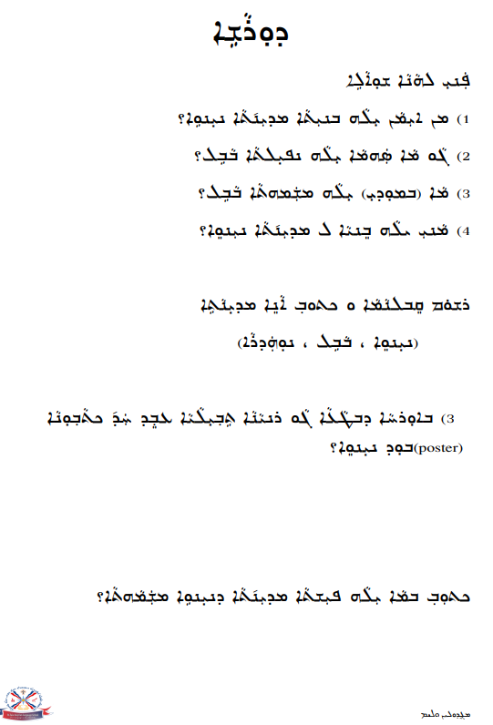
Resource C- Assyria Worksheet
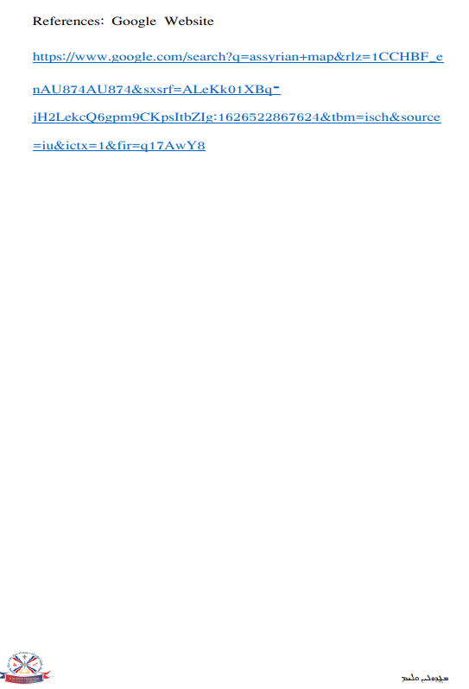
Resource C- Assyria Worksheet
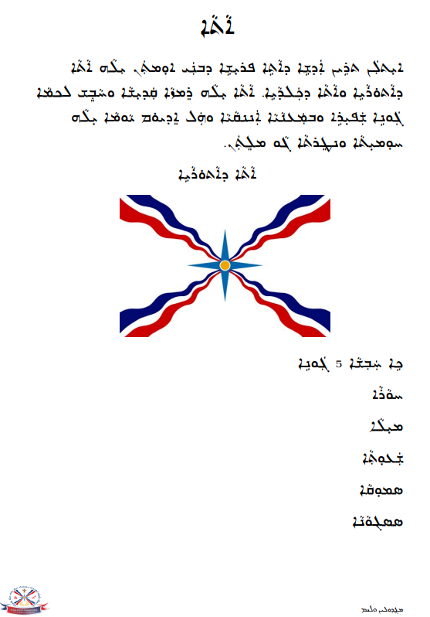
Resource D- Flag Worksheet
Resource D- Flag Worksheet
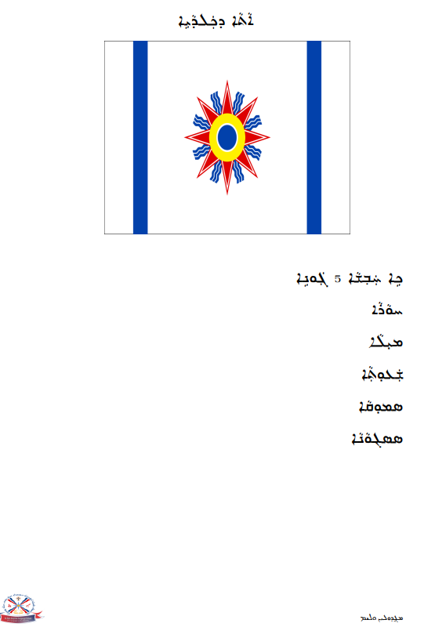
Resource D- Flag Worksheet
Resource D- Flag Worksheet
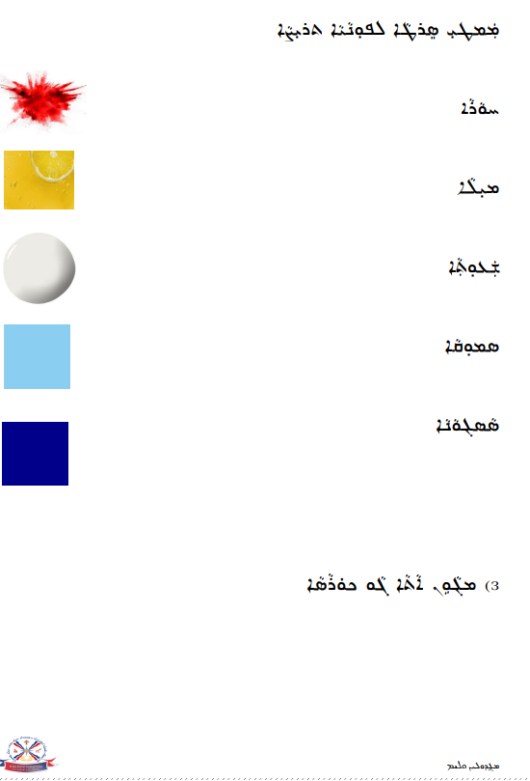
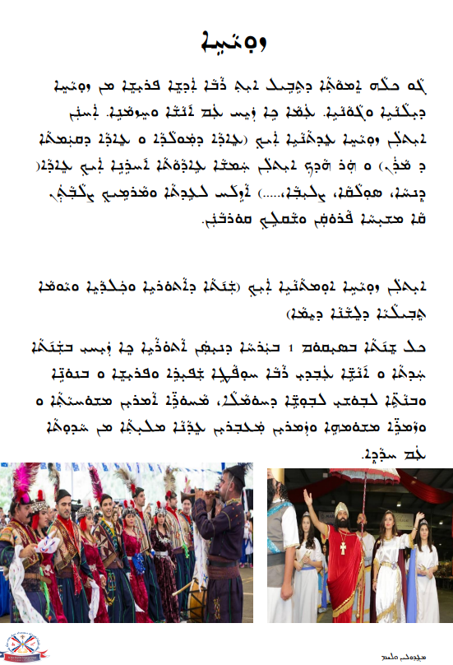
Resource E- Assyrian New Year Worksheet
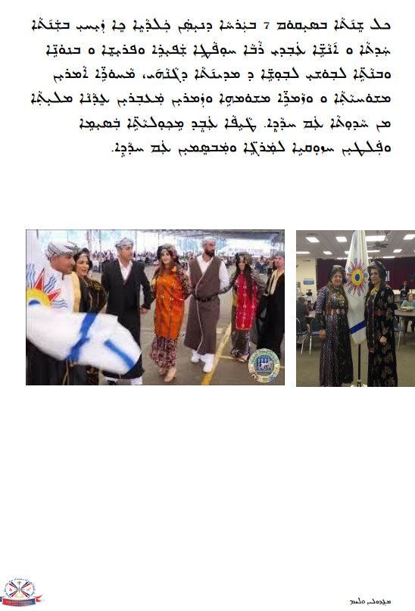
Resource E- Assyrian New Year Worksheet
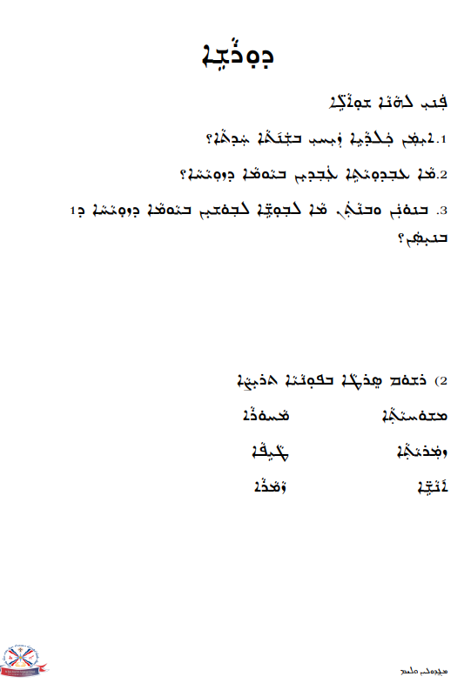
Resource E- Assyrian New Year Worksheet
Resource E- Assyrian New Year Worksheet
Resource F- Assyrian Kings and Empires Worksheet
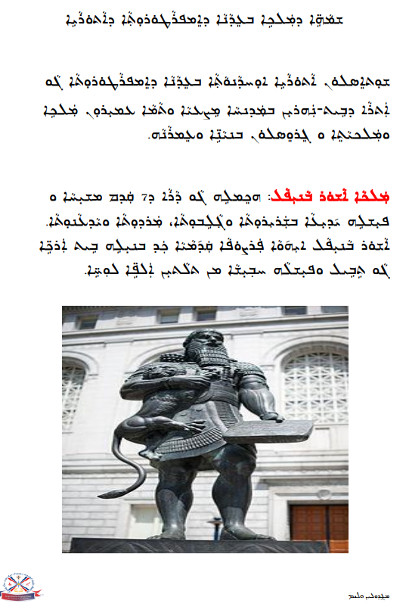
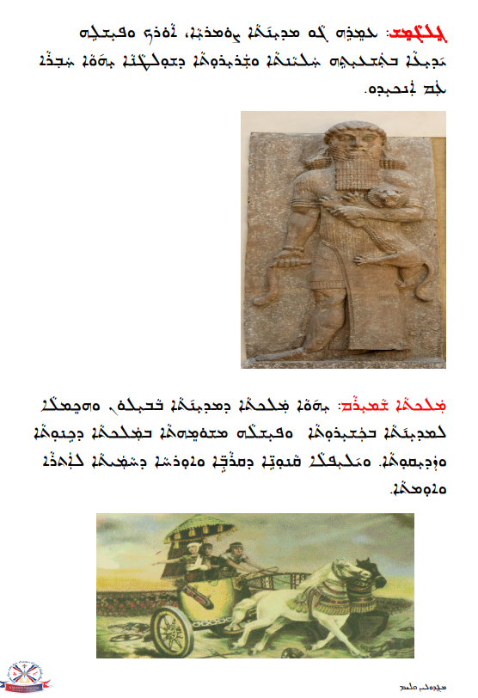
Resource F- Assyrian Kings and Empires Worksheet
Resource F- Assyrian Kings and Empires Worksheet
Resource F- Assyrian Kings and Empires Worksheet
Resource F- Assyrian Kings and Empires Worksheet

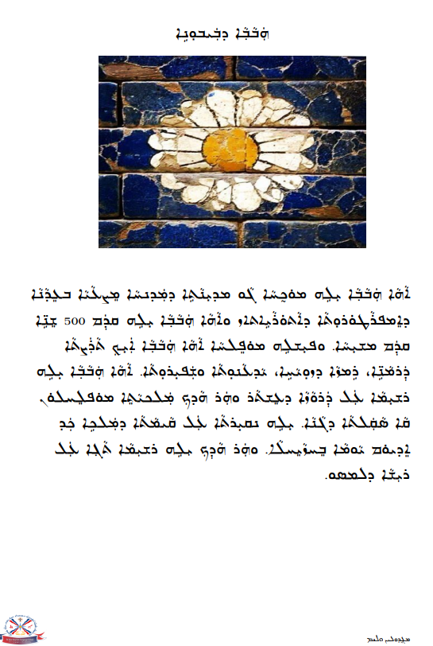
Resource G- National Flower Worksheet
Resource G- National Flower Worksheet

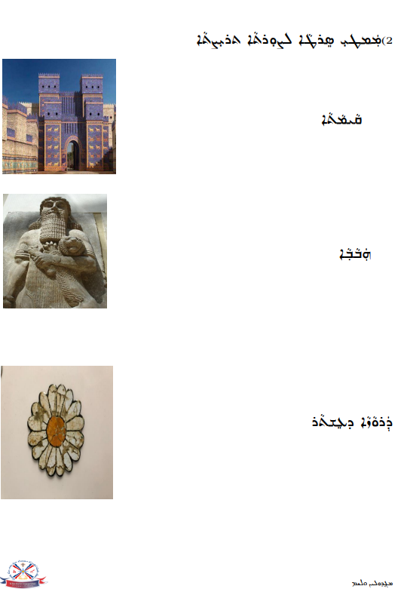
Resource G- National Flower Worksheet
Resource G- National Flower Worksheet
Resource G- National Flower Worksheet

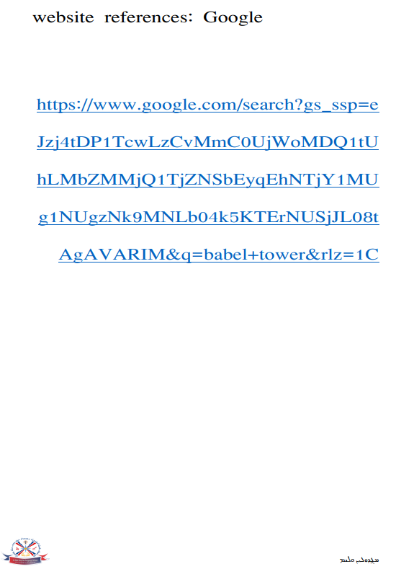
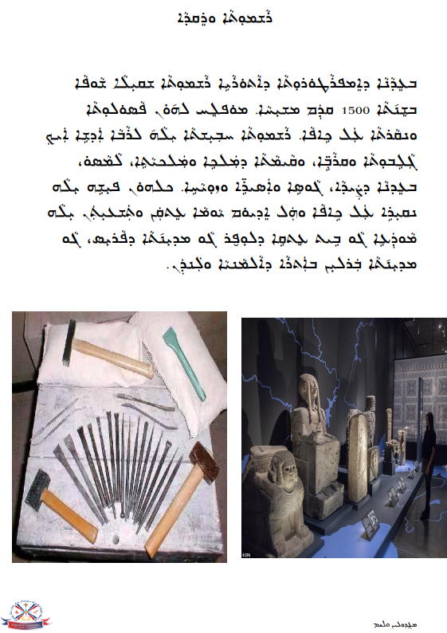
Resource H- Art and Dance Worksheet
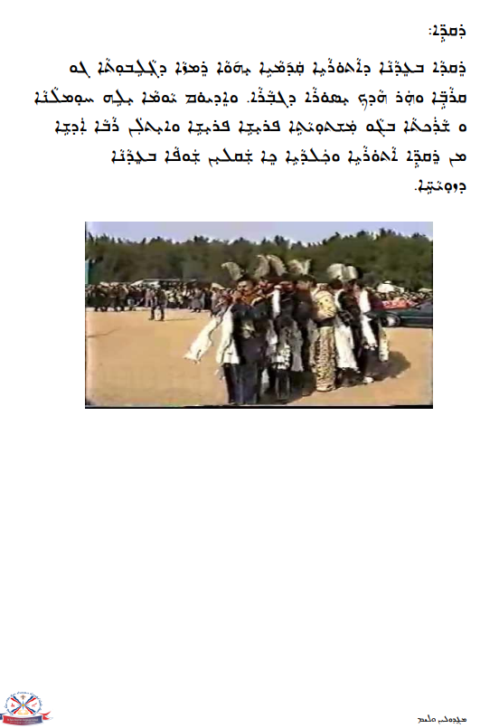
Resource H- Art and Dance Worksheet
Resource H- Art and Dance Worksheet
Resource H- Art and Dance Worksheet

