Transport

Stage 2: Year 4 | Unit Duration: 6 lessons | Weeks: 1 2 3 4 5 6 7 8 | Terms: 1 2 3 4
Unit Description and Overview | All students will develop the knowledge about the transport system and its importance.  Students will also explore the different ways of travel people used in the past.  members.  Students will also learn and use vocabulary from the Assyrian and Chaldean Language throughout the unit, which they can use in other lessons.  Teaching and learning activities are designed to help students construct understanding for deeper learning. A variety of tasks will be included, both in theory and practice to ensure students get a mix of activities that cater to their needs.
Lesson Overview | 1. What is transport?  2. How did people travel in the past?  3. Mode of Transportation (Water)  4. Mode of Transportation (Air)  5. Mode of Transportation (Land)  6. Travel (Why do we travel? What do we need to travel?)  7. Transport Sustainability (might require 2 lessons)  8. Speech (assessment)
Organisation | All lessons are designed to ensure teachers lead learning and content and students have opportunities to listen and respond. This will ensure all students are active participants of their learning.  All lessons will include:  - Learning Intentions, Success Criteria, Vocabulary and Language, Warm Up and Wrap Up Activities.  - Modelled Teaching, Independent tasks, group tasks, partner tasks, Think/Pair/Share, technology use and reflection etc.
Essential Questions | 1. What is transport? (Name different modes of transport).  2. How did people travel in the past?  3. How do people travel by water and why?  4. How do people travel by air and why?  5. How do people travel on land and why?  6. Why do we travel? What do we need to travel?  7.How and Why is transport bad for the environment?
Assessment | Teachers have assessment opportunities before and after the unit to track progress. Students can verbally identify different types of transport to show their understanding before the unit commences and after. The assessment for learning is ongoing.
Technology and Useful Websites | Teachers may use resources such as iPads and laptops to support students with their learning. Students should be exposed to a variety of songs, rhymes, books etc. to support their learning.  Some websites that may be helpful for teachers to visit before and during the unit for support include:  https://www.youtube.com/watch?v=0gb3lBr24l8  https://www.youtube.com/watch?v=uHzTqOwlPiU&t=13s  https://youtu.be/FaLCQo8NJFA  https://games4esl.com/lesson-plans/transportation/  https://youtu.be/b3QZpBL8-Tg
Transport

Year: 4 Lesson Sequence: 1 of 8

Subject: Transport Topic: Transport

Learning Intention: We are learning to identify Transport in Chaldean/Assyrian Language.

Success Criteria: I will be successful if I can name various ways of transport in Chaldean/Assyrian Language.

Key words: cars, trains, buses, airplanes, boats, etc.

Resources: Transport Flash cards (Resource A), whiteboards, Transport and Travel Worksheet (Resource B), pencils, glue sticks and scissors.

Starter:
- Class discussion:
- Brainstorm what transport is in English.
- Introduce the word ‘transport’ in Chaldean/Assyrian.
- Name some examples of transport that you know in Assyrian/Chaldean?
- What are some examples of transport that people used in the past?
- Consolidate transports vocabulary using flashcards.
- Play ‘What Am I?” game with the whole class.
- Display the transport flashcards, they can call out the answer in English/Chaldean/Assyrian or use the PowerPoint attached.

Activity:
- Students will be given the Transport and Travel worksheet to complete. They need to write the correct word in English and Assyrian/Chaldean for the images of transportation.

Wrap-up:
- In partners, students play Charades. One student holds a flashcard up, while the other student tries to give hints about what we use the transport for. Students to speak in Chaldean/Assyrian when they are playing the game.

Transport

Year: 4 Lesson Sequence: 2 of 8

Subject: Transport Topic: Ways of travel in the past

Learning Intention: We are learning to identify transport in Chaldean/Assyrian Language.

Success Criteria: I will be successful if I can label various ways that people traveled in the past in Chaldean/Assyrian.

Key words: Walk, Animals, Carriages, etc.

Resources: History of Transport Worksheets (Resource C in A3 and A4), pencils, coloured pencils, pencils, glue sticks and scissors

Starter:
- Class discussion:
- Revise what transport is in Chaldean/Assyrian.
- Revise transport modes in Chaldean/Assyrian.
- Introduce the question: How did people travel in the past?
- As a class, Discuss the ways people traveled in the past.
- What is the oldest way of travel?
- How long did take people to go from place to another if they traveled by land?
- What kind of problems did they face?

Activity:
- Watch the History of Transportation video on YouTube: https://youtu.be/FaLCQo8NJFA
- In partners, complete the timeline of when modes of transportation started showing and when using the information just learned in the video, on the History of Transport Worksheet.
- Discuss what kind of transport we might see in the future?

Wrap-up:
- Students sit in a circle and share their answers with their class, talking about different modes of transport.
- Give feedback on spelling and grammar of Chaldean/Assyrian words
- Students to play a guessing game by watching this video.
https://games4esl.com/lesson-plans/transportation/

Transport
Year: 4 Lesson Sequence: 3 of 8

Subject: Transport Topic: Water Transport

Learning Intention: We are learning to identify water transportation in the Chaldean/Assyrian Language.

Success Criteria: I will be successful if I can name various water transport in Chaldean/Assyrian.

Key words: Boat, ship, ferry, submarine, ship, sailboat.

Resources: Water Transport Label Worksheet (Resource D in A3 and A4), pencils, coloured pencils, a4 paper.

Starter:
- Class discussion:
- Introduce the term ‘water transportation’.
- Discuss some examples and what people use to travel by water?
- As a class, label the way people travel by water using the A3 version of the Water Transport Label Worksheet in Chaldean/Assyrian.
- Students transfer information into their own worksheet.

Activity:
- As a class Watch a video on YouTube about water transportation and give the vocabulary in Assyrian/Chaldean: https://www.youtube.com/watch?v=0gb3lBr24l8
- Students watch a video on YouTube on how to make a paper boat: https://youtu.be/b3QZpBL8-Tg
- Afterwards, students attempt to make their own using a4 paper.
- As a class, fill up a large container with water. Students may like to test their paper boat to se which one floats the longest!

Wrap-up:
- Students draw their favourite mode of water transport.
- Students sit in a circle and share their drawing with the class and talk about it.

Transport
Year: 4 Lesson Sequence: 4 of 8

Subject: Transport Topic: Air Transport

Learning Intention: We are learning to identify air transportation in the Chaldean/Assyrian Language.

Success Criteria: I will be successful if I can name various air transport in Chaldean/Assyrian.

Key words: Airplane, helicopter, hot air balloon, jet, rocket, Space shuttle etc.

Resources: Air Transport Label Worksheet (Resource E in A3 and A4), coloured pencils, magazines etc.

Starter:
- Class discussion:
- Introduce the word ‘air transportation’
- Revise different modes of water transportation in Chaldean/Assyrian.
- Discuss with student how people started flying?
- As a class, look at some ways that people used to fly.
- Discuss the purpose of flying.

Activity:
- As a class, label the way people travel by air using the A3 version of the Air Transport Label Worksheet in Chaldean/Assyrian.
- Students transfer information into their own worksheet.
- Ask student if they have been on a plane?
- Student name places they have been to and talk about their journey.

Wrap-up:
- Give feedback about spelling and grammar of Chaldean/Assyrian words.
- Use Magazines to locate different kinds of air transport examples.

Transport

Year: 4 Lesson Sequence: 5 of 8

Subject: Transport Topic: Land Transport

Learning Intention: We are learning to identify land transportation in the Chaldean/Assyrian Language.

Success Criteria: I will be successful if I can name various land transport in Chaldean/Assyrian.

Key words: land transport, car, bus, truck, carriage, race car, bicycle, motorcycle, train, trams etc.

Resources: Cardboard paper, magazines, coloured pencils, glue sticks, scissors etc.

Starter:
- Class discussion:
- Introduce the word ‘land transportation’
- Revise different modes of land transportation in Chaldean/Assyrian.
- Why is land transportation so significant? (It helps us move around, convenient, cheap methods etc.)
- Discuss some modern and traditional methods of land transportation.
- What are their features? What are their benefits?
- Discuss air pollution and land transport as a cause for it.

Activity:
- Class Poster on Land Transportation.
- Students get into small groups and pick mode of land transportation. They then do some research on older models and newer models. They need to label features, what it’s mainly used for and its impact on the environment.

Wrap-up:
- Students present their poster information to their peers in Assyrian/Chaldean.

Transport

Year: 4 Lesson Sequence: 6 of 8

Subject: Transport Topic: Travel

Learning Intention: We are learning about travel and using transport in Chaldean/Assyrian Language.

Success Criteria: I will be successful if I can explain what transport I should use to travel in Assyrian/Chaldean.

Key words: all words from previous lessons

Resources: Suitcase Worksheet (Resource F), coloured pencils etc.

Starter:
- Class discussion:
- Revise the vocabulary from the previous lessons.
- Revise why people travel.
- Brainstorm different reasons for traveling.
- What do you need when you travel overseas?

Activity:
- Travel Suitcase Task
- Students are each given a destination they will travel to. They are to draw what items of clothing or equipment they would need to take with them to the place in the suitcase worksheet provided. Some destination examples include:
Hawaii (tropical)
Antarctica (Freezing)
Australia (during Summer)
Italy (during Winter)

Wrap-up:
- Students to present their suitcase worksheet task by talking in Assyrian/Chaldean and giving reasons for what they drew.

Transport

Year: 4 Lesson Sequence: 7 of 8

Subject: Transport Topic: Sustainability

Learning Intention: We are learning about how to use transport better for a more sustainable future.

Success Criteria: I will be successful if I can design a sustainable method of transport.

Key words: transport, sustainable, pollution, environment, energy, bicycle, design etc.

Resources: cardboard paper, coloured pencils, scissors, glue sticks etc.

Starter:
- Class discussion:
- Revise the vocabulary from the previous lesson.
- Revise why people travel.
- What effect does transportation have on the environment?
- Why is it important to look after the environment?

Activity:
- My Dream Bicycle.
Students are given an image of a bicycle. They are to design their own dream sustainable bicycle which considers the environment and label it with the features, materials used, and reasons why they used it.

Wrap-up:
- Students to present their dream bicycle posters to the class. They will present in Assyrian/Chaldean and use some vocabulary words learned throughout the unit during their presentation.

Students may need 2 lessons to design and complete their project.

Transport

Year: 4 Lesson Sequence: 8 of 8

Subject: Transport Topic: Assessment

Learning Intention: We are learning about how transport is important in society.

Success Criteria: I will be successful if I can present a speech about transport.

Key words: transport, sustainable, pollution, environment, energy, air transport, water transport, land transport. etc.

Resources: paper, pencils, PowerPoint.

Starter:
- Class discussion:
- Revise the vocabulary from previous lessons about water, air and land transportation and their benefits/ disadvantages.

Activity:
- Transportation Speech
Students to write and deliver a speech between 1-3 minutes about some of the information they have learned throughout the unit. The topics they can discuss include:
- Water transport
- Air transport
- Land transport
- Sustainability and the effects of transport on the environment
- Advantages and disadvantages of transport
- Future transportation modes

Wrap-up:
- Students to deliver their speeches by presenting in Assyrian/ Chaldean to the best of their ability.

Resource A- Transport Flashcards

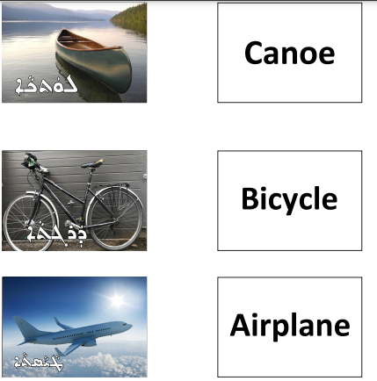

Resource A- Transport Flashcards

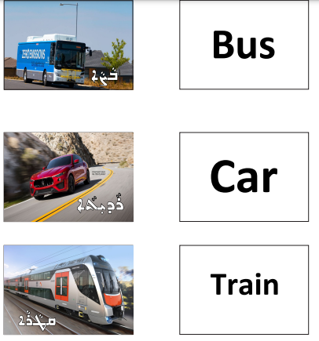

Resource A- Transport Flashcards

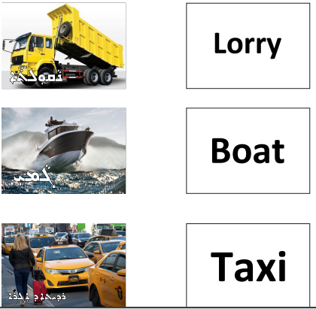

Resource A- Transport Flashcards

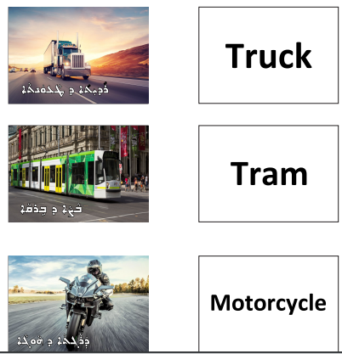

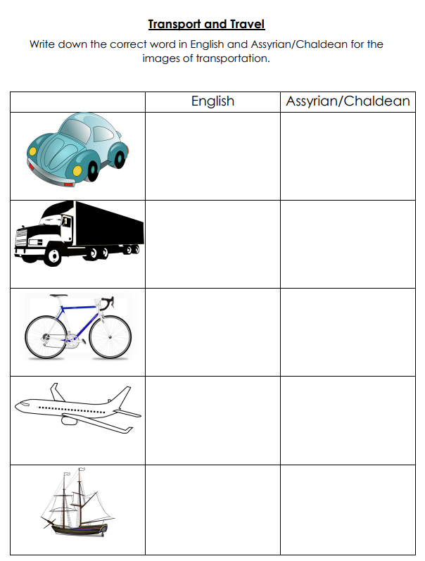
Resource B- Transport and Travel Worksheet

Resource C- History of Transport

Resource C- History of Transport
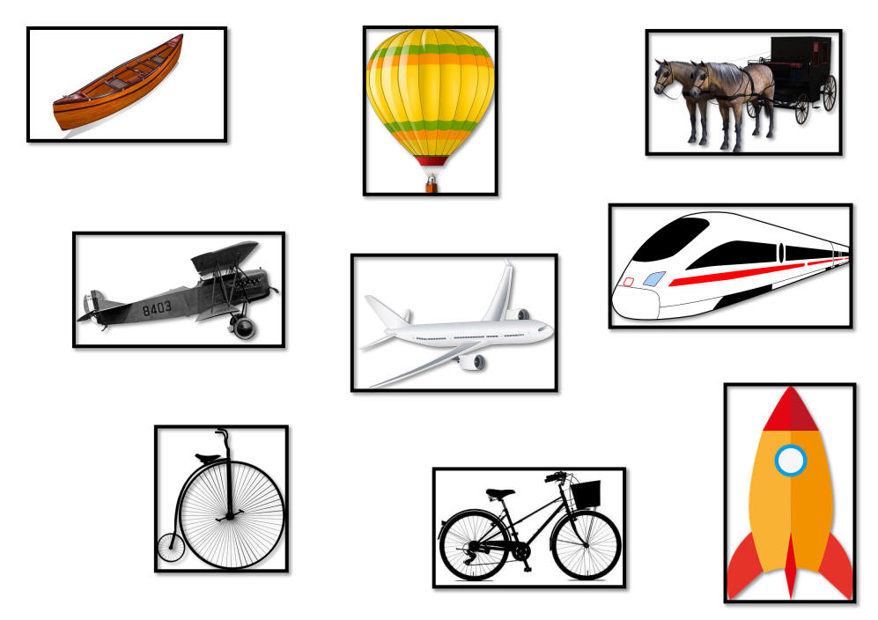

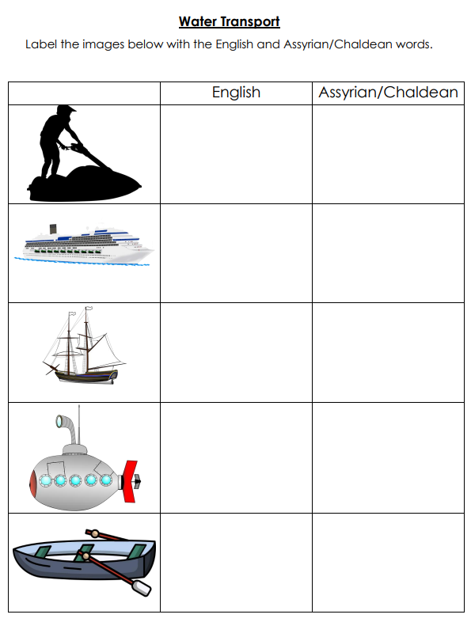
Resource D- Water Transport Label Worksheet

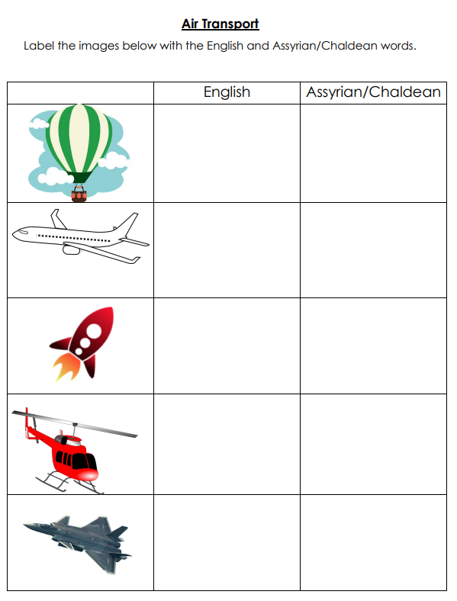
Resource E- Air Transport Label Worksheet

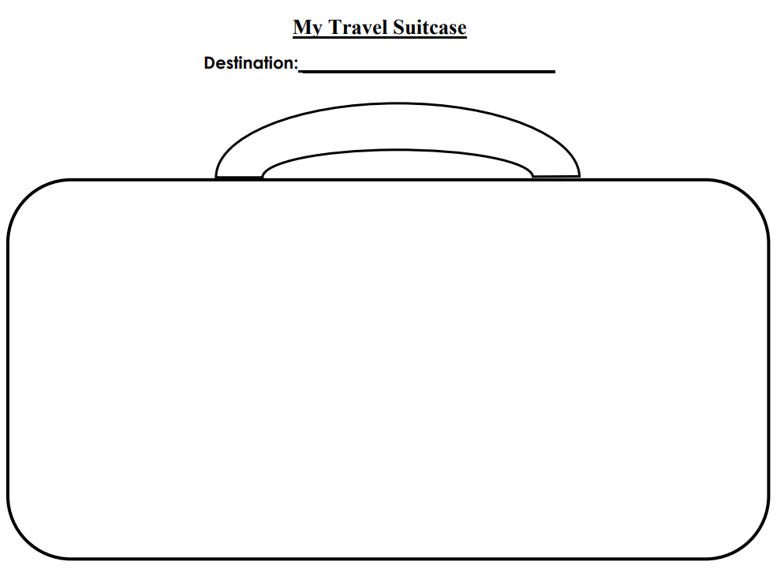
Resource F- Suitcase Worksheet

